# Introduction

This article applies only to OrangePi3 Armbian Buster.

# RAK831 and OrangePi3 connection diagram

|  |  |  |  |  |
| --- | --- | --- | --- | --- |
| RAK831 pin | Description | Orange Pi pin | Description | Color |
| 1,2 | +5 Volt | 2, 4 |  | Orange |
| 3,5 | Ground | 6,9 |  | Brown |
| 15 | CSN (chip select) | 24 | GPIO13 - SPI1 CS0 | Blue |
| 18 | SCP (SPI clock) | 23 | GPIO14 – SPI1 SCLK | Green |
| 16 | MOSI | 19 | GPIO15 – SPI1 MOSI | Brown-white |
| 17 | MISO | 21 | GPIO16 – SPI1 MISO | Green-white |
| 19 | RST (Reset) | 26 | GPIO360 | Blue-white |

The cable looks like this:

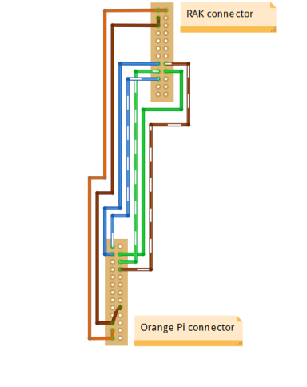

# RAK833/RAK2247 and OrangePi3 connection diagram

1. If you have a PCIE to USB converter, you can connect the RAK833/RAK2247 to the USB interface of the OrangePi3 via a converter.

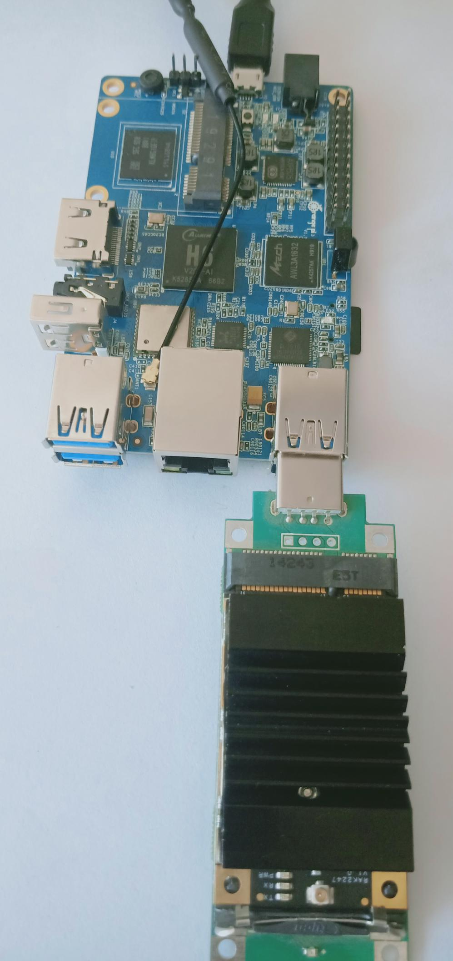

1. You can also connect the RAK833/RAK2247 directly to the PCIE interface of the OrangePi3.

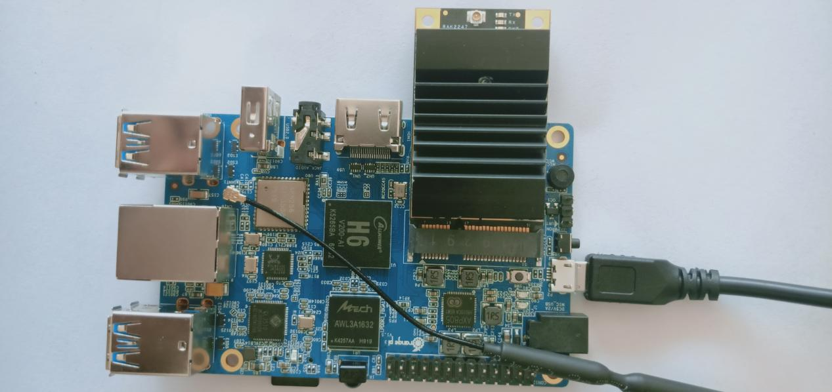

# Installation procedure

1. Download and install Raspbian Stretch LITE.
2. Use "sudo armbian-config" command, enable spi-spidev1.

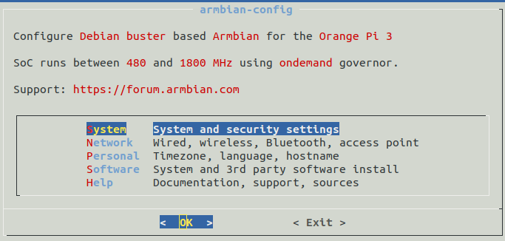

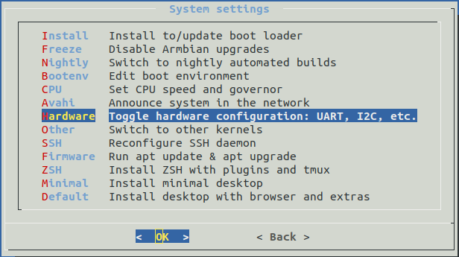

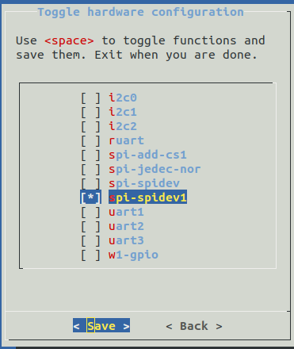

* 1. Reboot OrangePi3.

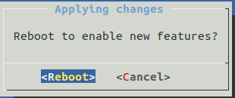

1. Clone the installer and start the installation.

$ git clone https://github.com/RAKWireless/rak_gateway_for_OrangePi3.git rak_gateway_for_OrangePi3

$ cd rak_gateway_for_OrangePi3

$ sudo ./install.sh