**LAL-independent-2D**, LALINDEPENDENT strategy trained on a synthetic dataset of cold start

**LAL-iterative-2D**,LALITERATIVE strategy trained on a synthetic dataset of cold start

Cold start 初始数据集两个样本，一正类一负类

checkerboard2x2 checkerboard4x4

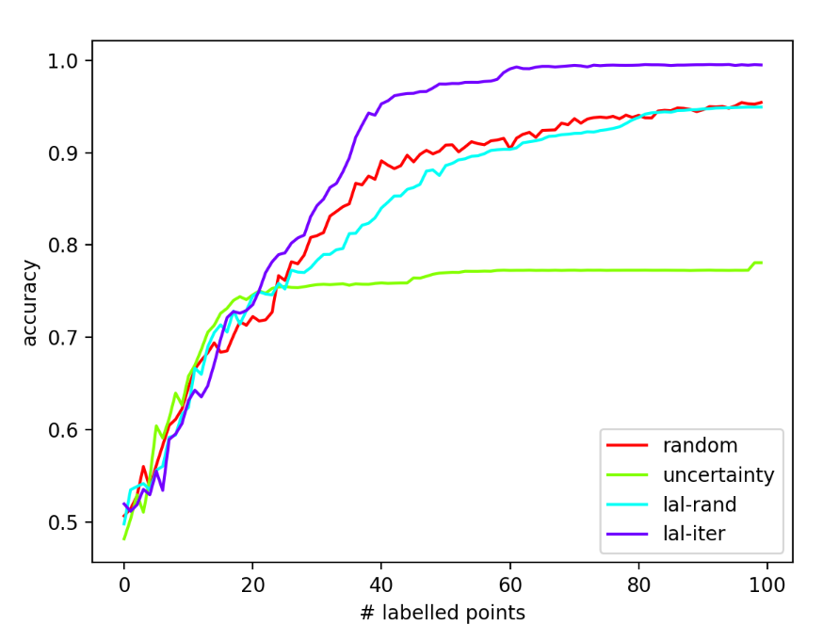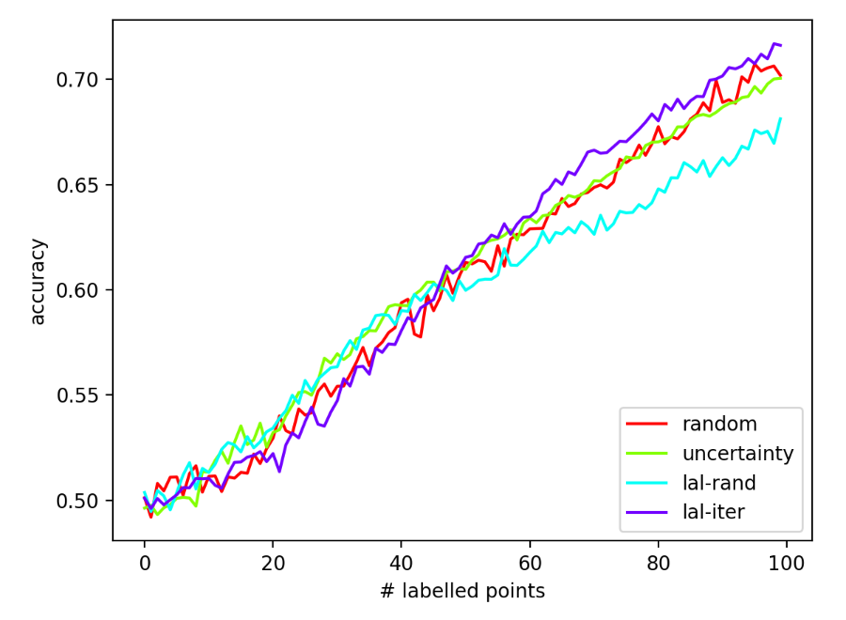

rotated-checkerboard2x2 Striatum

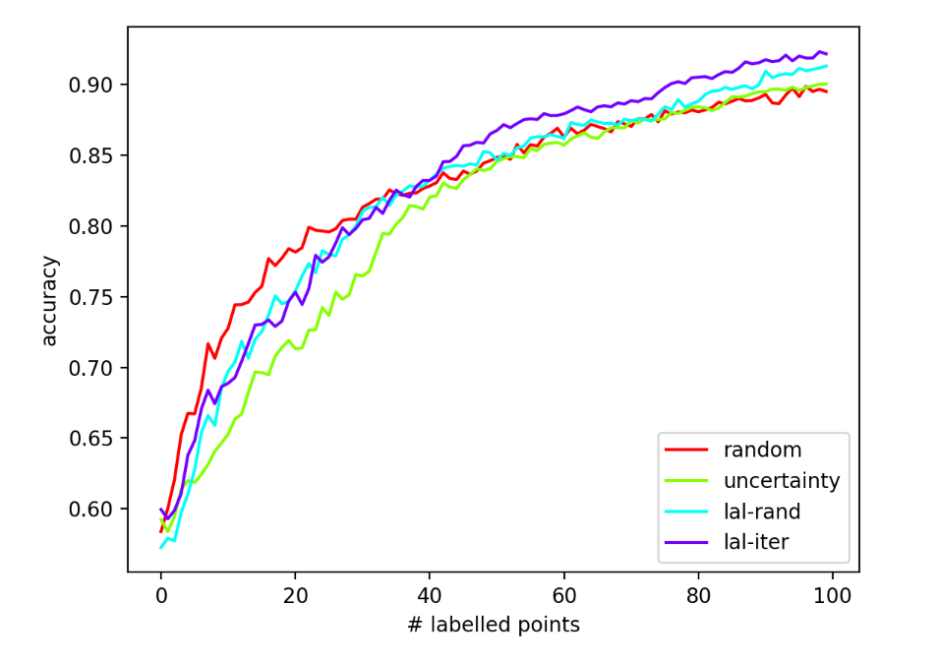 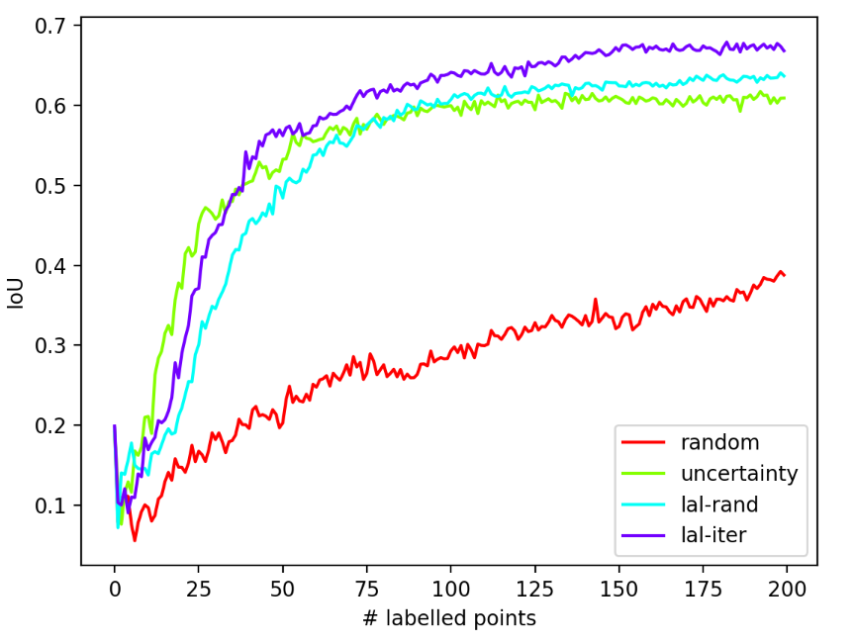

checkerboard2x2 checkerboard4x4

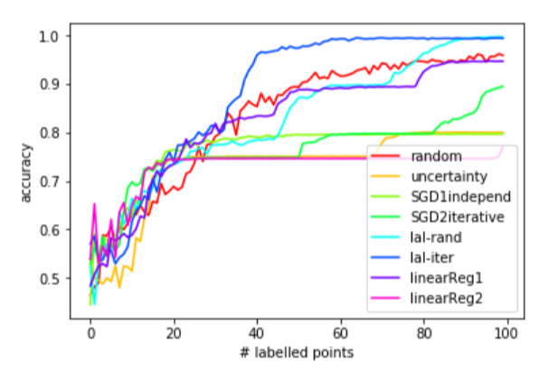 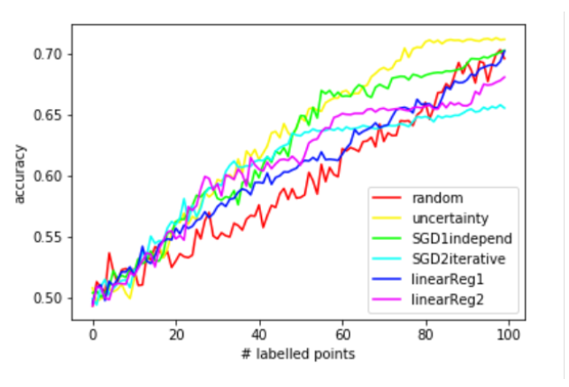

rotated-checkerboard2x2 Striatum

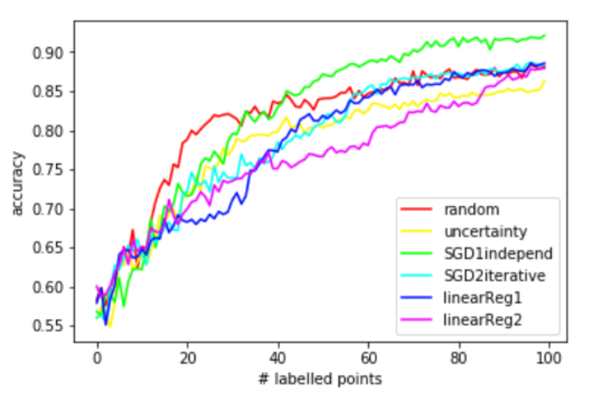

SimulatedUnbalanced

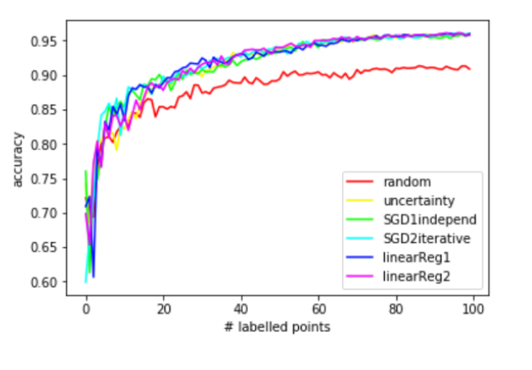

DatasetDiabetes Datasetwaveform_5000_1_2

