First Order Logic

# 1.1 First-Order Logic

* Vocabulary = set of 2-tuples, where the first element of the 2-tuple is a predicate, and the second element is the "arity" of the predicate
  + Ex: 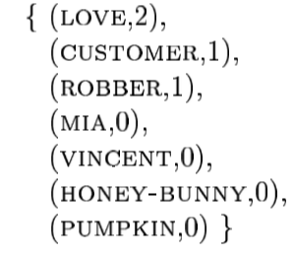
  + love has arity 2, because it is a binary predicate (describes a relationship between 2 entities)
  + customer has arity 1, because it is a unary predicate (describes property of 1 entity)
  + Vincent has arity 0, because it names a particular entity
* Model = “situation” or semantic entity, derived from a vocabulary
  + 1. Identifies the Domain (set of objects d1, d2, d3,…)
  + 2. Maps each symbol in the vocabulary to a semantic entity(ies) in D
  + is an ordered pair (D,F) consisting of domain D, and interpretation function F
  + vocabulary symbols with n-arity are mapped to sets of n-tuples:
    - 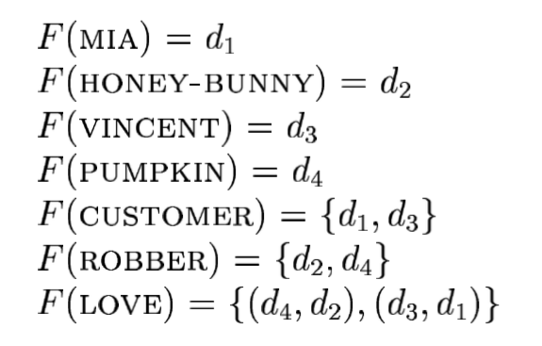
  + exact model = model where every entity in D is named by exactly one constant (like Vincent, or Pumpkin, etc)
* First Order Language over a Vocabulary =
  + 1. All symbols in the vocabulary = ‘non-logical symbols’ of the language
  + 2. Countably infinite collection of variables x,y,z,w…
  + 3. Boolean connectives (negation, implication, disjunction, conjunction)
  + 4. Quantifies (universal and existential)
  + 5. Parentheses and commas (for ordering)