Bioinformatics 2019-2020

Date: 15 January 2020

Project report

|  |
| --- |
| Bioinformatics@Data Science A.Y. 2019-2020  **Network Medicine project**  Simone Faricelli, Lorenzo Germano  Group no. 09 Abstract In this project we analyzed the genes relatives to the human disease Diabetes Mellitus. We analyzed the structure of the network generated by their connections and extracted graph and information from two different databases. We also made use of tools called Erichr for the Gene Ontlogies and Pathways extraction. We clustered our Largest Connected Component in order to obtain Putative Disease Modules and applied hypergeometric test to calculate their pvalue. We finally used the tool DIAMOnD to compare our results. |

Basic introduction about the disease/process

Diabetes mellitus: More commonly referred to as "diabetes", a chronic disease associated with abnormally high levels of the sugar glucose in the blood.

Diabetes is due to one of two mechanisms: Inadequate production of insulin (which is made by the pancreas and lowers blood glucose), or Inadequate sensitivity of cells to the action of insulin.

The two main types of diabetes correspond to these two mechanisms and are called insulin dependent (type 1) and non-insulin dependent (type 2) diabetes. In type 1 diabetes there is no insulin or not enough of it. In type 2 diabetes, there is generally enough insulin but the cells upon which it should act are not normally sensitive to its action. Both are caused by a combination of genetic and environmental risk factors.

The signs and symptoms of both types of diabetes include increased urine output and decreased appetite as well as fatigue. Diabetes is diagnosed by blood glucose testing, the glucose tolerance test, and testing of the level of glycosylated hemoglobin (glycohemoglobin or hemoglobin A1C). The mode of treatment depends on the type of the diabetes.

The major complications of diabetes include dangerously elevated blood sugar, abnormally low blood sugar due to diabetes medications, and disease of the blood vessels which can damage the eyes, kidneys, nerves, and heart.

Seed genes

We started from the DisGeNet dataset, looking for every gene involved in the disease of Diabetes mellitus regarding the Homo Sapiens. We manually downloaded the whole dataset from the site and stored in the following table all the information about the above-mentioned genes using Matlab and selecting only the genes with the corresponding pathology code of Diabetes ('C0011853’).

Besides the gene symbols, we stored also the corresponding Gene Entrez ID, UniProt ID, Protein Name and (only inside the “**Data Table Gene Seed.xls**” file) also related gene description, by requesting the additional information with a GET call to the “Hugo Gene Nomenclature Committee” site.

|  |  |  |  |
| --- | --- | --- | --- |
| Gene_Symbol | Gene_ID | Uniprot_ID | Protein_Name |
| ACOX1 | 51 | Q15067 | acyl-CoA oxidase 1 |
| ADRA1A | 148 | P35348 | adrenoceptor alpha 1A |
| ADRB3 | 155 | P13945 | adrenoceptor beta 3 |
| AGT | 183 | P01019 | angiotensinogen |
| FAS | 355 | P25445 | Fas cell surface death receptor |
| STS | 412 | P08842 | steroid sulfatase |
| ATF3 | 467 | P18847 | activating transcription factor 3 |
| ATP2A2 | 488 | P16615 | ATPase sarcoplasmic/endoplasmic reticulum Ca2+ transporting 2 |
| ATP2A3 | 489 | Q93084 | ATPase sarcoplasmic/endoplasmic reticulum Ca2+ transporting 3 |
| BAX | 581 | Q07812 | BCL2 associated X, apoptosis regulator |
| BCL2 | 596 | P10415 | BCL2 apoptosis regulator |
| BCL2L1 | 598 | Q07817 | BCL2 like 1 |
| BDKRB1 | 623 | P46663 | bradykinin receptor B1 |
| CASP3 | 836 | P42574 | caspase 3 |
| CAT | 847 | P04040 | catalase |
| CAV1 | 857 | Q03135 | caveolin 1 |
| CAV3 | 859 | P56539 | caveolin 3 |
| CD68 | 968 | P34810 | CD68 molecule |
| CHRM2 | 1129 | P08172 | cholinergic receptor muscarinic 2 |
| CPT1A | 1374 | P50416 | carnitine palmitoyltransferase 1A |
| CPT1B | 1375 | Q92523 | carnitine palmitoyltransferase 1B |
| CYBA | 1535 | P13498 | cytochrome b-245 alpha chain |
| CYBB | 1536 | P04839 | cytochrome b-245 beta chain |
| CYP1A1 | 1543 | P04798 | cytochrome P450 family 1 subfamily A member 1 |
| ACE | 1636 | P12821 | angiotensin I converting enzyme |
| NQO1 | 1728 | P15559 | NAD(P)H quinone dehydrogenase 1 |
| EDN1 | 1906 | P05305 | endothelin 1 |
| ESRRA | 2101 | P11474 | estrogen related receptor alpha |
| ACSL1 | 2180 | P33121 | acyl-CoA synthetase long chain family member 1 |
| FOXO3 | 2309 | O43524 | forkhead box O3 |
| GCK | 2645 | P35557 | glucokinase |
| GPD2 | 2820 | P43304 | glycerol-3-phosphate dehydrogenase 2 |
| GPX1 | 2876 | P07203 | glutathione peroxidase 1 |
| GSR | 2936 | P00390 | glutathione-disulfide reductase |
| HK1 | 3098 | P19367 | hexokinase 1 |
| HMOX1 | 3162 | P09601 | heme oxygenase 1 |
| HSD11B1 | 3290 | P28845 | hydroxysteroid 11-beta dehydrogenase 1 |
| IAPP | 3375 | P10997 | islet amyloid polypeptide |
| ICAM1 | 3383 | P05362 | intercellular adhesion molecule 1 |
| ID1 | 3397 | P41134 | inhibitor of DNA binding 1, HLH protein |
| IFNG | 3458 | P01579 | interferon gamma |
| IGF1 | 3479 | P05019 | insulin like growth factor 1 |
| IL1B | 3553 | P01584 | interleukin 1 beta |
| IL6 | 3569 | P05231 | interleukin 6 |
| INSR | 3643 | P06213 | insulin receptor |
| PDX1 | 3651 | P52945 | pancreatic and duodenal homeobox 1 |
| IRS1 | 3667 | P35568 | insulin receptor substrate 1 |
| KCNJ11 | 3767 | Q14654 | potassium inwardly rectifying channel subfamily J member 11 |
| LEP | 3952 | P41159 | leptin |
| LEPR | 3953 | P48357 | leptin receptor |
| MAP3K5 | 4217 | Q99683 | mitogen-activated protein kinase kinase kinase 5 |
| MFGE8 | 4240 | Q08431 | milk fat globule EGF and factor V/VIII domain containing |
| MMP2 | 4313 | P08253 | matrix metallopeptidase 2 |
| MMP9 | 4318 | P14780 | matrix metallopeptidase 9 |
| MPO | 4353 | P05164 | myeloperoxidase |
| COX2 | 4513 | null | null |
| ND1 | 4535 | null | null |
| NEUROD1 | 4760 | Q13562 | neuronal differentiation 1 |
| NKX6-1 | 4825 | P78426 | NK6 homeobox 1 |
| NOS2 | 4843 | P35228 | nitric oxide synthase 2 |
| NOS3 | 4846 | P29474 | nitric oxide synthase 3 |
| SERPINE1 | 5054 | P05121 | serpin family E member 1 |
| PAX6 | 5080 | P26367 | paired box 6 |
| PCK1 | 5105 | P35558 | phosphoenolpyruvate carboxykinase 1 |
| PCSK2 | 5126 | P16519 | proprotein convertase subtilisin/kexin type 2 |
| PDK4 | 5166 | Q16654 | pyruvate dehydrogenase kinase 4 |
| PFKM | 5213 | P08237 | phosphofructokinase, muscle |
| PKLR | 5313 | P30613 | pyruvate kinase L/R |
| PPARA | 5465 | Q07869 | peroxisome proliferator activated receptor alpha |
| PPARG | 5468 | P37231 | peroxisome proliferator activated receptor gamma |
| PRKCA | 5578 | P17252 | protein kinase C alpha |
| PRKCD | 5580 | Q05655 | protein kinase C delta |
| PRKCE | 5581 | Q02156 | protein kinase C epsilon |
| PTGS2 | 5743 | P35354 | prostaglandin-endoperoxide synthase 2 |
| RELA | 5970 | Q04206 | RELA proto-oncogene, NF-kB subunit |
| REN | 5972 | P00797 | renin |
| S100A6 | 6277 | P06703 | S100 calcium binding protein A6 |
| CCL20 | 6364 | P78556 | C-C motif chemokine ligand 20 |
| CX3CL1 | 6376 | P78423 | C-X3-C motif chemokine ligand 1 |
| SLC2A2 | 6514 | P11168 | solute carrier family 2 member 2 |
| SLC2A4 | 6517 | P14672 | solute carrier family 2 member 4 |
| SLC9A1 | 6548 | P19634 | solute carrier family 9 member A1 |
| SLC9A3 | 6550 | P48764 | solute carrier family 9 member A3 |
| SNAP25 | 6616 | P60880 | synaptosome associated protein 25 |
| SOD1 | 6647 | P00441 | superoxide dismutase 1 |
| SOD2 | 6648 | P04179 | superoxide dismutase 2 |
| SREBF1 | 6720 | P36956 | sterol regulatory element binding transcription factor 1 |
| TGFB1 | 7040 | P01137 | transforming growth factor beta 1 |
| TIMP1 | 7076 | P01033 | TIMP metallopeptidase inhibitor 1 |
| TIMP2 | 7077 | P16035 | TIMP metallopeptidase inhibitor 2 |
| TNF | 7124 | P01375 | tumor necrosis factor |
| TNFRSF1A | 7132 | P19438 | TNF receptor superfamily member 1A |
| TP53 | 7157 | P04637 | tumor protein p53 |
| UCP2 | 7351 | P55851 | uncoupling protein 2 |
| VEGFA | 7422 | P15692 | vascular endothelial growth factor A |
| YWHAH | 7533 | Q04917 | tyrosine 3-monooxygenase/tryptophan 5-monooxygenase activation protein eta |
| AOC3 | 8639 | Q16853 | amine oxidase copper containing 3 |
| IRS2 | 8660 | Q9Y4H2 | insulin receptor substrate 2 |
| S1PR4 | 8698 | O95977 | sphingosine-1-phosphate receptor 4 |
| AIFM1 | 9131 | O95831 | apoptosis inducing factor mitochondria associated 1 |
| S1PR2 | 9294 | O95136 | sphingosine-1-phosphate receptor 2 |
| PPARGC1A | 10891 | Q9UBK2 | PPARG coactivator 1 alpha |
| SIRT1 | 23411 | Q96EB6 | sirtuin 1 |
| FGF21 | 26291 | Q9NSA1 | fibroblast growth factor 21 |
| S1PR5 | 53637 | Q9H228 | sphingosine-1-phosphate receptor 5 |
| GPAM | 57678 | Q9HCL2 | glycerol-3-phosphate acyltransferase, mitochondrial |
| ACOT1 | 641371 | Q86TX2 | acyl-CoA thioesterase 1 |
| NCF1 | 653361 | P14598 | neutrophil cytosolic factor 1 |

**Tab.1: Seed Genes Information**

Notes: As noticeable in the above table, the genes named “COX2” and “ND1” found no match in the HUGO dataset. So, we manually check for the correspondence found in the HUGO Dataset and we show the results in the following images.

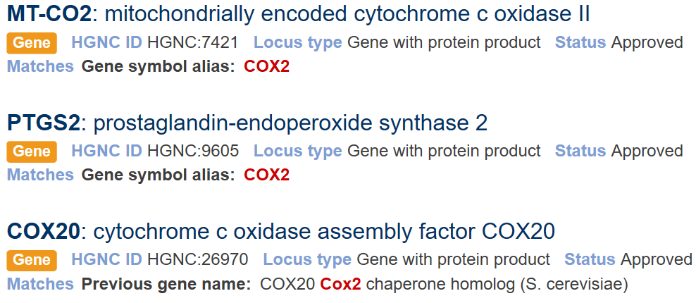

**Fig. 1:** COX2 results from HUGO

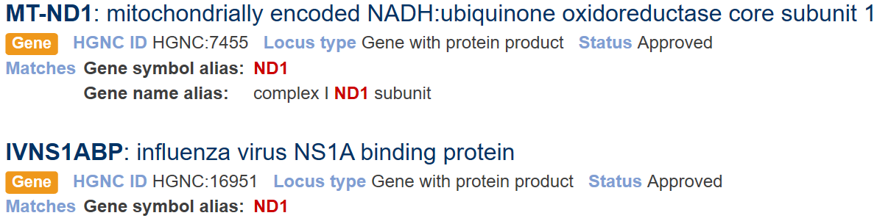

**Fig. 2:** ND1 results from HUGO

Summary on interaction data

In order to collect always updated information about the interactions between seed genes and non-seed genes connected to them we chose to use their REST site service to make in-code API call, requesting to their database all the interaction needed. Even if just one request, with the whole list of gene seeds, would have fulfilled the demand of point 1.2.a in the project requests, we decided to make multiple requests, asking for the connection of just one seed per-call and being careful to consider only Homo Sapiens genes interactions (Tax ID code: 9606). That’s because the GET request to the site can only answer with a json file of maximum 10.000 interactions. So, we obtained all the interaction for each gene and their corresponding interactome and put everything together in an excel file called “**Biogrid Interaction Table_1.2.xls**”. We ended up with a total number of 29461 interactions. The same process was performed with the second dataset, the one called Integrated Interactions Database, and like the previous one, all the interactions are stored in the excel file called “**IID Integrated Interactions Database_1.2**”, in which can be found a total number of 115558 interactions, due to excel tabs limitations, placed into 2 columns.

The following table shows the summary of the interactions for the two datasets.

|  |  |  |  |
| --- | --- | --- | --- |
| Database | Genes_Found_in_DB | Proteins_Interacting | Interactions |
| BioGrid Human | 106 | 4012 | 29460 |
| Integrated Interactions Database | 106 | 4314 | 115558 |

**Tab. 2: Summary Interactions**

# Interactomes data

For a matter of dimensions we started from the IID interactions data, which contains more PPI than the other one, storing in a .mat file a table variable which contains 5 columns with respectively “*interactor A gene symbol, interactor B gene symbol, interactor A Uniprot AC, interactor B Uniprot AC*” and “*database source*” which actually contains only “IID” string. After that we opened the set of interactions obtained from Biogrid Human and, interaction by interaction, we checked if the couple Symbol_A-Symbol_B or Symbol_B-Symbol_A already appears in the above-mentioned table. When the answer was positive, we just added the string “Biogrid” to the last column, otherwise we added a new row with the interaction and its corresponding database source.

We applied this method of analysis on interactions between only seed genes and store the results inside the file “**Seed Gene Interactome.mat**”, and also on interactions between genes in which at least one of them is a seed gene, considering only Intersection between the two databases (“**Instersection Interactome.mat**”) and considering only the union of the two (“**Union Interactome.mat**”).

# Enrichment analysis

Due to the lack of useful API call to the Enrichr server site, we manually copied the list of seed genes and the list of union interactome genes, carried-out by the previous step. The first 10 results are showed in the graphs below, sorted by pvalue ranking, which is nominally computed from the Fisher exact test, which is a proportion test that assumes a binomial distribution and independence for

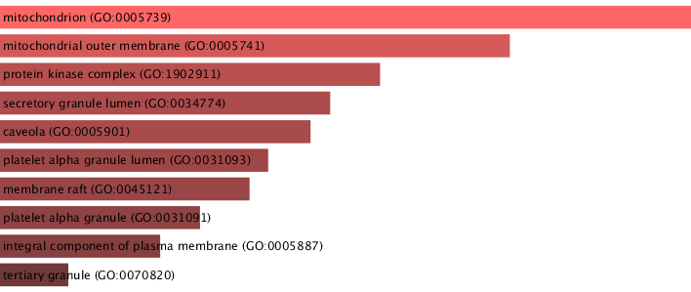probability of any gene belonging to any set.

**Fig. 3: The GO Biological Process graph of seed genes**

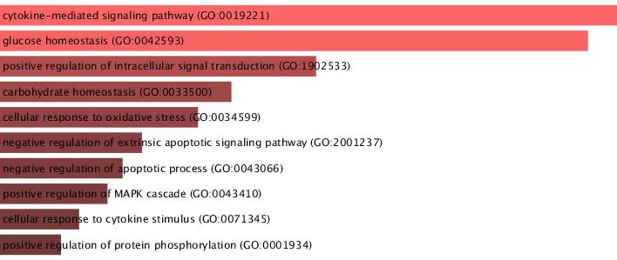

**Fig. 4: The GO Cellular Component graph of seed genes**

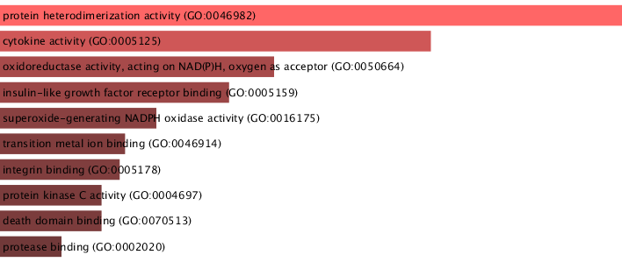**Fig. 5: The GO Molecular Function graph of seed genes**

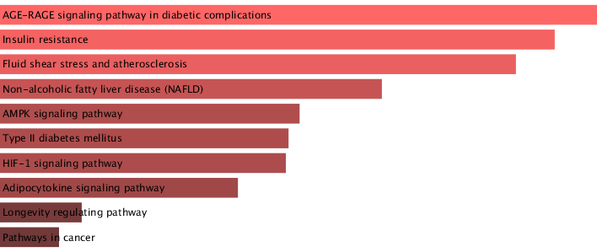

**Fig. 6: The overrepresented pathways from KEGG 2019 Human graph of seed genes**

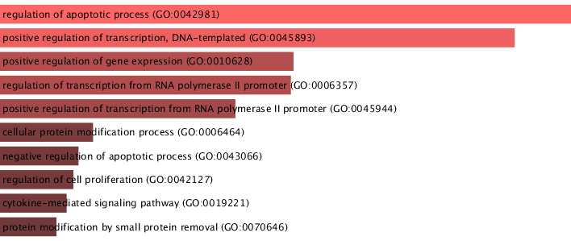

**Fig. 7: The GO Biological Process graph of union interactome genes**

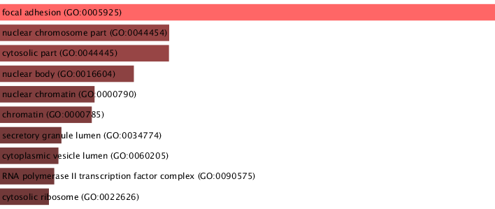

**Fig. 8: The GO Cellular Component graph of union interactome genes**

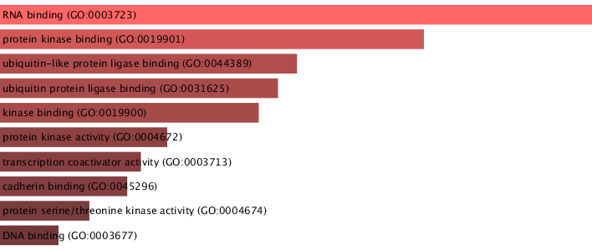

**Fig. 9: The GO Molecular Function graph of union interactome genes**

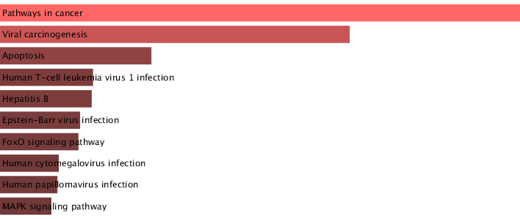

**Fig. 10: The overrepresented pathways from KEGG 2019 Human graph of union interactome genes**

# Network analysis

After generating the tables of the interactions mentioned in the previous step, we can now build each Graph with the help of the so-called built-in MATLAB class and compute the main networkmeasures, which results are showed in table below, through the use of methods and properties provided by above-mentioned MATLAB class. Listed below, we also show the results of an adjustments of the graph, meaning that, through the use of the method *conncomp()*, we extracted and analyzed the Largest Connected Component (which luckily was also the only one present in the graph after discarding connected components with a number of nodes less than 20).

|  |  |  |  |  |  |  |  |  |  |  |
| --- | --- | --- | --- | --- | --- | --- | --- | --- | --- | --- |
| **NETWORK** | No. of nodes | No. of links | No. of connected components | No. of isolated nodes | Average path length | Average degree | Average clustering coefficient | Network diameter | Network radius | Centralization |
| Seed Genes Interactome (SGI) | 88 | 219 | 1 | 12 | 3,2211 | 5,6389 | 1,0628 | 8 | 4 | 0,2489 |
| Union (U) | 4314 | 8378 | 1 | 0 | 3,5853 | 3,8841 | 1,1811 | 8 | 4 | 0,2542 |
| Intersection (I) | 2919 | 4382 | 1 | 28 | 4,0548 | 2,9338 | 0,8649 | 8 | 5 | 0,1027 |
| Intersection largest connected component (I-LCC) | 2891 | 4362 | None | None | 4,0548 | 2,9338 | 0,8649 | 8 | 5 | 0,1027 |
| Union largest connected component (U-LCC) | 4314 | 8378 | None | None | 3,5853 | 3,8841 | 1,1811 | 8 | 4 | 0,2542 |

**Tab. 3: Global Measures of Networks**

About local measures, we stored the arrays containing “*Node degree, Betweenness centrality, Eigenvector centrality, Closeness centrality, ratio Betweenness/Node degree*”, respectively in the file named **x_node_degree.mat**, **x_betweenness.mat**, **x_eigenvector.mat**, **x_closeness.mat** and **x_ratio.mat** where x has to be replaced by “i” for the intersection or “u” for the union. All the measures have been obtained with the method *centrality(‘method’)* provided by the class *Graph*.

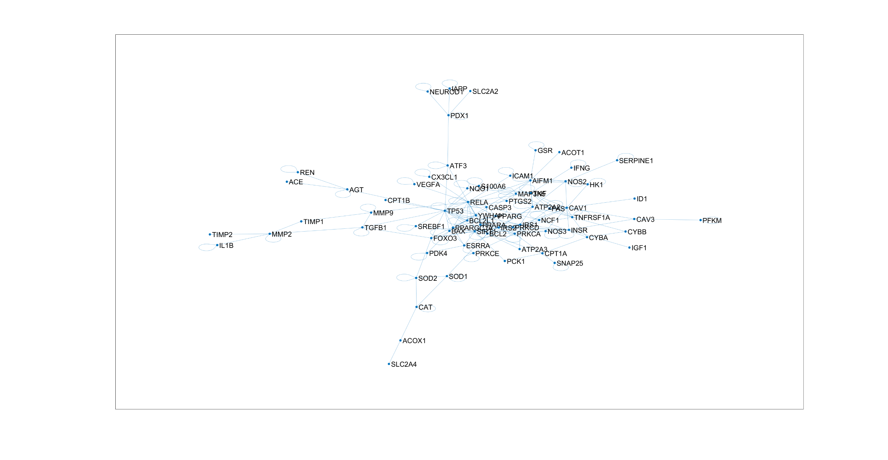

**Fig. 11: SGI Network**

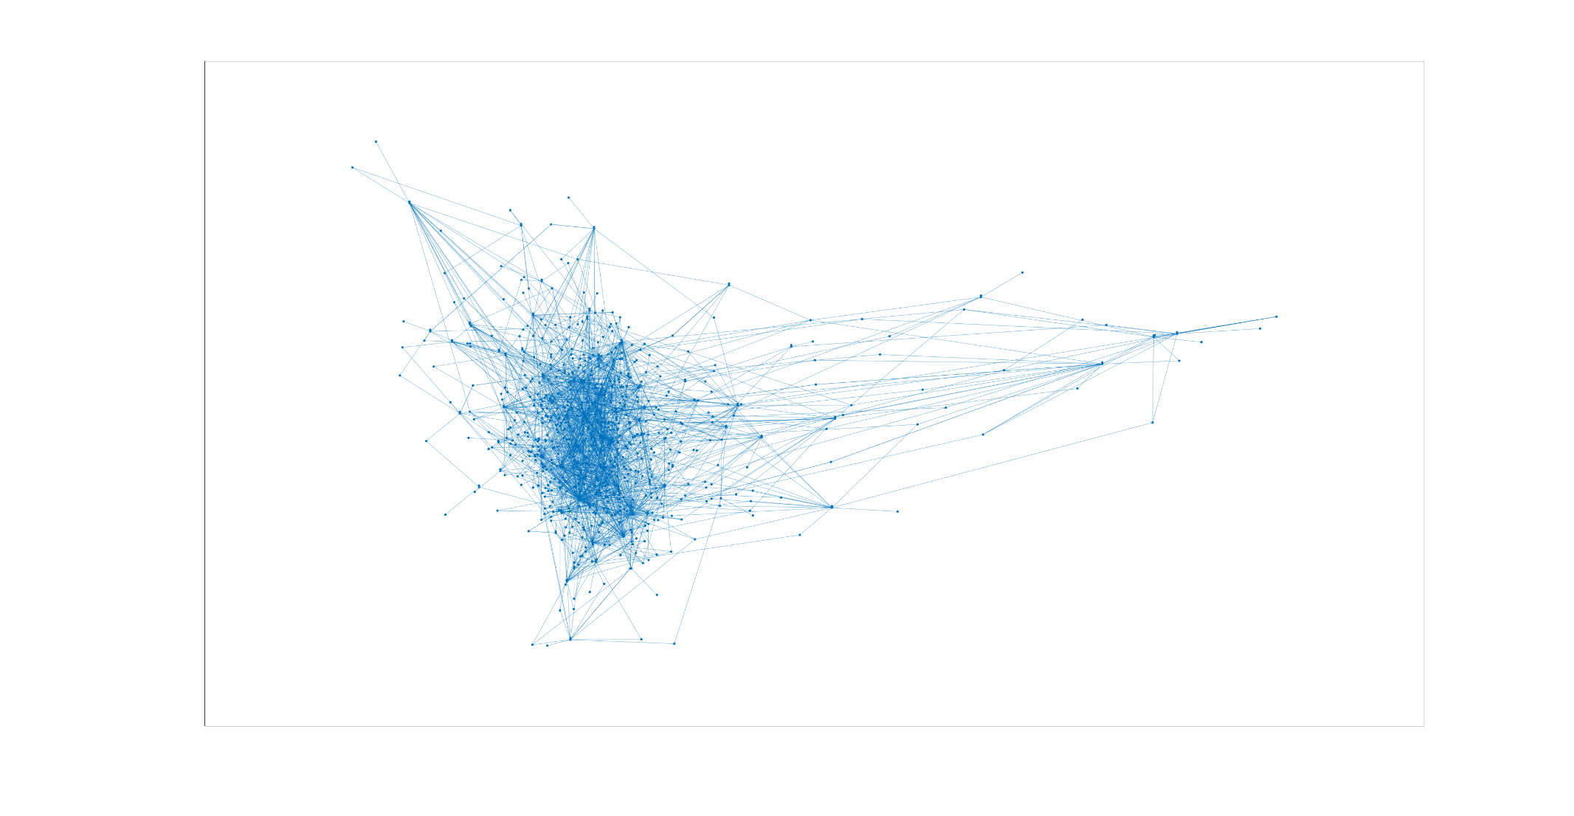

**Fig. 12: I-LCC Network**

|  |  |
| --- | --- |
| SOD1 | 24,52563035 |
| TP53 | 23,08719302 |
| RELA | 16,60545247 |
| YWHAH | 12,92891081 |
| SIRT1 | 11,7086911 |
| ICAM1 | 11,00727929 |
| TNFRSF1A | 10,2290645 |
| CAV1 | 10,10574153 |
| PRKCA | 10,07765607 |
| NOS2 | 8,623284091 |
| TNF | 6,770377009 |
| AIFM1 | 6,606237279 |
| FAS | 6,124461168 |
| ELAVL1 | 5,5934732 |
| CASP3 | 5,534540364 |
| PPARG | 5,473559634 |
| CYP1A1 | 5,050700403 |
| ATP2A2 | 4,968645522 |
| TGFB1 | 4,733671883 |
| PRKCD | 4,555303398 |

**Tab. 4: First 20 highest ranking genes for betweenness for I-LCC**

|  |  |
| --- | --- |
| TP53 | 52,04539611 |
| RELA | 18,06781786 |
| SOD1 | 13,25927148 |
| YWHAH | 12,62444802 |
| PRKCA | 12,16863859 |
| SIRT1 | 9,813613219 |
| CAV1 | 9,100157303 |
| TNFRSF1A | 8,195268053 |
| TNF | 7,653001577 |
| TGFB1 | 7,575633533 |
| AIFM1 | 6,228569627 |
| CASP3 | 6,019219382 |
| PRKCD | 5,853813199 |
| PPARG | 5,259228824 |
| ICAM1 | 5,182855828 |
| INSR | 4,542305812 |
| BCL2 | 4,429574337 |
| NOS2 | 4,164277675 |
| FAS | 3,674815101 |
| BCL2L1 | 3,436192893 |

**Tab. 5: First 20 highest ranking genes for betweenness for U-LCC**

We then divide the LCC into sub-clusters for disease modules discovery, using Markov Clustering Alghoritm, through the use of a third-party library for MATLAB which exploits Dijkstra Alghoritms to calculate them. We finally calculate the pvalue of each sub-cluster using the hypergeometric test thanks to the built-in MATLAB function *hygepdf().*

|  |  |  |  |  |
| --- | --- | --- | --- | --- |
| Algorithm | Module_ID | n_Seed_Genes_in_Module | n_Genes_in_Module | Pvalue_of_Module |
| MCL | 1-I | 3 | 137 | 0,028931438 |
| MCL | 2-I | 1 | 199 | 0,003671278 |
| MCL | 3-I | 1 | 121 | 0,04750068 |
| MCL | 4-I | 4 | 254 | 0,000513587 |
| MCL | 5-I | 1 | 150 | 0,019089122 |
| MCL | 1-U | 29 | 2791 | 2,12949E-47 |

**Tab. 6: Putative Disease Modules Summary**

The rest of information needed, as the list of genes mentioned in the table above, are stored in the matlab table called “**putative_disease_modules_table.mat**”.

The Enrichr analysis for each putative disease module is stored in the folder called “**Part2.3**” as .png images.

**DIAMOnD Tool**

The following list contains the first 30 genes identified by DIAMOnD Tool from the Putative Disease Proteins using as reference the whole Biogrid Human interactome dataset, already used to collect PPIs.

'COL2A1'

'GNA12'

'ECT2'

'COL12A1'

'MOAP1'

'MAFA'

'CFLAR'

'TRAF3'

'ACTBL2'

'LIG4'

'UFL1'

'MTDH'

'COL6A1'

'RNF123'

'THBS1'

'COL5A1'

'COL4A1'

'COL4A2'

'FYN'

'NEDD4'

'JAK2'

'CSK'

'AHSG'

'MAD2L1'

'EPHB2'

'UBQLN1'

'HNRNPL'

'GRB10'

'ARRB1'

'IDE'

The Enrichr analyses for the 200 newly found genes resulting from DIAMOnD Tool usage, are showed below.

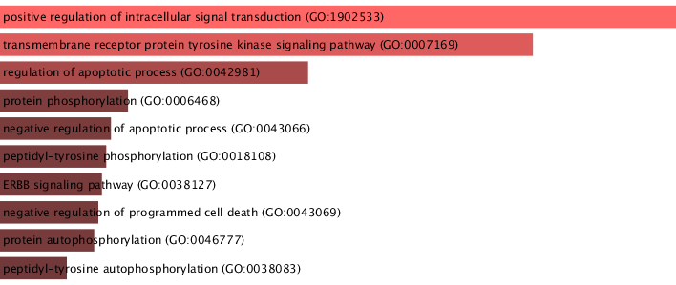

**Fig. 13: The GO Biological Process graph of 200 newly genes**

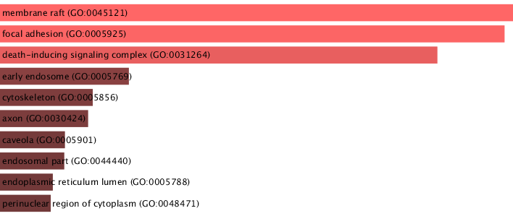

**Fig. 14: The GO Cellular Component graph of 200 newly genes**

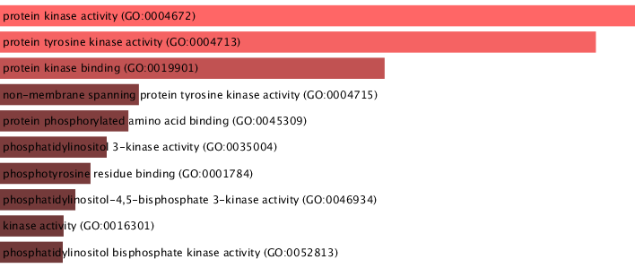**Fig. 15: The GO Molecular Function graph of 200 newly genes**

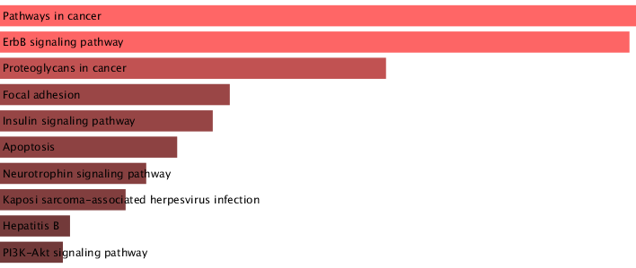

**Fig. 16: The overrepresented pathways from KEGG 2019 Human graph of 200 newly genes**