

**ELEMNETS OF PROGRAMMING**

**CSC 1100**

**Section 3**

**FINAL REPORT**

**FOR**

**THE AUTOMATIC CAR/VEHICLE WASH**

**Lecture: DR.SURIANI BINT SULAIMAN**

**Prepared by:**

**GROUP NAME:**

**HANAN&KIKY&ABUBAKAR**

**GROUP MEMBERS:**

**ABUBAKAR YAGOUB 1625897**

**HANAN ALLIL 1617888**

**ICHSANUDIN FUKKY G1710308**

**INTRODUCTION:**

The main purpose of this project is to ensure how to do programming design with usage of general purpose object oriented language that is C++ language and is an extension of the C-language. In certain scenarios, it can be coded by using the features of both high and low-level language. As it encapsulates the usage of user input, functions, pointer, array, selection and repetition.

In our program that’s about **AUTOMATIC CAR/VEHICLE WASH**, the user will select the type of vehicle and list of services which preferred to serve the vehicle in it, the program has the formula that needed to calculate the total price that will be payed for the process of washing vehicles with various type of services.

The washing process will be ongoing after the payment has been done by customer and the payment receipt will be printed for the user.

**LIST OF FUNCTIONS:**

* 1. tags(): Decoration, separating between different parts of the program.
  2. Services(): Services and their selection of many options.
  3. Receipt(): print Receipt after service is finished.
  4. Meta(): generate a service number and get today's date.
  5. Another_Service(): function to let user choose another service after finishing first service.
  6. payment(): function to calculate the total price of washing process with various types of service and for different pattern of vehicle.

**Flow Chart:**

1. Main flow chart:Clarify the purpose of every function in our program and describe how the connection between functions at all and what every function will return.

It was included the following functions:

main(), tags(), Services(), Receipt(), Meta(), Another_Service()

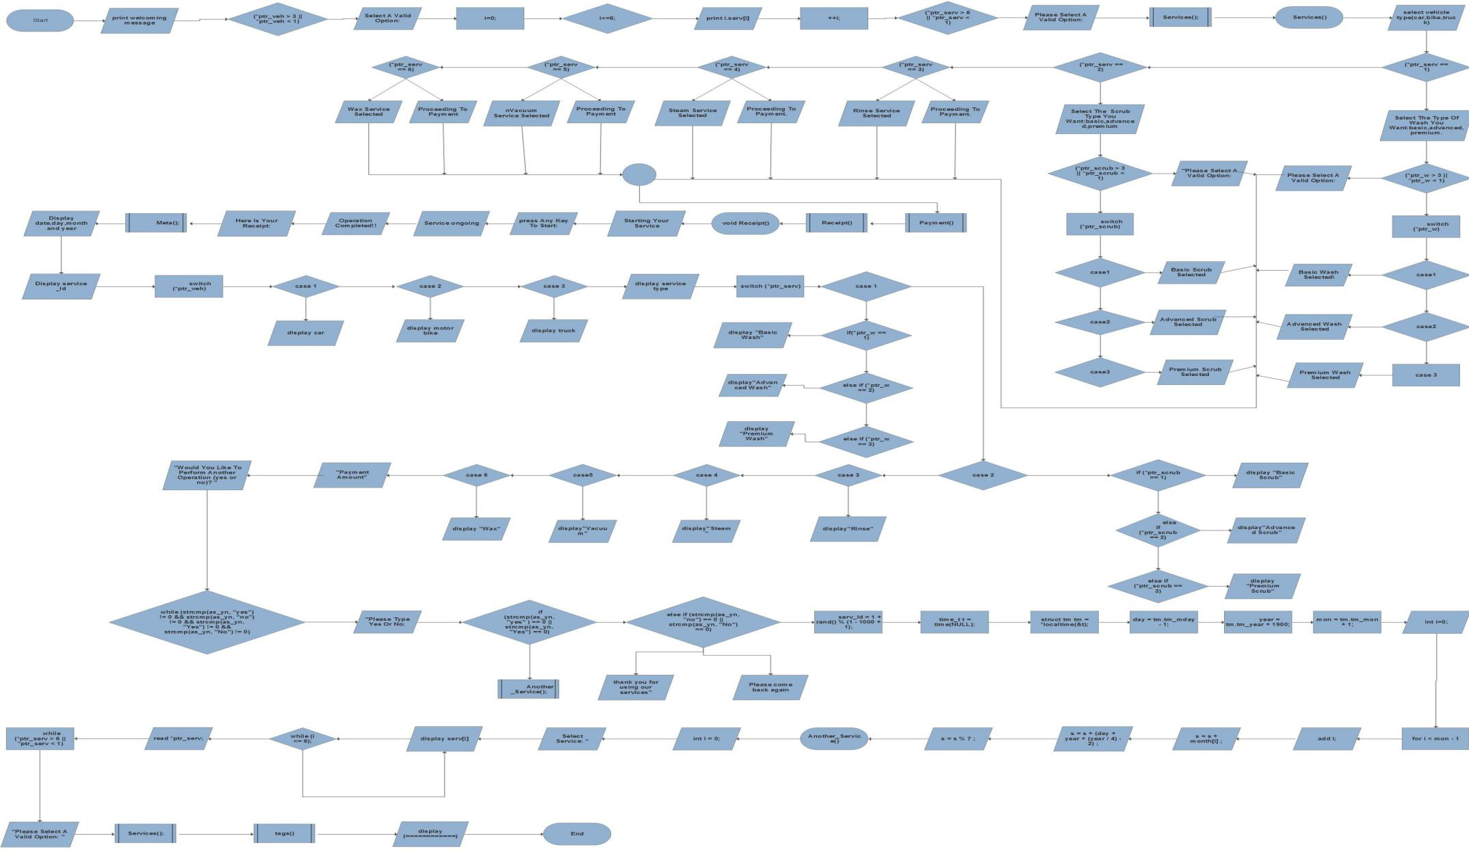

1. Header file flow chart: In this flow chart we have include function payment() that encompasses the process of calculating the price of specific service based on vehicle and service type.

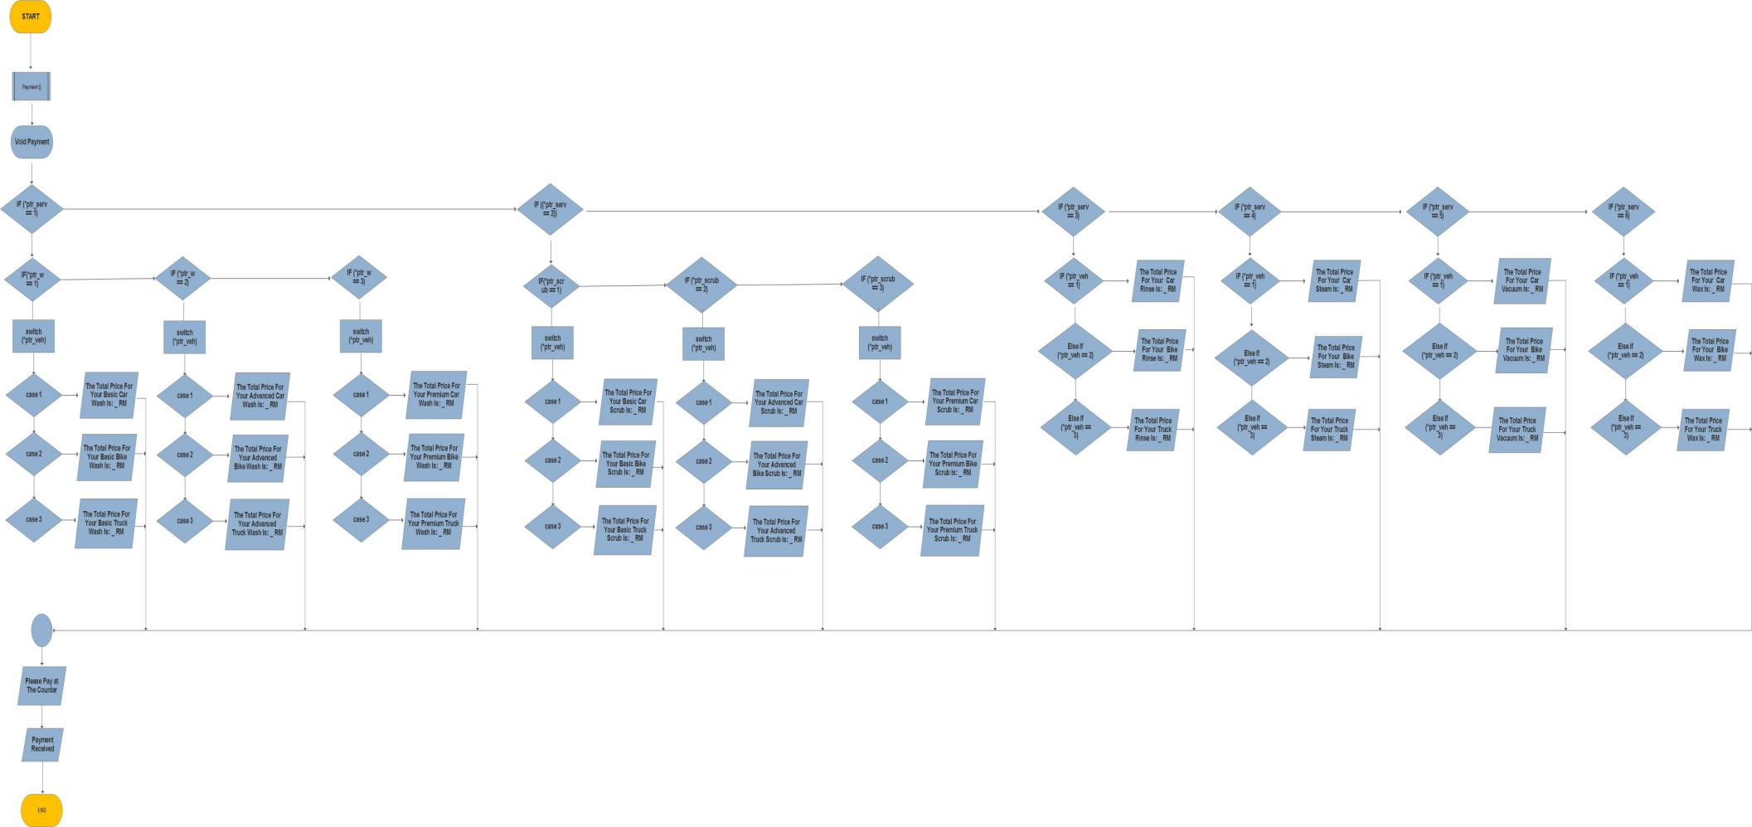

**Samples of the program:**

