Title: AntarAalay.ai: AI-Powered Vastu Interior Design Platform

Submitted By:
Ms.Surbhi Pagar,
Mrs. Reena Sahane,
Suhani Yadav (BEAD22577),
Sujit Nirmal (BEBD22605),
Soham Gulhane (BEBD22648),
Swarup Mandhare (BEBD22643)

Problem Statement:
The conventional interior designing process is costly, time-consuming, and reliant on professional designers. This serves as a barrier to individuals who wish to design and view living spaces. To circumvent this, an AI-based system model will be developed that is capable of layout generation autonomously and of making designing affordable and accessible to the masses.

Abstract:
An AI system simplifies interior design with the application of generative models and real-time sensing. Users can upload home pictures or simple room videos and process them to create interactive 3D room models with suggested furniture placement. The system integrates two key modules: an AI-powered Vastu Shastra analyzer that examines layouts based on conventional Indian concepts and a Pandit Chatbot that is pre-trained to respond to popular Vastu queries with expert-suggested answers. The process enables users to design and analyze their spaces through a combination of contemporary technology and ancient Vastu concepts, rendering home planning feasible and culturally relevant.

Keywords: Interior Design, Generative Models, 3D Layout, Vastu Shastra, Real-Time Sensing, Automation

Introduction:
It takes time, money, and professional designer consultation to design a well-functioning interior space. The old techniques are hand planning and static visualizations, which are time-consuming and will never get to the actual appearance of the final room. This creates a disconnection between what the users feel and the end product, which does not allow for personalization.
The system model is created to solve such problems. It employs generative AI and real-time sensing to transform a room video into a 3D model. The system then proposes furniture placements and applies Vastu Shastra principles to create balanced and harmonious rooms. Through automation of the major design stages, this solution offers a quicker, less expensive solution for home planning.

Motivation:
- Less Planning Time: Automates the creation of 3D room models and furniture layouts, dramatically accelerating the design process.Increased Visualization: Enables users to visualize their design concepts in interactive 3D, eliminating guesswork and expensive mistakes.
- Cultural Relevance: Applies traditional Vastu Shastra principles to ensure designs are stimulating, fostering harmony and balance, and attractive to users seeking culturally appropriate design..
- Accessibility: Facilitating non-professionals to be able to access interior design without advanced skill or high-tech software..
- Improved Decision Making: Enables users to make smart design decisions with rational, AI-driven recommendations backed by the latest technology and sound architectural practices.

System Architecture:
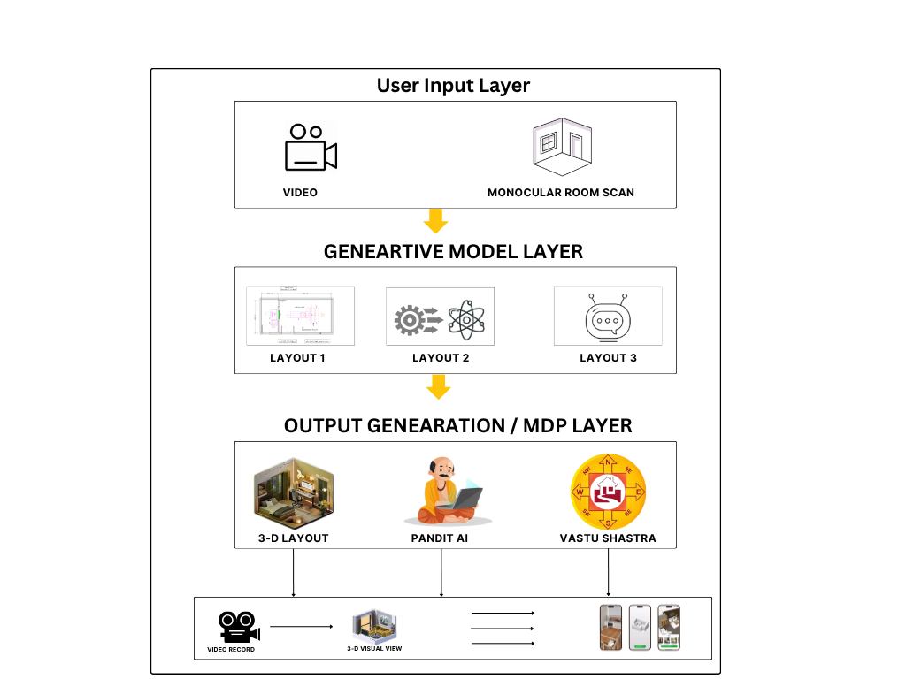

Figure 1.Proposed AI-Based Interior Design Automation Framework
Technical Details:
Problem Description:
The typical individual then grapples with the inherent pitfalls of interior design: imagining room layouts, finding furniture that suits both room and budget, and knowing how those items will work together in a living room. Conventional approaches—using tape measures, hand-drawing, or sophisticated desktop programs—are unlikely, time-consuming, and involve some degree of proficiency that most individuals lack. This leads to a frustrating process of trial and error, expensive buying errors, and resultant configurations that are neither functional nor aesthetically pleasing.
Our solution fills this gap by doing the most difficult part of the design process automatically. It accepts a simple video of a room as an input, automatically creates a dimensionally accurate 3D model, and then uses an AI engine to offer optimized layout suggestions. With the inclusion of constraints like user preference, budget, and Vastu Shastra rules, the platform provides a holistic and simple solution to what would otherwise be a complex puzzle.

Research Questions:
- How would you process a room video to properly and effectively build a high-fidelity 3D model with proper spatial dimensions?
- What algorithms would be best suited to suggest furniture arrangements that are not only aesthetically pleasing and functional but also compliant with the principles of Vastu Shastra?
- How do we convert the qualitative Vastu Shastra rules into a quantitative model that an AI can use to generate acceptable layouts to it?
- How might real-time cost estimation be incorporated into the design process in an accurate and useful manner for user budgeting without disrupting the creative process?
- How does the system efficiently leverage real-time user feedback to dynamically adapt and improve the personalization of its design recommendations?
Objectives:
- Create a smart and self-managed software to assist users in interior design.
- Automatically generate accurate 3D room plans from low-level video feeds.
- Offer customized furniture planning guidance through AI that meets functionality and design requirements.
- Integrate Vastu Shastra principles to enhance the designed plans to enhance harmony and balance.
- Develop an easy-to-use application that provides advanced interior design capability, regardless of the user's level of technical skill.
Outcomes:
- A smart and computer-based software to help users in interior designing.
- Automatically generated 3D room layout from image or video.
- Customized furniture placement suggestions for the room.
- 3D house plans showing Vastu Shastra principles of harmony and balance.
- An easy-to-use software package with sophisticated interior design functionality for all people, no technical skill needed.
Applications:
- Personal Use: For homeowners and to plan renovations and experiment with furniture layouts virtually.
- Real Estate: To virtually equip vacant buildings for more appealing online listings.
- Professional Designers: As a tool for rapid prototyping and presentation to clients.
- Small Business Owners – To create Vastu-friendly store or office layouts without the professional assistance of a designer.

