# ****Welcome****

netTransformer is a conceptual software prototype of a network transformation manager able to:

* Discover current network infrastructure
* Capture its state
* Build a graph data model out of it
* Provide ability to review and reason about L2, L3, OSPF, ISIS and BGP topology
* Automate device configuration process through simplified template interface!
* Track the network evolution process
* Transform a network from one state to the other

If that sounds interesting and you want to find out more please read the rest of this guide or visit our [Youtube channel](http://www.youtube.com/channel/UCVrXTSM9Hj6d3OFbIdF4Z2w).

Table of Contents

Welcome 1

Table of Contents **Error! Bookmark not defined.**

netTransformer Ideology 4

Runtime Environment 5

Ready, Set and Go 6

Prerequisites 6

First run 6

Step 1 Fire up netTransformer 6

Step 2 Create a new network project 7

Step 3 Configure SNMP network discovery resources 8

Step 4 Start SNMP Network Discovery 9

Step 5 Configure BGP peering Map network discoverer 10

Step 6 Start BgpPeeringMap network discovery 11

Step 7 Review the discovered Network Topology 12

GUI features, tips and tricks 15

Main menu panel 15

File 15

Discoverers 18

Graph Tools 19

Network Activation 25

Window 26

Help 26

Graph management panel 26

Refresh - Redraws the current topology picture 26

Plus/Minus - Zoom in/Zoom out 26

RightClicks 27

Shorthest Path 27

TabViewerOpener 28

Connect 28

Console_SSH2 29

HTTP/HTTPs 29

Putty 29

Reports 30

Device Neighborship Report 31

CableCut Report 31

IPv4 Address Space Report 32

IPv6 Addressing Report 32

MPLS L3 VPN Report 33

Object Tree Browser 33

Node&Path Activation 34

Remove 37

netTransformer files 37

Raw data files 37

Device xml files 38

Graphml files 39

netTransformer Configuration guidelines 40

Configure snmpNetwork discovery projects 40

Viewer Settings 40

Icon selection 42

Filters 43

Tooltips definition 43

Hops 44

RighclickHandlers 44

Configure SNMP discovery parameters 40

Configuring netTransformer RighClickHandlers 44

NewTab 45

HTTP/HTTPS 45

Putty 45

Reports 47

NodeActivation 47

ObjectTreeBrowser 48

Configure logging 48

Getting an additional information 49

Bibliography **Error! Bookmark not defined.**

# netTransformer Ideology

Each network consists of nodes and edges. The nodes could be devices that have certain hardware and software, configured in certain way, BGP autonomous systems part of the Global Internet, human profiles or HTML in the global WWW. The links could be cables, routing protocols neighbourships, social links or just links between documents.

The network state can be captured and uploaded in a certain data model. Once captured the network state could be previewed so YOU (the network stakeholder) can reason about it. If there is a need, you can even change it. The change is actually a trigger of a transformation process to another state. After the change, happens you might want again to review your current network state, to reason about it and so on until each and every node and link of the network disappears.

The described lifecycle is nothing else but a transformation from one state to another. The transformation could happen in many different ways and could be driven by many different reasons.

Typically each network stakeholders has his own context and his own reasons why he would like to change certain network state. In the IP networking world the reason for the change could be for example the introduction of a new service into the network a network extension to new geographical areas or the ongoing global network transformations as the one from IPv4 to IPv6. Another good example of a network transformation that will happen is from an IP networking world of CLI (Command Line Interface) warriors to the world of network programmability known as SDN (Software Defined Networking).

netTransformer is a concept designed specifically to fulfill such network transformation lifecycles and to help to various Network stakeholders to perform and track their network evolution transformations in much more easier and controllable way.

# Runtime Environment

[netTransformer](http://itransformers.net/wiki/iTransformer) has been written in JAVA programming language. It also uses XSLT and GROOVY in some of its components. It is platform independent and runs and performs equally well on Linux, Unix, MacOS and Windows operating systems.

# Ready, Set and Go

[netTransformer](http://itransformers.net/wiki/iTtransformer) is designed to setup quickly and without almost any effort. The next couple of pages will show you how to do this in a couple of easy steps.

The current version of the software can be obtained from the portal for free software <http://sourceforge.net>.

[http://sourceforge.net/projects/iTransformer/files/latest/download](http://sourceforge.net/projects/itransformer/files/latest/download)

## Prerequisites

Java runtime environment (JRE 1.6.x or newer)

* There have to be a IP network. Currently netTransformer supports IP networks only. To be more specific the software supports IP networks that are SNMP version 1 or version 2c enabled. The devices have to have common SNMP read community. If you do not know what that is… Hmm read [here](http://www.paessler.com/manuals/prtg_traffic_grapher/whatisansnmpcommunitystring.htm) first…
* The host on which you are running the [netTransformer](http://itransformers.net/wiki/iTtransformer) discoverers has to have SNMP connectivity to ANY IP address in your network. If there is no such connectivity the software won’t be able to discover those parts of your network that are hidden from the netTransformer host. The hosts, which do not respond to the SNMP queries
* You have to count to three and to cross your fingers :)
* The discovery process might take a while. For example SNMP network discovery of a network with 8 routers takes a couple of minutes. A production network of a medium sized network operator with 500 routers/switches and thousands of hosts takes about 6 hours. A discovery of the entire global BGP peering map might take a couple of days.

## First run

This guide covers the current version of netTransformer. At the moment of writing this is version 0.6.

### Step 1 Fire up netTransformer

First and most important step is to fire up the [**netTransformer**](http://itransformers.net/wiki/iTransformer). It will discover your network and will populate your inventory data model. Depending from your operation system go to [netTransformer](http://itransformers.net/wiki/iTtransformer)\bin and execute from the command line the following:

**!On Windows**  
cd bin

netTransformer.bat

**! On Linux/Unix**  
cd bin  
./netTransfomrer.sh

Once you do this netTransformer GUI (Graphical User Interface) will appear.

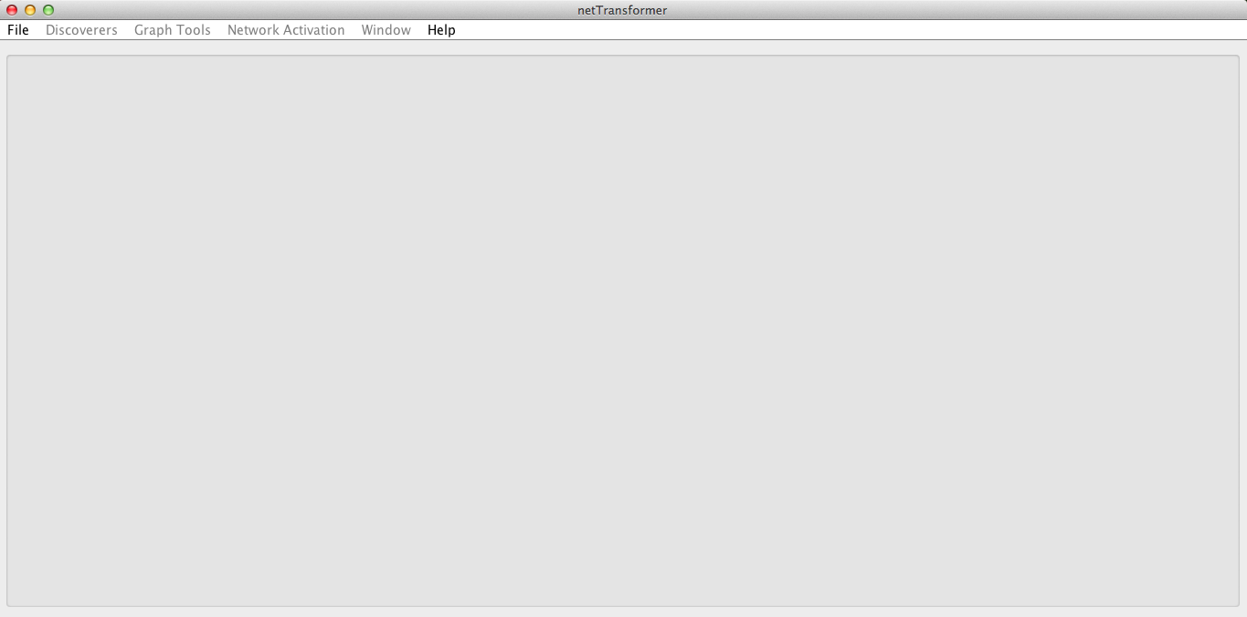

Figure netTransformer GUI

Then you will have to create a new network project or to open an existing one. Note that in the project zip is provided a demo network project that you can open in order to introduce itself to the software.

### Step 2 Create a new network project

netTransformer introduces the concept that each network has to be managed as an independent project.

Whatever you do in netTransformer, you do that in the context of a project. A project is an organizational unit that represents a complete network solution. Each project consists of certain configuration and files that represent your network.

To create your first network project go to the file menu and select New Project.

Figure Create a new project

Then select the project type and choose the path where the new project will reside. The currently supported project types are netTransformer and bgpPeeringMap.

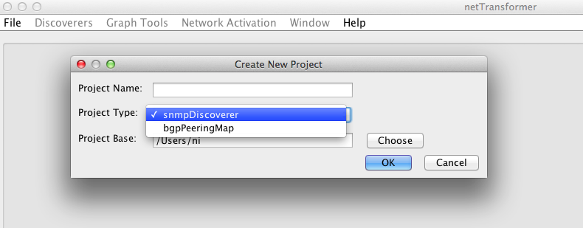

Figure Choose project type

Hopefully soon will be also released also an SDN (Software Defined Networking).

If you have chosen as project type netTransformer please proceed to step 3. If you have chosen bgpPeeringMap please proceed to step 5.

### Step 3 Configure SNMP network discovery resources

Go to the Discoverers menu navigate to **SNMP Network Discovery** and select **Configure Resource**.

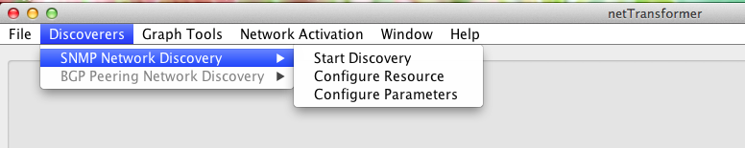

Figure SNMP network discovery menu

Once the item opens you have to change the [SNMP](http://itransformers.net/wiki/SNMP) community strings of the DEFAULT resource in order to fit to the one in your network.

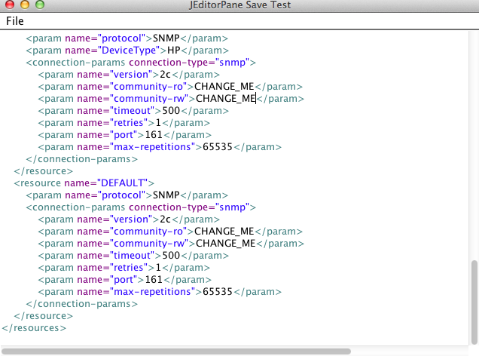

Figure Configuring SNMP network discovery resources

If all your devices share the same SNMP Communities the default resource is enough for the discovery of the entire network.

However if certain devices have SNMP security restrictions or respond slowly to certain large SNMP walks you will need also additional resources. Each resource can be matched on a combination of parameters such as DeviceType and DeviceName.

An additional resource that will be used for the discovery of HP devices part of your network will look like the one shown just bellow the default resource.

### Step 4 Start SNMP Network Discovery

Go to the Discovery menu and select **Start Discovery**. Enter the IP address of the initial network device leave the Label empty and hit the Start button.

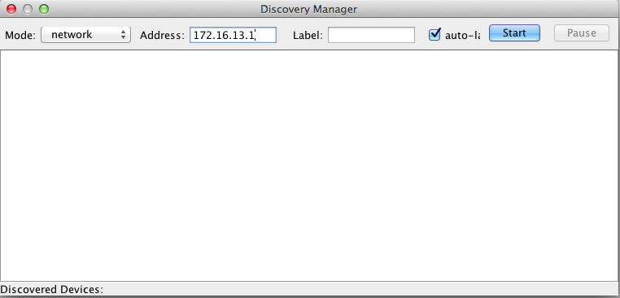

Figure Starting a new network discovery

If you have connectivity to the device and if you got the SNMP communities section right the discovery process will fire up. In the low left corner you will be able to track the how many devices are discovered.

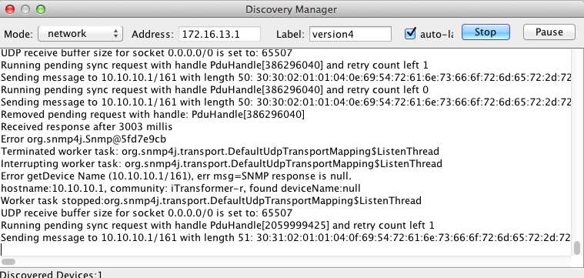

Figure Discovery Process running

Once the discovery process finishes you can proceed to Step number 7.

Note that in large networks you can review the currently discovered topology prior the process to finish.

### Step 5 Configure BGP peering Map network discoverer

Go to the Discoverers menu navigate to BGP peering Map Network Discovery and select **Configure Parameters**.

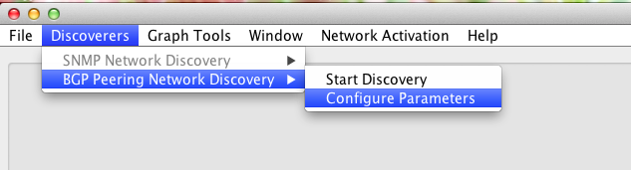

Figure BGP peering map network discovery menu

netTransformer configuration editor will appear. Here you have to change just the SNMP “community-ro” parameter and the timeouts, retries and max-repetitions values depending of your network device. Do not change the rest of the parameters if you do not know what you are doing.

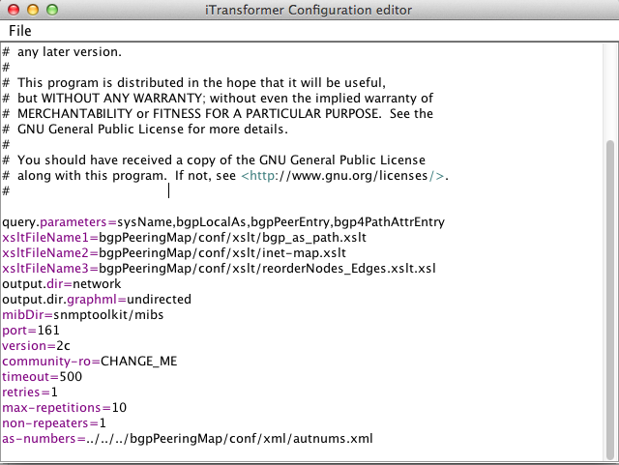

Figure Configuring BGP peering map parameters

Once ready go to the File menu press Save and Exit and proceed to the next step.

### Step 6 Start BgpPeeringMap network discovery

Navigate to Start Discovery menu option and enter the BGP router IP address then press the Start button. This will trigger the discovery procedure. If the discovery is working correctly you will notice a lot of output in the console window.

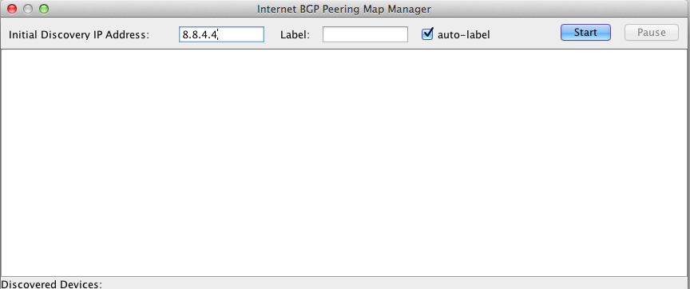

Figure Starting BGP peering Map network discovery

Note that BGP peering network discovery on a router containing the global Internet Routing table currently takes several days.

The end of the discovery process is marked by a message like this:

Output Graphml saved in a file in/Users/demo/bgpPeeringDemo1/network/version4/undirected

Once the process finish you can proceed to step number 7.

### Step 7 Review the discovered Network Topology

Go to the File Menu and choose open graph.

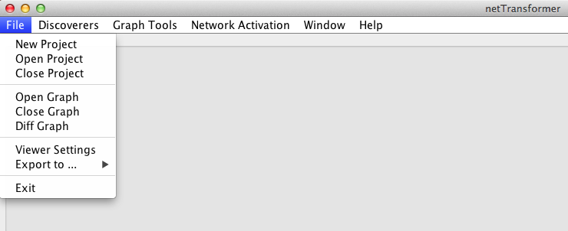

Figure Open a network graph

The menu will trigger a dialog in which you should select the folder containing version1 of the discovered network state. Navigate inside the version folder and select the undirected.graphmls or directed.graphmls file. Typically undirected.graphmls file creates a better network view.

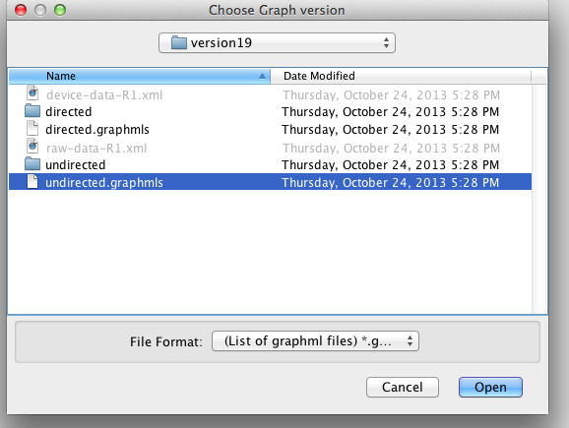

Figure Choose a network graph to be open

Once you hit the open button the discovered network topology will be visualized.

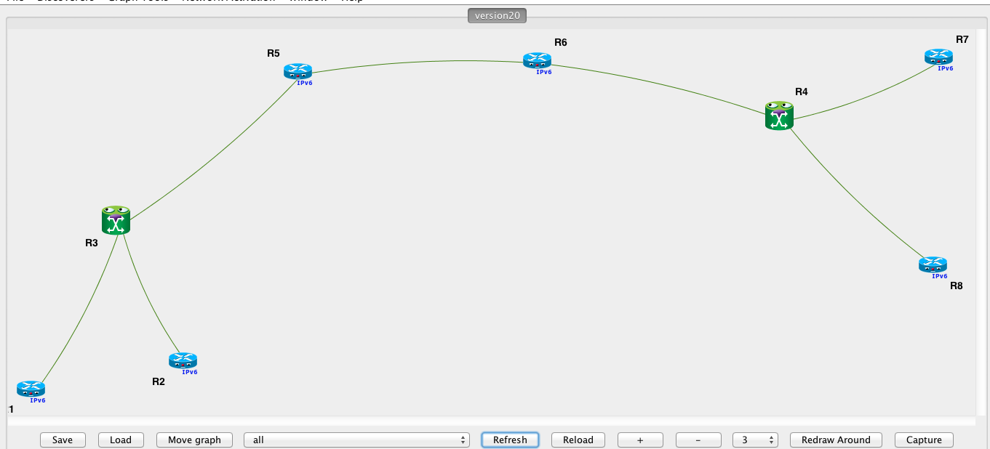

Figure Discovered IP Network topology preview

bgpPeeringMap network discovery will create views like those bellow:

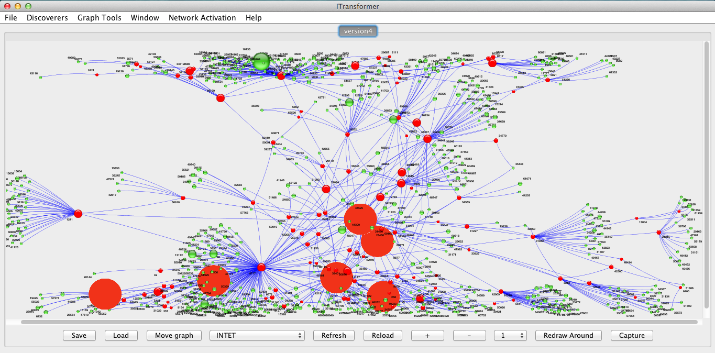

Figure Discovered BGP peering Map topology preview

The red dots are transit autonomous systems and the green dots are end autonomous systems. The size of the dot is calculated based on the rank of the node. Currently the number of the originated IP prefixes determines the rank.

# GUI features, tips and tricks

## Main menu panel

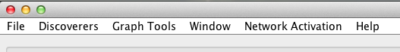

Figure Main menu pannel

netTransformer main menu consists of several sub menus described in the following sections.

### File

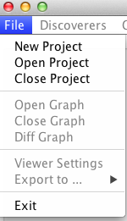

Figure File menu

#### Project Management section

**New Project** allows the user to create a new network project. For more information please refer to **Step 2 Create a new network project**.

**Open Project** allows the user to open an existing network project. Once selected the user will be prompted to choose a project file with a .pfl extension.

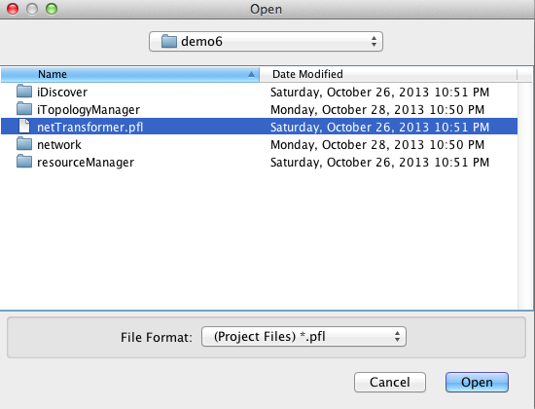

Figure Open an existing network project

**Close Project** closes an already opened project.

#### Graph Management section

* **Open Graph** allows the user to open an already discovered version of the network. netTransformer allows the user to open multiple graphs in multiple tabs.
* **Close Graph** allows the user to close an already opened graph.
* **Diff Graph** allows the user to create a network diff between any two versions of the discovered network. Once selected the diff dialog will appear. Then the user has to select the graphmls file of the versions that will be a subject to the diff.

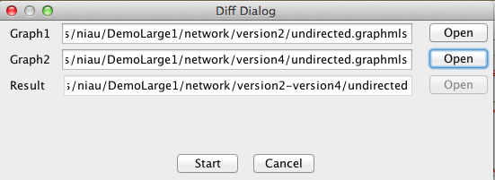

Figure Configure a network diff

Once the **Start button** has been clicked a diff progress bar will be displayed.

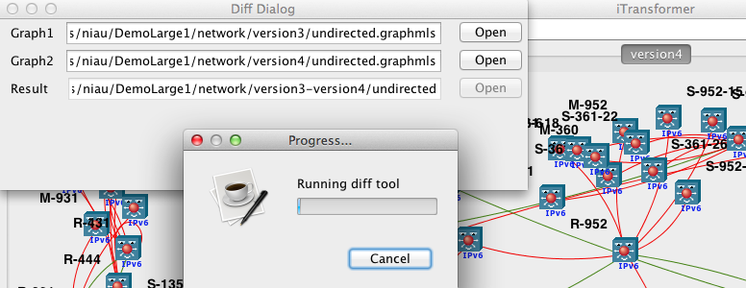

Figure Network diff running

Once the diff has finished you will see a view like the one bellow.

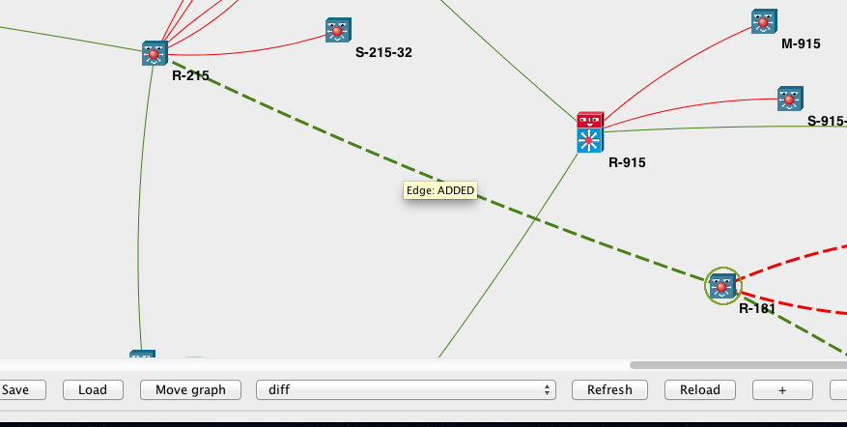

Figure Graphical representation of a network diff

Note that in order to view the diff tooltips (showing what has been added, deleted or changed) you will have to select the “diff” filter from the down panel.

* **Viewer Settings** - allows the user to edit the Viewer XML file. Here you may add new or change existing topology filters, icons and node rightclicks. Viewer settings are edited through netTransformer configuration manager. More about the principles behind the viewer settings configuration could be find in that section
* **Export to** - allow the user to export the current graph view to a jpeg or png image file formats.
* **Exit -** closes netTransformer

### Discoverers

#### SNMP Network Discovery

SNMP Network discovery is the part of netTransformer responsible for discovering IP networks through SNMP. Its algorithm is designed around the idea that each network consists of one or more nodes that are linked between each other. SNMP Network discovery implements a complex network algorithm based around the idea that giving just a single network node as an input shall be sufficient for discovering a whole network. It does not need a range of IP addresses to fire up. That is the main difference between our discovery and most of the other open or commercial network discovery tools.

In order certain network to be discovered netTransformer has to have full network connectivity to each IP address part of the current network infrastructure and common credentials. In its initial implementation the algorithm uses just SNMP so in fact to fire up a discovery are needed SNMP community string/s and an initial IP address.

The algorithm will discover the initial ip address, will find its neighbors and then will jump up to the neighbor devices will discover their neighbors and so on until the whole network is discovered.

The discovery is possible by the implementation of various methods for neighbor network device discovery. Currently the it supports but is not limited to the following discovery methods:

* CDP (Cisco Discovery Protocol) - this method is useful for physical network discovery in Cisco based network.
* LLDP (Local Link Discovery Protocol) - this method is useful for physical network/data link network topology discovery in Metro Ethernet network.
* ARP (Address Resolution Protocol) - this method is based on ARP table neighbors’ discovery. Useful but dangerous in certain cases (e.g when the expected network is too large). Use that one with care. Have a look on the configuration guide regarding how to customize the network discovery requests in order to skip one or another method.
* MAC (Media Access Control) - this method is based on MAC table neighbors’ discovery. Useful but dangerous in certain cases (e.g when the expected network is too large). Use that one with care. Have a look on the configuration guide regarding how to customize the network discovery requests in order to skip one or another method.
* MACtoARP - Combination between MAC/ARP tables of the device.
* Slash30/31 - Method based on calculation of neighbor IP address in point-to-point networks.
* IP routing table discovery - Method based on finding the unique neighbor next hops as per IP route SNMP MIB. Note that SNMP MIB on which that method is based is already deprecating so maybe better to focus on the next method.
* ip forwarding table discovery That method is based on ip forwarding MIB. It contains more then 10 different methods and is well document in “New Discovery Methods development Guide”.
* Open Shortest Path First - Discovering OSPF routing protocol neighbors.
* Border Gateway Protocol - Discovering BGP routing protocol neighbors.

More information about how to develop your own SNMP network discovery method could be found in “New SNMP discovery Methods development Guide”.

#### Configure parameters

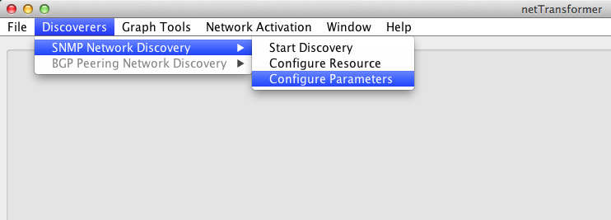

Most of the parameters of the SNMP network discoverer are configurable by this sub menu in fact allows the user to edit the iDiscover/conf/xml/discoveryParameters.xml file. This file contains configuration that allows the user to specify different SNMP network discovery OIDs used for the discovery of various types of devices.

### Graph Tools

#### Layouts

The layouts determine the positional representation of the different nodes and edges of the graph. Graph layouts influence the understandability of the network (one of the principles in netTransformer ideology).

##### FR-Layout



This layout implements the Fruchterman-Reingold force-directed algorithm for node layout. For more information please have a look on “Fruchterman and Reingold, ‘Graph Drawing by Force-directed Placement’”, <http://i11www.ilkd.uni-karlsruhe.de/teaching/SS_04/visualisierung/papers/fruchterman91graph.pdf>

##### KK-Layout

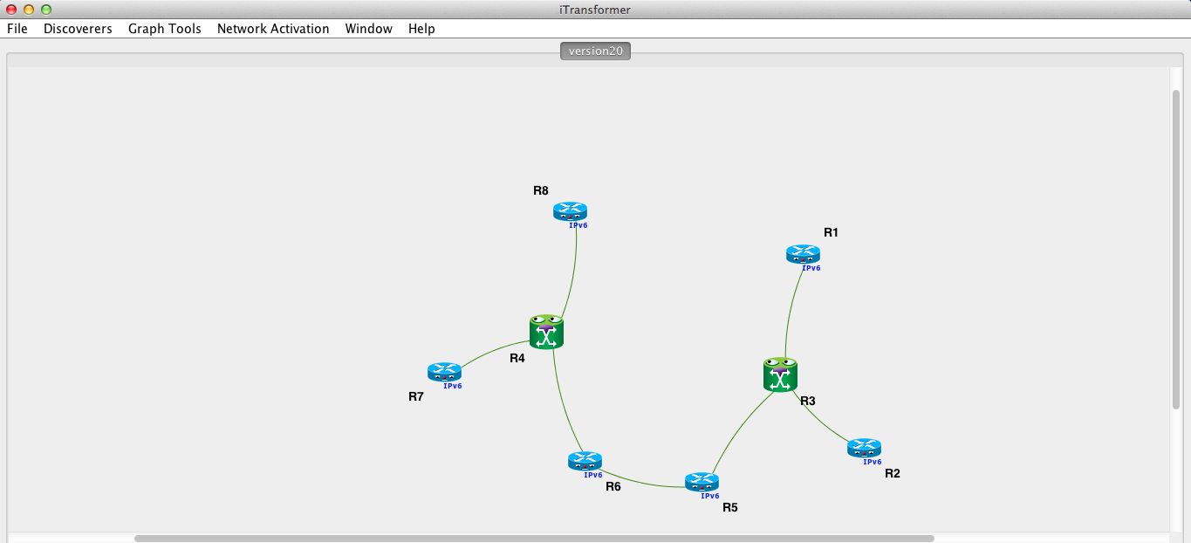

Implements the Kamada-Kawai algorithm for node layout [1].

##### Circle Layout

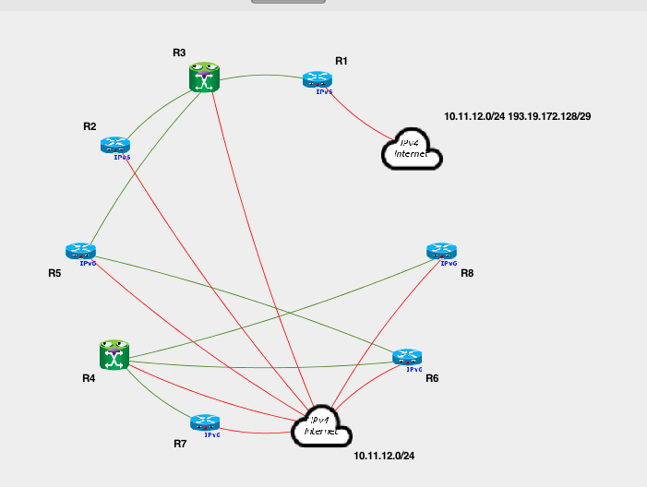

This Layout implementation positions the nodes equally spaced on a regular circle.

##### Spring Layout

Spring Layout represents a visualization in which the nodes and edges of the graph get “alive”. Our implementation follows closely the initial one part of JUNG [2]

##### ISOM Layout

ISOM layout implements a self-organizing map layout algorithm, based on Meyer’s self-organizing graph methods [3].

#### Node Search

##### Search by Name Current graph

This menu item performs a search into the currently displayed graph. The user will see a dropdown with the nodes part of the current graph and has to select a node from it. Once select will be displayed the graph node properties for the selected node.

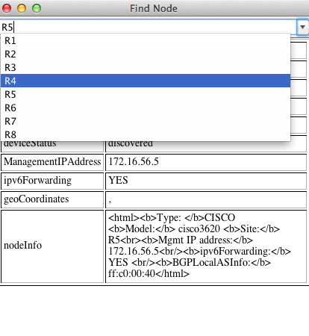

##### Search by Name Entire graph

This menu options performs a search into the entire graph. The user will see a dropdown with the nodes part of the entire graph and has to select a node from it. Once select will be displayed the graph node properties for the selected node.

##### Search by Key

##### Search by IP

#### Ranking Algorithms

The ranking algorithms enables network researchers and engineers to determine the rank of the nodes of the discovered real networks.

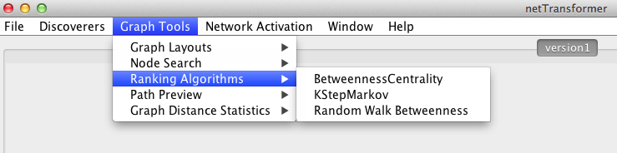

The results are displayed in html format that allows the researcher to copy the values and to use them for further network research.

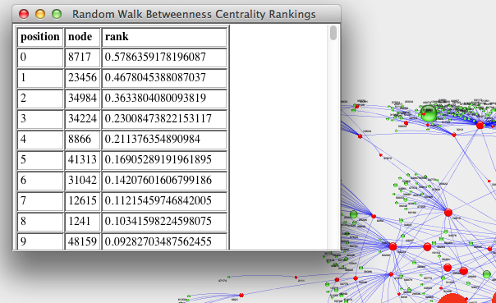

##### Betweenss Centrality

Computes betweenness centrality for each vertex and edge in the graph. Note: Many social network researchers like to normalize the betweenness values by dividing the values by (n-1)(n-2)/2. The values given here are unnormalized.

Running time is: O(n^2 + nm).

More information about that ranking algorithm here “Ulrik Brandes: A Faster Algorithm for Betweenness Centrality. Journal of Mathematical Sociology 25(2):163-177, 2001.”

##### KStepMarkov

This ranking algorithm is a variant of PageRankWithPriors that computes the importance of a node based upon taking fixed-length random walks out from the root set and then computing the stationary probability of being at each node. Specifically, it computes the relative probability that the markov chain will spend at any particular node, given that it start in the root set and ends after k steps.

###### You can find more information about the algorithm here

“Algorithms for Estimating Relative Importance in Graphs by Scott White and Padhraic Smyth, 2003”

##### Random Walk Betweeness

Computes betweenness centrality for each vertex in the graph. The betweenness values in this case are based on random walks, measuring the expected number of times a node is traversed by a random walk averaged over all pairs of nodes.

Running time is: O((m+n)*n^2).

“Mark Newman: A measure of betweenness centrality based on random walks, 2002.”

#### Path Preview

Path preview allows network engineers and researchers to compute the shortest paths between any two nodes in their network.

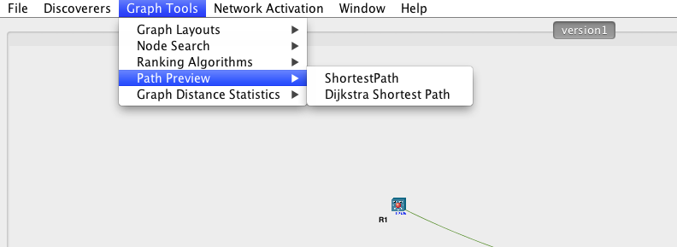

Currently are supported two algorithms. Internally developed shortest path and the classic Dijkstra shortest path.

Each one will ask you for an A and B nodes.

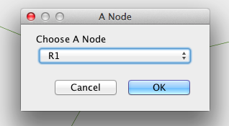

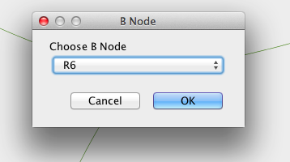

Finally the shorthest path will be displayed.

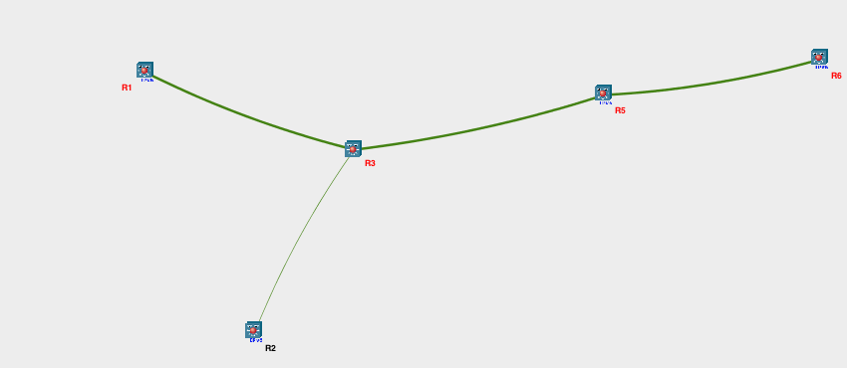

### Network Activation

This menu allows the user to configure everything related to the configuration of the network activation.

#### Configure Parameters

This submenu allows the user to configure various parameter-factories parameter factories are used for supplying with parameters the network activation. Parameters could be manual, from device-xml, from graphml or parameters part of the currently loaded into the memory graph.

#### Configure Resources

This submenu allows the user to configure various resources used for communication with the network. Note that the template interface currently supports only telnet protocol.

#### Configure Bindings

This submenu allows the user to do the binding between the template with a parameter-factory and resource.

#### Configure Templates

This submenu allows the user to open or create new network activation templates.

### Window

#### New Tab

#### Close Tab

#### Close Other Tabs

#### Close All Tabs

### Help

##### User Guide

##### About

## Graph management panel



Figure Graph management pannel

**Save** – saves the topology graph layout to a file.

**Load** – loads the saved layout

**Move graph** – allows the user to move of the whole topology

**Filters Selection** – allows selection of different topology filters.  Filters give you the possibility to reason about the network as per certain topology view. For example there are filters that will allow you reason about your Layer 2 topology or about your OSPF or BGP topologies.

## **Refresh** - Redraws the current topology picture

**Reload** – Reloads the network inventory information. If there are newly discovered devices they will be picked up and displayed on your screen next to the current one.

## **Plus/Minus** - Zoom in/Zoom out

**Redraw Around** – redraws the network to a certain number of hops around one or more selected nodes. The feature is useful when you want to reason only about a particular set of nodes.

## RightClicks

There are a number of functionalities available when the user right clicks on one or more than one selected network topology nodes.

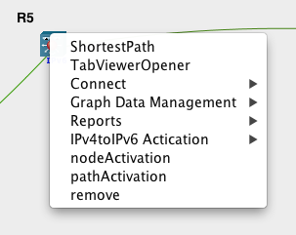

Figure RightClick Menu

Shorthest Path

Calculates the shorthest path between the current node and a B node.

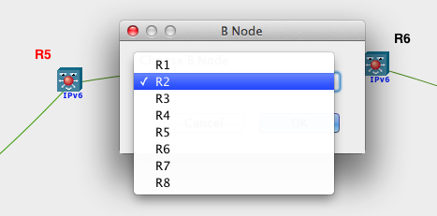

Figure Shorthest Path rightclick

Once the B node selected it will draw the shortest path between the node on which you have performed the rightclick (A node) and the destination (B node).

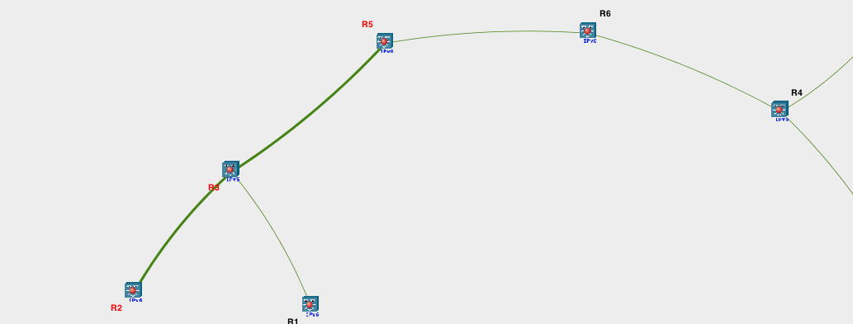

Figure Shorthest path preview

TabViewerOpener

This is a rightclick able to open a new tab with the same network graph. The same feature is available from the Window/ New Tab menu. This will allow you to improve the reasoning about the network by having different network views of the same network in different tabs. For example in one tab you may have a view of the OSPF network and in another of the BGP.

Connect

Connect rightclicks allows the user to perform manual connects to the selected node through various methods and protocols. Currently are supported - telnet and ssh through putty, http/https through opening a new tab in a browser and SSHv2 through a JConsole.

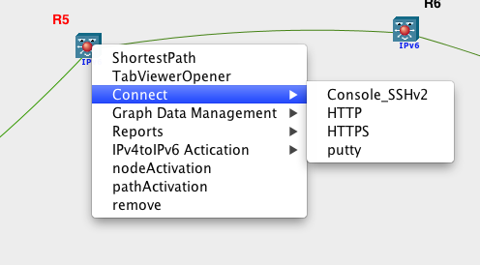

Figure Connect through

Console_SSH2

This rightclick opens an SSH v2 session in Java console to the selected node. It uses the resources accessible through the Network Activation menu in order to perform a basic login to the device.

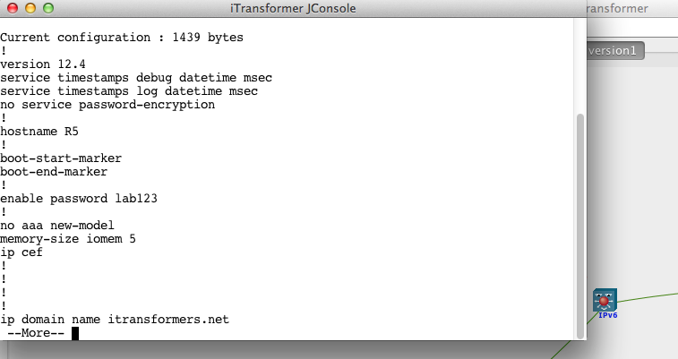

Figure JConsole window

HTTP/HTTPs

HTTP/HTTPs rightclicks will open http or https connections through your default browser to the management IP address of the selected node to a specific port. The exact port is configurable in Viewer Settings.

<rightClickItem name=”HTTP” handlerClass=”net.iTransformers.topologyviewer.rightclick.impl.URLRightClickOpener”>

<param name=”protocol”>http</param>

<param name=”port”>8080</param>

</rightClickItem>

<rightClickItem name=”HTTPS” handlerClass=”net.iTransformers.topologyviewer.rightclick.impl.URLRightClickOpener”>

<param name=”protocol”>https</param>

<param name=”port”>443</param>

</rightClickItem>

Putty

Another useful rightclick invokes putty. Putty is an example for external application integrated in iTopoManger. It allows network administrator to perform manual topology driven configuration of the devices in their networks.

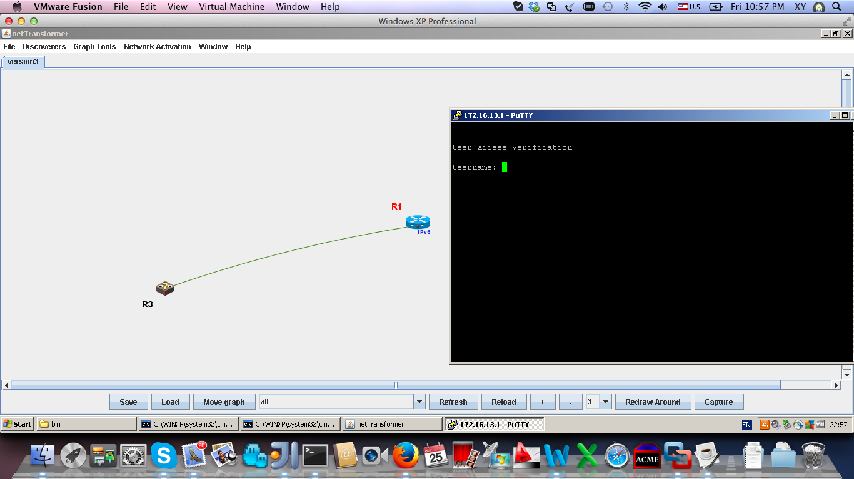

Figure Putty

The putty rightclick handler performs automatic credentials selection from the same resource.xml file located as the one used for network activation. Resource configuration and handling is described in more details in netTransformer’s configuration guide.

PuttyRightClick handler allows direct communication with network devices or communication through a proxy.

<rightClickItem name=”putty” handlerClass=”net.iTransformers.topologyviewer.rightclick.impl.PuttyRightClickHandler”>

<param name=”puttyRelativePath”>../lib/putty/putty.exe</param>

<param name=”ssh_no_saved_session”>-ssh -l %s -pw %s %s</param>

<param name=”ssh_saved_session”>-ssh -l %s -pw %s -load %s %s </param>

<param name=”telnet_no_saved_session”>-telnet -l %s %s</param>

<param name=”telnet_saved_session”>-telnet -l %s -load %s %s</param>

<param name=”resource”>resourceManager/conf/xml/resource.xml</param>

<param name=”saved_session”></param>

</rightClickItem>

**Note:** The putty works only in windows environments. Thus it won’t open anything in linux or windows environments. __________________________________________________________________________________

Reports

As the names suggest the Reports rightclick allow you to display various report information about the discovered network node.

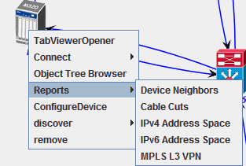

Figure RightClick Reports

Device Neighborship Report

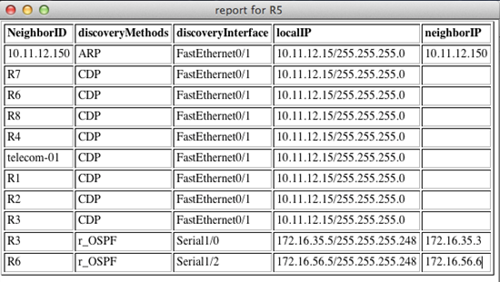

Figure DeviceNeighborship report

Device Neighborship report contains information about device Neighbors and the methods through that they are discovered. The third column provides information about the discovery Interfaces. If the neighbor is logical (e.g Routing protocol Neighbor) no discoveryInterface will be displayed.

CableCut Report

CableCut is a device port state in which the Administrative Status of the port is UP but the operational one is down. E.g there is a problem with the physical link. The report contains three columns - InterfaceName, AdministrativeStatus (UP) and operStatus (DOWN).

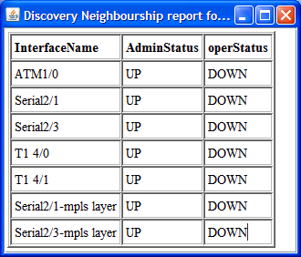

Figure CableCut report

IPv4 Address Space Report

That report provides information about the current IPv4 address ranges on the device and the interfaces on that they are used. The report has four columns - Subnet (Range Subnet and Range Subnet Mask), IPv4Address (the IP address reserved in that IP range), SubnetMask (in four octet notation) and the Interface Name.

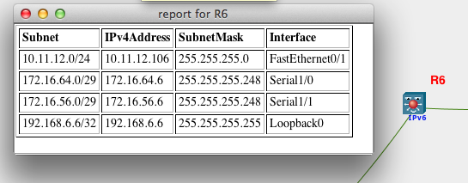

Figure IPv4 Address Space report

IPv6 Addressing Report

That report provides information about the current IPv6 address allocations on the device and the interfaces on that they are used. The report has five columns - IPv6 Address, SubnetMask, ipv6AddrType - the type of the address, ipv6AddrAnycastFlag - is the address anycast or not and the Interface Name.

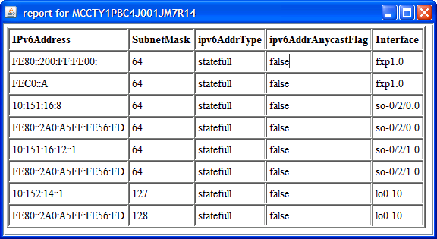

Figure IPv6 Address Space report

MPLS L3 VPN Report

MPLS L3 VPN contians information about MPLS L3 vpns configured on the particular node. It contains four columns - vrfName (the name of the VRF), RD - Route Distinguisher, RT -Route Target, Interfaces (Interfaces on that the VRF has been applied.

Figure MPLS L3 VPN

Graph Data Management

Object Tree Browser

This rightclick creates an object oriented xml database inventory model of network devices there has to be a way this information to be revealed. The object browser is a useful tool that displays xml device xml filled in java tree GUI outlook.

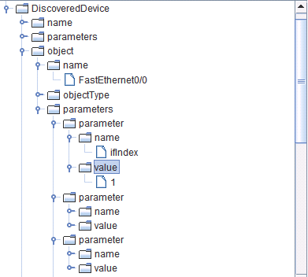

Figure ObjectTreeBrowser

Node&Path Activation

PuttyRight Click handler allows manual device configuration. netTransformer aims controlled network transformation from one state to the other. To do so it has to change device configurations not manually through putty but through much more automated configuration engine. The Node and Path activation are the first step in that direction. Prior activating anything in your network you have to configure the resources for communication with the it, to create network configuration templates, determine from where the configuration parameters will come from and finally to bind that together (). one is demonstrated how to use it. The typical sequence of events is

1. Select one or more than one network nodes.

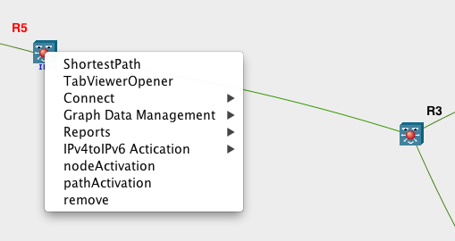

1. Then click on node or path activation rightclicks and select one of the previously configured templates.

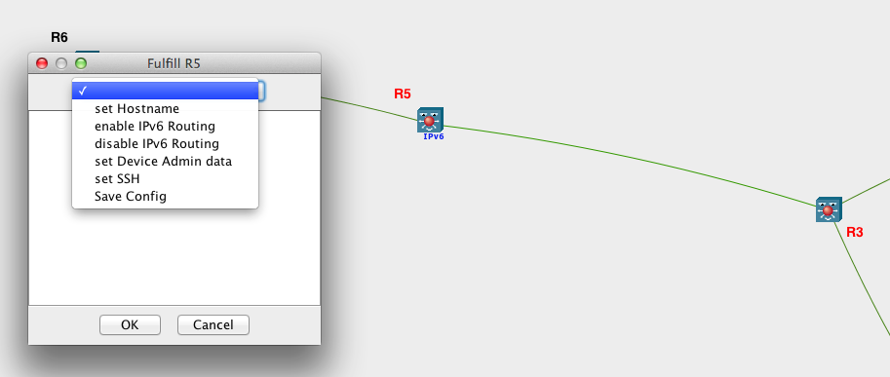

Figure Invoke Node Activation rightclick and select set Hostname

Once you do that you will be asked for manual parameter input if there is such or if there isn’t the network activation will happen.

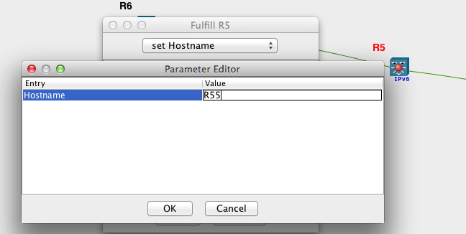

Figure Pass Manual Input parameters to set Hostname

As a final result you will see a dialog with the communication with the network device. Currently it is quite rough but hopefully in the next version we will be able to give you something much better.

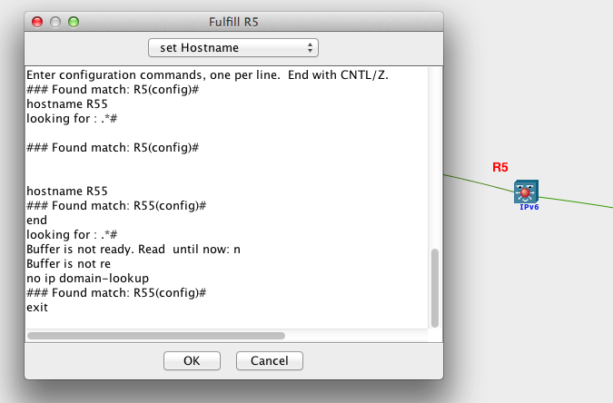

Figure The final result of invoking a template

Here comes the question but how can be ensured that the network really changed its state and the configuration engine actually worked. That question could be answered in several different ways. The most obvious answer is “Please use the putty or JConsole rightclicks to login to the device and verify its configuration and current state”. Another way is to use again the same engine and issue a verification command that will verify does the new configuration work or not. An example for such one could be ping, traceroute or some other verification/display command. The third option is to preform a new network discovery and to compare the two versions of the network through the network diff functionality.

In the example bellow R5 has disappeared due to the change of hostname and R55 has appeared. The same could be said for the links between the node and R3 and R6.

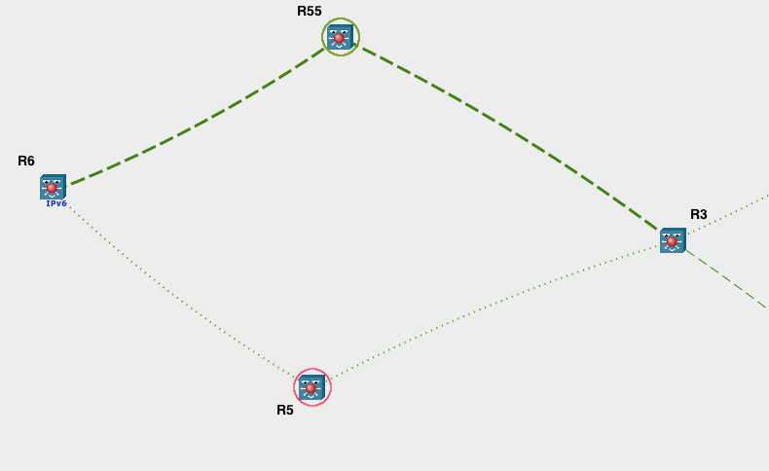

Figure Perform a network diff after a hostname change

Remove

As the name suggests that rightclick removes the selected nodes/edges from the graph view.

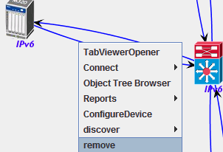

Figure Remove RightClick

netTransformer files

The current implementation of netTransformer does not use any kind of a database instead it is using xml structures stored in files on the file system. In this chapter we will walk over the different kinds of files created by it. All files that are created during each discovery process will be stored under the respected network/version folder in your netTransformer project.

Raw data files

Raw data files are located directly under the network/version folder in your netTransformer project. They contain structured xml that represents the direct communication with the network device. The example bellow shows raw data generated by the SNMP network discoverer.

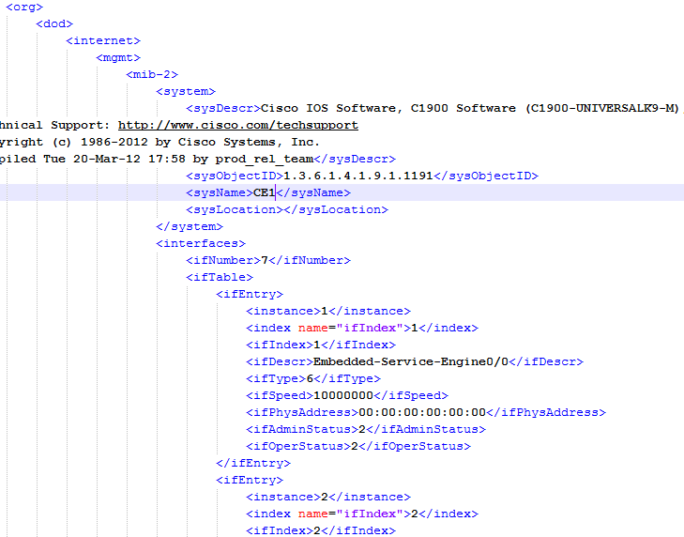

Figure SNMP Raw data file

Device xml files

Device xml are generated by the SNMP network discovery through a transformation of the raw-data files and are located under the under the network/version folder in your netTransformer project.

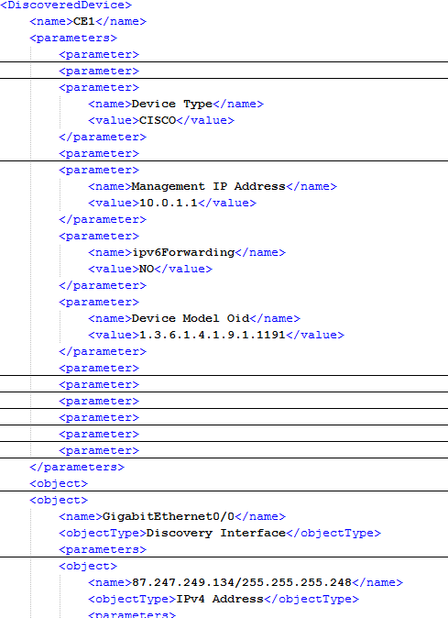

Figure device xml file

Graphml files

Graphml files follow the graphml file format as defined in [4]. They are generated by transforming the device.xml files in the case of netTransformer and are used by netTransformer viewer in order to generate the network views.

Each node or edge described in the graphml is represented by a node/edge id and a number of data keys. Typical list might contain data keys as deviceModel, deviceType, deviceStatus, ManagementIPAddress, site, geoCoordinates and deviceInfo. The complete list of node properties for any device could be reviewed from the graphml file for the particular device through the Graph data management/Graphml viewer rightclick.

<node id="C7">

<data key="hostname">C7</data>

<data key="deviceModel">cisco2611</data>

<data key="deviceType">CISCO</data>

<data key="deviceStatus">discovered</data>

<data key="ManagementIPAddress">10.11.222.2</data>

<data key="site">Moskow</data>

<data key="geoCoordinates">23.13661,12.687546</data>

<data key="ipv6Forwarding">NO</data>

<data key="deviceInfo"><![CDATA[ <html><b>Type: </b>CISCO <b>Model:</b> cisco2611 <b>Site:</b> C7<br><b>Mgmt IP address:</b> 10.11.2.2<br/><b>ipv6Forwarding:</b> NO<b>BGPLocalASInfo:</b> 0</html>]]></data>

</node>

Config Example Node data keys (from graphml)

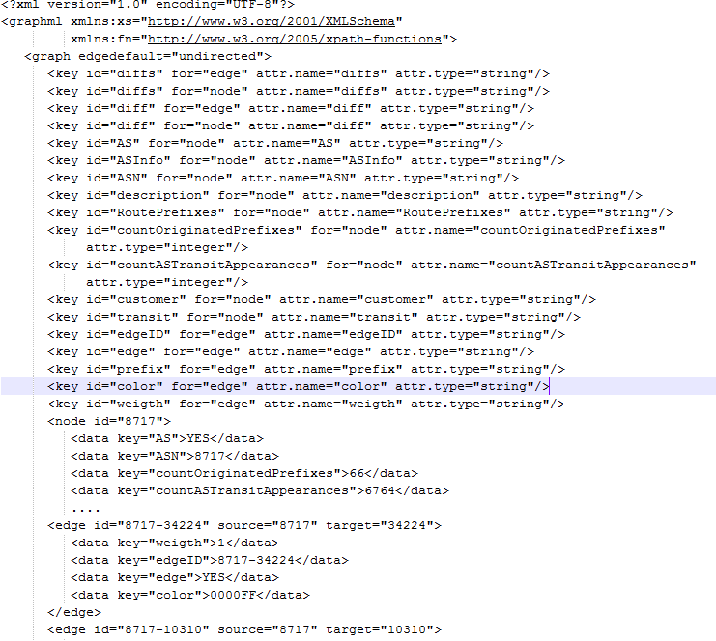

netTransformer Configuration guidelines

Note that if you want to edit the configuration on per project basis you have to edit either of the files bellow located in your project folders. If you want to edit the files that will be used for the instantiation of those configuration files in multiple project you have to edit the located in primary netTransformer location.

Configure snmpNetwork discovery projects

Configure SNMP discovery parameters

Discovery-helper allows customization of the SNMP requests for each deviceType that might be found in the network. The current discovery process retrieves device hostname and type. Once it knows the type it can choose the rest of the request. If the device is from an unknown type it will always assemble the “Default” request. Current discovery support Cisco, Juniper, Huawei, HP, and Tellabs devices.

Each device section has several subsections. Discovery users might delete some of the SNMP requests from some of the sections or the whole section completely but can not change section names. For example if ARP requests are not needed for certain deviceType has to be delete ipNetToMediaTable from PHYSICAL discovery section. This way of configuration allows network administrator really to fine-tune the requests towards any network devices.

<discovery-helper>

<device type="DEFAULT" xslt="iDiscover/conf/xslt/transformator.xslt">

<!-- Contain snmp oid names needed for general device description -->

<general>

ifIndex,ifDescr,ifOperStatus,ifAdminStatus,ifNumber,ifPhysAddress,ifType,dot1dTpFdbAddress,system,ipAddrTable,ifIndex, ifName

</general>

<!-- Contain parameteters needed for physical description of the device and physical discovery methods -->

<discovery-method name="PHYSICAL">

dot1dBaseBridgeAddress,dot1dStpDesignatedRoot, dot1dStpPortEntry,dot1dTpFdb,dot1dTpFdbStatus,dot1dTpFdbPort,dot1dBasePort,dot1dBasePortIfIndex,ipNetToMediaTable,lldpRemoteSystemsData,cdpCacheDevicePort,cdpCacheDevicePlatform,cdpCacheDeviceId,cdpCacheIfIndex,cdpCachePrimaryMgmtAddrType,cdpCachePrimaryMgmtAddr, dot1qVlanStaticEntry

</discovery-method>

<!-- Contain request parameters needed for next-hop discovery methods -->

<discovery-method name="NEXT_HOP">

ipRouteIfIndex, ipRouteNextHop

inetCidrRouteType, inetCidrRouteIfIndex, inetCidrRouteNextHop, inetCidrRouteProto, inetCidrRouteNextHopAS

</discovery-method>

<!-- Contain request parameters needed for OSPF discovery methods -->

<discovery-method name="OSPF">

ospfRouterId,ospfNbrEntry,ospfAdminStat,ospfVersionNumber,ospfAreaBdrRtrStatus,ospfASBdrRtrStatus,ospfAreaTable,ospfIfEntry

</discovery-method>

<discovery-method name="BGP">

bgpLocalAs,bgpPeerEntry

</discovery-method>

<discovery-method name="ISIS">

isisISAdjIPAddrEntry

</discovery-method>

<discovery-method name="RIP">

rip2IfConfTable,rip2IfStatTable

</discovery-method>

<discovery-method name="ADDITIONAL">

mplsVpnVrfName,mplsVpnVrfRouteDistinguisher,mplsVpnVrfRouteDistinguisher,

dot1dBaseNumPorts, dot1qVlanStaticTable

</discovery-method>

<discovery-method name="IPV6">

ipv6Forwarding, ipv6IfIndex, ipv6AddrEntry,ipv6NetToMediaEntry,ipv6RouteEntry

</discovery-method>

</device>

</discovery-helper>

Config Example 2 DiscoveryParameters xml

To add new device just add a new devicetype section to the file and specify a xslt transformation file that will transform the raw data xml gathered from the devices with that type.

<device type="NEW_DEVICE" xslt="iDiscover/conf/xslt/transformator.xslt">

</devicetype>

Config Example 3 Adding new device to DiscoveryParameters xml

Each discoverytype contains a general section that contains SNMP OID names general device parameters and several other discoverymethods. If you want to customize discovery methods just add your SNMP OIDS to the current one. If those are not enough and a new method has to be implemented add a new discovery-method section to the deviceType that might support the method.

<discovery-method name="NEW_METHOD">

SNMP_OID_NAME_1, SNMP_OID_NAME_X….

</discovery-method>

Config Example 4 Adding new discovery method to certain device in DiscoveryParameters xml

discoveryParameters.xml contains also another section that specifies a set of stop criteria rules. Stop criteria specify what to be discovered and what to not be discovered.

For example if all devices with hostnames starting with CE shall not be discovered the stop criteria has to match the hostname with a regex match.

If discovery has not to discover devices from certain range the match rule has to regex that IP range. An interesting combination is the regex “.*” “Match rule for all ip addresses”.

<match property="host">CE*</match>

<match property="ipAddress.ipAddress">.*</match>

<match-not property="ipAddress.ipAddress">10\..*</match-not>

<match-not property="ipAddress.ipAddress">172\..*</match-not>

<match-not property="ipAddress.ipAddress">192\.168.*</match-not>

Config Example 5 Discovery Stop Criteria

In this case discovery process will run itself only on devices with private ip addresses.

Note that everything that is matched will not be discovered and everything that is matched will be discovered.

Viewer Settings

Viewer settings contains configuration for icons, filters, tooltips and rightclicks required for normal netTransformer GUI viewer operation.

Viewer settings configuration file is network specific. For IP networks discovered through SNMP it located in iTopologyManager/topology-viewer/conf/xml/viewer-config.xml.

Icon selection

Each device has to be correctly presented as a graph node with a specific icon. Icon selection is based on node data key match. One or more data keys of the node choose the icon. The major rule is - first icon matched is selected. That means icons that have more properties have to be in configuration prior those that might match on smaller number of properties. If no icon is matched a default icon will be used.

<!--TELLABS-->

<icon name="/images/76xx.png,,/images/circle_red_big.png">

<data key="deviceType">TELLABS</data>

<data key="diff">REMOVED</data>

</icon>

<icon name="/images/76xx.png,/images/circle_green_big.png">

<data key="deviceType">TELLABS</data>

<data key="diff">ADDED</data>

</icon>

<icon name="/images/76xx_ipv6.png,/images/circle_blue_big.png">

<data key="deviceType">TELLABS</data>

<data key="diff">YES</data>

<data key="ipv6Forwarding">YES</data>

</icon>

<icon name="/images/76xx.png,/images/circle_blue_big.png">

<data key="deviceType">TELLABS</data>

<data key="diff">YES</data>

</icon>

<icon name="/images/76xx_ipv6.png">

<data key="deviceType">TELLABS</data>

<data key="ipv6Forwarding">YES</data>

</icon>

<icon name="/images/76xx.png">

<data key="deviceType">TELLABS</data>

</icon>

<!--Output omitted-->

<!--Default icon-->

<icon name="/images/unknown_switch.png">

</icon>

Config Example topology-viewer - Icon Definition

Filters

Each filter selects nodes and edges based on their data key properties. Simple filter definition is presented below. Each user might create its own filters specifying different combination of dataKeys. Note that firstly positioned filter is always used for the initial network display.

<filter name="Physical-view - without unreachable neighbors">

<include dataKey="deviceStatus" dataValue="discovered" for="node"/>

<include dataKey="deviceStatus" dataValue="initial" for="node"/>

<include dataKey="method" dataValue="NEXT_HOP" for="edge"/>

<include dataKey="method" dataValue="CDP" for="edge"/>

<include dataKey="method" dataValue="LLDP" for="edge"/>

<include dataKey="method" dataValue="Slash30" for="edge"/>

<include dataKey="method" dataValue="Slash31" for="edge"/>

<include dataKey="method" dataValue="MAC" for="edge"/>

</filter>

Config Example viewer-config.xml filter definition

Tooltips

Each filter view allows the selection of a certain edge/node tooltip. If no tooltip is specified a default one is used.

<tooltip dataKey="nodeInfo" for="node" transformer="net.itransformers.topologyviewer.nodetooltip.HTMLCSVNodeTooltipTransformer"/>

<tooltip dataKey="method" for="edge" transformer="net.itransformers.topologyviewer.edgetooltip.CSVEdgeTooltipTransformer"/>

Config Example default Tooltips for nodes and edges

If a specific tooltip has to be specified for certain filter the tooltip tag has to be added to the filter configuration.

<filter name="IPLinkLayer-reachable+unreachable">

<include dataKey="ipLink" dataValue="YES" for="edge"/>

<tooltip dataKey="deviceInfo" for="node"/>

<tooltip dataKey="localIPAddress" for="edge" transformer="com.topolgyviewer.edgetooltip.DashEdgeTooltipTransformer"/>

</filter>

Config Example filter tooltip Tooltip

Hops

TopologyViewer allows network topology to be redrawed around certain node by a certain number of hops. That could be achieved by RedrawArround button. Note that each filter also redraws network based on a certain number of hops from the nodes selected by the filter. That number and also the number of hops used by RedrawArround button are specified in topology-viewer xml file in the hops tag. The selected number is the default number of hops used by the filter or by the button.

<hops selected="3">1,2,3,4,5,6,7,8,9,10</hops>

Config Example hops definition

RighclickHandlers

The rest of topology-viewer configuration file is dedicated to rightclickhandlers. Each handler has to have a name and to point to a rightclick handler class. Then it might have one or more parameters.

<rightClickItem name="Device Neighbors" handlerClass="com.topolgyviewer.rightclick.impl.XsltReportCreator">

<param name="xsl_transformator">rightclick/conf/xslt/deviceNeighbors.xslt</param>

<param name="table_transformator">rightclick/conf/xslt/table_creator.xslt</param>

</rightClickItem>

Config Example viewer-config.xml right click handler definition

Rightclicks are also used to link the different other functionalities of netTransformer as ParameterFactory, FulfillmentFactory and ResourceManager.

Configuring netTransformer RighClickHandlers

netTransformer RighClickHandlers configuration is part of viewer-config xml files. Due to the fact that there are quite a lot of rightclicks we have split their configurations to a separate configuration chapter.

Shotherst Path

TabViewOpenerTab

NewTab opens the already loaded graph in a new tab. It does not need any additional parameters so as configuration it is enough just to be specified the class that handlers that.

<rightClickItem name="NewTab" handlerClass="com.topolgyviewer.rightclick.impl.TabbedViewerOpener"/>

Config Example New Tab rightclick

Connect

JConsole

HTTP/HTTPS

<rightClickItem name="HTTP" handlerClass="net.itransformers.topologyviewer.rightclick.impl.URLRightClickOpener">

<param name="protocol">http</param>

<param name="port">8080</param>

</rightClickItem>

<rightClickItem name="HTTPS" handlerClass="net.itransformers.topologyviewer.rightclick.impl.URLRightClickOpener">

<param name="protocol">https</param>

<param name="port">443</param>

</rightClickItem>

Config Example HTTP/HTTPs rightclick handler configuration

This rightclick constructs an URL string and opens it though your default browser. The URL string is constructed as per the following rule:

<protocol>://<ManagementIPAddress>:<port>

It has two configurable parameters.

* Protocol - specifies the protocol part of the URL that will be passed to the browser.
* Port - specifies the port part of the URL.

Putty

This RightClickHandler integrates netTransformer with a third party application - Putty. It allows opening of telnet or ssh connections to the devices through putty. The RightClickHandler has the following set or parameters

ssh_no_saved_session - specifies the path to putty.exe and putty command line options if the connection protocol is ssh and there is a saved_session.

ssh_saved_session - specifies the path to putty.exe and putty command line options if the connection protocol is ssh and there isn’t a saved_session.

telnet_no_saved_session - specifies the path to putty.exe and putty command line options if the connection protocol is telnet and there isn’t a saved_session.

telnet_saved_session - specifies the path to putty.exe and putty command line options if the connection protocol is telnet and there is a saved_session.

resource - specifies the file with resource parameters needed for the putty right click method (connection types - ssh/telnet, cred, etc). Note that in case of telnet the protocol itself does not support credentials pass through so those are not supported by putty and in the end by netTransformer.

saved_session. Allows putty to use saved sessions. Saved putty sessions are really useful when netTransformer can’t connect directly to the devices and needs a proxy. This is a common case since usually the place where discovery is executed is different than the place where the netTransformer is invoked.

The example bellow describes a possible socks proxy configuration

* Step 1 Startup the proxy manually from your local PC. Putty supplies a plink.exe that could be used for the purpose.

plink -D 5566 -l <username> -pw <pass> -N <hostname>

<username> - ssh username

<pass> - ssh user password

<hostname> - the hostname of the host on which discovery is executed. Normally this shall be a host with openssh installed.

* Step 2 create a putty session called saved_session and in it configure only the proxy tab

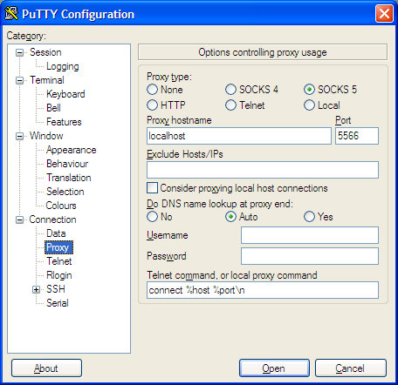

Figure Putty proxy session config

Then all your putty connections from topology viewer will be forwardh through localhost 5566 port to the hostname and then to the target device.

Reports

Reports are a basic html created through a double xslt transformation of the device xml output file. Each report has two parameters:

* xsl_transformator - the xslt file used for the device xml transformation into a valid xml table report.
* table_transformator - optional parameter that specifies the path to the xslt file that creates html table from the xml structure created by the previous xslt transformator.

<submenu name="Reports">

<rightClickItem name="Device Neighbors" handlerClass="net.itransformers.topologyviewer.rightclick.impl.XsltReportCreator">

<param name="xsl_transformator">iTopologyManager/rightClick/conf/xslt/deviceNeighbors.xslt</param>

<param name="table_transformator">iTopologyManager/rightClick/conf/xslt/table_creator.xslt</param>

</rightClickItem>

<rightClickItem name="Cable Cuts" handlerClass="net.itransformers.topologyviewer.rightclick.impl.XsltReportCreator">

<param name="xsl_transformator">iTopologyManager/rightClick/conf/xslt/cableCut.xslt</param>

<param name="table_transformator">iTopologyManager/rightClick/conf/xslt/table_creator.xslt</param>

</rightClickItem>

<rightClickItem name="IPv4 Address Space" handlerClass="net.itransformers.topologyviewer.rightclick.impl.XsltReportCreator">

<param name="xsl_transformator">iTopologyManager/rightClick/conf/xslt/IPv4.xslt</param>

<param name="table_transformator">iTopologyManager/rightClick/conf/xslt/table_creator.xslt</param>

</rightClickItem>

<rightClickItem name="IPv6 Address Space" handlerClass="net.itransformers.topologyviewer.rightclick.impl.XsltReportCreator">

<param name="xsl_transformator">iTopologyManager/rightClick/conf/xslt/IPv6.xslt</param>

<param name="table_transformator">iTopologyManager/rightClick/conf/xslt/table_creator.xslt</param>

</rightClickItem>

<rightClickItem name="MPLS L3 VPN" handlerClass="net.itransformers.topologyviewer.rightclick.impl.XsltReportCreator">

<param name="xsl_transformator">iTopologyManager/rightClick/conf/xslt/mplsL3VPN.xslt</param>

<param name="table_transformator">iTopologyManager/rightClick/conf/xslt/table_creator.xslt</param>

</rightClickItem>

</submenu>

Config Example topology viewer - Reports submenu

Node&Path Activation rightclick

This is the RightClick where are combined parameterFactory, ResourceManager and the fulfillmentFactory. Therefore the only parameters it requires are the paths to:

* parameterFactoryXml - local path to ParameterFactory xml configuration file
* Resource - local path to Resource xml configuration file
* fulfillment-factory - local path to fulfillment factory xml configuration file

<rightClickItem name="nodeActivation" handlerClass="com.topolgyviewer.rightclick.impl.CmdRightClickHandler">

<param name="parameterFactoryXml">parameter-factory/conf/xml/param-factory.xml</param>

<param name="resource">resource-manager/conf/xml/resource.xml</param>

<param name="fulfilment-factory">fulfilment-factory/conf/xml/fulfilment-factory.xml</param>

</rightClickItem>

Graph Data Management

ObjectTreeBrowser

<rightClickItem name="Object Tree Browser" handlerClass="com.topolgyviewer.rightclick.impl.XMLTreeViewHandler"

</ rightClickItem >

Config Example - ObjectTreeBrowser

#### Graphml Xml viewer

#### RawData Xml viewer

#### Device Xml viewer

## Configure logging

netTransformer and its modules use log4j for event logging. Each module has its own log file. An example log4j properties file is presented below.

#log4j.properties

# Set root logger level to DEBUG and its only appender to CONSOLE.

log4j.rootLogger=DEBUG, CONSOLE

# CONSOLE is set to be a ConsoleAppender.

log4j.appender.CONSOLE=org.apache.log4j.ConsoleAppender

log4j.appender.CONSOLE.layout=org.apache.log4j.PatternLayout

#log4j.appender.CONSOLE.layout.ConversionPattern=%-4r [%t] %-5p %c %x - %m%n

log4j.appender.CONSOLE.layout.ConversionPattern=%d{MM-dd@HH:mm:ss} %-5p (%13F:%L) %3x - %m%n

log4j.appender.FILE1=org.apache.log4j.FileAppender

log4j.appender.FILE1.File=discovery.log

log4j.appender.FILE1.layout=org.apache.log4j.PatternLayout

log4j.appender.FILE1.layout.ConversionPattern=%d{MM-dd@HH:mm:ss} %-5p (%13F:%L) %3x - %m%n

# CONSOLE uses PatternLayout.

log4j.appender.FILE2=org.apache.log4j.FileAppender

log4j.appender.FILE2.File=topology.log

log4j.appender.FILE2.layout=org.apache.log4j.PatternLayout

log4j.appender.FILE2.layout.ConversionPattern=%d{MM-dd@HH:mm:ss} %-5p (%13F:%L) %3x - %m%n

log4j.appender.FILE3=org.apache.log4j.FileAppender

log4j.appender.FILE3.File=parameter-factory.log

log4j.appender.FILE3.layout=org.apache.log4j.PatternLayout

log4j.appender.FILE3.layout.ConversionPattern=%d{MM-dd@HH:mm:ss} %-5p (%13F:%L) %3x - %m%n

log4j.appender.FILE4=org.apache.log4j.FileAppender

log4j.appender.FILE4.File=resource-manager.log

log4j.appender.FILE4.layout=org.apache.log4j.PatternLayout

log4j.appender.FILE4.layout.ConversionPattern=%d{MM-dd@HH:mm:ss} %-5p (%13F:%L) %3x - %m%n

log4j.appender.FILE5=org.apache.log4j.FileAppender

log4j.appender.FILE5.File=fulfilment-factory.log

log4j.appender.FILE5.layout=org.apache.log4j.PatternLayout

log4j.appender.FILE5.layout.ConversionPattern=%d{MM-dd@HH:mm:ss} %-5p (%13F:%L) %3x - %m%n

# Print only messages of level WARN or above in the package com.foo.

log4j.logger.com.discovery.core=DEBUG, FILE1

log4j.logger.com.snmpdiscoverer.MibLoaderHolder=DEBUG, CONSOLE, FILE1

#log4j.logger.org.apache.commons.beanutils=INFO, CONSOLE

log4j.logger.org.snmp4j=DEBUG, FILE1

log4j.logger.com.snmpdiscoverer.Walk=DEBUG, FILE1

log4j.logger.com.discovery.discoveryhelpers.xml.SnmpGetNameForXslt=DEBUG, FILE1

log4j.logger.com.snmpdiscoverer.transport.LogBasedTransportMapping1=DEBUG, FILE1

log4j.logger.com.snmpdiscoverer.messagedispacher.LogBasedMessageDispatcherFactory=DEBUG, FILE1

log4j.logger.com.snmpdiscoverer=DEBUG, FILE1

# Print only messages of level WARN or above in the package com.foo.

log4j.logger.com.topolgyviewer=DEBUG,FILE2

log4j.logger.com.XmlParamFactoryElement=DEBUG,FILE3

log4j.logger.com.ResourceManager=DEBUG,FILE4

More about log4j could be found at <http://logging.apache.org/log4j/1.2/manual.html>.

# Getting an additional information

[netTransformer](http://itransformers.net/wiki/iTransformer) comes with a number of ready to use features. It is distributed under an open (GPL v3). For more information please visit also our [YouTube channel](http://www.youtube.com/channel/UCVrXTSM9Hj6d3OFbIdF4Z2w?feature=watch).

If you still feel uncomfortable about something and something or have any other questions please visit our web page [http://iTransformers.net](http://itransformers.net/) and do not hesitate to contact us on [info@iTransformers.net](mailto:info@itransformers.net)

# Bibliography

1. **Kawai, Tomihisa Kamada and Satoru.** An algorithm for drawing general indirect graphs. *Information Processing Letters .* 31, 1989, Vol. 1, 7-15.

2. **Team, JUNG Framework Development.** Java Universal Network/Graph Framework. *http://jung.sourceforge.net/.* [Online]

3. **Meyer, Bernd.** *http://www.csse.monash.edu.au/~berndm/ISOM/.* [Online] 1998.

4. **Team, GraphML.** The GraphML File Format. *http://graphml.graphdrawing.org/.* [Online]