* Ok, I think we are ready to explore Power Query, let’s do so on a relatively clean dataset so we can get a nice lay of the land here and how to use the interface because it’s honestly kind of disorienting and intimidating at first.
* So let’s open up this dataset, star.xlsx, we are going go feed this into Power Query, and to do that we will use the Data tab. The data tab will be our somewhat secret portal into Power Query and you will see here this first group is called Get & Transform Data, which makes sense given what you know about ETL, that yes we are going to extract and transform some data!
* And you will see that there are quite a few options here for where to get our data, we can get them from files, from databases and so forth. Keep in mind that I am on a PC so my menu is going to be fuller than if you are on a Mac but hopefully all these features will be out on Mac in the near future.
* I am going to focus on getting our data from a Table or a Range, so I want to leave my cursor somewhere in this dataset and click that. The first thing that will happen is our dataset will be converted into a Table, Power Query and Excel Tables have a special relationship.
* And now you are going to see a new menu, this is sitting on top of classic Excel, so to get some practice with this I am going to discard what we have done, and let’s have you walk through this again, can you remember how we got into that Power Query editor?
* That’s right it’s through the Data tab, Get & Transform, from Table.
* Now a tour of what you are seeing here.
  + - This is a clean dataset but there are still things we can do with PQ.
  + Load a first data source into Power Query, inspect it with data profiling, and begin the data cleaning process
  + Data -> From Table/Range
  + Tour of what you will see in Excel Power Query:

<https://people.highline.edu/mgirvin/AllClasses/348/MSPTDA/Content/PowerQuery/003-MSPTDA-IntroToPowerQuery.pdf>

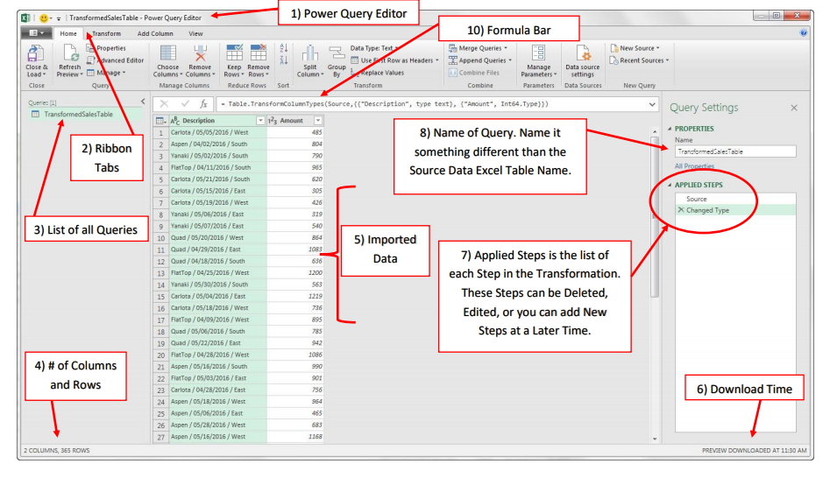

* + Overview of the Home Ribbon – focus on the first three tabs, those are going to have the data cleaning functionality.
  + Then go into the dataset, show that we can click on the rows and cells and we can see their value at the bottom.
  + Then go to the header row, you will also see there are some shortcut options you can choose here.
  + Click on the column you’ll see you can filter it just like in native Excel.
  + You’ll also see that they have data types. Each of these columns have an explicit type.
  + Right click on the column and you’ll see you can get more options here.
    - Hit Control and page over columns to look for more.
  + Go to the View tab
    - Initially this is based on just the first 1,000 rows. There is a bottom waaay at the bottom, “Column Profiling Based on Top 1000 Rows,” click on that and it will expand through the other rows.
* Ok for a drill I will have you open up this file, computers. Just read this into Power Query and use the Data Preview functionality to explore this data.
* You can go ahead and just discard your changes when you are done.