**TRANSFORMING ROWS IN POWER QUERY – DEMO NOTES**

Demo: office-rsvps.xlsx

Worksheet: signups

1. You are consulting with the Party Planning Committee to clean up a list of RSVP’s to a party. We would like to have the list sorted alphabetically, with duplicates, blanks and misprints removed.
2. This could be accomplished easily enough in classic Excel, but we would like to track each step of the data cleaning process, and we would like a solution that continues to work as more people RSVP to the list. These requirements make Power Query an excellent choice.
3. Create the connection from the range. Your data will be converted into a table.
4. You will see that blank values have been populated as null in Power Query. This is a special value indicating a missing value. It’s not the same thing as zero!



1. We want to filter out missing records, so select the drop-down on the column label and de-select null. This will remove them.

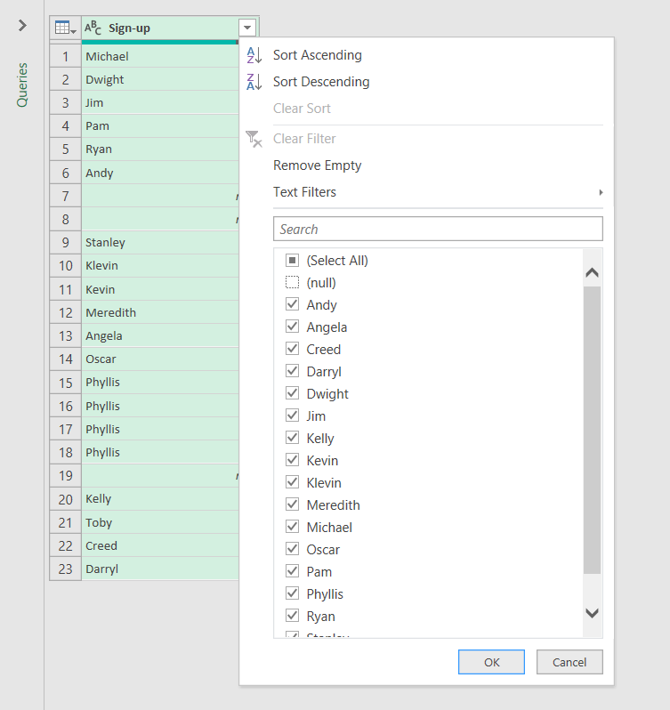

1. We can also sort the list A-Z with the same menu.
2. You will begin to see a running list of the steps we have taken on the right-hand side of the editor (Applied Steps).

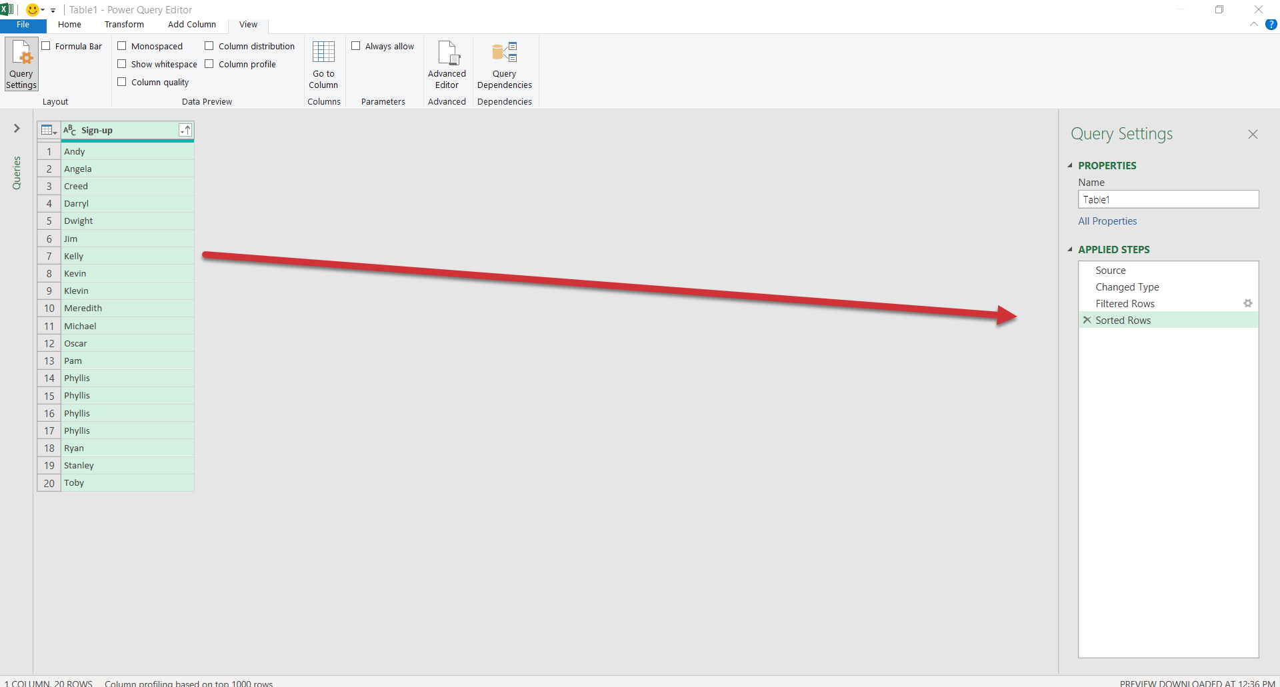

1. Let’s remove the third step, Filtered Rows. Our dataset remains sorted A-Z, but nulls are no longer filtered out.
   1. **Careful: There is no “undo” for removing an applied step!**
2. Go ahead and re-filter the nulls from the data. You will see that becomes the last Applied Step.
3. You can modify the ordering of an Applied Step by right-clicking it.

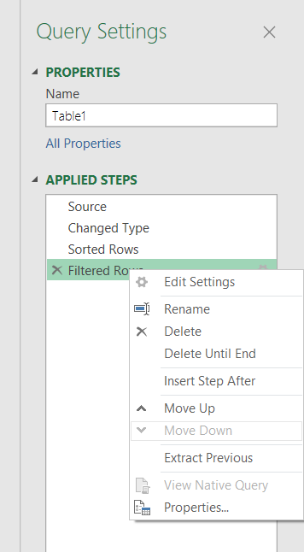

1. Remove duplicates by going to Home on the ribbon, then Remove Rows -> Remove Duplicates.
   1. You’ll also see there is an option here to remove blank rows, this would have been another way to filter out nulls.
2. Last but not least, there is a misprint in the data: a `Klevin` in here. We don’t want that either, so filter it out.
3. On the upper left of the Home tab, there is a Close & Load menu. Click the drop-down and select Close & Load.

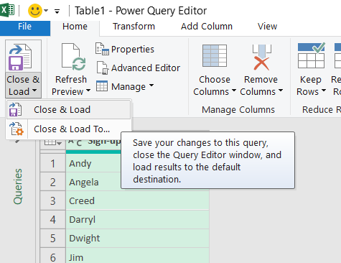

1. The result of our query has been *loaded* back into Excel (the L part of ETL!).
2. To the right of our table is a Queries & Connections menu. Our query is named Table1. That’s not a very descriptive name, so let’s rename it to party_rsvp.
   1. If you want to close out this menu, you can open it again under Data -> Queries & Connections.

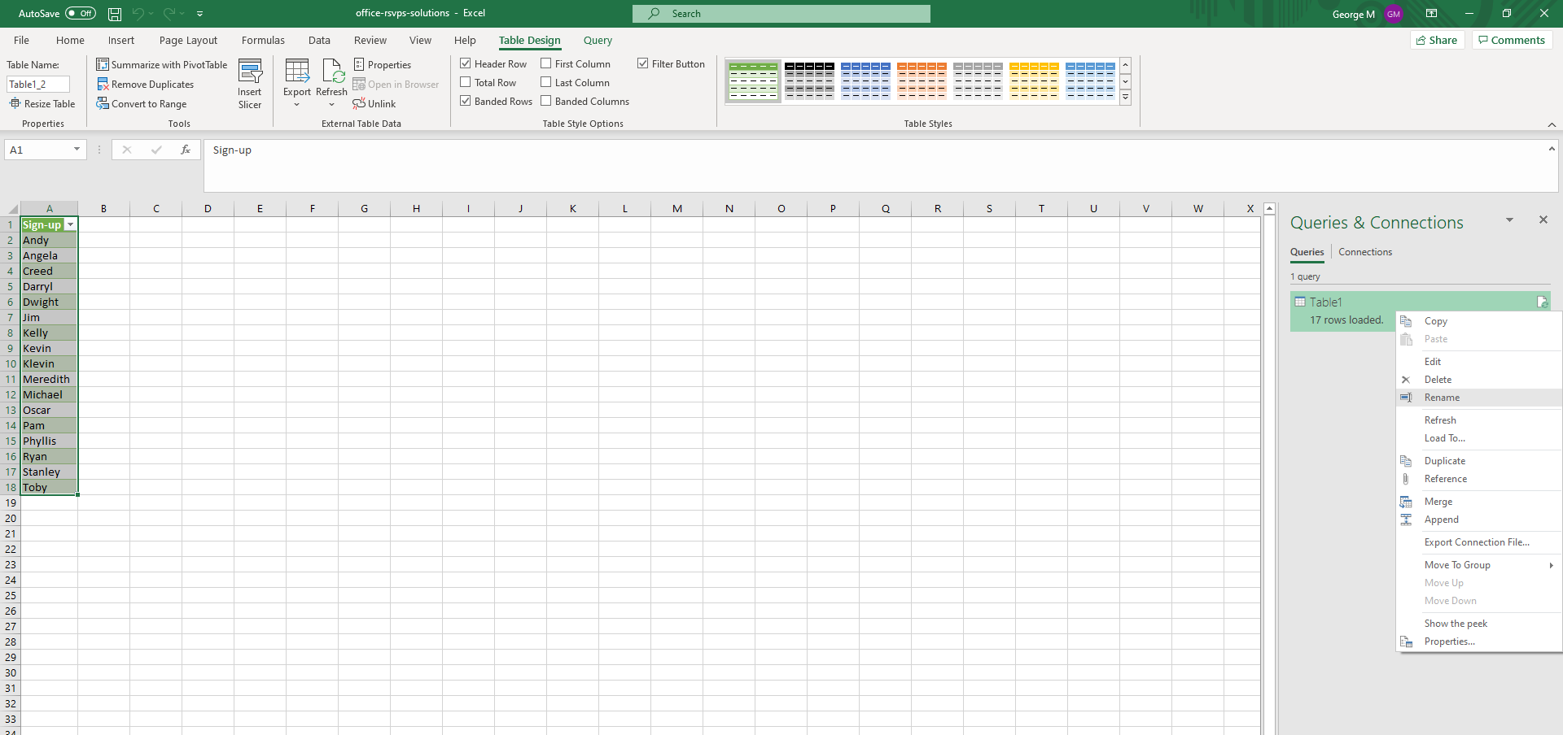

1. Now, any changes made to our source data will be re-loaded into Power Query, go through each step of the data-cleaning process, and be loaded into this new table upon refresh.
2. For an example, I am going to insert two lines into my table, Roy and a blank row.

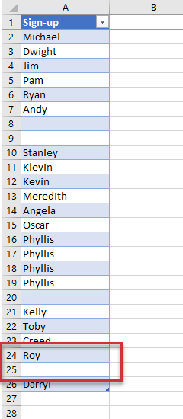

1. Go back to the loaded query, right-click and select Refresh.

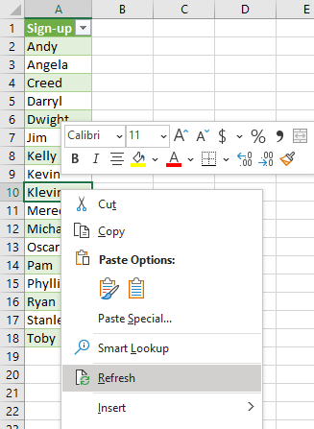

1. Roy made it into the RSVP, the blank didn’t and the results remain sorted alphabetically!

Worksheet: roster

This time, the data has been created with commas separating each name by department. You would like to set up a report to automatically count how many people signed up from each department.

1. Bring the table into Power Query as usual.
2. Click the column and head to Transform > Split Column > By Delimiter.
3. We do want to split by each occurrence of a comma. We also want to click on Advanced Options and select “Split into Rows.”

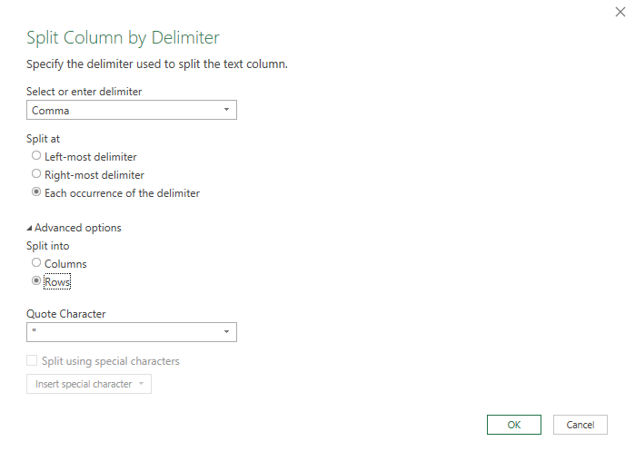

1. Click OK.
2. It looks like there is some leftover white space from this delimiting, so let’s clean that up.
   1. Right-click on the column, select Transform and Trim.
3. Close and load. Now our data is tidy.

Demo: regional-sales.xlsx

1. This table does not have a header row and we need to fill down the Region fields. We would like to feed this data into a PivotTable for easy analysis.
2. Import our data into Power Query; remember that this time our Table does *not* have headers.
   1. We can rename the columns by double-clicking on them in the Query Editor. Name the three columns Region, Day and Amount, respectively.
3. To fill down the blanks for Region, highlight that column by clicking on it, then go to the Transform tab on the ribbon, you will select Fill, Fill Down to fill the nulls down with blanks.

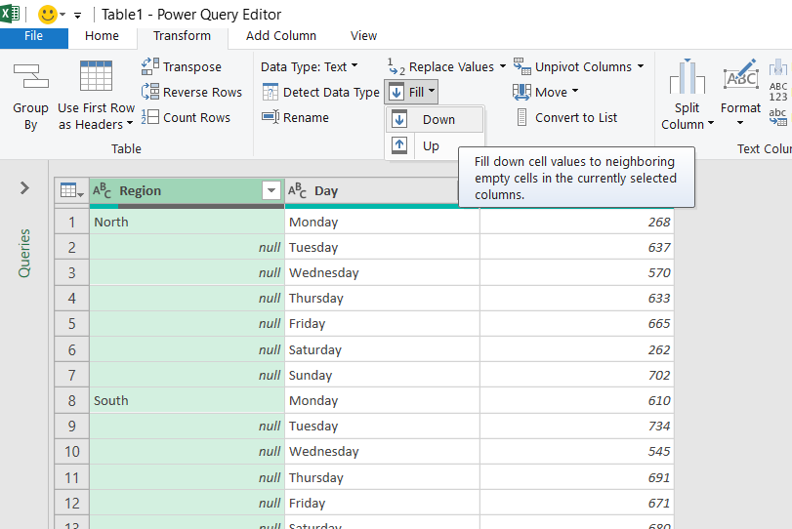

1. We are ready to close and load this data. This time, select Close & Load To. This will give us some options for how to load the data:
   1. By default, Power Query loads into an Excel Table.
   2. We can also load it into a PivotTable or PivotChart. (PivotTable Report = PivotTable)
   3. Finally, there is the connection to only create connection. This means that the query is available in your workbook but not loaded into any worksheet.
   4. Note the checkmark at the bottom, “Add this data to the Data Model.” This would be if you wanted to build a relational schema in your workbook using Power Pivot.

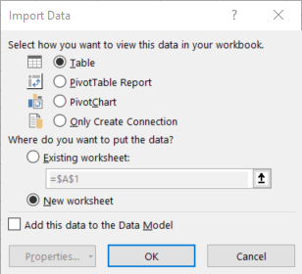

1. Select PivotTable and we can build a PivotTable from the data just like any other dataset.

Drill: state-populations.xlsx

Worksheet: states

1. Name the query State_populations.
2. Remove the United States row from the data.
3. Fill down blanks on the Region and Division columns
4. Sort by Population from high to low
5. Load results into a PivotTable

Worksheet: midwest_cities

These are the 50 largest cities in the Midwest.

1. Convert this data into a table so that each city is in its own row.

Notes for drill:

1. Operate on two columns at a time by holding down Ctrl and selecting each.
2. It’s also possible to rename a query in the Query Settings menu within the Query Editor.

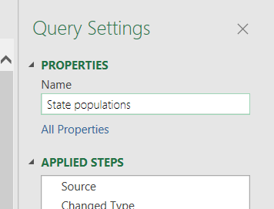

Additional demonstration on State populations:

1. It’s possible to group/aggregate data in Power Query as you would using SUMIFS or a PivotTable.
2. As an example, right-click on region and select Group By.
3. For example, we can aggregate this data by total population by region by creating a new column total_population which is the sum of the population field.

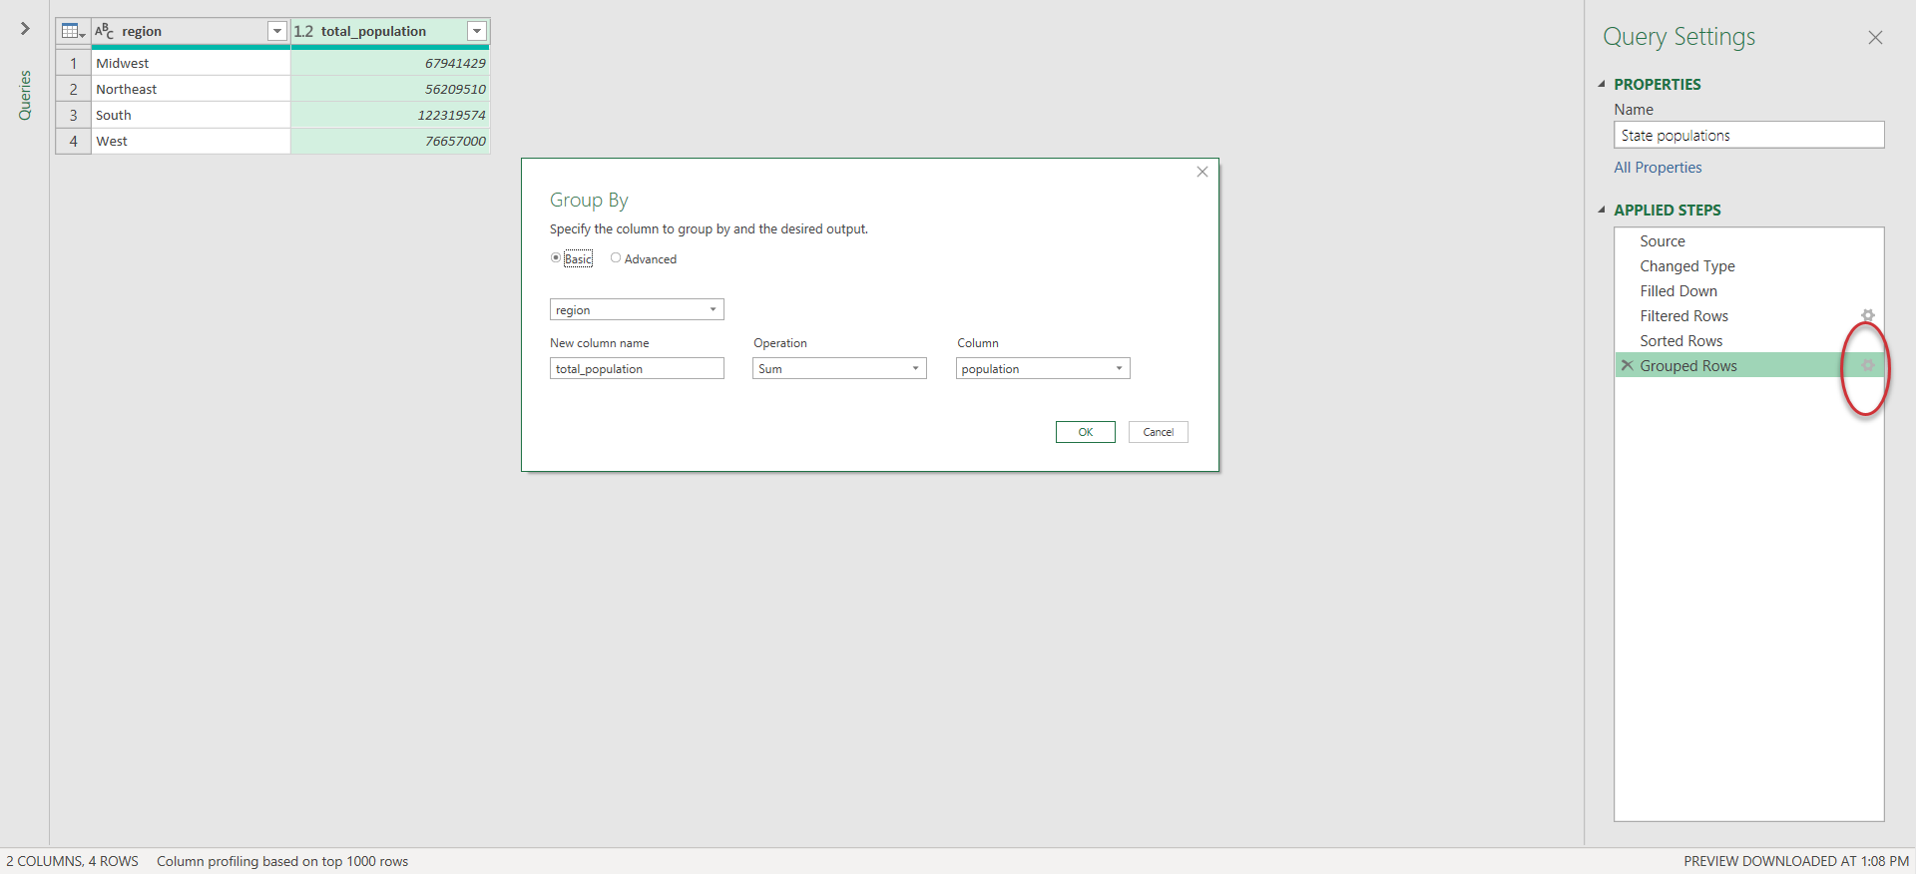

1. To look back at the settings of prior Applied Steps, click on the gear-wheel to the right of that step where applicable.