**APPENDING TABLES IN POWER QUERY – DEMO NOTES**

**Demo: oscars_yes.csv, oscars_no.csv**

1. Start with a blank workbook.
2. This time we will connect to a csv file. Still go to Data -> Get & Transform Data and select From Text/CSV.
   1. Connect to oscars_yes.csv
   2. An import menu will appear previewing the data. If we wanted to re-shape this data, we could select Transform Data at the bottom; however Excel seems to have done a good job with the import, so let’s go ahead and load it to a table.

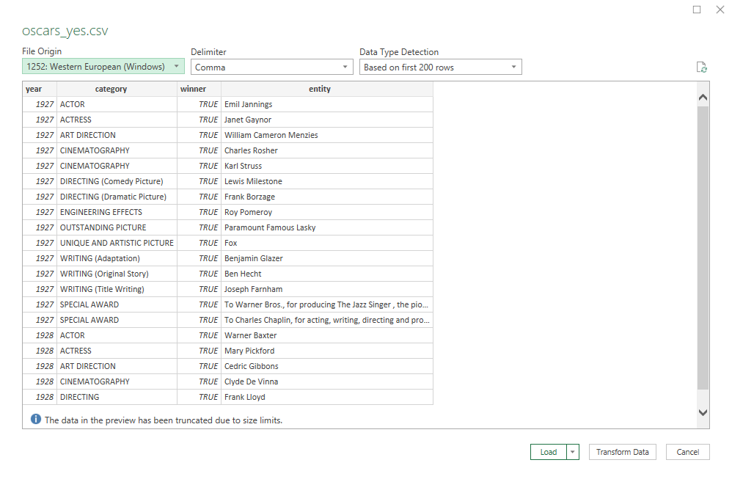

1. Do the same thing to export oscars_no.csv into this workbook.
2. There are now two queries in the Queries & Connections menu.
3. Right-click on the oscars_yes query and select Append.

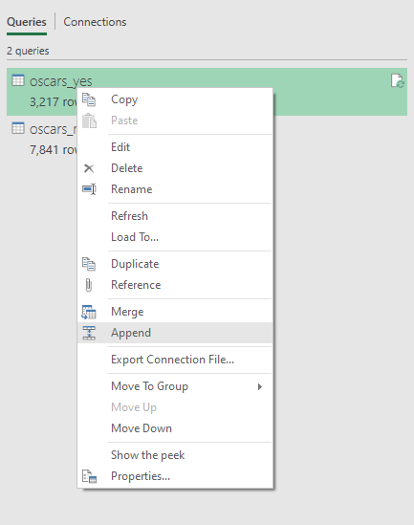

1. Now we can append oscars_no to oscars_yes.

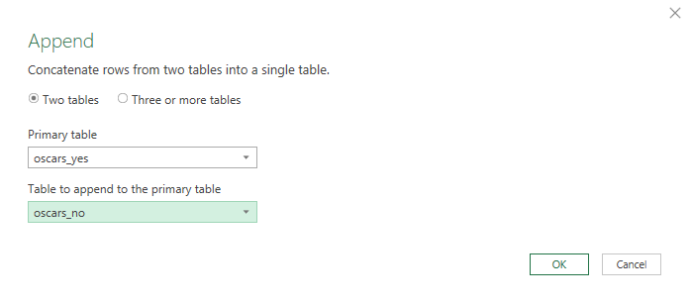

1. This will make a *new* query, named by default Append1. Rename it to oscars_append.
2. To get a visual look at how our workbook’s queries are related, go to the View tab on the ribbon and select Query Dependencies.

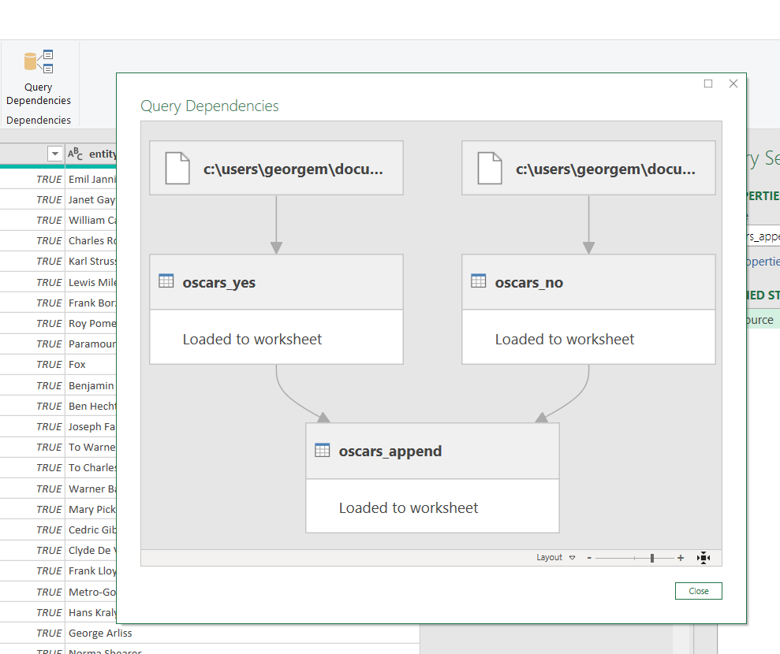

**Drill: hof_inducted.csv, hof_not_inducted.csv**

1. Append these tables.

*Return to slides*