**JOIN BEYOND THE BASICS – DEMO NOTES**

**Demo: championships.xlsx**

We would like to find what cities can claim *only* a baseball or football championship.

1. Preface: This data has been wrangled using Column From Examples. This is a powerful way to add a conditionally-formatted column to a table.
   1. To do this, open the football query, select WINNER field and head to the query editor and Add Column > Column From Examples > From Selection.
   2. What we want to do is start typing the name of the team in the new column. Power Query will start to use conditional logic to begin to complete the field for us.
   3. This is an iterative process. Power Query might get things right at first and then not later. Eventually it should get to “the truth” as determined by you. You can then click OK and use the column in your query.

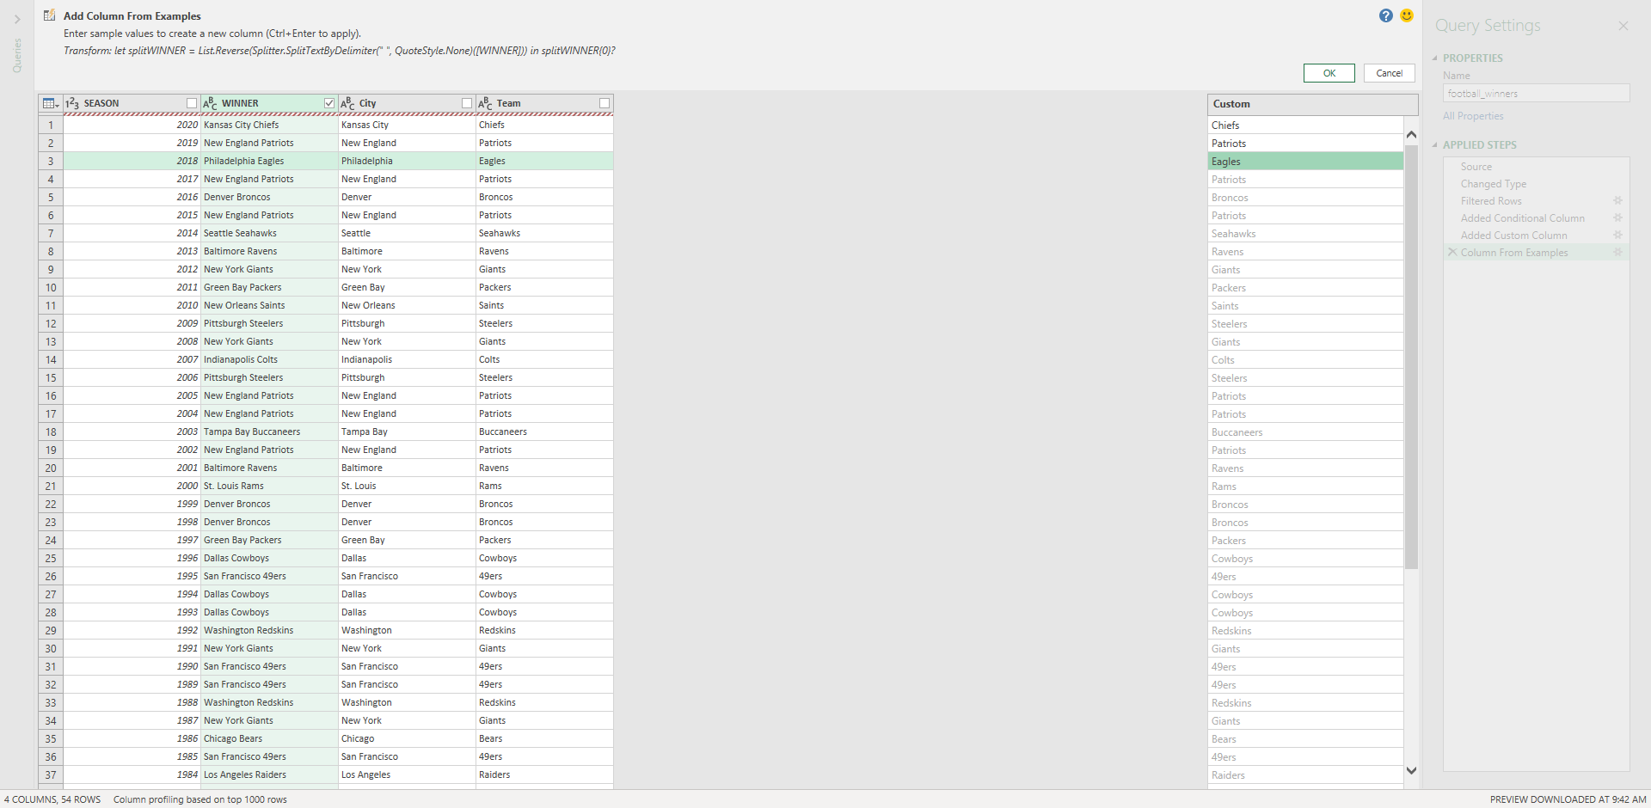

1. Back to the task at hand: We want to find what teams have a baseball championship and not a football championship.

Drill: championships-2.xlsx

Which cities can claim *only* a hockey or basketball championship?

**Demo: office-employees.xlsx**

Worksheet:get-to-know-you

HR wants to set up a get-to-know-you activity for the sales team. You need to set up a table so that each salesperson can fill out their favorite color, food, sport to play and sport to watch.

We can do this with a cross join in Power Query:

1. We’ve already loaded each of these tables in as queries. Click into the names query to edit.
2. We want to add a custom column (Add Column > Custom Column). We will name this column favorite_things.
   1. The formula for our column will be favorite_things. This is another query that shows up in the Intellisense.

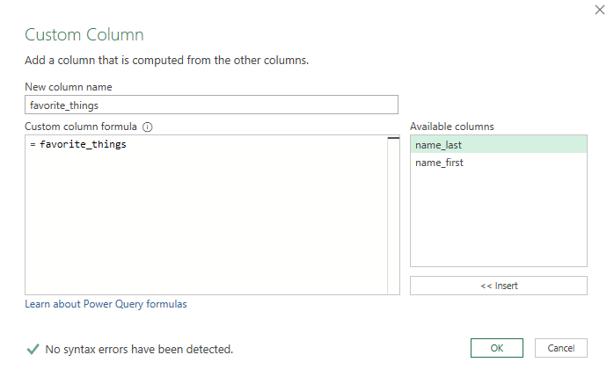

1. Click OK. Now if you click on any of the favorite_things cells, you can get a preview of the resulting data at the bottom of your screen:

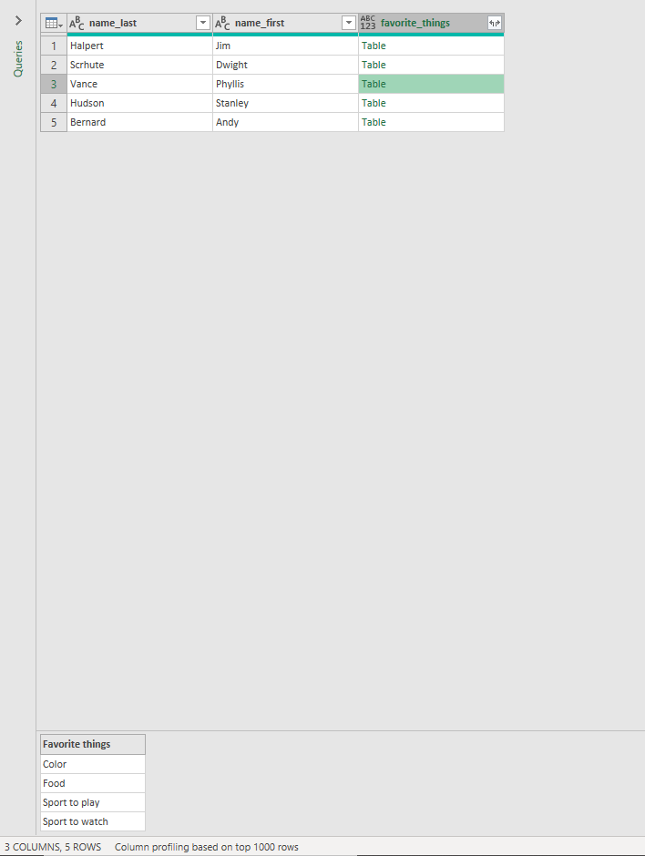

1. Go ahead and expand the data now. We will get this in a tabular form now.
2. To pivot this table to make a checklist, we first need a “values” column to pivot on. This is blank for now so we can insert a blank or null field:

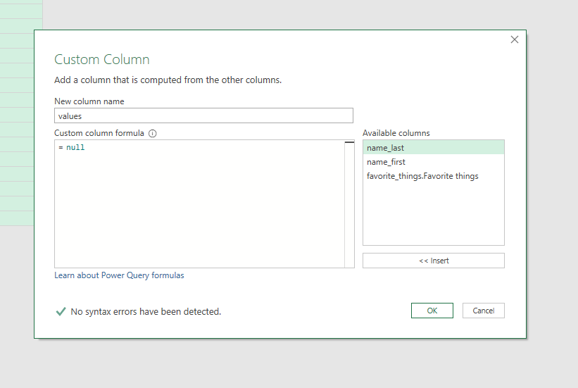

1. Now we need to “pivot” on top of this field, based on the values column.
   1. Select that column and go to Transform > Pivot Column.
   2. Select values as the column to pivot on, then select Advanced Options and choose “Don’t Aggregate” as your aggregate value function.

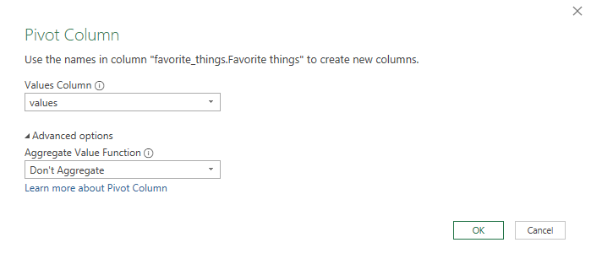

1. We now have a “checklist” table that we can load into Excel.

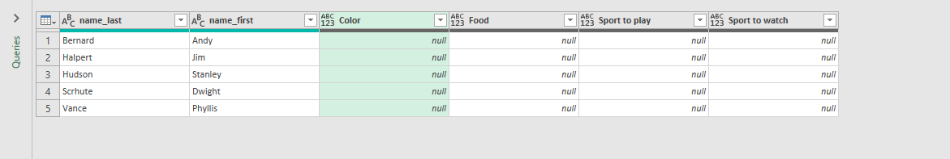

1. Currently the names query is loading to a connection only. If we want to change that we can right-click on the query and select Load To.

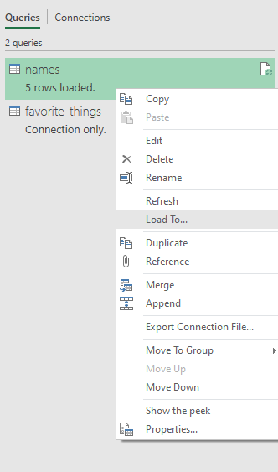

Drill: states.xlsx

Create a table to record each state’s bird, flower and capital.