LAB 02 · ENTERPRISE SUPPORT OPERATIONS
Software Installation Failure Investigation
Rob Style Workbook · Painful Step-by-Step · Screenshot Evidence · Research Prompts

Purpose of this workbook
This workbook guides you through a realistic enterprise support investigation where a software deployment fails on a Windows workstation. You will capture evidence, enable installer logging, inspect Event Viewer, identify a missing prerequisite or installation blocker, remediate it, validate the successful install, and document the ticket like a real support analyst.
Lab Identity | Details
Official Title | LAB 02 · Software Installation Failure Investigation
Series | Enterprise Support Operations
Primary Skill Area | Software deployment troubleshooting
Environment | Windows VM or test workstation
Main Tools | MSI installer, msiexec, Event Viewer, PowerShell, Programs and Features, Windows Installer logs
Portfolio Outcome | A documented support case showing software install failure investigation, root cause analysis, remediation, and validation evidence

1. Lab Objective
Determine why a business application fails to install on a Windows workstation and restore the installation pipeline through evidence-based troubleshooting.
SCREENSHOT PROMPT: LAB02_00_LabStart_Environment.png
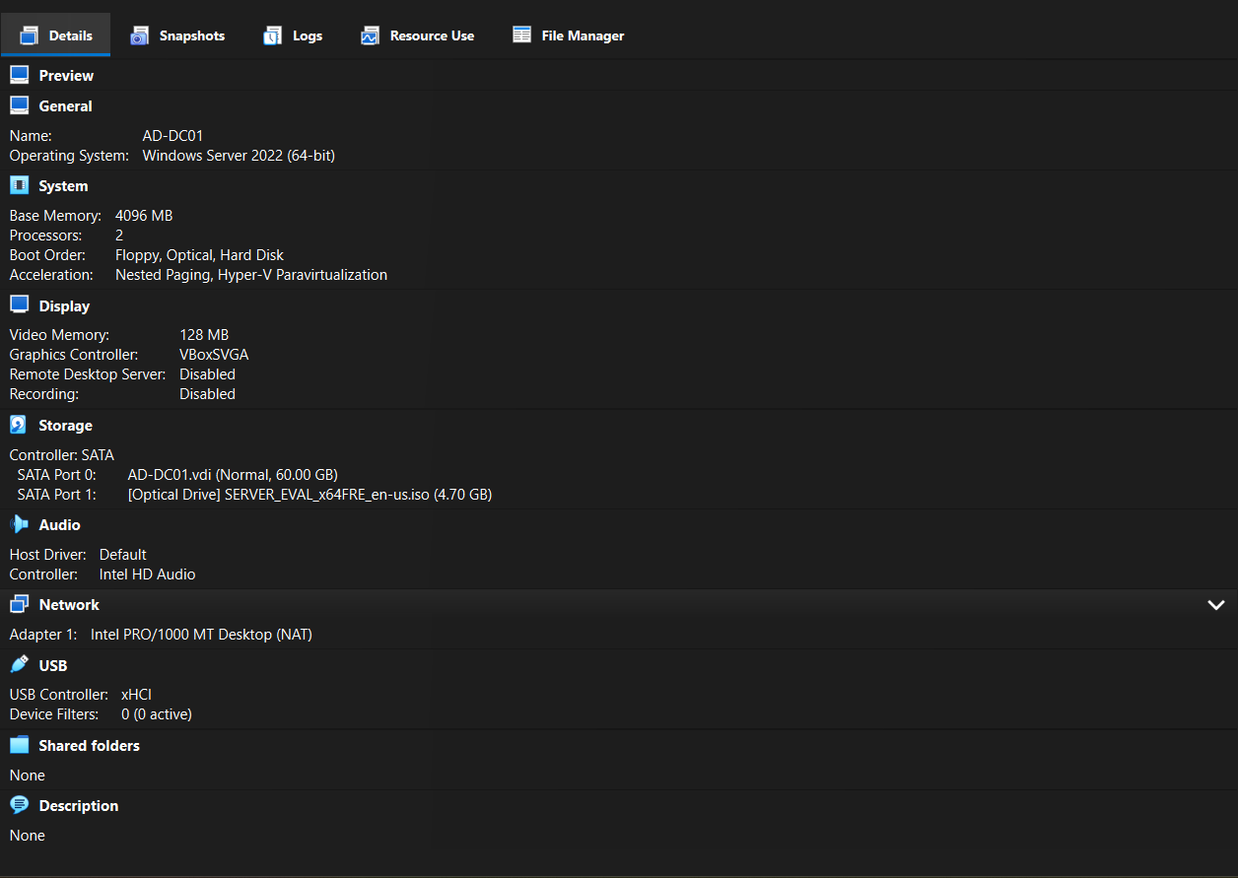
Proof captured: Your Windows VM or test workstation is running, named, and ready for the lab.
RESEARCH PROMPTING QUESTIONS - answer these in your own words
1. What is the difference between an EXE installer and an MSI installer? The MSI file is standardized. It is used by the built-in window installer service, and it is good for large scale, automated deployments. The EXE installer is self-contained and can be customized by developers.
2. Why do enterprises care about repeatable software deployment instead of one-off manual installs? It eliminates human error, provide a level consistency operationally, and enable rapid, low stress updates. This is preferred because it is a scalable process and reduces costs that is associated with downtime.
3. What information should be captured before making changes to a failed installation? Error codes, timestamped logs, the exact step at which the failure occurred, and systems diagnostics.

2. Business Scenario
Scenario
Accounting software deployment fails silently on one of forty workstations during rollout. The user reports that the installer closes without an obvious error, the application does not appear in Programs and Features, and the shortcut is missing. You are assigned the ticket and must determine whether this is a workstation issue, installer issue, missing dependency, permission issue, or deployment process issue.
Your goal is not to guess. Your goal is to collect evidence, reproduce the failure, inspect the logs, identify the root cause, remediate, and validate.
RESEARCH PROMPTING QUESTIONS - answer these in your own words
1. What is a silent installation failure? When software deployment in the background, without any prompts, pop-ups, or user interface, halts or aborts before completion. In other words, the installation crashes without the user or administrator receiving an error message that communicate there is a problem.
2. Why can the same installer work on some endpoints but fail on others? Because OS versions and patch levels can be different. Furthermore, if certain dependencies and perquisites are not there leads to this issue as well. Lastly any conflict that exist with security software or any hardware architecture mismatches can also cause such a problem as well.
3. What business risk exists when an accounting application fails during a deployment window? The risk that exist are primarily financially, operationally, compliance, and reputational. In terms of the operational disruption, the business may not be able to process transaction, inability to run payroll, accounts payable and receivable causing workflow bottlenecks. In terms of financial exposure, loss of revenue exist. When we are talking about compliance and legal penalties, this can lead to missing critical tax filings deadlines or failing to meet strict statutory reporting standards. With reputational damage, this happens given the delayed services and system unreliability clients will lose trust.

3. Lab Setup and Folder Structure
Create a clean evidence folder before starting. This makes your screenshots and logs easier to place into your portfolio later.
Create this folder structure in Documents:
LAB02_Software_Install_Failure\
01_Screenshots\
02_Installer\
03_Logs\
04_Ticket_Notes\
05_Research_Notes\
- Open File Explorer.
- Go to Documents.
- Create a folder named LAB02_Software_Install_Failure.
- Inside that folder, create the five subfolders listed above.
- Place your installer file inside 02_Installer. If you do not have a formal business app installer, use any safe test MSI or EXE installer available in your lab environment.
SCREENSHOT PROMPT: LAB02_01_FolderStructure_Created.png
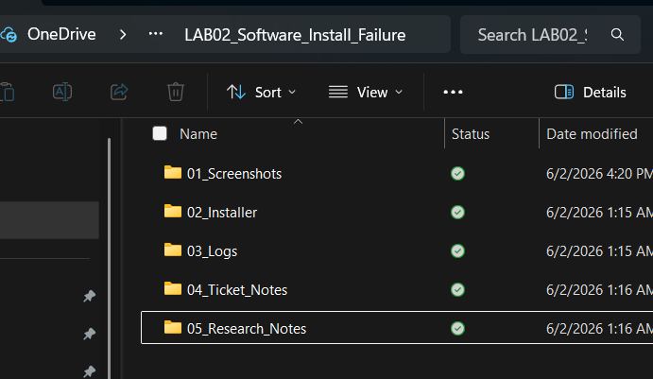
Proof captured: The organized evidence folder structure exists inside Documents.
RESEARCH PROMPTING QUESTIONS - answer these in your own words
1. Why is evidence organization important in enterprise support? It is important due to the following five reasons:
- Allow teams to focus on facts that are verified versus using their assumptions when it comes to making decisions as well as protecting the team from the various management fads that can arise. Essentially the importance gives testament to the use of evidence-based tools that help to identify the root causes of problems as they come up and also streamlines operations.
- Improves Resolution time: This is where the knowledge base comes to mind. With well-organized evidence one make easier the ability to reference key information to get stuff done. This helps with overall job satisfaction and efficiency for the support staff.
- Drives Proactive Development: Enable one to identify the trends that arise to truly show what customers are struggling with. This is great as it will lead to better ticket management, the designing of new features which all leads to optimization of the user experience.
- Enhancing Auditing and Compliance: Maintains a central repository of institutional knowledge that simplify the administration of compliance through the department. This also helps to maintain compliance with regards to Information security standards SOC2, or ISO 27001
- Standardizing SLAs: Organization enables to benchmark the operations to any SLAs that may be associated with the given project. This maintains consistency across all units.
2. Why should logs and screenshots be separated from installer files? For starters they serve different purposes. Installers is to be only stored once per software version and considered to be static documents. Logs and screenshots vary depending on the circumstance and situation. Thus, storage cost is different, leading to the separation of them. Next is the difference in retention and lifecycle and the policies thereof. Installers are to be maintained long-term for legacy based systems, Logs and screenshots is transient that are usually deleted per the completion of a ticket. Compliance, privacy, and security risks also plays a role. Logs and screenshots may contain PII, proprietary business data, and security tokens. Installers do not contain any of this. If an organization was to merge any of this causes a risk in privacy violations and compliance failures because the sensitive information being screenshotted or logged may get exposed to unauthorized individuals. Lastly, it is search and retrieval performance. When it comes to engineers they will require fast indexes to query text logs and scan user screenshots, deployment systems requires high-throughput download speeds to distribute stuff and if both the installer, logs, and screenshots are stored in one location the index performance will become degraded, the search queries will slow and critical workflows will bottleneck.
3. What naming convention would make evidence easier to review six months later? A standardized delimited structure such as the following: [YYYYMMDD]_[TicketID]_[AssetType]_[Component]_[Description].[Extension]

4. Establish the Baseline
Before running the installer, prove the starting condition. You need to show that the target application is not already installed and that the workstation is in a known state.
- Open Settings > Apps > Installed apps OR Control Panel > Programs > Programs and Features.
- Search for the target application name.
- Verify that the application is not already installed.
- Open File Explorer and confirm that no application shortcut exists on the Desktop or Start Menu.
- Open System Information if needed to document OS version and architecture.
Optional PowerShell baseline checks:
Get-ComputerInfo | Select-Object WindowsProductName, WindowsVersion, OsArchitecture
Get-Package | Sort-Object Name | Select-Object Name, Version | Out-File "$env:USERPROFILE\Documents\LAB02_Software_Install_Failure\03_Logs\InstalledPackages_Before.txt"
SCREENSHOT PROMPT: LAB02_02_ProgramsAndFeatures_Baseline.png
Proof captured: The target application is not currently installed.
SCREENSHOT PROMPT: LAB02_03_SystemInfo_Baseline.png
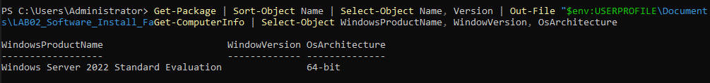
Proof captured: Windows version, architecture, and machine context are visible.
RESEARCH PROMPTING QUESTIONS - answer these in your own words
1. Why should you prove the starting state before attempting remediation? Its gives me a baseline in which to start with. If I don’t establish the baseline it would be difficult to know if the remediation attempts have failed or succeeded. The miscue could lead to an even more vulnerable environment.
2. What is the difference between checking Installed Apps and checking installed packages with PowerShell? Check apps looks up UWP (Universal Windows Platform)/packaged software apps, whereas checking for installed packages check traditional desktop programs and specific stuff like that MSI installer.
3. Why does OS architecture matter for software installation? It dictates how the CPU processes data and how much RAM can be accessed. If that information is off then the software will not run.

5. Reproduce the Installation Failure
Reproduce the issue carefully. Do not immediately fix it. Capture the failure behavior first.
- Right-click the installer and choose Run as administrator if that matches the ticket scenario.
- Observe whether the installer launches, freezes, rolls back, closes silently, or displays an error code.
- If an error appears, do not close it until you capture the screenshot.
- If no error appears, note that the symptom is a silent or unclear failure.
- Return to Installed Apps or Programs and Features and confirm the application still did not install.
SCREENSHOT PROMPT: LAB02_04_InstallerFailure_Observed.png
Proof captured: The failure behavior, error dialog, rollback, or missing install result is captured.
SCREENSHOT PROMPT: LAB02_05_AppStillMissing_AfterFailure.png
Proof captured: The app is still missing after the failed install attempt.
RESEARCH PROMPTING QUESTIONS - answer these in your own words
1. What is the difference between an installer failing before launch and failing during installation?
2. What does it mean when an installer rolls back?
3. Why should you avoid changing multiple things before capturing the failure?

6. Generate a Verbose Installer Log
If the installer is an MSI, use msiexec to generate a verbose log. This is one of the most important skills in this lab.
Use this command if the installer is an MSI:
msiexec /i "C:\Users\Administrator\Documents\LAB02_Software_Install_Failure\02_Installer\YourInstaller.msi" /L*V "C:\Users\Administrator\Documents\LAB02_Software_Install_Failure\03_Logs\LAB02_MSI_Install.log"
If the installer is an EXE, check whether it supports logging by running:
YourInstaller.exe /?
YourInstaller.exe /help
- Open Command Prompt as Administrator.
- Run the msiexec command with your actual MSI filename.
- Wait for the install attempt to finish.
- Open the 03_Logs folder and confirm the log file was created.
- Open the log in Notepad and search for: Return value 3, error, failed, prerequisite, dependency, denied, access, rollback.
SCREENSHOT PROMPT: LAB02_06_MSILog_CommandExecuted.png
Proof captured: The msiexec command was executed with verbose logging enabled.
SCREENSHOT PROMPT: LAB02_07_MSILog_FileCreated.png
Proof captured: The verbose installer log exists inside the 03_Logs folder.
SCREENSHOT PROMPT: LAB02_08_MSILog_ErrorSearch.png
Proof captured: A relevant log search result is visible, such as Return value 3 or a dependency/prerequisite clue.
RESEARCH PROMPTING QUESTIONS - answer these in your own words
1. What does msiexec do?
2. What does /L*V mean in an msiexec command?
3. Why is Return value 3 important in MSI troubleshooting?
4. Why can the real cause of failure appear many lines before the final error?

7. Review Event Viewer for Installer Evidence
Event Viewer provides system-level evidence that supports or challenges what the installer log says.
- Open Event Viewer.
- Navigate to Windows Logs > Application.
- Filter or search for MsiInstaller events.
- Look for warning or error events around the timestamp of the failed install.
- Open the event details and review the message, event ID, product name, and error code.
- Also check Windows Logs > System if the failure appears related to services, drivers, or system dependencies.
SCREENSHOT PROMPT: LAB02_09_EventViewer_Application_MsiInstaller.png
Proof captured: Application log with MsiInstaller events visible.
SCREENSHOT PROMPT: LAB02_10_EventViewer_ErrorDetails.png
Proof captured: The selected event details show installer-related failure information.
RESEARCH PROMPTING QUESTIONS - answer these in your own words
1. What is the MsiInstaller event source?
2. Why is timestamp correlation important when reviewing logs?
3. What is the difference between Application logs and System logs in Event Viewer?
4. Why should Event Viewer findings be compared against the installer log instead of trusted alone?

8. Check for Missing Prerequisites or Dependencies
Many installation failures are caused by missing runtimes, missing frameworks, blocked services, insufficient permissions, or unsupported OS versions.
- Review the installer documentation or known requirements if available.
- Check whether the application requires a Visual C++ Redistributable, .NET Desktop Runtime, WebView2 Runtime, Java Runtime, specific Windows build, or admin rights.
- Open Installed Apps / Programs and Features and search for the suspected prerequisite.
- If the prerequisite is missing, document the missing dependency before installing it.
- If the prerequisite is present, check whether the version or architecture is correct.
Optional PowerShell checks:
Get-Package | Where-Object {$_.Name -match "Visual|Redistributable|\.NET|Runtime|WebView|Java"} | Select-Object Name, Version
Get-Service msiserver
Get-Service | Where-Object {$_.Name -match "bits|crypt|wuauserv|msiserver"}
SCREENSHOT PROMPT: LAB02_11_Prerequisite_Check.png
Proof captured: Installed Apps or PowerShell output showing whether the required prerequisite is present or missing.
SCREENSHOT PROMPT: LAB02_12_ServiceStatus_Check.png
Proof captured: Service status check for Windows Installer or related services, if relevant.
RESEARCH PROMPTING QUESTIONS - answer these in your own words
1. What is a software prerequisite?
2. Why do some applications require Visual C++ Redistributables?
3. What is the difference between x86 and x64 runtime dependencies?
4. Why can a missing dependency produce a generic installation failure?

9. Validate Permissions and Execution Context
Do not assume the failure is only technical. Determine whether the installer was run with the correct rights and from a trusted location.
- Confirm whether the installer was run as Administrator.
- Check whether the installer is located in a user profile, network share, downloads folder, or controlled location.
- Right-click the installer > Properties and check whether Windows blocked the file because it came from another computer.
- Check NTFS permissions on the installer folder if needed.
- If the install writes to Program Files, HKLM registry keys, or system services, administrator rights are usually required.
Optional commands:
whoami
whoami /priv
icacls "C:\Users\Administrator\Documents\LAB02_Software_Install_Failure\02_Installer"
PowerShell:
Get-ExecutionPolicy -List
SCREENSHOT PROMPT: LAB02_13_InstallerProperties_Context.png
Proof captured: Installer properties, unblock status, or file location context captured.
SCREENSHOT PROMPT: LAB02_14_Whoami_Privileges.png
Proof captured: whoami /priv output or administrator context captured if relevant.
RESEARCH PROMPTING QUESTIONS - answer these in your own words
1. Why do enterprise installations often require administrator rights?
2. What is the difference between user context and system context during software deployment?
3. What does the Windows file unblock option mean?
4. Why can installing from a network share behave differently than installing locally?

10. Remediate the Root Cause
After collecting evidence, apply one controlled remediation. Do not fix five things at once. The goal is to prove what solved the issue.
Recommended simulated root cause for this lab
Missing application prerequisite, such as Visual C++ Redistributable, .NET Runtime, WebView2 Runtime, or another required dependency. If your actual lab reveals a different root cause, document the actual cause instead.
- Document the suspected root cause in your ticket notes before fixing it.
- Install the missing prerequisite or correct the identified blocker.
- Capture the prerequisite installation or corrective action.
- Do not rerun the business application installer until the prerequisite remediation is complete.
- After remediation, rerun the installer using the same method as before.
SCREENSHOT PROMPT: LAB02_15_Prerequisite_Installed.png
Proof captured: The missing prerequisite or corrective action has been applied.
SCREENSHOT PROMPT: LAB02_16_Reinstall_Attempt_AfterFix.png
Proof captured: The application installer was rerun after remediation.
RESEARCH PROMPTING QUESTIONS - answer these in your own words
1. Why should remediation be controlled and documented?
2. How do you prove that the prerequisite fixed the installation failure?
3. What is the risk of making multiple changes before retesting?

11. Validate Successful Installation
Validation is not optional. You need to prove the application installed and launched successfully.
- Open Programs and Features or Installed Apps and confirm the application is listed.
- Launch the application.
- Confirm the application opens without error.
- Check the application version if visible.
- If a service was installed, confirm the service exists and is running.
- If a log file was generated during the successful install, preserve it for evidence.
Optional validation commands:
Get-Package | Where-Object {$_.Name -match "YourAppName"}
Get-Service | Where-Object {$_.DisplayName -match "YourAppName"}
If using an MSI product code later:
wmic product get name,version | findstr /i "YourAppName"
SCREENSHOT PROMPT: LAB02_17_AppInstalled_ProgramsAndFeatures.png
Proof captured: The application is listed as installed.
SCREENSHOT PROMPT: LAB02_18_AppLaunch_Success.png
Proof captured: The application launches successfully after remediation.
SCREENSHOT PROMPT: LAB02_19_FinalValidation_PowerShell.png
Proof captured: Optional PowerShell validation shows installed package or service status.
RESEARCH PROMPTING QUESTIONS - answer these in your own words
1. What counts as successful validation after a software install?
2. Why is “installer completed” not always enough evidence?
3. What is the difference between installed, configured, and usable?

12. Ticket Documentation
Write the support ticket as if another technician, manager, or auditor may read it later.
Ticket Section | What You Should Write
User Complaint | One or two sentences summarizing the reported failure.
Business Impact | Who is affected, what work is blocked, and whether this impacts a deployment window.
Troubleshooting Performed | List baseline checks, failed install reproduction, msiexec logging, Event Viewer review, prerequisite validation, and retest.
Root Cause | State the specific root cause you proved. Example: missing prerequisite, permission issue, blocked installer, service issue, corrupted installer, unsupported OS.
Resolution | State the exact remediation applied.
Validation | State how you proved the issue was resolved.
Escalation Decision | Explain why escalation was or was not needed.
SCREENSHOT PROMPT: LAB02_20_TicketNotes_Final.png
Proof captured: Your completed ticket notes or lab summary are visible.
RESEARCH PROMPTING QUESTIONS - answer these in your own words
1. What makes a ticket note useful to another technician?
2. Why should ticket notes separate symptoms, root cause, and resolution?
3. What information should be included before escalating a software deployment issue?

13. Escalation Decision Logic
Not every issue needs escalation. But you must know when escalation is appropriate.
Escalate If | Why It Matters
Installer fails across multiple machines | This may indicate a bad package, deployment system issue, or vendor problem.
Logs show access denied to domain-controlled resources | May require AD, GPO, or endpoint management team involvement.
Application requires licensing server or backend configuration | May require application owner or vendor support.
Event Viewer shows service control, driver, or system corruption issues | May require desktop engineering or systems team support.
User needs access to restricted software group | May require manager approval or IAM workflow.
RESEARCH PROMPTING QUESTIONS - answer these in your own words
1. What is the difference between escalation and handoff?
2. What evidence should be attached before escalation?
3. Why should you avoid escalating with only “it does not work” as the problem statement?

14. Final Evidence Checklist
Evidence Item | Filename | Complete
Lab environment start | LAB02_00_LabStart_Environment.png | ☐
Folder structure | LAB02_01_FolderStructure_Created.png | ☐
Baseline installed apps | LAB02_02_ProgramsAndFeatures_Baseline.png | ☐
System info baseline | LAB02_03_SystemInfo_Baseline.png | ☐
Install failure observed | LAB02_04_InstallerFailure_Observed.png | ☐
App still missing after failure | LAB02_05_AppStillMissing_AfterFailure.png | ☐
MSI logging command | LAB02_06_MSILog_CommandExecuted.png | ☐
Installer log created | LAB02_07_MSILog_FileCreated.png | ☐
Installer log error search | LAB02_08_MSILog_ErrorSearch.png | ☐
Event Viewer Application log | LAB02_09_EventViewer_Application_MsiInstaller.png | ☐
Event Viewer error details | LAB02_10_EventViewer_ErrorDetails.png | ☐
Prerequisite check | LAB02_11_Prerequisite_Check.png | ☐
Service status check | LAB02_12_ServiceStatus_Check.png | ☐
Installer properties/context | LAB02_13_InstallerProperties_Context.png | ☐
whoami privileges | LAB02_14_Whoami_Privileges.png | ☐
Prerequisite installed | LAB02_15_Prerequisite_Installed.png | ☐
Reinstall attempt after fix | LAB02_16_Reinstall_Attempt_AfterFix.png | ☐
Application installed | LAB02_17_AppInstalled_ProgramsAndFeatures.png | ☐
Application launched | LAB02_18_AppLaunch_Success.png | ☐
Final validation command | LAB02_19_FinalValidation_PowerShell.png | ☐
Ticket notes | LAB02_20_TicketNotes_Final.png | ☐

15. Portfolio Reflection Prompts
Answer these in your own voice after the lab. Do not answer them until you complete the technical work.
- What was the original symptom reported by the user or deployment team?
- What evidence proved the installation failed?
- What was the root cause?
- What logs were most useful and why?
- How did you validate the fix?
- What would you include in the ticket if this were a real enterprise support case?
- What would trigger escalation to desktop engineering, application support, or vendor support?
- What did this lab teach you about troubleshooting instead of guessing?
16. Final Portfolio Summary Draft - Fill In After Completion
Write your own final paragraph here
In this lab, I investigated a failed enterprise software installation by reproducing the failure, generating installer logs, reviewing Event Viewer, checking prerequisites, identifying the root cause, applying remediation, and validating successful installation. This lab strengthened my understanding of software deployment troubleshooting, installer logging, dependency analysis, and enterprise support documentation.

