NETWORK FUNDAMENTALS LAB 01
DHCP Configuration and Troubleshooting
Rob Style Workbook
Scenario: You are a Network Support Technician for Green Valley Public Schools. Teachers report that computers are showing 'No Internet'. Your task is to verify DHCP functionality and troubleshoot connectivity issues.
Learning Objectives
- Explain DHCP
- Configure DHCP settings
- Verify DHCP lease assignment
- Release and renew IP addresses
- Identify DHCP failures
- Troubleshoot connectivity
Research Prompt #1
- What does DHCP stand for? Dynamic Host Configuration Protocol
- Why is DHCP preferred over static addressing? It eliminates manual work and prevents network errors
- What are the four DHCP DORA steps?
- Discover (Client to Network) – The client device boots up and connects to the network and realize a IP address is needed
- Offer (Server to Client) – DHCP servers receive the request which is sent as a broadcast and then they check their pool of Ip addresses
- Request (Client to Server) – The client device will then receive the offer(s) and then select one that they want to use
- Acknowledge – (Server to Client) – DHCP receives the confirmation of the selected IP address
Lab Steps
- Step 1: Run ipconfig and capture Screenshot 01.
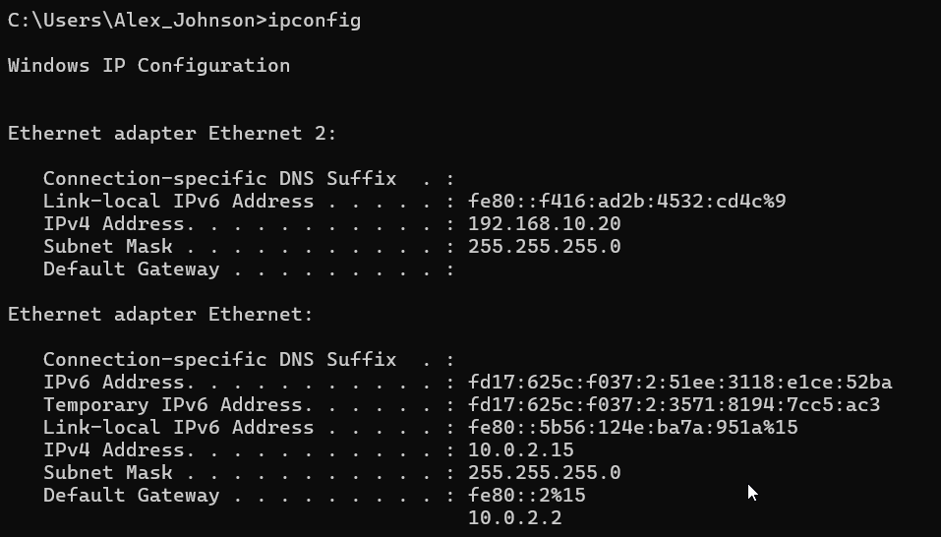
- Step 2: Run ipconfig /all and capture Screenshot 02.
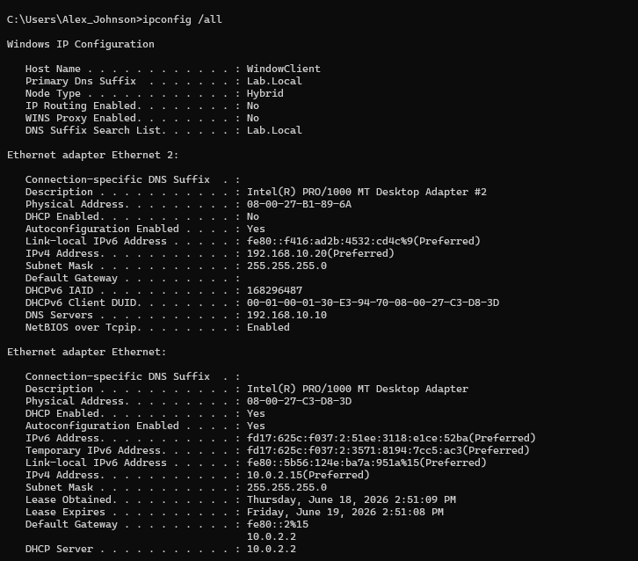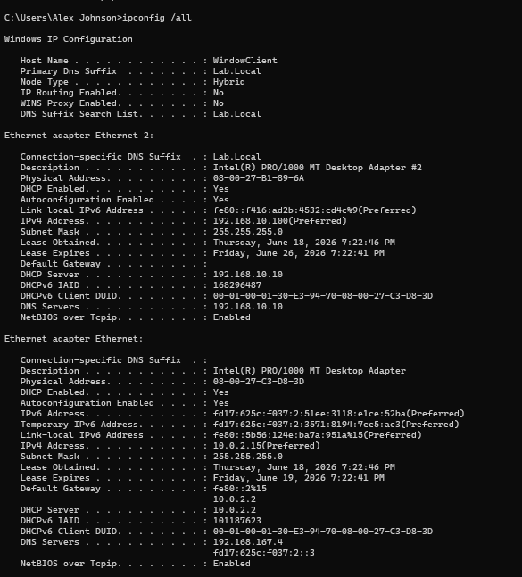Step 3: Run ipconfig /release and capture Screenshot 03.
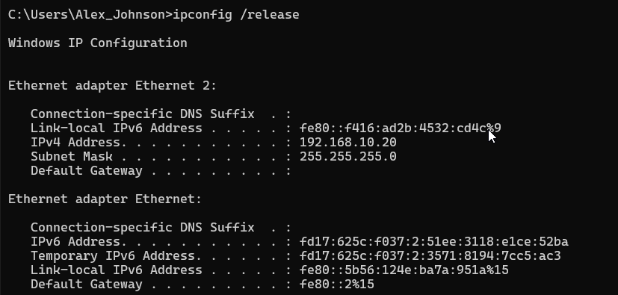
- Step 4: Run ipconfig /renew and capture Screenshot 04.
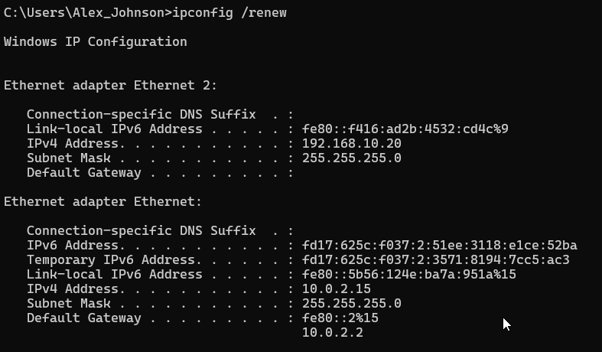
- Step 5: Perform ping tests and capture Screenshot 05.

Ping Test 1 Local TCP/IP Stack
This is to test to see if the windows networking is functioning and if the TCP/IP stack is loaded. If the test fails then ti will communicate that the windows networking is broken
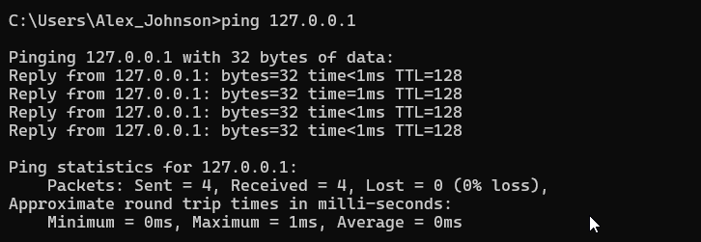

Ping Test 2 My IP address
This is to make sure that the NIC is functioning and if the IP is assigned correctly

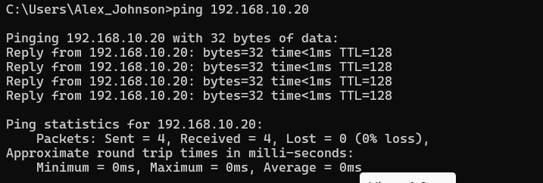

Ping Test 3 – Default Gateway
To ensure that the workstation can communicate with the local network. If this fails it could mean that we have problems with the network adapter, VLAN, Switch, or the Gateway
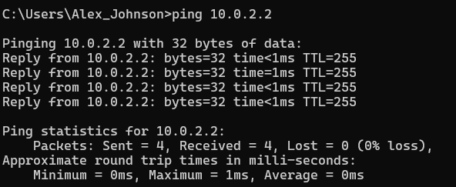

Ping Test 4 – Domain Controller
This is to make sure that the workstation can reach the server
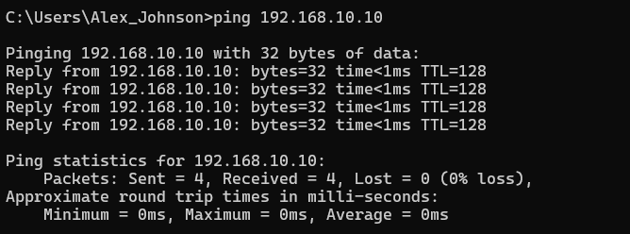

Ping Test 5 – Internet Connectivity
This is to determine that traffic can leave the local network and reach the internet
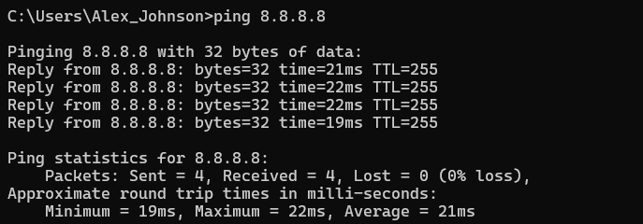

Ping Test 6 – DNS Resolution
This is to determine that the DNS is working. If this fails along with 8.8.8.8 then it can be a possible issue with the DNS server.
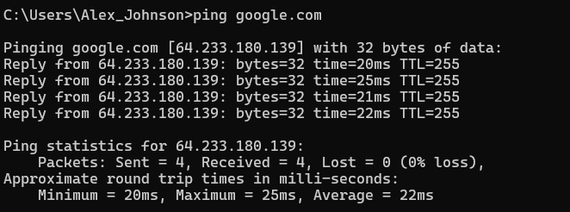
- Step 6: Disable and re-enable the adapter. Capture Screenshot 06.

Shows that the teacher workstation lost connection to the school network. All network connectivity was lost to the AD and the DNS on the DC and the DHCP on the DC. The NAT adapter (Ethernet) was still active. This communicates that the work station is multi hoed and has a separate enterprise and internet facing network conection The NAT adapter is connected through the virtual box. Given the fact that the NAT adapter is still present we will not see an APIPA address.
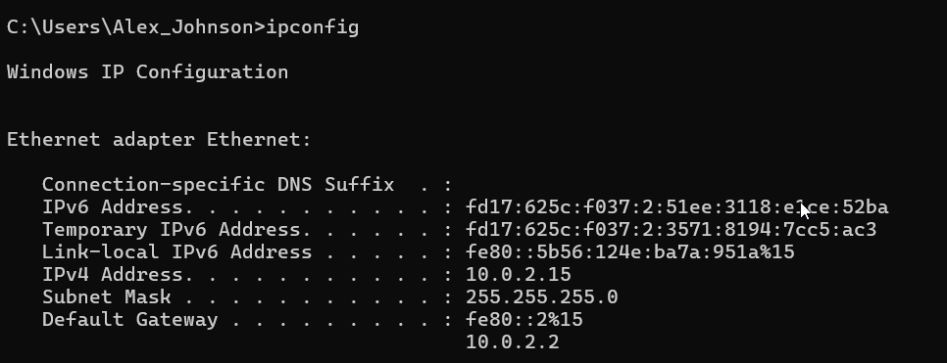
- Step 7: Simulate DHCP failure and identify APIPA addressing. Capture Screenshot 07.

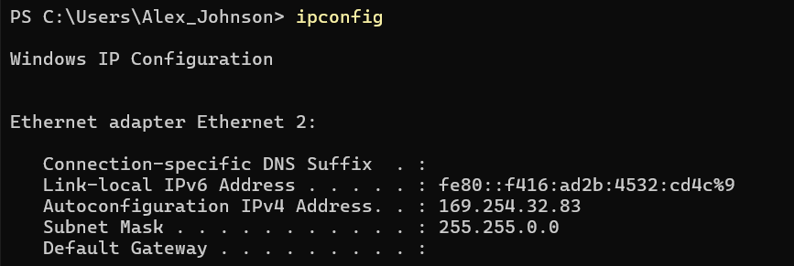

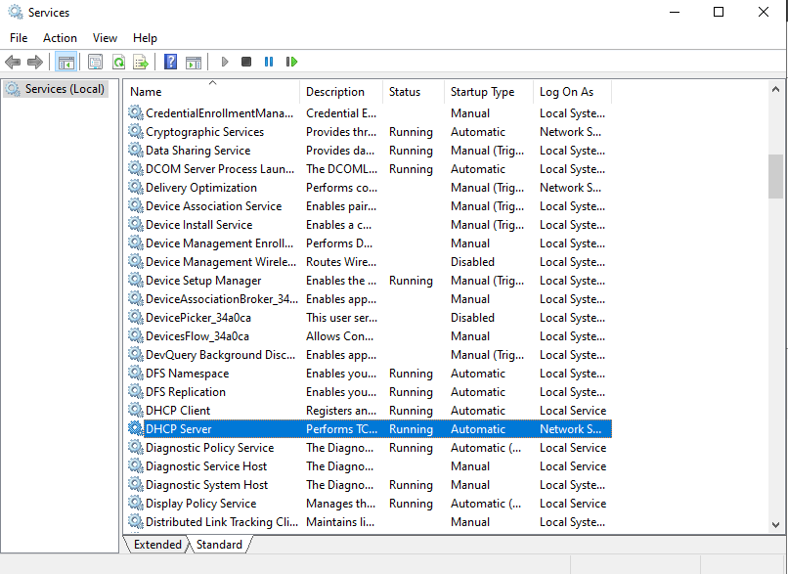

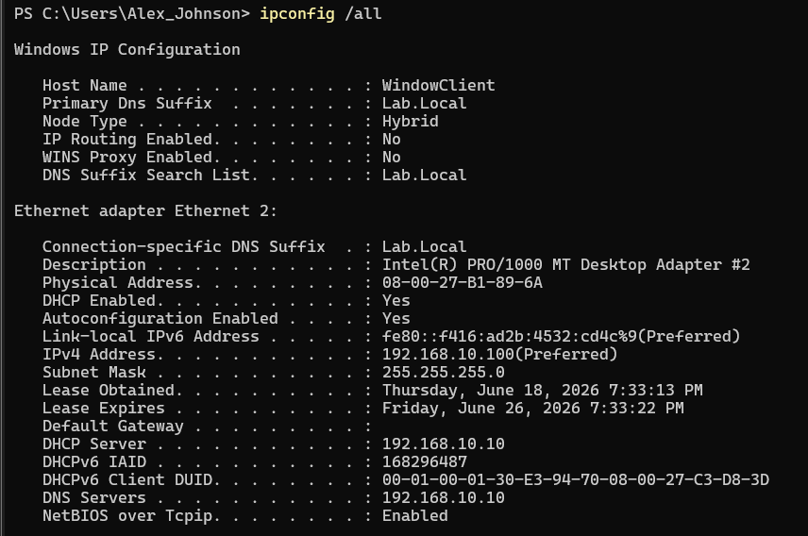
DHCP services were provided by the VirtualBox NAT network (10.0.2.2) rather than the Windows Server 2022 Domain Controller. As a result, DHCP failure simulation through the Domain Controller was not possible in the current lab architecture.

Identified an APIPA addressing issue, implemented a temporary static addressing solution, deployed and configured a Windows Server DHCP service, created a scope, configured DNS integration, and validated dynamic address assignment to a domain-joined workstation.
Research Prompt #2
- What is a DHCP lease? Time bound assignment of an IP address to a device on a network
- Why do leases expire? It prevents the network from running out of IP addresses
- What happens if a client cannot contact a DHCP server? They cannot get a new IP address or renew the current. IN this case there will be an APIPA address provided or an alternative configuration used (which can sometimes be the pre-configured profile)
Research Prompt #3
- Why does ping 127.0.0.1 work without a network connection? Because the loopback interface that is built directly onto my operating system.
- What does the default gateway do? Act as a bridge between my local network and the external network such as the internet
- Why can DNS failures still prevent browsing when ping works? Because web browsers rely on the name resolution to fetch web pages. Pings have the ability to use cached IP addresses or bypass standard resolutions
Research Prompt #4
- What is APIPA? Automatic Private IP addressing that automatically assigns an Ip address when the device cannot reach the DHCP server to get one.
- Why does Windows assign a 169.254.x.x address? It is used as a fallback mechanism when it cannot contact a DHCP server to get a valid address
- Can APIPA devices reach the Internet? Why or why not? APIPA addresses cannot reach the internet because it is a non routable address. they are considered link local addresses. Also the public internet is programmed to drop and ignore traffic that comes form such an Address. Also APIPA does not have a configured Default gateway which mena sit has no pass to pass out data to external networks. Lastly it is due to the missing DNS configuration which APIPA does not provide thus it cannot translate human readable URLs
Real-World Case Study
- Research CVE-2023-20198 (Cisco IOS XE).
- Description – A zero-day privilege escalation and authentication bypass vulnerability in the web user interface of cisco IOS XE software. It enable remote access to unauthorized attackers. They were able to create highly privileged admin accounts and then take full control of the network devices subsequently deploying more malicious implants
- Initial access Path validation flaw 9system fail to verify a file or URL path)
- Privilege Escalation – Commands injected to create the privileged user accounts
- Takeover – Create account used to exploit another vulnerability (CVE 2023 20273 – command injection vulnerability allowing the attacker that had been authenticated to execute arbitrary commands on the OS) of the system then elevating to root and creating a backdoor.
- Solution – Apply patches through software update disabled Web UI if the patching is not possible and also perform network isolation restricting the management interfaces to the trusted networks versus public internet exposure
- How could compromised network infrastructure affect DHCP services? It would provide an unauthorized attacker full control to manipulate or shut down the DHCP services further hijacking traffic or disrupting the network. The primary risk that was research is DHCP spoofing and DHCP starvation. DHCP spoofing is when the attacker sets up a fake DHCP server on a device that has been compromised. This server is then assigns incorrect IP configs listing the attakcers machine as the default gateway and dns server intercepting spying or modifying the network traffic. DHCP starvation is when the DHCP serfer is flooded with thousands of fake MAC addresses leading to a denial of service prevent devices from connecting to the network. IT can also lead to DNS redirection due to the modification of the DNS server options within the DHCP leases. The attacke can force the connected devices to resolve websites using the malicious dns servers sterring the user to a phishing site. Laslty infrstructure mapping can ensue in which the which the attacker gains access to the DHCP lease table enabling them to see every connected device o the network including the hostname and any assigned IP addresses given them a full picture of the network infrastructure. Effective defenses agains any of this includes DHCP snooping that can be enable on the switches that help to distinguish between trusted ports and compromised ports leading an automtic block of the unauthorized DHCP server messages. Also implementing port security in which the amdinstrator retirctis the number of MAC addresses that are allowed on a given switch. That is a great defense against DHCP starfation attacks and lastly is network segmentation which act to isolate critical management interfaces this is a defnse against any rogue DHCP that attempts to broadcast a message across the entire network leading to its isolation in one neterk to be addresses
Final Deliverables
- README.md
- 7 screenshots
- 4 research documents
- GitHub-ready documentation

