ENTERPRISE SYSTEMS SUPPORT VM BUILDOUT WORKBOOK
Virtual Machine Environment Buildout for Enterprise Support Labs 03-08
Prepared By: Robert Blackwell III
Windows Enterprise Support Analyst Series
Purpose: Build the full virtual lab environment before running the enterprise troubleshooting labs. This workbook is designed for printable documentation, screen print evidence, GitHub proof, and ePortfolio presentation.
Operational Focus
This is not just a VM setup. This is the foundation for proving enterprise support habits: stable lab deployment, repeatable configuration, screenshot evidence, ticket discipline, rollback planning, and clean documentation.

BUILDOUT OVERVIEW

Environment Purpose
This workbook prepares the virtual environment required to complete the Enterprise Systems Support and Troubleshooting Operations labs. The VM will represent an enterprise workstation, user endpoint, support target, and controlled troubleshooting environment.

Labs Supported By This VM Buildout
☐ LAB 03 - Windows Services Failure Recovery
☐ LAB 04 - Network Connectivity and DNS Troubleshooting
☐ LAB 05 - Event Viewer and System Log Analysis
☐ LAB 06 - Remote Support Workflow Simulation
☐ LAB 07 - Ticketing, Documentation and SLA Escalation Operations
☐ LAB 08 - End-to-End Enterprise Incident Resolution Simulation

Required Host Machine Resources
Component | Minimum | Recommended
RAM | 8 GB | 16 GB or higher
CPU | 4 cores | 6-8 cores if available
Storage | 120 GB free | 250 GB+ free or portable SSD
OS | Windows 10/11 | Windows 11 Pro preferred
Internet | Required | Stable broadband

Folder Structure To Create First
C:\Enterprise_Systems_Support\
Screenshots\
Ticket_Notes\
Logs\
Research\
Lab_Exports\
Documentation\
Installers\
Snapshots_Notes\

SCREENSHOT REQUIRED: ESS_VM_00_Folder_Structure_Created
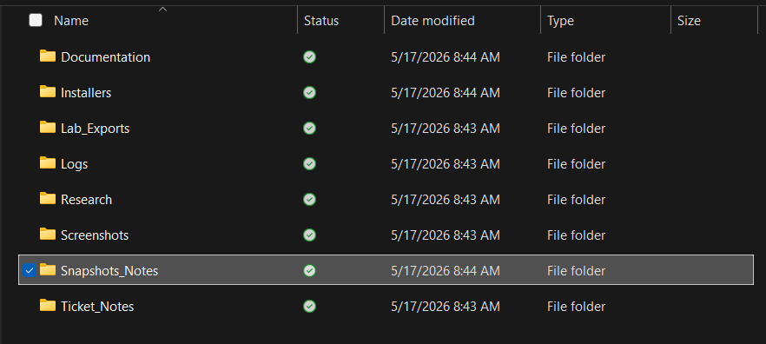

PHASE 1 - Download Required Software

PHASE 1 - Download Required Software

Download VirtualBox
- Open a browser on the host computer.
- Go to the official Oracle VirtualBox website.
- Click Downloads.
- Download the Windows hosts installer.
- Save it inside the Installers folder.
- Do not run it yet until the download fully completes.
SCREENSHOT REQUIRED: ESS_VM_01_VirtualBox_Installer_Downloaded

Download Windows ISO
- Open the official Microsoft Windows download page.
- Download the Windows 10 or Windows 11 ISO.
- Save the ISO inside the Installers folder.
- Rename the ISO file clearly if needed, but do not use spaces.
- Confirm the file finished downloading before moving forward.
SCREENSHOT REQUIRED: ESS_VM_02_Windows_ISO_Downloaded

Download Enterprise Support Tools
- Download 7-Zip.
- Download Notepad++.
- Download Google Chrome or Firefox installer if needed.
- Download Sysinternals Suite from Microsoft.
- Place every installer inside the Installers folder.
SCREENSHOT REQUIRED: ESS_VM_03_Support_Tools_Downloaded
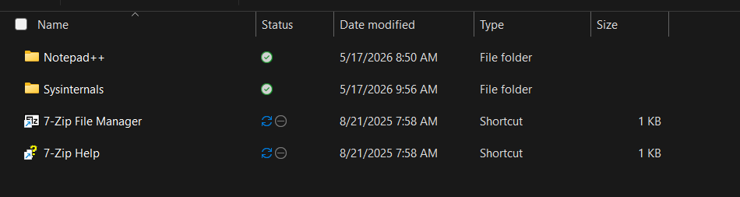

Research Prompting Questions
- Why should enterprise analysts download tools from official sources? To protect sensitive corporate networks from malware, avoid severe legal penalties regarding intellectual property, and maintain strict data compliance.
- Why is software integrity important before building a lab? It ensures the lab environment is secure, predictable, and produces accurate results. If the software is compromised before I begin, every test and configuration inside the lab becomes unreliable.
- Why does folder organization matter before screenshots and documentation begin? It ensures a logical workflow, prevents data loss, and makes my final guides easy for others to navigate.
PHASE 2 - Install VirtualBox

PHASE 2 - Install VirtualBox

Run VirtualBox Installer
- Open the Installers folder.
- Right-click the VirtualBox installer.
- Select Run as administrator.
- Click Next on the setup wizard.
- Keep default installation features selected.
- Click Next.
- Accept network adapter installation prompts.
- Click Install.
- Allow installation to finish.
- Click Finish.
SCREENSHOT REQUIRED: ESS_VM_04_VirtualBox_Installed
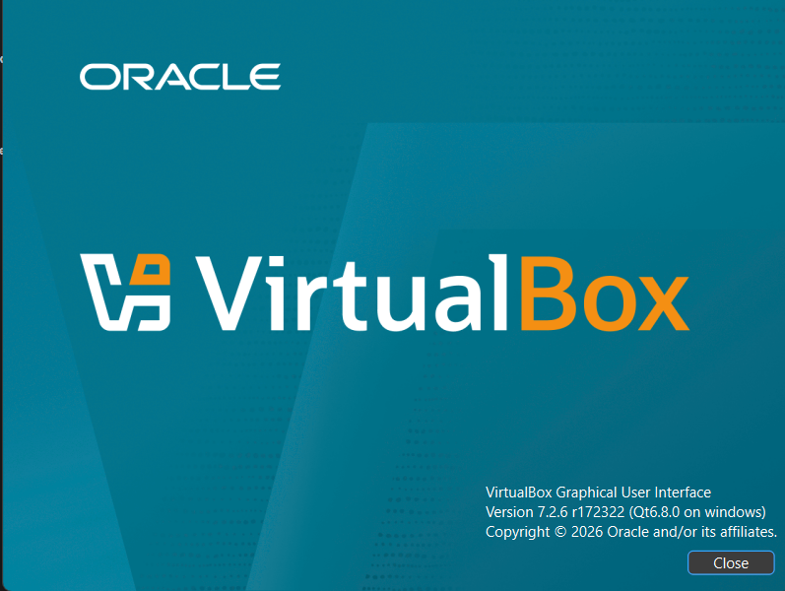

Verify VirtualBox Opens Correctly
- Open the Windows Start Menu.
- Search for Oracle VirtualBox.
- Open VirtualBox Manager.
- Verify the main manager window loads without errors.
SCREENSHOT REQUIRED: ESS_VM_05_VirtualBox_Manager_Opened
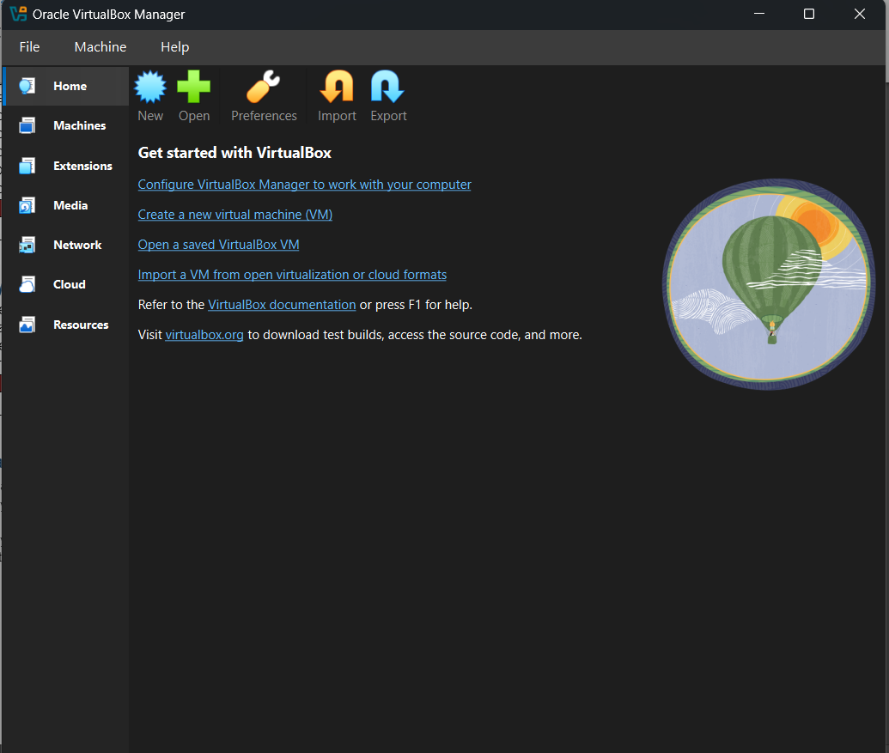

Research Prompting Questions
- What is a Type 2 hypervisor? Software that installs on top of an existing operating system.
- Why does VirtualBox install network drivers? To bridge the physical gap between my computer’s internet hardware and the virtual machines.
- Why should analysts verify the platform before creating VMs? It prevents installation failures, severe performance bottlenecks, and software incompatibility. Checking these upfront ensures the host hardware can safely isolate and support the guest operating systems.

PHASE 3 - Create Enterprise Support VM

PHASE 3 - Create Enterprise Support VM

Start New VM Wizard
- Open VirtualBox Manager.
- Click New.
- Name the VM Enterprise_Support_VM.
- Set Type to Microsoft Windows.
- Set Version to Windows 10 64-bit or Windows 11 64-bit depending on ISO.
- Click Next.
SCREENSHOT REQUIRED: ESS_VM_06_New_VM_Wizard
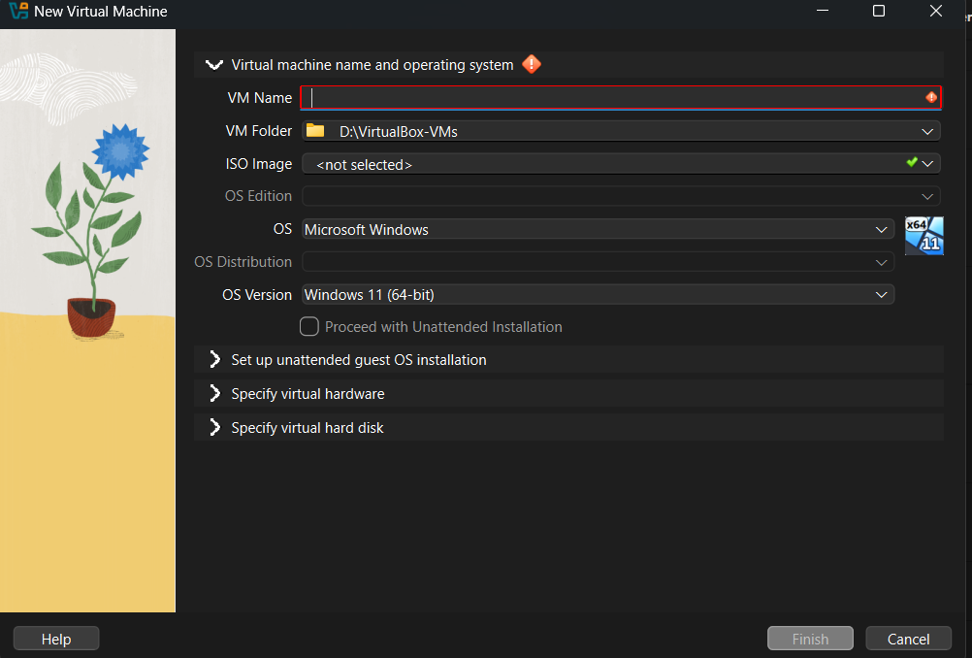

Assign Memory and CPU
- Assign 4096 MB RAM minimum.
- Assign 8192 MB RAM if the host has enough memory.
- Assign 2 processors minimum.
- Do not over-allocate CPU from the host machine.
- Click Next.
SCREENSHOT REQUIRED: ESS_VM_07_RAM_CPU_Configured
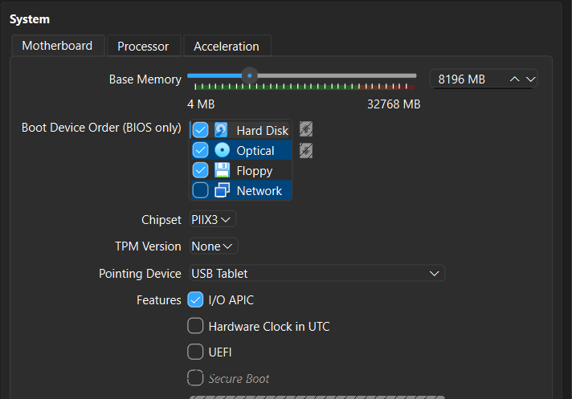

Create Virtual Hard Disk
- Select Create a virtual hard disk now.
- Select VDI.
- Choose Dynamically allocated.
- Set disk size to 80 GB minimum.
- Use 100 GB if storage allows.
- Click Finish.
SCREENSHOT REQUIRED: ESS_VM_08_Virtual_Disk_Created
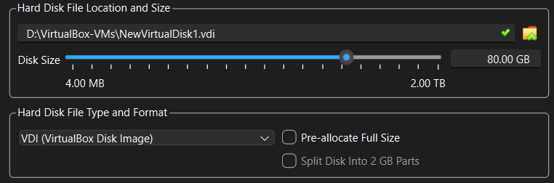

Research Prompting Questions
- Why is RAM allocation important? It dictates the stability, performance, and operational capacity of both my virtual machines and my physical host computer.
- What can happen if the VM is under-resourced? It will suffer from severe performance degradation, frequent application crashes, and may become completely unresponsive. It can artificially bottleneck the system leading to a disruption of my testing.
- Why are dynamically allocated disks useful for lab environments? They conserve your physical host’s storage space y only consuming disk capacity as files are added to the virtual machine. A dynamic disk grows with the demand of the system.

PHASE 4 - Configure VM Settings Before Installation

PHASE 4 - Configure VM Settings Before Installation

Configure System Settings
- Right-click Enterprise_Support_VM.
- Click Settings.
- Go to System.
- Confirm boot order places Optical before Hard Disk during install.
- Go to Processor.
- Confirm 2 CPUs are assigned.
- Click OK only after reviewing settings.
SCREENSHOT REQUIRED: ESS_VM_09_System_Settings
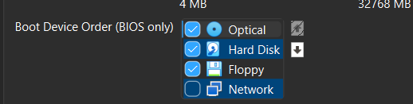

Configure Display
- Open VM Settings.
- Click Display.
- Increase Video Memory to the maximum allowed.
- Enable 3D Acceleration only if stable on your host.
- Click OK.
SCREENSHOT REQUIRED: ESS_VM_10_Display_Settings
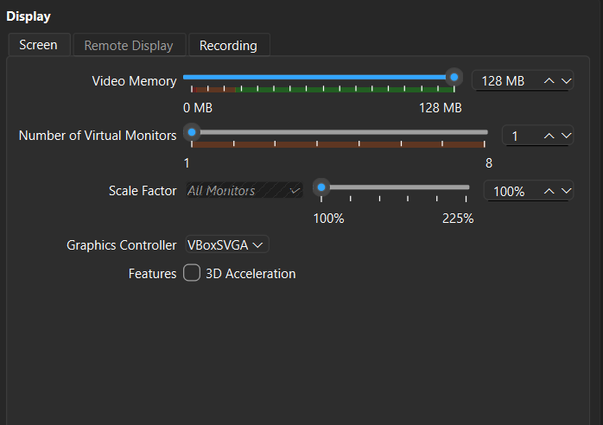

Configure Network Adapter
- Open VM Settings.
- Click Network.
- Ensure Adapter 1 is enabled.
- Set Attached to NAT for internet access.
- Document that Bridged Adapter can be used later for network testing.
- Click OK.
SCREENSHOT REQUIRED: ESS_VM_11_NAT_Network_Configured
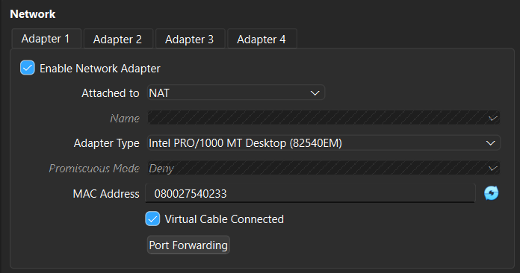

Enable Clipboard and Drag Drop
- Open VM Settings.
- Click General.
- Open Advanced tab.
- Set Shared Clipboard to Bidirectional.
- Set Drag and Drop to Bidirectional.
- Click OK.
SCREENSHOT REQUIRED: ESS_VM_12_Clipboard_DragDrop_Configured
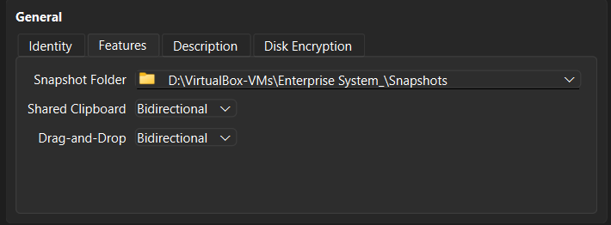

Research Prompting Questions
- What is NAT networking? A virtual networking mode that allows your virtual machine to connect to the internet by sharing my host computer’s IP address.
- When would Bridge networking be useful? When a virtual machine (VM) needs to act like an independent physical computer on my local machine.
- Why should clipboard settings be documented in support labs? To maintain data security boundaries, ensure test repeatability, ad streamline troubleshooting workflows.

PHASE 5 - Install Windows Inside The VM

PHASE 5 - Install Windows Inside The VM

Attach Windows ISO
- Select Enterprise_Support_VM.
- Click Start.
- When prompted for startup disk, select the Windows ISO.
- Click Start.
- Wait for Windows setup to load.
SCREENSHOT REQUIRED: ESS_VM_13_Windows_ISO_Attached
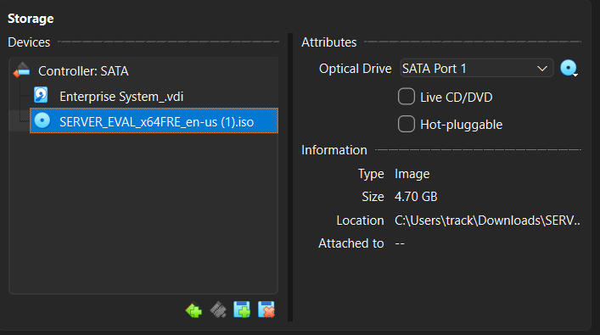

Perform Windows Installation
- Select language and keyboard options.
- Click Install Now.
- Choose I do not have a product key if prompted.
- Select Windows Pro edition if available.
- Accept license terms.
- Choose Custom Install.
- Select the virtual disk.
- Click Next.
- Allow installation to complete.
SCREENSHOT REQUIRED: ESS_VM_14_Windows_Installing
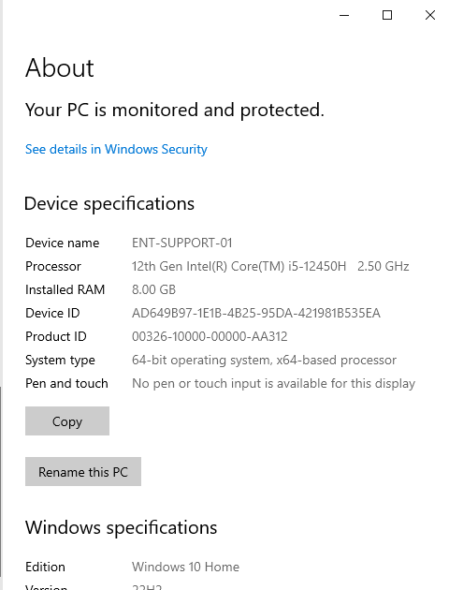

Create Local Analyst Account
- Create local account named SupportAnalyst.
- Create a strong password.
- Answer security questions if required.
- Complete privacy options using minimal necessary settings.
- Allow Windows to finish setup.
SCREENSHOT REQUIRED: ESS_VM_15_SupportAnalyst_Account_Created
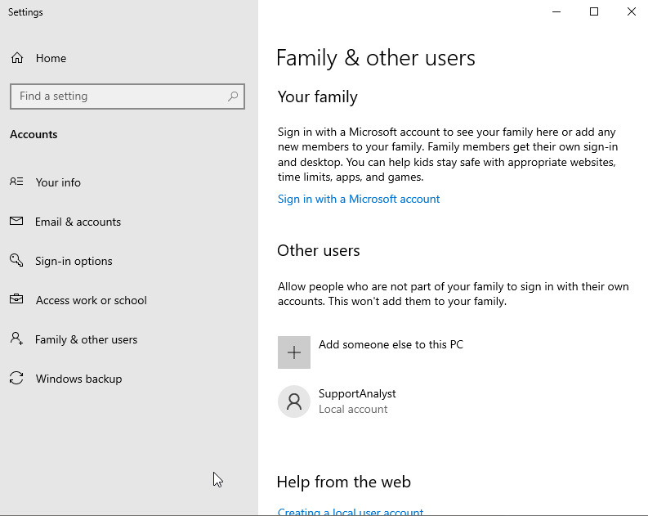

Research Prompting Questions
- Why use Windows Pro for enterprise labs? It unlocks critical virtualization capabilities, centralized management tools, and higher hardware limits.
- Why should local account names be consistent? To automate deployment scripts, simplify permission mapping, and ensure seamless log correlation.
- Why is least privilege important even in a lab? It prevents malicious code from escaping, isolates misconfigurations, and accurately mirrors real-world production environments.

PHASE 6 - Install Guest Additions and Stabilize VM

PHASE 6 - Install Guest Additions and Stabilize VM

Install Guest Additions
- Log into Windows VM as SupportAnalyst.
- In the VirtualBox menu, click Devices.
- Click Insert Guest Additions CD Image.
- Open File Explorer inside the VM.
- Open the mounted Guest Additions drive.
- Run VBoxWindowsAdditions.exe as administrator.
- Accept prompts.
- Reboot the VM.
SCREENSHOT REQUIRED: ESS_VM_16_Guest_Additions_Installed
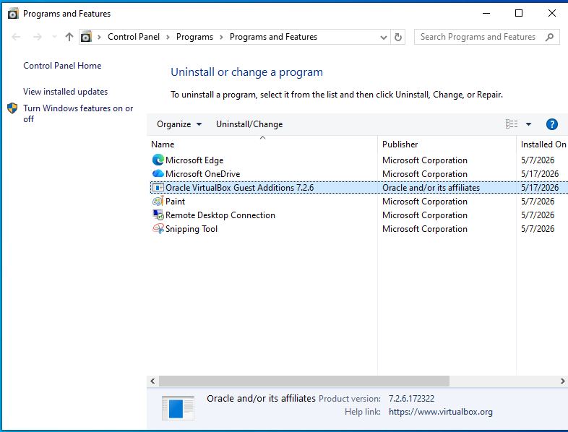

Verify Display and Clipboard
- After reboot, resize the VM window.
- Confirm screen resolution adjusts properly.
- Copy text from host to VM using Notepad.
- Copy text from VM back to host.
- Document whether clipboard works.
SCREENSHOT REQUIRED: ESS_VM_17_Guest_Additions_Validated
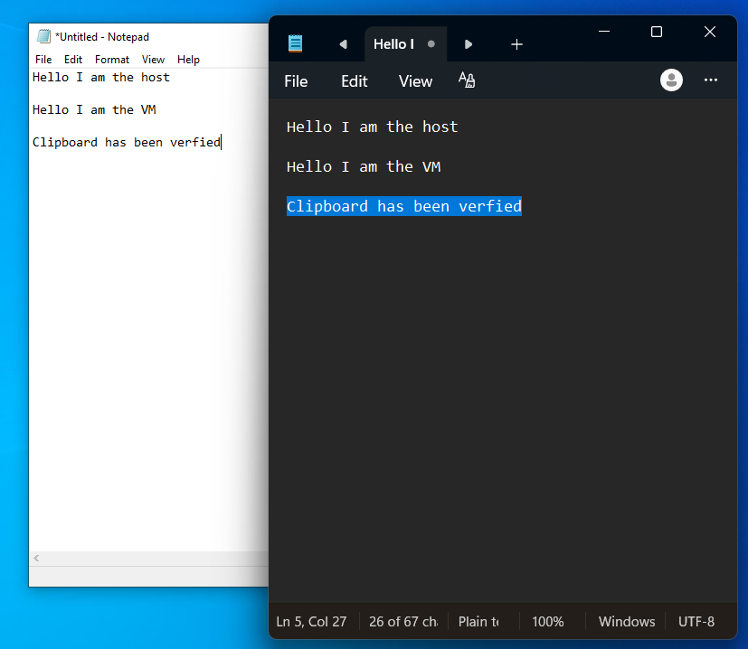

Research Prompting Questions
- Why are Guest Additions important? They install specialized device drivers and system applications inside the virtual machine to optimize its performance and integrate it seamlessly with my host computer.
- How does display scaling affect documentation? It alters the visual quality, layout, and size consistency of your captured screenshots.
- Why is clipboard functionality useful during support labs? It acts as a direct data bridge between the host environment and the virtual machine, maximizing analyst efficiency and reducing human error.

PHASE 7 - Configure Enterprise Workstation Identity

PHASE 7 - Configure Enterprise Workstation Identity

Rename Computer
- Open Settings.
- Click System.
- Click About.
- Click Rename this PC.
- Rename the computer ENT-SUPPORT-01.
- Restart when prompted.
SCREENSHOT REQUIRED: ESS_VM_18_Computer_Renamed
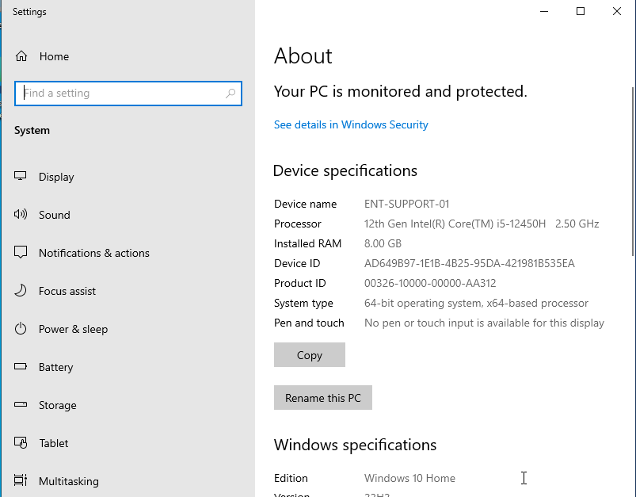

Create Restore Point
- Search Create a restore point.
- Open System Properties.
- Select the system drive.
- Click Configure.
- Turn on system protection.
- Allocate disk space.
- Click Create.
- Name restore point Clean_Enterprise_Base.
SCREENSHOT REQUIRED: ESS_VM_19_Restore_Point_Created
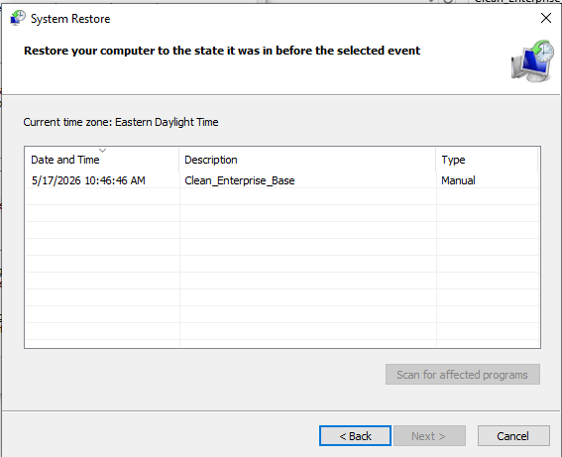

Create VirtualBox Snapshot
- Shut down the VM cleanly.
- In VirtualBox Manager, select the VM.
- Click Snapshots.
- Click Take.
- Name the snapshot Clean_Enterprise_Base.
- Add a note explaining this is the rollback point before labs.
SCREENSHOT REQUIRED: ESS_VM_20_VirtualBox_Snapshot_Created
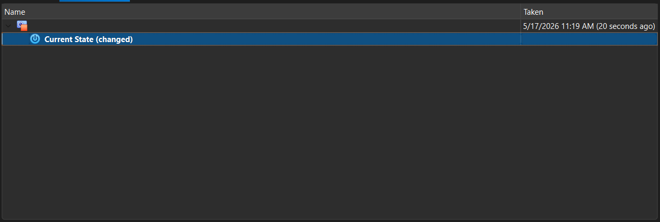

Research Prompting Questions
- Why is computer naming important? It serves as the foundation for network identification, security tracking, and automated infrastructure management.
- Why are restore points and snapshots different? They operate entirely different layers of my computer and capture completely different scopes of data.
- Why should analysts create rollback options before changes? To guarantee business continuity, isolate testing variables, and mitigate the risks of catastrophic data loss. Having a verified fallback plan ensures that unexpected errors or security incidents can be instantly reversed without paralyzing operations.

PHASE 8 - Update Windows and Install Support Toolkit

PHASE 8 - Update Windows and Install Support Toolkit

Run Windows Update
- Open Settings.
- Click Windows Update.
- Click Check for updates.
- Install all available updates.
- Reboot when required.
- Repeat until no major updates remain.
SCREENSHOT REQUIRED: ESS_VM_21_Windows_Updated
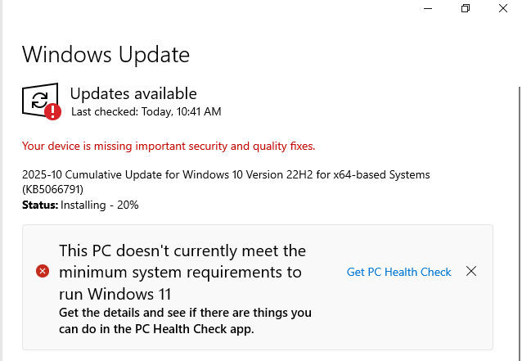

Create Support Tools Folder
- Open File Explorer.
- Open Local Disk C:.
- Create folder named SupportTools.
- Create subfolders: Sysinternals, Installers, Logs, TicketNotes.
SCREENSHOT REQUIRED: ESS_VM_22_SupportTools_Folder_Created
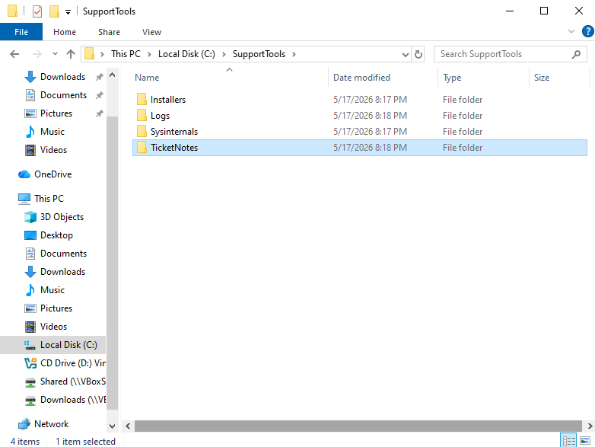

Install Tools Inside VM
- Install 7-Zip.
- Install Notepad++.
- Install Chrome or Firefox.
- Extract Sysinternals Suite into C:\SupportTools\Sysinternals.
- Open the folder and verify tools are present.
SCREENSHOT REQUIRED: ESS_VM_23_Tools_Installed
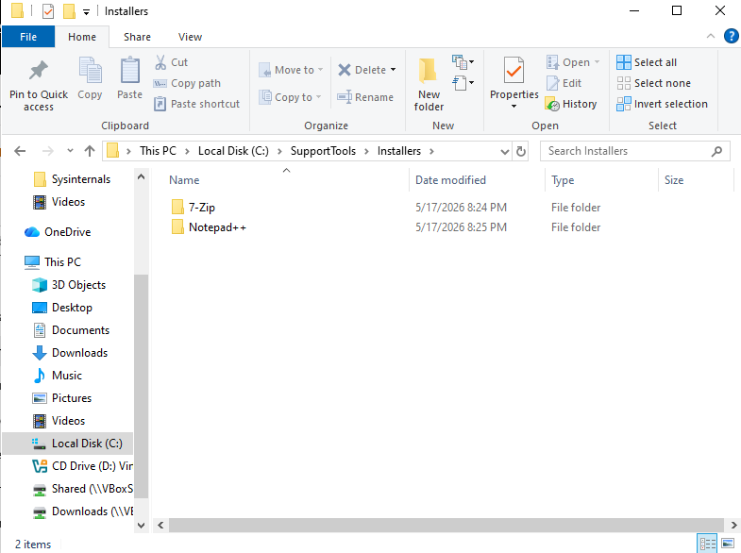

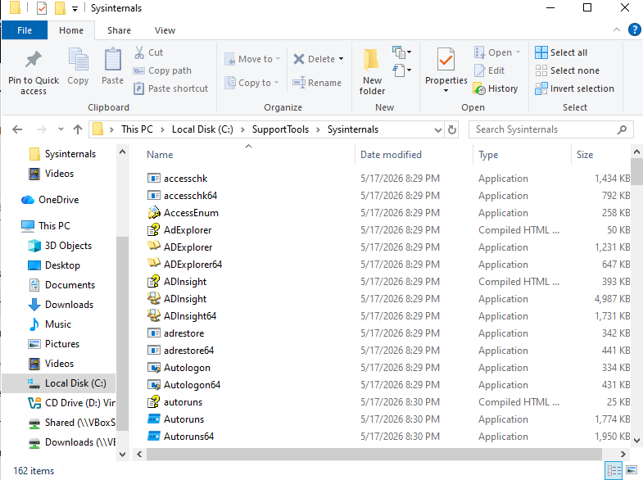

Research Prompting Questions
- Why are updates important before running labs? It ensures my environment is stable, secure and compatible with modern tools. It will also prevent flawed lab results, and also shield my host network, and avoid disruptions during critical testing.
- Why do enterprise teams standardize toolkits? To boost productivity, ensure regulatory compliance, and drastically lower operation costs.
- Why should analysts verify tools after installation? To ensure data accuracy, confirm security compliance, and guarantee system stability before starting active investigations. If I was to skip this step I would make my system susceptible to corrupted evidence missed security threats, or any sudden tool failures during critical operations.

PHASE 9 - Create Lab Users and Documentation Templates

PHASE 9 - Create Lab Users and Documentation Templates

Create OperationsEmployee User
- Right-click Start.
- Open Computer Management.
- Expand Local Users and Groups.
- Click Users.
- Right-click in the pane and select New User.
- Create user OperationsEmployee.
- Set a password.
- Uncheck User must change password at next logon.
- Check Password never expires for lab consistency.
- Click Create.
SCREENSHOT REQUIRED: ESS_VM_24_OperationsEmployee_Created
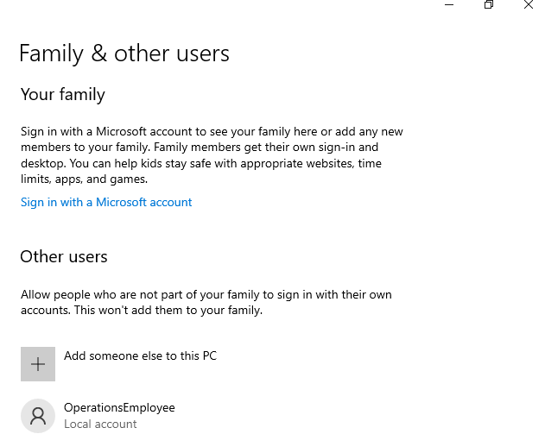

Create RemoteEmployee01 User
- In Local Users and Groups, click Users.
- Create user RemoteEmployee01.
- Set a password.
- Configure password settings for lab consistency.
- Click Create.
SCREENSHOT REQUIRED: ESS_VM_25_RemoteEmployee01_Created
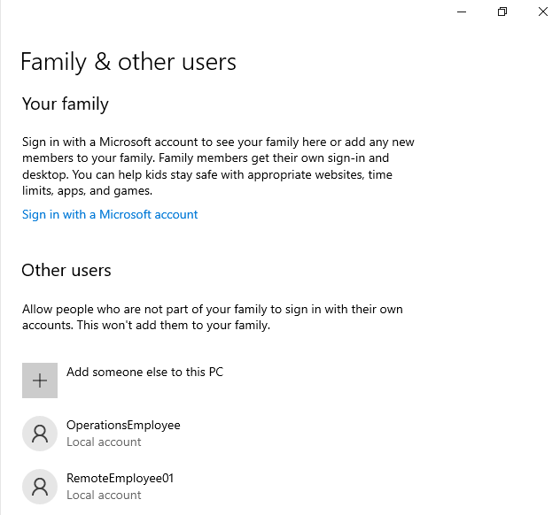

Create Ticket Template
- Open Notepad++.
- Create a ticket template with fields for Ticket Number, Date/Time, User, System, Symptoms, Business Impact, Troubleshooting, Root Cause, Resolution, Escalation, Validation, Analyst Notes.
- Save inside C:\SupportTools\TicketNotes as ESS_Ticket_Template.txt.
SCREENSHOT REQUIRED: ESS_VM_26_Ticket_Template_Created
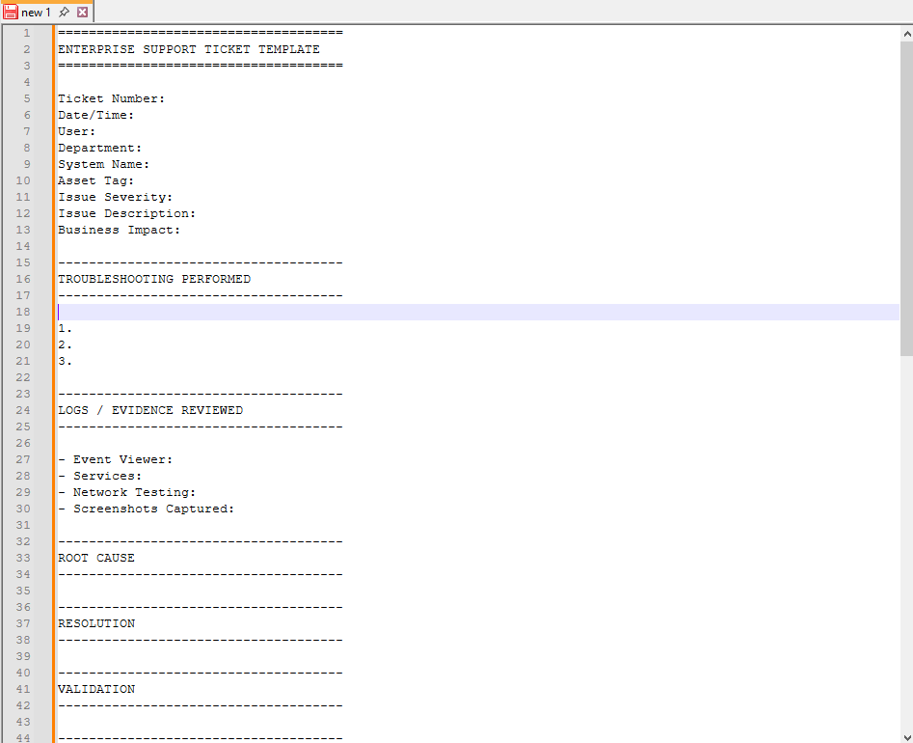

Research Prompting Questions
- Why should lab users be separated from the admin account? To enforce security boundaries, prevent accidental system damage, and ensure accurate tracking of user activities.
- Why do support teams use ticket templates? To ensure data consistency, speed up response times, and reduce agent burnout.
- Why is business impact part by technical documentation? To align engineering decisions with corporate strategy, justify project funding, and accelerate incident response.

PHASE 10 - Final VM Validation Before Labs

PHASE 10 - Final VM Validation Before Labs

Validate Core Utilities
- Open Event Viewer using eventvwr.msc.
- Open Services using services.msc.
- Open Device Manager using devmgmt.msc.
- Open Task Manager.
- Open Command Prompt as Administrator.
- Confirm all tools launch successfully.
SCREENSHOT REQUIRED: ESS_VM_27_Core_Utilities_Validated
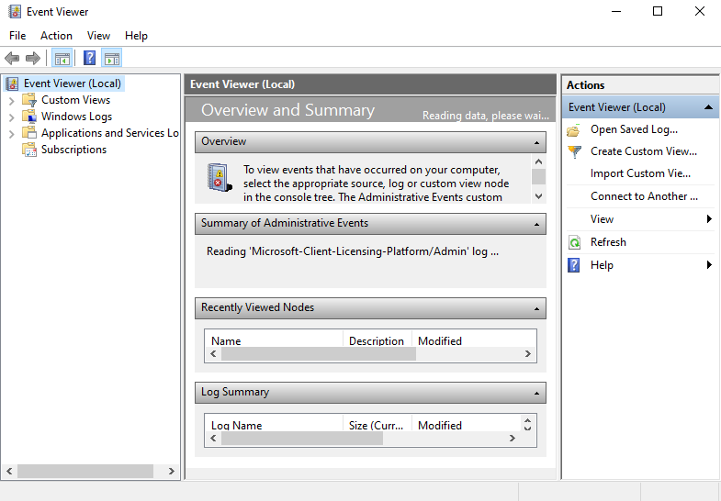

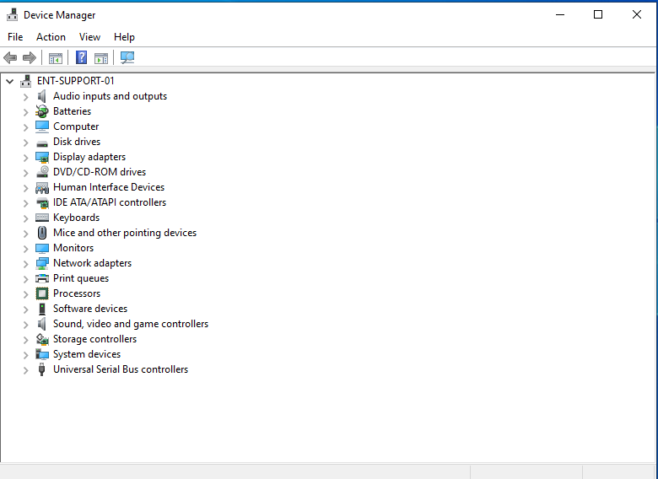
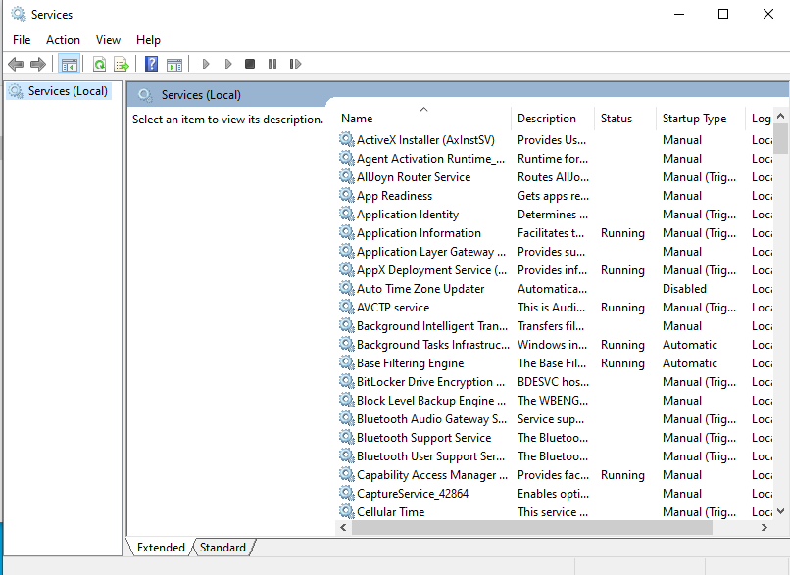

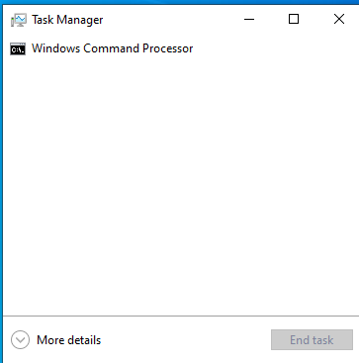

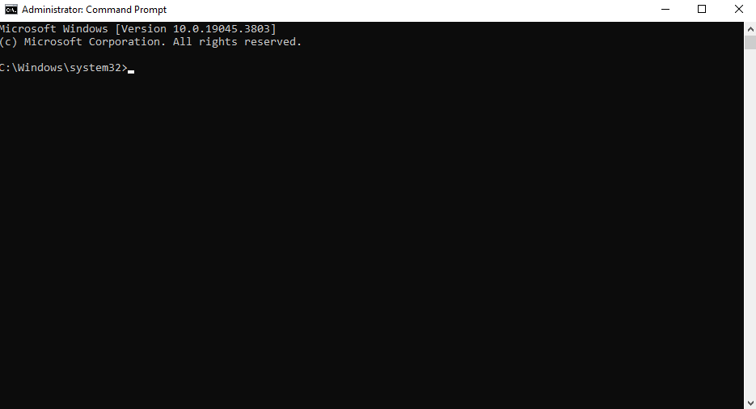

Validate Network Connectivity
- Open Command Prompt.
- Run ipconfig /all.
- Run ping 127.0.0.1.
- Run ping 8.8.8.8.
- Run nslookup google.com.
- Confirm network and DNS are functional.
SCREENSHOT REQUIRED: ESS_VM_28_Network_Validated
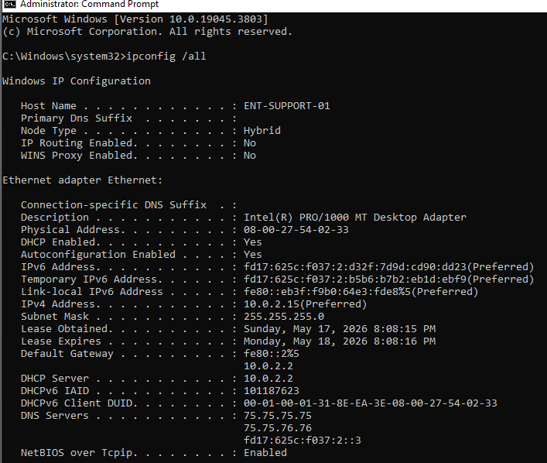

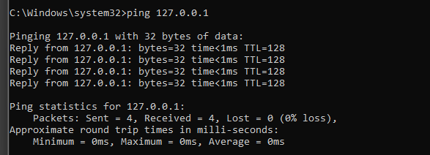

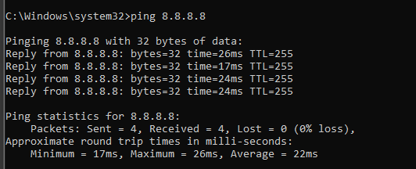

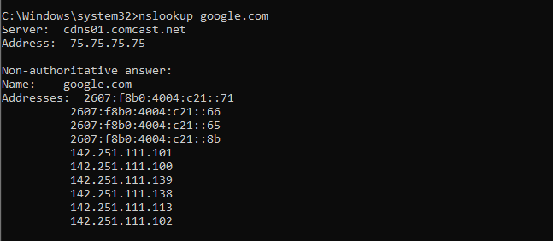

Create Final Ready Snapshot
- Shut down VM cleanly.
- Open VirtualBox Snapshots.
- Create snapshot named Enterprise_Labs_Ready.
- Add note: Ready for Labs 03-08.
SCREENSHOT REQUIRED: ESS_VM_29_Final_Ready_Snapshot
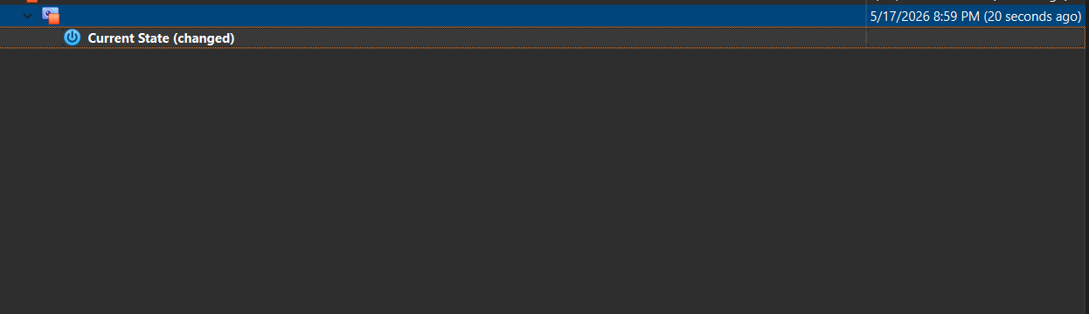

Research Prompting Questions
- Why validate the VM before beginning incident simulations? To ensure the attack scenarios execute realistically, data logs capture accurately, and the underlying host remains completely secure. If I didn’t validate the environment this could lead to broken simulation scripts, corrupt telemetry, or unintended network exposure.
- Why should analysts test tools before an outage? Because it guarantees immediate readiness, bypasses technical during a crisis, and ensure data accessibility when primary networks fail.
- Why is a final ready-state snapshot important? It will establish a fully configured baseline that will allow me to instantly recover from failures, run repeatable tests, and eliminate the time-consuming process of rebuilding a system from scratch. Essentially it will act as a safety net and starting point.

FINAL BUILDOUT CHECKLIST

Before Starting LABS 03-08, Verify Everything Below
✓ VirtualBox installed and functioning
✓ Windows VM created
✓ Windows installed successfully
✓ Guest Additions installed
✓ VM renamed ENT-SUPPORT-01
✓ Restore point created
✓ Clean base snapshot created
✓ Windows fully updated
✓ SupportTools folder created
✓ Sysinternals extracted
✓ Notepad++ installed
✓ 7-Zip installed
✓ Browser installed
✓ OperationsEmployee account created
✓ RemoteEmployee01 account created
✓ Ticket template created
✓ Event Viewer tested
✓ Services console tested
✓ Task Manager tested
✓ Network connectivity validated
✓ Final Enterprise_Labs_Ready snapshot created

Buildout Reflection Prompt
- What part of the VM buildout required the most attention? The most attention for me was the organization of the varying folders and ensuring the appropriate information was being captured to ensure I was building a solid foundation for future work.
- What configuration mistake would cause the biggest issue later in the labs? Not allocating enough RAM for operations.
- How did snapshots change the safety of the lab environment? It gave me a restore point for the VM setup thus if I had suddenly stopped or I accidentally something that I shouldn’t I can use these snapshots to roll back the configuration.
- Why is this buildout more than just installing Windows? It is more than just installing windows because it is setting up the appropriate systems in order to operate somewhat seamlessly in a secure manner.
- How does this environment support enterprise troubleshooting practice? The biggest way in which it will support is through the development of the troubleshooting ticket template that was created for efficient and consistent documentation.
- What would you improve before using this lab environment in a real team training setting? Instead of installing Windows Home I would have installed Windows Pro.
Portfolio Placement Note
Use this workbook as the environment setup artifact for the Enterprise Systems Support ePortfolio page. The screen prints prove that the lab environment was built cleanly before operational troubleshooting began.
ePortfolio Evidence Upload Checklist
- Upload the completed VM buildout workbook as the environment setup artifact.
- Upload screenshots using the exact ESS_VM numbering shown in this workbook.
- Keep screenshots in chronological order so the buildout story is easy to follow.
- Add a short written note explaining that this VM is the baseline environment for Labs 03-08.
- Mention that the snapshots prove rollback discipline before troubleshooting simulations begin.
- Link this buildout page to the Enterprise Systems Support lab series page.
Final Portfolio Statement
This buildout proves that the enterprise troubleshooting labs were not performed randomly. The environment was prepared, validated, documented, and snapshotted before incident simulations began. That is the operational habit expected in real support environments.

