Network Security Hardening Lab Rebuild Guide
Cisco Packet Tracer • VLAN Security • Access Control • Network Hardening
1. What this lab is teaching you
- How to reduce network exposure using VLAN segmentation
- How to restrict communication using access control concepts
- How to prevent unauthorized access to switch ports
- How misconfigurations can lead to security risks
2. Scenario
An organization has segmented its network into VLANs, but there are concerns about unauthorized access and unnecessary communication between systems. Your task is to harden the network by restricting access and improving security controls.
3. Lab Objectives
- Secure unused switch ports
- Implement port security concepts
- Restrict VLAN communication
- Understand how segmentation reduces risk
4. Topology Overview
- 1 Switch
- 4 PCs
- 2 VLANs (20 and 30)
5. Build the topology
- Open Packet Tracer
- Add 1 switch and 4 PCs
- Connect PCs to switch (Fa0/1–Fa0/4)
- Assign VLAN 20 to Fa0/1 & Fa0/2
- Assign VLAN 30 to Fa0/3 & Fa0/4
6. Configure VLANs (Configured via the Switch)
- enable
- conf t
- vlan 20 and vlan 30 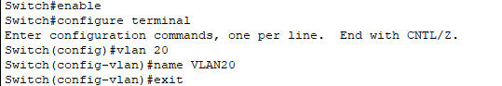

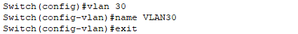
7. Assign ports to VLANs
- interface f0/1 → VLAN 20 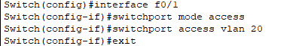
- interface f0/2 → VLAN 20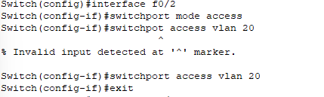
- interface f0/3 → VLAN 30
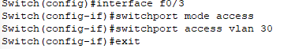
- interface f0/4 → VLAN 30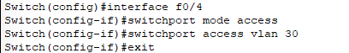

Show VLAN Brief
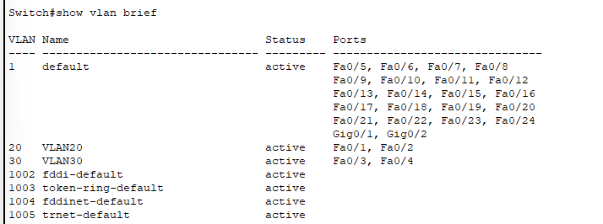

Show running-config

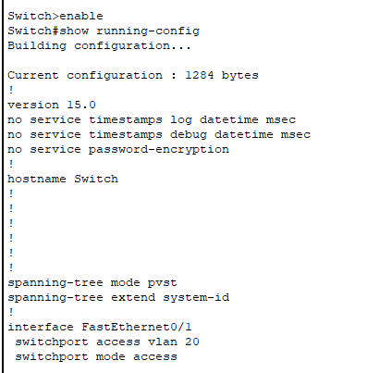
8. Secure unused ports
- Identify unused ports (Fa0/5–Fa0/21)
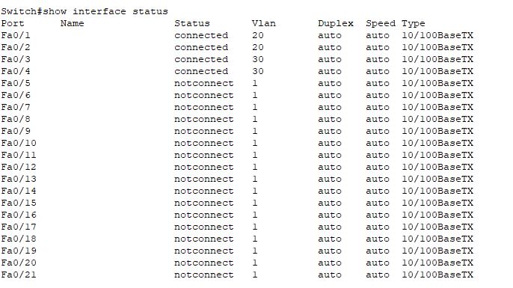
- interface range f0/5-21
- shutdown
9. Enable basic port security (conceptual)
- interface f0/1
- switchport mode access
- switchport port-security
- switchport port-security maximum 1
10. VLAN Verification and Testing Behavior Post Port Security Setup

Prior to Port Security just overall pinging to check connection
Ping between VLAN 20 devices → should work
- BB(172.16.0.1) – RB4 (172.16.0.1): 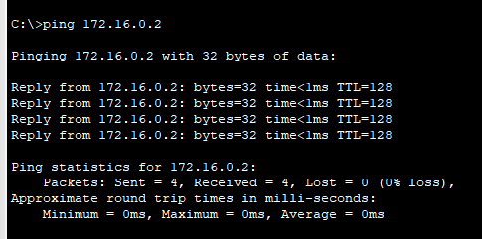
- RB4 – BB: 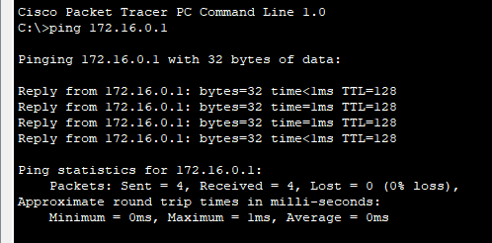
- Ping between VLAN 30 devices → should work
- NJB (172.16.0.3) – ICB (172.16.0.4)
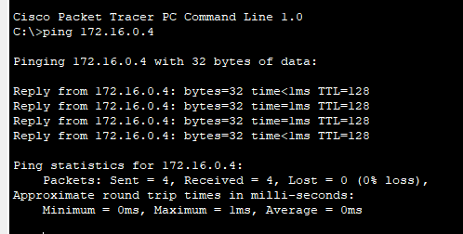

- ICB-NJB: 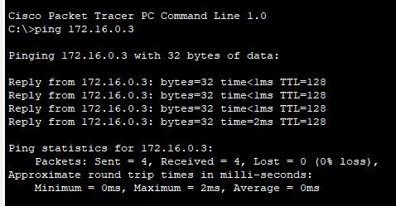
- Ping between VLAN 20 and VLAN 30 → should fail
- BB-NJB: 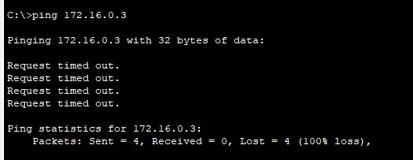
- BB-ICB: 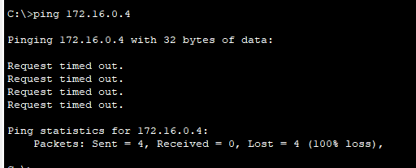

- RB4-NJB: 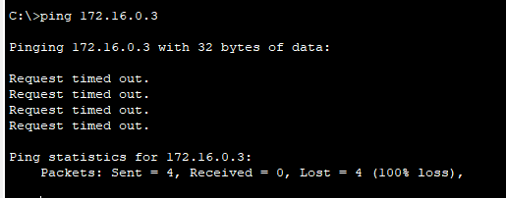

After Port security has been Establish

Command: 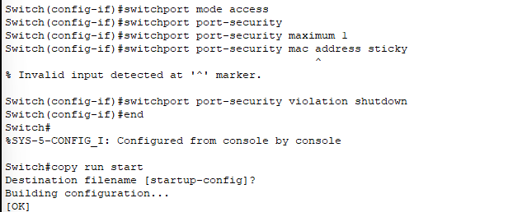

F0/1:
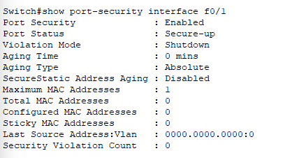

F0/2:
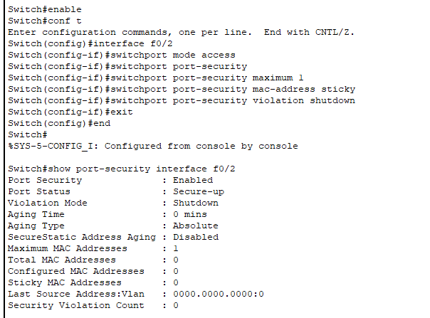

F0/3:
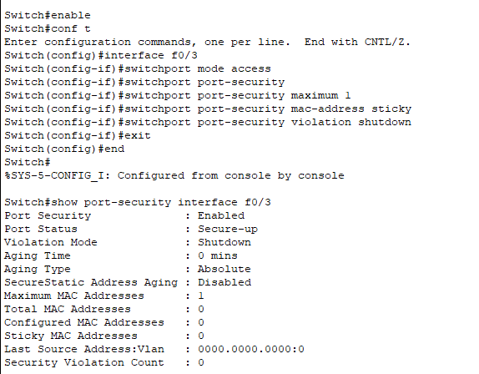

F0/4:
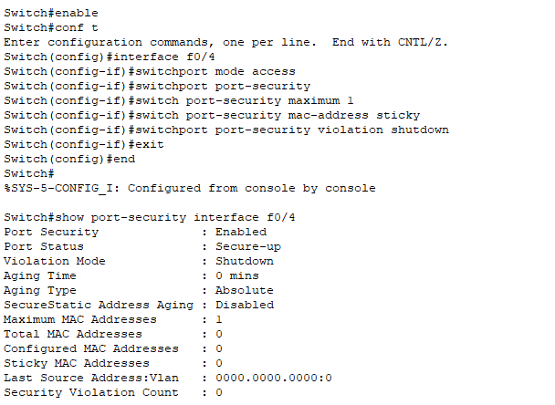

Showing running-config
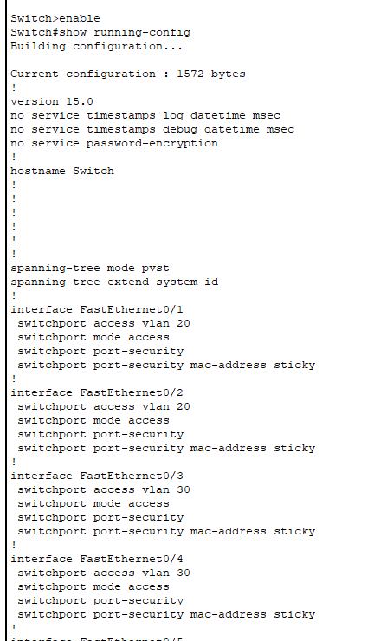

Due to uniform configuration across all interfaces, a single test case was sufficient to validate enforcement behavior across the entire switch.

11. Screenshot Checklist
- VLAN configuration
- Port assignments
- Port shutdown (unused ports)
- Ping success within VLAN
- Ping failure between VLANs
12. Key Understanding
- Segmentation reduces attack surface
- Unused ports are security risks
- Port security limits unauthorized devices
- Network hardening is proactive defense
13. Research Questions
- Why are unused ports dangerous? Because there become entry points for attackers to get through without being detected. Once that access is gained they then are able to launch malware and steal data.
- What is port security and how is it used? Port security will restrict access to a port by way of limiting the number of MAC addresses or identifying specific MAC addresses that allowed to connect to it. It will drop the traffic or shut down the port altogether.
- How does segmentation prevent lateral movement? It divides the network into smaller, isolated security zones. This will restrict the traffic between creating an authorized path of travel meaning that one would have to have security permission to enable traffic to past to the respective zone at which they are looking to communicate.
- What additional controls could be added to improve security? Additional controls include Port blockers (e.g. Kensington USB Port blockers), restrictions setting in BIOS/UEFI settings to disable ports, EDRs to whitelist USB, port covers, and locking enclosures. Group policy constraints could also be used in order to enhance security. For the sake of the network, one could use IEEE 802.1X authentication which requires all devices to authenticate before gain network access. Real time monitoring such as IDS and IPS can be used as well. Lastly, a policy can be implored to use the command Win+L to lock their workstations when they are not there.

Notes
- Sticky MAC allows a switch to dynamically learn a device’s MAC address on a specific interface and bind it to that port within the running configuration. Once learned, the MAC address can be saved to the startup configuration, making the association persistent across reboots. This enhances security by ensuring that only the authorized device connected to that port is allowed to communicate. If an unknown device attempts to use the same port, the switch will enforce the configured port-security violation action (such as shutdown), effectively preventing unauthorized network access. When dealing with sticky Mac it is important to denote that it will only be learned when the switch sees traffic from a device on that port. Rule = No traffic = no MAC = 0

- For this lab, I intentionally approached the configuration as if I were operating in a real production environment. Instead of relying solely on pre-built instructions, I researched the required commands using sources such as Cisco’s official community forums and technical documentation. My goal was not only to execute the configuration, but to fully understand what each command does and why it is used. This approach allowed me to connect hands-on implementation with conceptual understanding through targeted research questions.

- This control simulates a real-world access layer security measure used to prevent rogue device connections and enforce endpoint trust at the network edge.

Troubleshooting & Validation Section

Issue Identified: Sticky MAC addresses were not being learned on secured interfaces.

Initial Observation: The MAC address table was empty and sticky MAC count remained at 0.
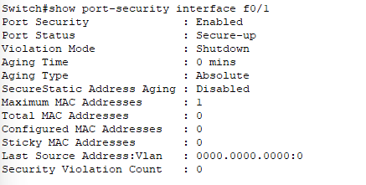
Analysis: Port security requires active traffic to dynamically learn MAC addresses. Although interfaces were configured and connected, no traffic had been generated.

Showing interface status to ensure the Port was active:
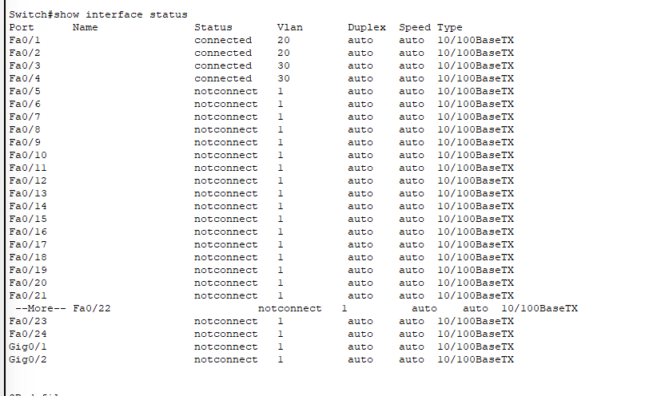

Checking to see if any traffic had occurred
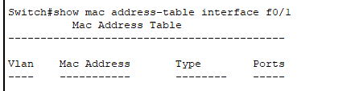
Resolution: Traffic was generated from each workstation using ICMP ping commands, allowing the switch to learn MAC addresses.
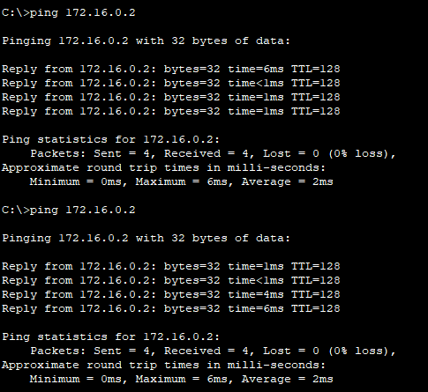

Traffic was generated from all connected workstations to trigger MAC address learning on each secured interface. For brevity, only a single representative ping is shown. Validation of traffic across all interfaces is confirmed through the populated MAC address table and sticky MAC bindings.

Validation:
- MAC addresses appeared in the MAC address table
- Entries were listed as STATIC due to sticky MAC configuration
- Sticky MAC count increased to 1 on all secured ports

Verification of Traffic via the MAC address table:
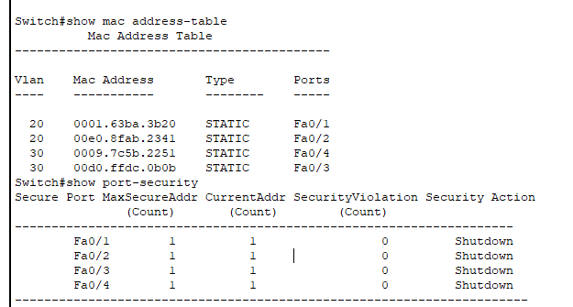

Verification that the MAC Stick addresses was active
