**QUANTITATIVE ANALYSIS OF CANDIDATES IN THE 2019 LOK SABHA ELECTION**

**INTRODUCTION**

The 2019 Lok Sabha election in India was a pivotal event in the country's democratic history. It was the world's largest democratic election, involving over 900 million eligible voters and more than 2,000 political parties and independent candidates. This introduction provides a brief overview of the quantitative analysis of candidates in the 2019 Lok Sabha elec

* 1. **OVERVIEW**

The 2019 Lok Sabha election in India was a significant political event, and quantitative analysis of candidates and their performance can provide valuable insights into the election's dynamics. Here's an overview of the quantitative analysis of candidates in the 2019 Lok Sabha election:

* 1. **PURPOSE**

The purpose of a quantitative analysis of candidates in the 2019 Lok Sabha election in India would typically involve the use of statistical and numerical methods to assess various aspects of the election. Here are some key objectives and areas of analysis that such a study might cover:

PROBLEM STATEMENT

Analyzing the results of the 2019 Lok Sabha election in India can be a complex task, as it involves a vast amount of data and numerous factors. Here's a problem statement related to the quantitative analysis of candidates in the 2019 Lok Sabha election:

**Problem Statement:**

You are tasked with conducting a comprehensive quantitative analysis of the candidates who participated in the 2019 Lok Sabha election in India. The analysis should aim to provide insights into the candidates' performance, demographics, party affiliations, and other relevant factors.

**2.1 EMPATHY MAP:**

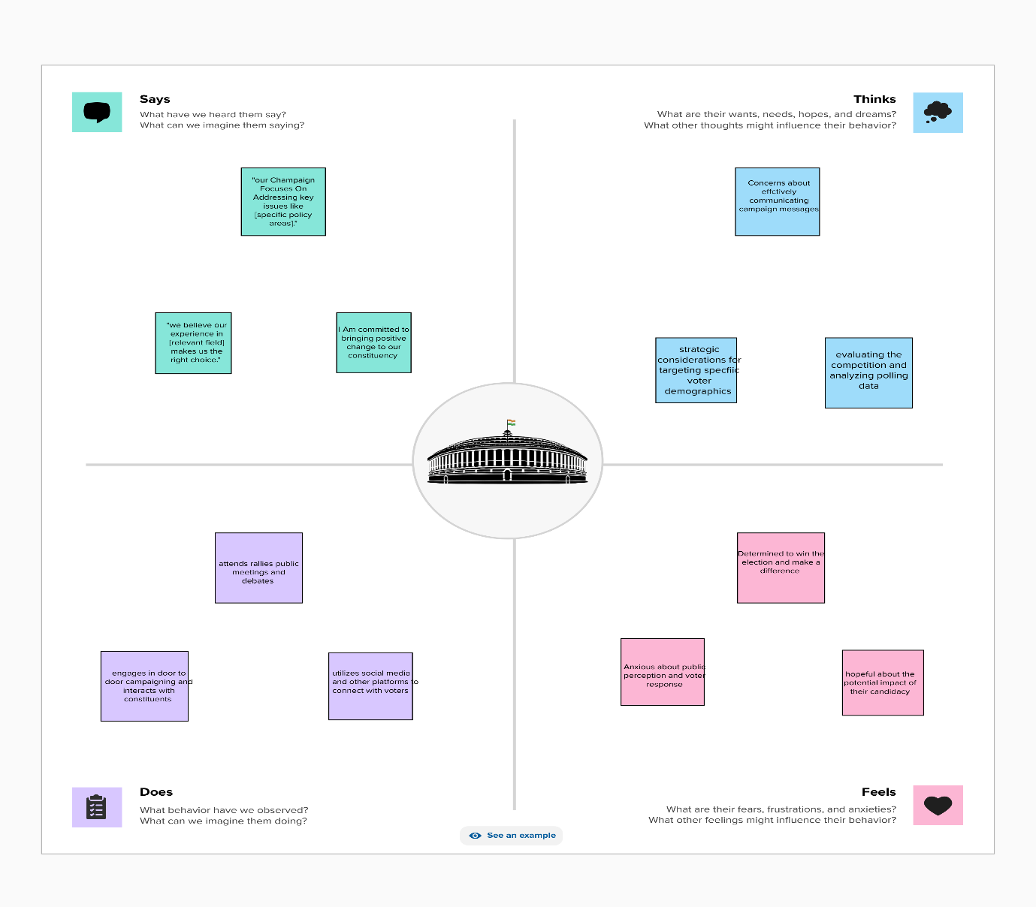

**2.2 IDEATION AND BRAINSTOMING MAP:**

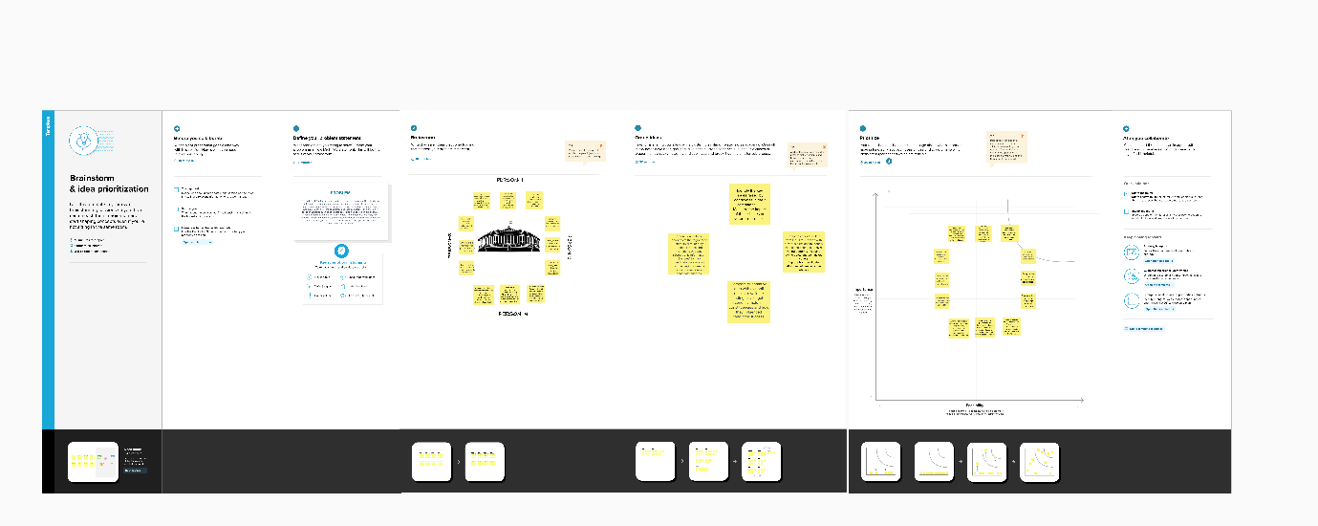

**3. RESULT:**



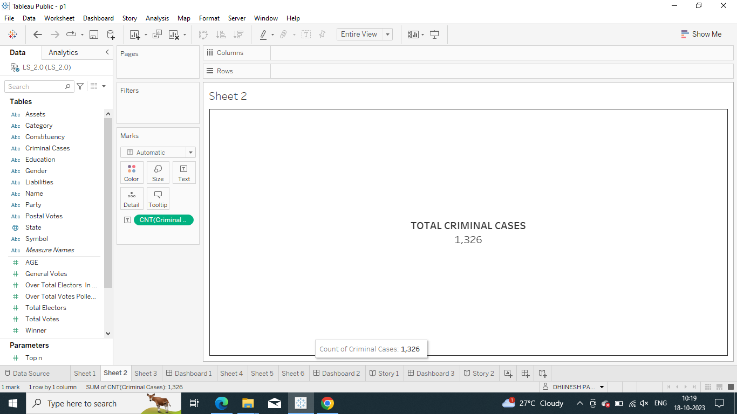



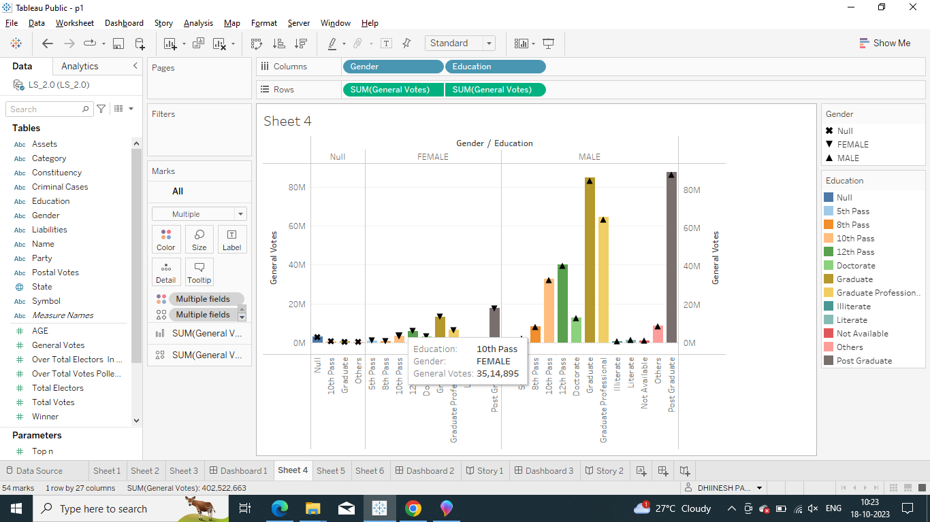

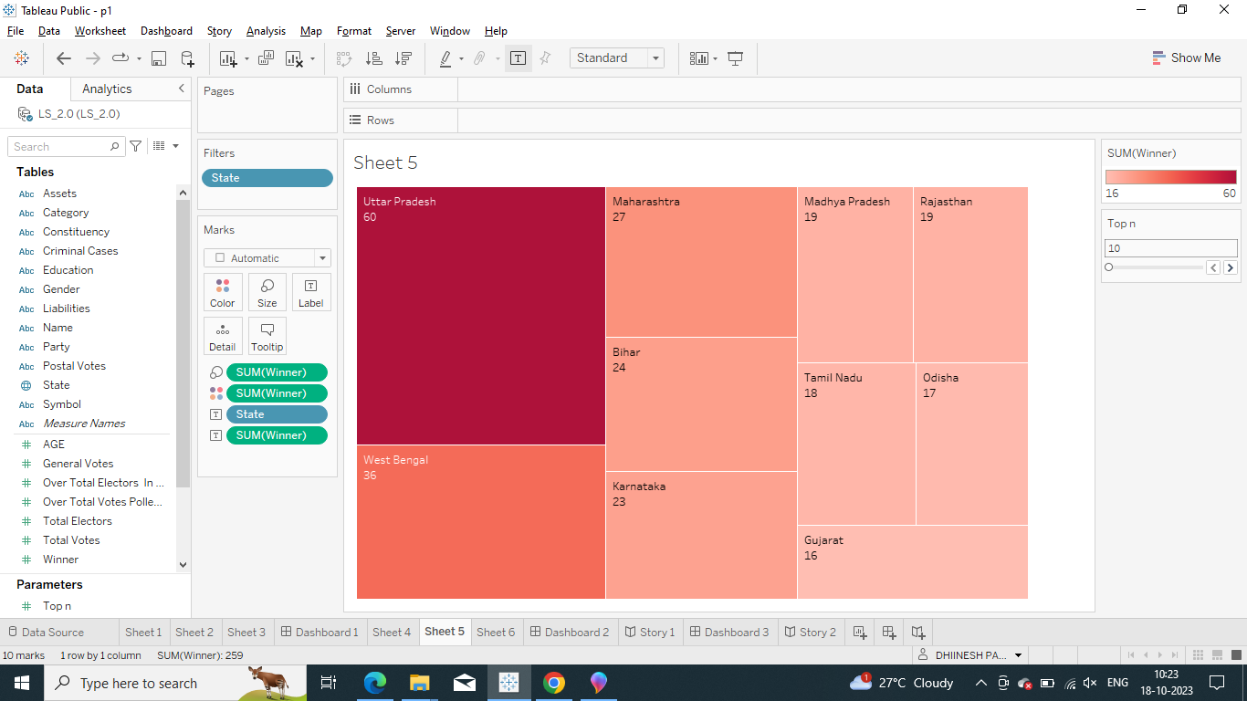

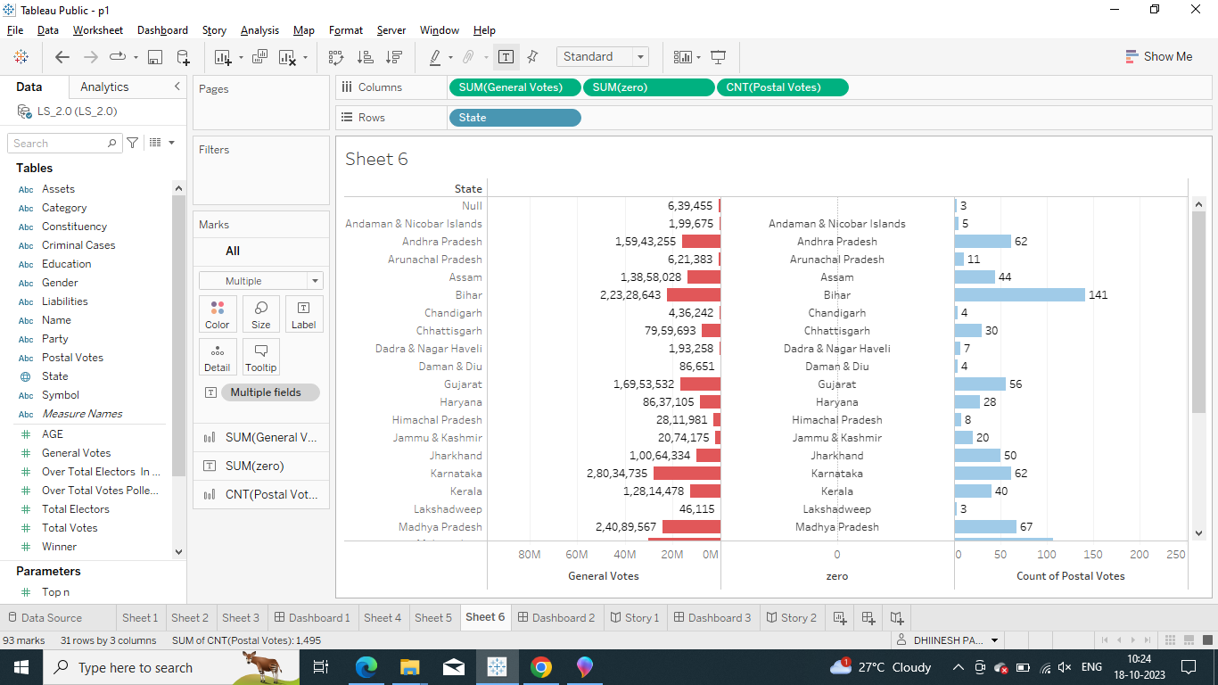

**DASHBOARD:**

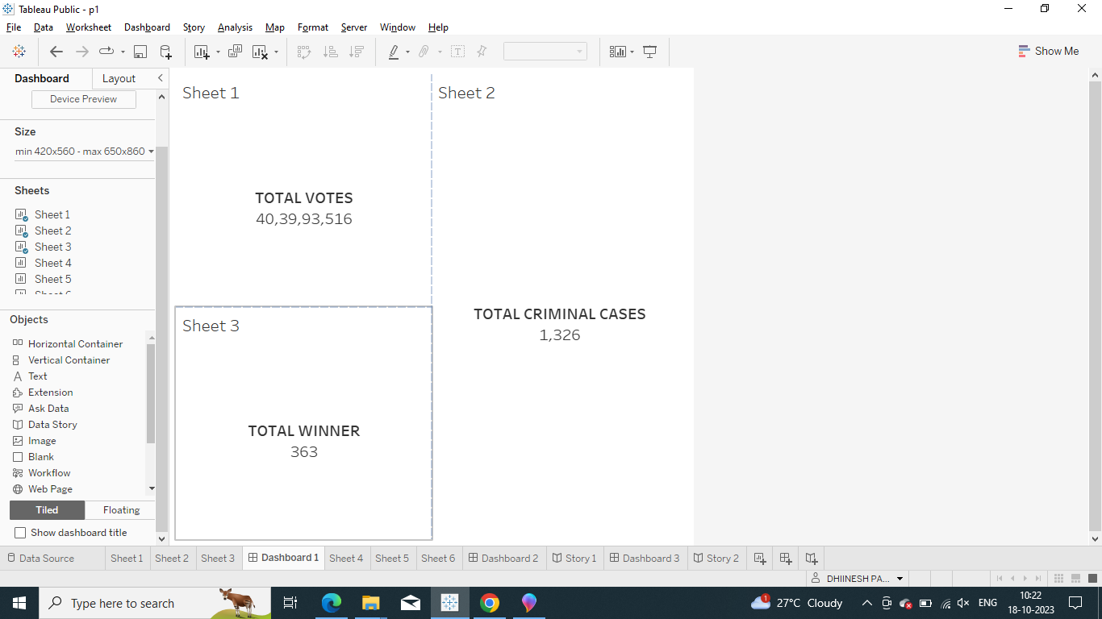

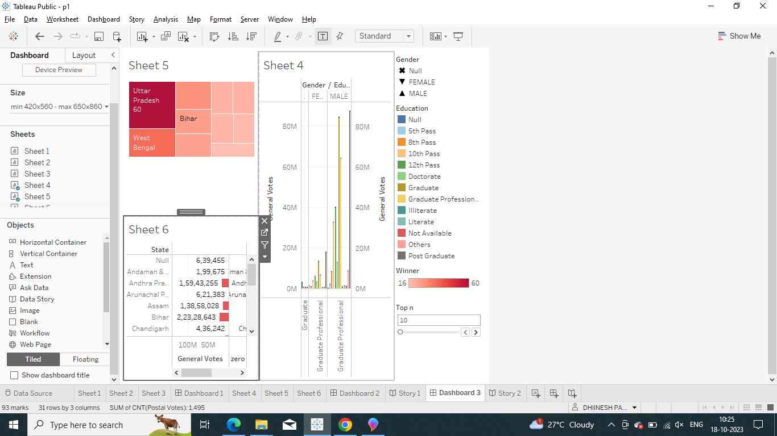

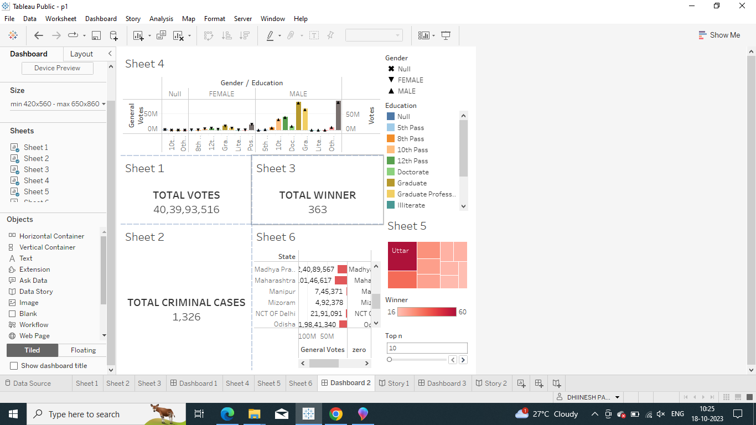

**STORY:**

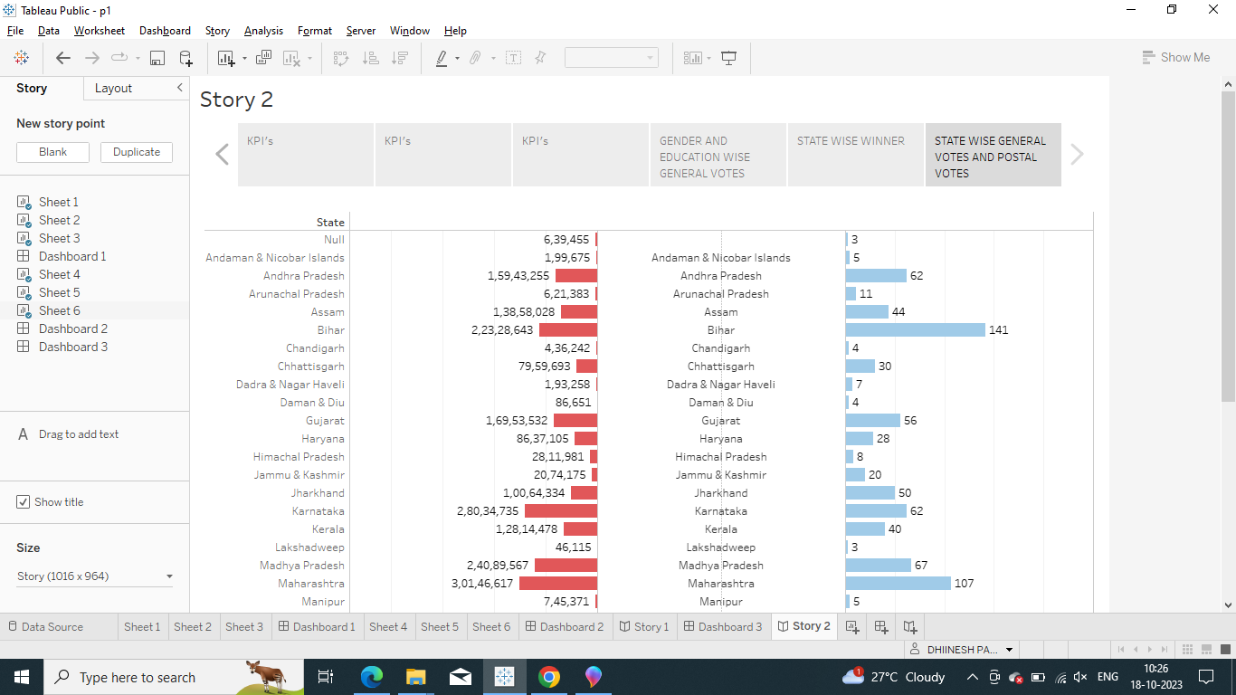

**Advantages:**

1. **Data-Driven Insights:** Quantitative analysis relies on data, which allows for objective and data-driven insights into the election. This can help in uncovering trends, patterns, and correlations that might not be immediately apparent through qualitative analysis.
2. **Large-Scale Understanding:** With a large number of candidates and constituencies in a national election like the Lok Sabha, quantitative analysis can help in gaining a broad understanding of the election dynamics across the country. It enables researchers to examine a wide range of variables simultaneously.
3. **Statistical Significance:** Quantitative analysis allows for the calculation of statistical significance, which helps in determining the reliability of the findings. This is important for drawing robust conclusions and making predictions.
4. **Comparative Analysis:** It enables researchers to compare candidates, parties, and constituencies on various parameters, such as vote share, demographic characteristics, campaign spending, and more. This can shed light on which factors are influential in the electoral process.
5. **Policy Implications:** Quantitative analysis can inform policy decisions and electoral strategies. For example, understanding which demographic groups favor a particular candidate or party can help in tailoring campaign messages and policies.

**Disadvantages:**

1. **Simplification:** Quantitative analysis often involves simplification of complex phenomena. It may not capture the full complexity of individual candidate profiles, voter behavior, or the broader political landscape.
2. **Data Quality:** The quality of data used for quantitative analysis is crucial. Errors or biases in data collection can lead to inaccurate results. In the context of elections, some data, like campaign spending, can be difficult to verify.
3. **Oversimplification:** Relying solely on quantitative data can lead to oversimplification and overlook the nuances of the electoral process, including cultural and social factors that may not be easily quantified.
4. **Inadequate Context:** Quantitative analysis may not provide the context necessary to understand why certain trends or correlations exist. Qualitative research can complement quantitative analysis by delving into the 'why' behind the numbers.
5. **Assumptions and Limitations:** All quantitative analyses are based on certain assumptions and limitations. For instance, they assume that the variables considered are the most relevant ones, which may not always be the case.
6. **Ethical Concerns:** Using personal data for quantitative analysis, such as voter preferences or demographics, raises ethical concerns related to privacy and data protection.

**5.APPLICATION**

**1. Data Collection:**

* Gather data on all the candidates who participated in the 2019 Lok Sabha election. This includes their names, party affiliations, constituencies, and demographic information.

**2. Voter Demographics:**

* Collect demographic data on the constituencies, including population, age distribution, income levels, and educational qualifications. This can help in understanding the voter profile in each constituency.

**3. Voting Patterns:**

* Analyze historical voting patterns in each constituency, including the results of previous Lok Sabha elections and state assembly elections. This will provide insights into the electoral history of the constituency.

**4. Candidate Information:**

* Gather information about each candidate, including their educational qualifications, criminal records, assets, and liabilities. This data is available from various sources like the Election Commission of India's website and independent research organizations.

**5. Party Performance:**

* Analyze the performance of political parties in the election, including the number of seats won, vote share, and changes in party strength compared to the previous election.

**6.CONCLUSION**

I'm happy to help you draw a conclusion based on a quantitative analysis of candidates in the 2019 Lok Sabha election. However, you haven't provided any specific analysis or data to work with. If you can share the data or specific findings from your analysis, I'd be more than happy to assist you in drawing a conclusion or providing insights based on that information.

**7.FUTURE SCOPE:**

1. **oter Demographics and Behavior:**
   * Analyze voter demographics, such as age, gender, and socioeconomic status, to understand how different groups voted and their preferences.
   * Study voter turnout and analyze factors that influenced voter participation, including geographic and demographic factors.
2. **Candidate Performance:**
   * Examine the performance of individual candidates, including their vote share, margin of victory or defeat, and changes in their performance compared to previous elections.
   * Identify the factors that contributed to the success or failure of specific candidates.
3. **Party Performance:**
   * Assess the performance of political parties in terms of the number of seats won, vote share, and regional variations.
   * Analyze the impact of alliances and coalition strategies on party performance.
4. **Campaign and Social Media Analysis:**
   * Investigate the role of campaign strategies, including the use of social media and digital marketing, in influencing voter behavior and candidate performance.
   * Identify trends in campaign spending and their correlation with electoral outcomes.
5. **Geospatial Analysis:**
   * Utilize geographic information systems (GIS) to map voting patterns and understand the spatial distribution of votes and candidate performance.
   * Analyze the influence of local issues and demographics on election results at the constituency level.

**THANK YOU**