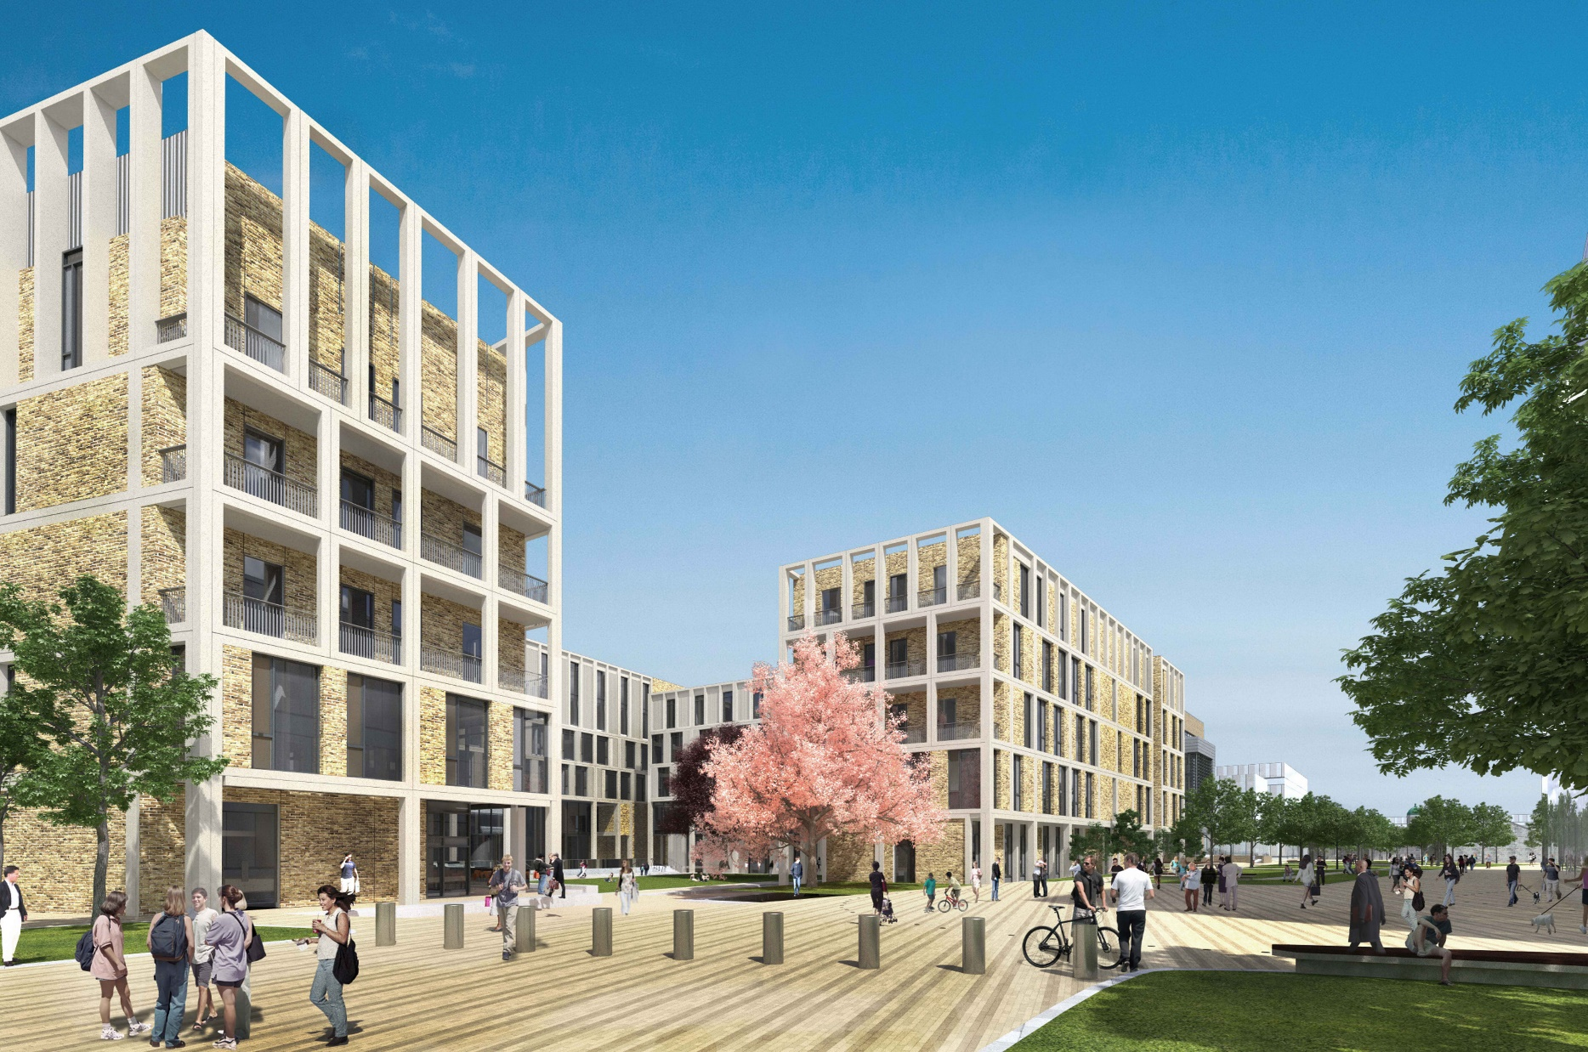

|  |
| --- |
| Library Report  Web Development 2 |
|  |
| December 2  Student Number: C20396243  Student Name: Aayush Gaur Course Code: DT228-2 / TU856-2 |

# List of PHP pages

## database.php

This file is used to connect to the library database by using *mysqli()*. It creates a variable *$conn* with the connection link for SQL uses. It also returns an error if the connection failed.

This file is included in all the pages which require the SQL DATABASE.

## header.php

This file contains the header. It displays the navigation bar at the top of the page. The navigation bar contains the link to each page so that the user can navigate between pages easily. It also has a **login** button on the right-hand side. This changes to the **logout** button if the user is already logged in. It also shows the name of the user if he has logged in.

## footer.php

## logout.php

## login.php

## register.php

## home.php

## search.php

## reserve.php

## view_reserved.php

## unreserve.php