Politecnico di Milano  
Industrial and Information Engineering  
Computer Science and Engineering

Software Engineering II Assignment

PowerEnJoy - car sharing

Academic Year: 2016/2017

Prof. Elisabetta Di Nitto

Alice Segato matr. 875045

Mark Edward Ferrer matr. 876650

Davide Bonacina matr. 876199

PowerEnJoy



Car Sharing App

# TABLE OF CONTENT

TABLE OF CONTENT 3

1 INTRODUCTION 5

1.1 Revision History 5

1.2 Purpose and Scope 5

1.3 List of Definitions and Abbreviations 5

1.4 List of Reference Documents 5

2 INTEGRATION STRATEGY 6

2.1 Entry Criteria 6

2.2 Elements to be Integrated 6

2.3 Integration Testing Strategy 7

2.4 Sequence of Component/Function Integration 7

2.4.1 Software Integration Sequence 7

Mobile Application and car computer component integration: 8

Integration of the system component: 9

2.4.2 Subsystem Integration Sequence 10

3 INDIVIDUAL STEPS AND TEST DESCRIPTION 12

3.1 Integration test case SI1 12

3.2 Integration test case SI2 12

3.3 Integration test case SI3 13

3.4 Integration test case SI4 14

3.5 Integration test case I1 14

3.6 Integration test case I2 15

3.7 Integration test case I3 15

3.8 Integration test case I4 15

3.9 Integration test case I5 16

3.10 Integration test case I6 16

3.11 Integration test case I7 17

3.12 Integration test case I8 17

3.12 Integration test case I9 18

3.13 Integration test case I10 18

3.14 Integration test case I11 19

3.15 Integration test case I12 19

3.16 Integration test case I13 20

3.17 Integration test case I14 20

3.18 Integration test case I15 21

3.19 Integration test case I16 21

3.20 Integration test case I17 21

3.21 Integration test case I18 22

3.22 Integration test case I19 22

3.23 Integration test case I20 22

3.24 Integration test case I21 23

3.25 Integration test case I22 23

3.26 Integration test case I23 24

4 TOOLS AND TEST EQUIPMENT REQUIRED 25

4.1 Tools 25

4.2 Test Equipment 25

5 PROGRAM STUBS AND TEST DATA REQUIRED 26

5.1 Program Stubs and Drivers 26

5.2 Test Data 27

6 EFFORT SPENT 27

# 1 INTRODUCTION

## 1.1 Revision History

|  |  |  |  |
| --- | --- | --- | --- |
| Version | Date | Authors | Summary |
| 1.0 |  | Mark Edward Ferrer, Alice Segato, Davide Bonacina | Initial release |

## 1.2 Purpose and Scope

This document describes the Integration Testing Plan for PowerEnJoy system. This testing is necessary in order to avoid unexpected behaviors of the system and guarantee its ability to fulfill all the requirements.   
The ITPD outlines the testing activities organization for the subsystems that make up the system.  
This document is composed by four parts:

* Integration Strategy: explains the selection of subsystems and their subcomponents for the testing and outlines, for each one, the project status that has to be met in order to start the testing.
* Individual Steps and Test Description: describes the integration testing approach, the sequence in which components and subsystems will be integrated and the planned testing activities for each integration step, including their input data and the expected output.
* Tools and Test Equipment Required: list of tools that will be employed during the testing activities and description of the environment for the test execution.
* Required Program Stubs and Test Data: list of program stubs and drivers to perform the necessary method invocations on the components to be tested.

## 1.3 List of Definitions and Abbreviations

* DD: Design Document.
* RASD: Requirements analysis and Specification Document.
* DB: the database layer, handled by a DBMS.
* UI: User Interface.
* GUI:graphical user interface is a type of user interface that allows users to interact with electronic devices through graphical icons and visual indicators;
* Application server: the layer, which provides the application logic and interacts with the DB and with the front-ends.
* Back-end: term used to identify the Application server.
* Front-end: the components, which use the application server services, namely the web front-end and the mobile applications.
* Web server: the component that implements the web-based front-end. It interacts with the application server and with the users’ browsers.
* Acknowledge: is a [signal](https://en.wikipedia.org/wiki/Message) passed between communicating [processes](https://en.wikipedia.org/wiki/Process_%28computing%29) or [computers](https://en.wikipedia.org/wiki/Computer) to signify acknowledgement, or receipt of response, as part of a [communications protocols](https://en.wikipedia.org/wiki/Communications_protocol).

## 1.4 List of Reference Documents

* RASD;
* Assignment AA 2016-2017.pdf;
* Integration testing example document.pdf;
* Sample Integration Test Plan Document.pdf.

# 2 INTEGRATION STRATEGY

## 2.1 Entry Criteria

In order to start testing the integration of all the components previously described in the Design Document, there are some conditions that have to be fulfilled before the integration:

* The components must have been already designed in the Design Document in order to figure out their role in the system;
* The components must have been unit tested and they must be correct.

## 2.2 Elements to be Integrated

The components that we are going to test are all the internal components of the Main System, the Car Computer and the Client App (as described in the section 2.3.1 of the Design Document). The components of the Third Party System and the relative clients (both web and mobile applications) have to be already tested and fully working, according to our assumptions described in the section 1.6 of the Requirements Analysis and Specification Document.

Realistically speaking, handling a full system testing is very difficult, for this reason we clamp together the components that have strong dependencies into subsystems to be tested, and then we integrate the subsystem gradually until we obtain the complete system.

*Main System*

* The Application Controller depends on User Manager, Reservation Manager, Utility Manager subsystems;
* The API Controller depends on the Algorithm Controller;
* The API Controller depends also on the Application Controller.

*Car Computer*

* The Mobile application controller relies on the Sensor Manager.

*User App*

* The Mobile application controller depends on the GPS Manager;

These three components generate five subsystems and the components themselves must be integrated in this order:

1. Main System with Car Computer;
2. User App with Main System;
3. All these three components with the Third Party System and the Database.

## 2.3 Integration Testing Strategy

To approach the integration test phase we decided to adopt the bottom-up strategy to test first the lower level components until we obtain greater subsystems. At this point we follow the critical-module-first approach to integrate together the subsystems found in the previous step. We will need only one stub of the User App component to be used during Main System subsystem testing. This stub will be called by the Main System to mock the behavior of the user app since this will be implemented later than the core system. The reason for this choice will be explained better in the Section 5 of This Document.

## 2.4 Sequence of Component/Function Integration

### 2.4.1 Software Integration Sequence

The components are tested starting from the most independent to the less one. This gives the opportunity to avoid the implementation of useless stubs for subcomponent testing, because when less independent components are tested, the components which they rely on have already been integrated. The components are integrated within their classes in order to create an integrated subsystem, which is ready for subsystem integration.

***Application Server component integration:*** 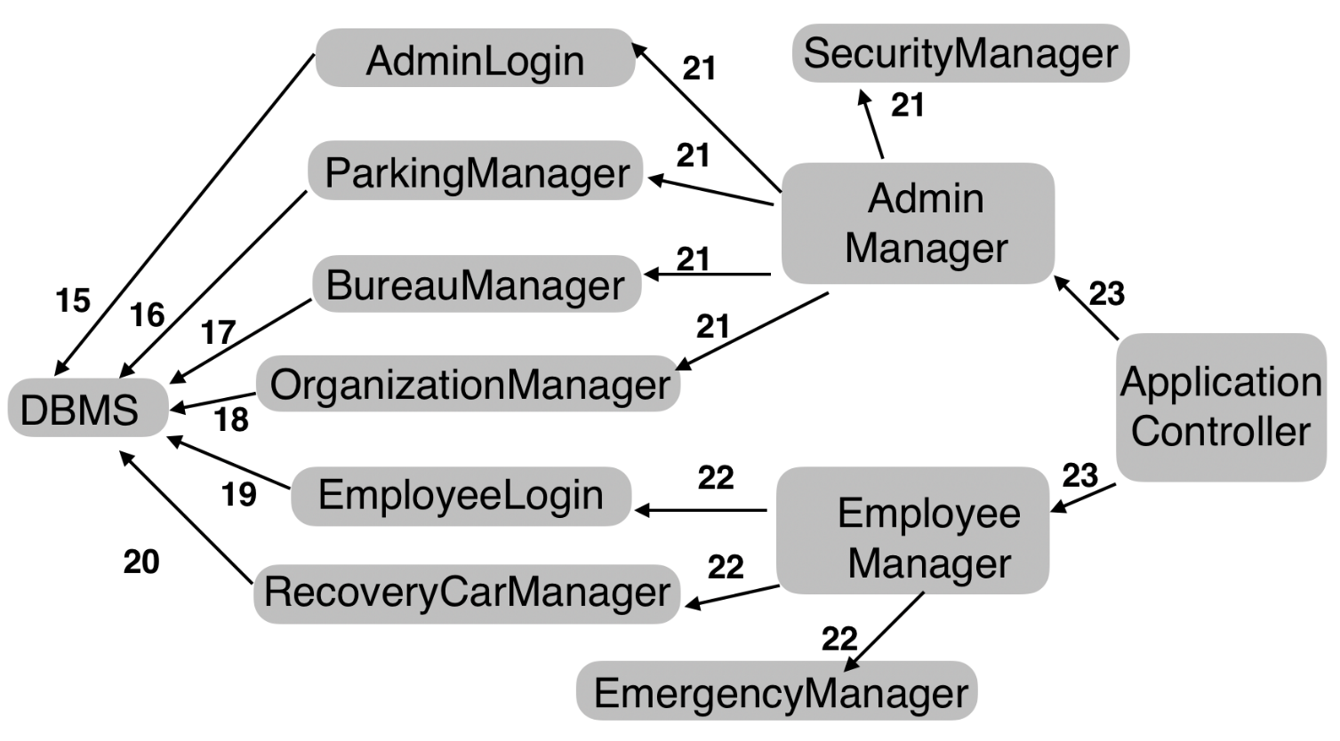

#### Figure 1

### Mobile Application and car computer component integration:

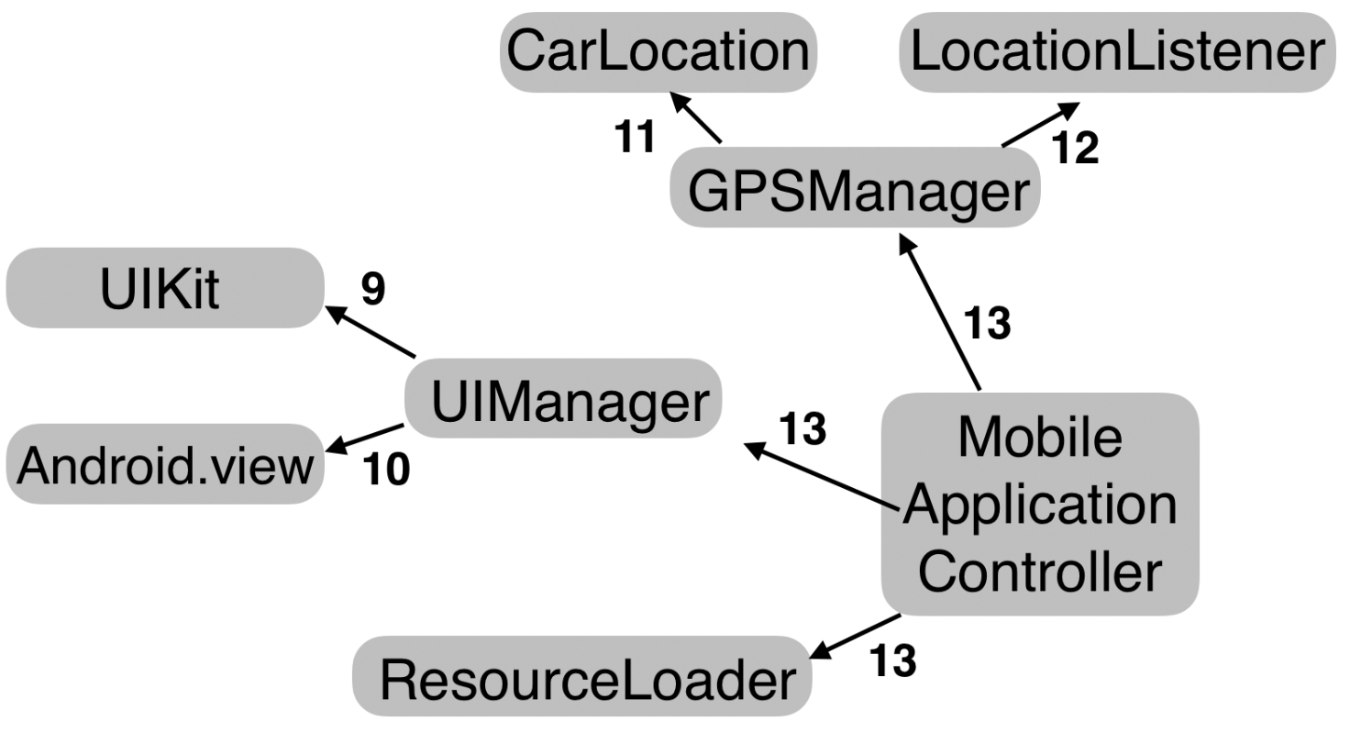

#### Figure 2

***Web Application component integration:***

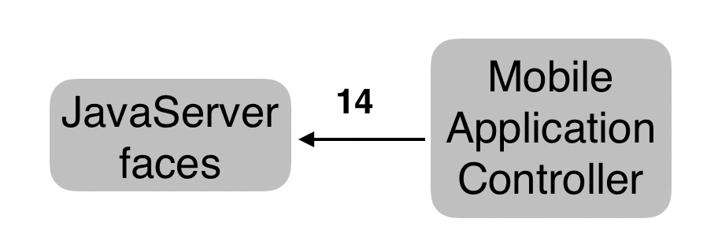

#### Figure 3

### Integration of the system component:

| **N** | **SUBSYSTEM** | **COMPONENT** | **INTEGRETES WITH** |
| --- | --- | --- | --- |
| I1 | Data Management, Logic | UserLogin | DBMS |
| I2 | Data Management, Logic | UserRegistration | DBMS |
| I3 | Data Management, Logic | Booking | DBMS |
| I4 | Data Management, Logic | Reservation | DBMS |
| I5 | Logic | UserManager | UserLogin  UserRegistration  DataManager |
| I6 | Logic | ReservationManager | Booking  Reservation  UnlockCarManager |
| I7 | Data Management, Logic | UtilityManager | EmailSender  PaymentManager |
| I8 | Data Management, Logic | ApplicationController | UserManager  ReservationManager  UtilityManager |
| I9 | User client | UIManager | UIKit |
| I10 | User client | UIManager | Android.view |
| I11 | User client | GPSManager | CarLocator |
| I12 | User client | GPSManager | LocationListener |
| I13 | User client | MobileAppController | UIManager  GPSManager  ResourceManager |
| I14 | Administration | WebAppController | JavaServerFaces |
| I15 | Data Management, Logic | AdminLogin | DBMS |
| I16 | Data Management, Logic | Parking Manager | DBMS |
| I17 | Data Management, Logic | Bureaucracy Manager | DBMS |
| I18 | Data Management, Logic | Organization Manager | DBMS |
| I19 | Data Management, Logic | Employee Login | DBMS |
| I20 | Data Management, Logic | RecoveryCarManager | DBMS |
| I21 | Logic | AdminManager | AdminManager  ParkingManager  BureauManager  OrganizationManager  SecurityManager |
| I22 | Logic | EmployeeManager | EmployeeLogin  CarRecoveryManager  EmergencyManager |
| I23 | Logic | ApplicationController | AdminManager  EmployeeManager |

### 2.4.2 Subsystem Integration Sequence

We made a choice to proceed with the integration process from the server side towards the client applications, integrating the mobile app before the Administration subsystem. The reason to do so

is that in order to have a functioning client you need to have a working Logic subsystem. The Logic subsystem, instead, can be tested without any client, by making API calls also in an automated fashion. By integrating the mobile application before the Administration subsystem, we aim to obtain a fully operational client-server system as soon as possible, since car sharing service cannot work without the mobile app. The Administration subsystem is less essential and can be integrated after the app.

***Directed Acyclic Graph representing the order of integration of the subsystems:***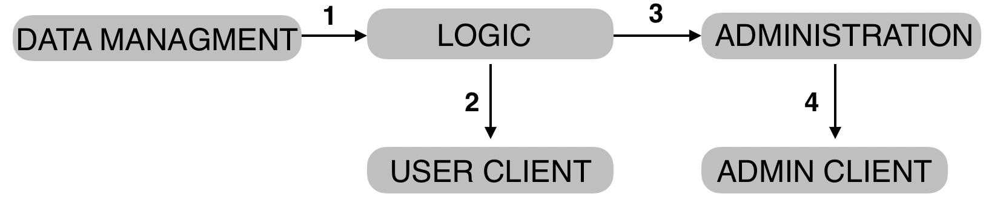

#### Figure 4

***Integration order of the subsystems:***

|  |  |  |
| --- | --- | --- |
| **N** | **SUBSYSTEM** | **INTEGRETES WITH** |
| SI1 | LOGIC | DATA MANAGEMENT |
| SI2 | USER CLIENT | LOGIC |
| SI3 | ADMINISTRATION | LOGIC |
| SI4 | ADMIN CLIENT | ADMINISTRATION |

# 3 INDIVIDUAL STEPS AND TEST DESCRIPTION

This chapter describes the individual test cases to be executed. Each test case is identified with a code and is directly mapped with the two tables for the integration between components and the integration between subsystems. Test cases whose code starts with SI are integration tests between subsystems; test cases whose code starts with I are integration tests between components.

### 3.1 Integration test case SI1

|  |  |
| --- | --- |
| **Test Case Identifier** | SI1T1 |
| **Test Item(s)** | Logic subsystem —> Data Management |
| **Input Specification** | Typical calls to the methods of the JPA Entities, mapped with tables in the Data tier. |
| **Output Specification** | The Data tier shall respond by doing the correct queries on the test database. It must also react in the right way both if the requests are made correctly and if they come from unauthorized sources that are trying to access the data. |
| **Environmental Needs** | Complete implementation of the Java Entity Beans, Java Persistence API, Test Database, driver that calls the Java Entity Beans. |
| **Test Description** | The response will be compared with the expected output of the queries. |
| **Testing Method** | Automated with Arquillian. |

### 3.2 Integration test case SI2

|  |  |
| --- | --- |
| **Test Case Identifier** | SI2T1 |
| **Test Item(s)** | Mobile Application —> Logic subsystem |
| **Input Specification** | Typical API calls to the Logic subsystem (REST API). |
| **Output Specification** | The Logic subsystem shall respond accordingly to the API specification. Also, it must react correctly if the requests are malformed or maliciously crafted. |
| **Environmental Needs** | Complete implementation of the Logic subsystem; REST API client (driver) that mocks the actual mobile client. |
| **Test Description** | The clients should make typical API calls to the application  tier; the responses are then evaluated and checked against the expected output. The driver of this test is a standard REST API client that runs on Java. |
| **Testing Method** | Automated with Arquillian. |

|  |  |
| --- | --- |
| **Test Case Identifier** | SI2T2 |
| **Test Item(s)** | Mobile Application —> Logic subsystem |
| **Input Specification** | Multiple concurrent requests to the REST API of the Logic subsystem. |
| **Output Specification** | The business tier must answer the requests in a reasonable time with the applied load. |
| **Environmental Needs** | Apache Server, fully developed Logic subsystem, Apache JMeter. |
| **Test Description** | This test case assesses whether the business tier fulfills the performance. |
| **Testing Method** | Automated with Apache JMeter. |

### 3.3 Integration test case SI3

|  |  |
| --- | --- |
| **Test Case Identifier** | SI3T1 |
| **Test Item(s)** | Administration subsystem —> Logic subsystem |
| **Input Specification** | Requests for services offered by the Logic subsystem, also invalid ones. |
| **Output Specification** | The Administration subsystem must call the proper REST APIs or report an error. |
| **Environmental Needs** | Apache Server, Administration subsystem |
| **Test Description** | This test has to ensure the right translation from HTTPS requests into REST APIs calls, reporting errors when needed. |
| **Testing Method** | Automated with Arquillian. |

|  |  |
| --- | --- |
| **Test Case Identifier** | SI3T2 |
| **Test Item(s)** | Administration subsystem —> Logic subsystem |
| **Input Specification** | Multiple concurrent API calls to the Logic subsystem. |
| **Output Specification** | Web requests should be served without problems when a reasonable load is applied on the Logic subsystem. |
| **Environmental Needs** | Apache Server, Administration subsystem, Apache JMeter. |
| **Test Description** | This test case assesses whether the business tier fulfills the performance |
| **Testing Method** | Automated with Apache JMeter. |

### 3.4 Integration test case SI4

|  |  |
| --- | --- |
| **Test Case Identifier** | SI4T1 |
| **Test Item(s)** | Admin client —> Administration subsystem |
| **Input Specification** | Typical and well-formed HTTPS requests from client browser; incomplete, malformed and maliciously crafted requests. |
| **Output Specification** | The Administration subsystem shall display the requested pages if the requests are valid; if the requests are invalid it shall display a generic error message. |
| **Environmental Needs** | Apache Server, fully developed Administration subsystem, HTTP client (driver). |
| **Test Description** | This test should emulate HTTP requests from typical users of the service and also incorrect requests. |
| **Testing Method** | Automated with Arquillian. |

|  |  |
| --- | --- |
| **Test Case Identifier** | SI4T2 |
| **Test Item(s)** | Admin client —> Administration subsystem |
| **Input Specification** | Multiple concurrent requests to the web server. |
| **Output Specification** | Web pages should be served without problems when a reasonable load is applied on the web server. |
| **Environmental Needs** | Apache Server, fully developed Administration subsystem, Apache JMeter. |
| **Test Description** | This test case assesses whether the Administration subsystem fulfills the performance |
| **Testing Method** | Automated with Apache JMeter. |

### 3.5 Integration test case I1

|  |  |
| --- | --- |
| **Test Case Identifier** | I1T1 |
| **Test Item(s)** | UserLogin —> DBMS |
| **Input Specification** | Typical queries on database tables |
| **Output Specification** | The queries return the correct results. |
| **Environmental Needs** | Apache server, Test Database, driver for the Java Entity Beans. |
| **Test Description** | The purpose of these tests is to check that the correct methods of the Entity Beans are called, and that they execute the correct queries to the DBMS. |
| **Testing Method** | Automated with JUnit. |

### 3.6 Integration test case I2

|  |  |
| --- | --- |
| **Test Case Identifier** | I2T1 |
| **Test Item(s)** | UserRegistration—> DBMS |
| **Input Specification** | Typical queries on database tables |
| **Output Specification** | The queries return the correct results. |
| **Environmental Needs** | Apache server, Test Database, driver for the Java Entity Beans. |
| **Test Description** | The purpose of these tests is to check that the correct methods of the Entity Beans are called, and that they execute the correct queries to the DBMS. |
| **Testing Method** | Automated with JUnit. |

### 3.7 Integration test case I3

|  |  |
| --- | --- |
| **Test Case Identifier** | I3T1 |
| **Test Item(s)** | Booking—> DBMS |
| **Input Specification** | Typical queries on database tables |
| **Output Specification** | The queries return the correct results. |
| **Environmental Needs** | Tomcat Server, Test Database, driver for the JavaEntity Beans. |
| **Test Description** | The purpose of these tests is to check that the correct methods of the Entity Beans are called, and that they execute the correct queries to the DBMS. |
| **Testing Method** | Automated with JUnit. |

### 3.8 Integration test case I4

|  |  |
| --- | --- |
| **Test Case Identifier** | I4T1 |
| **Test Item(s)** | Reservation —> DBMS |
| **Input Specification** | Typical queries on database tables |
| **Output Specification** | The queries return the correct results. |
| **Environmental Needs** | Tomcat Server, Test Database, driver for the JavaEntity Beans. |
| **Test Description** | The purpose of these tests is to check that the correct methods of the Entity Beans are called, and that they execute the correct queries to the DBMS. |
| **Testing Method** | Automated with JUnit. |

### 3.9 Integration test case I5

|  |  |
| --- | --- |
| **Test Case Identifier** | I5T1 |
| **Test Item(s)** | UserManager —> UserLogin, UserRegistration, DataManager |
| **Input Specification** | Methods call from UserManager to UserLogin, UserRegistration, DataManager to manage and update the information of the User. |
| **Output Specification** | The User information must be correct and up-to-date. |
| **Environmental Needs** | Tomcat Server. |
| **Test Description** | Verify that the information is correctly updated and that it refers  to the correct user. Control that the user’s information is persistently updated. |
| **Testing Method** | Automated with JUnit. |

### 3.10 Integration test case I6

|  |  |
| --- | --- |
| **Test Case Identifier** | I6T1 |
| **Test Item(s)** | ReservationManager —> Booking, Reservation, UnlockingCar |
| **Input Specification** | Methods call from ReservationManager to Booking, Reservation, UnlockingCar to update Reservation and Bookings’ status and to find an available car in a specified parking, and to unlock a car. |
| **Output Specification** | The reservation must be correctly updated without duplicating elements and the correct first available Car must be returned and removed from the ones available. The Booking status must be updated and the information of the user must be correctly checked when he tries to unlock a car. |
| **Environmental Needs** | Tomcat Server. |
| **Test Description** | The test aims to verify that the ReservationManager requests  are correctly satisfied by Booking, Reservation, UnlockingCar. |
| **Testing Method** | Automated with JUnit. |

### 3.11 Integration test case I7

|  |  |
| --- | --- |
| **Test Case Identifier** | I7T1 |
| **Test Item(s)** | UtilityManager —> EmailSender, PaymentMethod |
| **Input Specification** | Methods call from UtilityManager to the EmailSender in order to guarantee a right email authentication process. and also Method call from UtilityManager to the PaymentMethod in order to guarantee a right payment. |
| **Output Specification** | The email authentication process and payment process must be correctly handled. |
| **Environmental Needs** | Tomcat Server, e-mail sender and receiver and payment tools. |
| **Test Description** | Assure that a user can properly verify his/her email address in order to start using the system functionalities. and Assure that a payment is properly and automatically done when a user finish to use the car. |
| **Testing Method** | Automated with JUnit. |

### 3.12 Integration test case I8

|  |  |
| --- | --- |
| **Test Case Identifier** | I8T1 |
| **Test Item(s)** | ApplicationController —> UserManager, ReservationManager,  UtilityManager |
| **Input Specification** | Request from ApplicationController to UserManager, ReservationManager, UtilityManager for the functionalities offered. |
| **Output Specification** | The concurrency between the request must be properly managed and the ApplicationController has to be able to provide the right functionality carrying out the proper request. |
| **Environmental Needs** | Tomcat Server. |
| **Test Description** | Multiple requests for the UserManager, ReservationManager, UtilityManager SessionBeans have to be simultaneously carried out, in order to ensure that the users have no concurrency trouble. |
| **Testing Method** | Automated with JUnit. |

### 3.12 Integration test case I9

|  |  |
| --- | --- |
| **Test Case Identifier** | I9T1 |
| **Test Item(s)** | UIManager —> UIKit |
| **Input Specification** | Methods call from UIManager to the UI elements, to display output data and change their status. |
| **Output Specification** | The view shall change accordingly and display the output data. |
| **Environmental Needs** | Xcode, iOS Simulator. |
| **Test Description** | Verify that the bindings of the view items are correctly set in the controller and that the view actually changes and responds to method calls. Check that the output is displayed correctly. |
| **Testing Method** | Automated (iOS testing suite), manual testing on  physical devices. |

|  |  |
| --- | --- |
| **Test Case Identifier** | I9T2 |
| **Test Item(s)** | UIManager —> UIKit |
| **Input Specification** | Perform (or simulate) gestures on the UI elements. |
| **Output Specification** | The controller shall receive the actions and log them. |
| **Environmental Needs** | Xcode, iOS Simulator. |
| **Test Description** | Check that the gestures perform the correct actions on the controller. |
| **Testing Method** | Automated (Android testing suite), manual testing on physical devices. |

### 3.13 Integration test case I10

|  |  |
| --- | --- |
| **Test Case Identifier** | I10T1 |
| **Test Item(s)** | UIManager —> android.view |
| **Input Specification** | Methods call from UIManager to the UI elements, to display output data and change their status. |
| **Output Specification** | The view shall change accordingly and display the output data. |
| **Environmental Needs** | Android Emulator. |
| **Test Description** | Verify that the bindings of the view items are correctly set in the controller and that the view actually changes and responds to method calls. Check that the output is displayed correctly. |
| **Testing Method** | Automated (Android testing suite), manual testing on  physical devices. |

|  |  |
| --- | --- |
| **Test Case Identifier** | I10T2 |
| **Test Item(s)** | UIManager —> android.view |
| **Input Specification** | Perform (or simulate) gestures on the UI elements. |
| **Output Specification** | The controller shall receive the actions and log them. |
| **Environmental Needs** | Android Emulator. |
| **Test Description** | Check that the gestures perform the correct actions on the controller. |
| **Testing Method** | Automated (iOS testing suite), manual testing on physical devices. |

### 3.14 Integration test case I11

|  |  |
| --- | --- |
| **Test Case Identifier** | I11T1 |
| **Test Item(s)** | GPSManager —> CarLocation |
| **Input Specification** | Calls to the CarLocation framework methods to get location data of the car. |
| **Output Specification** | Car location data or a meaningful error status shall be returned. |
| **Environmental Needs** | Xcode, iOS Simulator. |
| **Test Description** | The purpose of the test is to check that our controller  (GPSManager) can correctly get the position from the  corresponding iOS API. Error statuses shall also be  checked. |
| **Testing Method** | Automated (iOS testing suite). |

### 3.15 Integration test case I12

|  |  |
| --- | --- |
| **Test Case Identifier** | I12T1 |
| **Test Item(s)** | GPSManager —> LocationListener |
| **Input Specification** | Calls to the Android Location framework methods to get location data of the user. |
| **Output Specification** | User location data shall be returned, or a meaningful error status. |
| **Environmental Needs** | Android Emulator. |
| **Test Description** | The purpose of the test is to check that our controller (GPSManager) can correctly get the position from the  corresponding Android API. Error statuses shall also be checked. |
| **Testing Method** | Automated (Android testing suite). |

### 3.16 Integration test case I13

|  |  |
| --- | --- |
| **Test Case Identifier** | I13T1 |
| **Test Item(s)** | MobileApplicationController —> UIManager, GPSManager, ResourceLoader |
| **Input Specification** | Calls to GPSManager methods to get the user’s location.  Load application resources (images, sounds, data) from ResourceManager. |
| **Output Specification** | The location data shall be returned from GPSManager in a suitable format, or an exception shall be raised if the location data is not available. ResourceManager should provide the required resources without errors. |
| **Environmental Needs** | Xcode, iOS Simulator, Android Emulator. |
| **Test Description** | GPSManager should be able to return the correct  GPS data in a universal and consistent format independently  from the architecture (iOS or Android). ResourceLoader is responsible for the retrieval of the resources stored into the application bundle. This test aims to assessing that all the resources can be accessed without errors by the mobile application. |
| **Testing Method** | Automated (Android and iOS testing suites). |

### 3.17 Integration test case I14

|  |  |
| --- | --- |
| **Test Case Identifier** | I14T1 |
| **Test Item(s)** | WebApplicationController —> JavaServerFaces |
| **Input Specification** | WebController is given the typical output to be displayed  on the web page. |
| **Output Specification** | JavaServerFaces shall display the required output in a correct way. |
| **Environmental Needs** | Tomcat Server, Stub of the Logic subsystem of the third part system to provide the output data. |
| **Test Description** | The purpose of this test case is to check if JSF can communicate correctly with the WebApplicationController bean. |
| **Testing Method** | Automated with JUnit. |

### 3.18 Integration test case I15

| **Test Case Identifier** | I15T1 |
| --- | --- |
| **Test Item(s)** | AdminLogin—> DBMS |
| **Input Specification** | Typical queries on database tables |
| **Output Specification** | The queries return the correct results. |
| **Environmental Needs** | Tomcat Server, Test Database, driver for the JavaEntity Beans. |
| **Test Description** | The purpose of these tests is to check that the correct methods of the Entity Beans are called, and that they execute the correct queries to the DBMS. |
| **Testing Method** | Automated with JUnit. |

### 3.19 Integration test case I16

| **Test Case Identifier** | I16T1 |
| --- | --- |
| **Test Item(s)** | ParkingManager—> DBMS |
| **Input Specification** | Typical queries on database tables |
| **Output Specification** | The queries return the correct results. |
| **Environmental Needs** | Tomcat Server, Test Database, driver for the JavaEntity Beans. |
| **Test Description** | The purpose of these tests is to check that the correct methods of the Entity Beans are called, and that they execute the correct queries to the DBMS. |
| **Testing Method** | Automated with JUnit. |

### 3.20 Integration test case I17

| **Test Case Identifier** | I17T1 |
| --- | --- |
| **Test Item(s)** | BureauManager—> DBMS |
| **Input Specification** | Typical queries on database tables |
| **Output Specification** | The queries return the correct results. |
| **Environmental Needs** | Tomcat Server, Test Database, driver for the JavaEntity Beans. |
| **Test Description** | The purpose of these tests is to check that the correct methods of the Entity Beans are called, and that they execute the correct queries to the DBMS. |
| **Testing Method** | Automated with JUnit. |

### 3.21 Integration test case I18

| **Test Case Identifier** | I18T1 |
| --- | --- |
| **Test Item(s)** | OrganizationManager—> DBMS |
| **Input Specification** | Typical queries on database tables |
| **Output Specification** | The queries return the correct results. |
| **Environmental Needs** | Tomcat Server, Test Database, driver for the JavaEntity Beans. |
| **Test Description** | The purpose of these tests is to check that the correct methods of the Entity Beans are called, and that they execute the correct queries to the DBMS. |
| **Testing Method** | Automated with JUnit. |

### 3.22 Integration test case I19

| **Test Case Identifier** | I19T1 |
| --- | --- |
| **Test Item(s)** | EmployeeLogin—> DBMS |
| **Input Specification** | Typical queries on database tables |
| **Output Specification** | The queries return the correct results. |
| **Environmental Needs** | Tomcat Server, Test Database, driver for the JavaEntity Beans. |
| **Test Description** | The purpose of these tests is to check that the correct methods of the Entity Beans are called, and that they execute the correct queries to the DBMS. |
| **Testing Method** | Automated with JUnit. |

### 3.23 Integration test case I20

| **Test Case Identifier** | I20T1 |
| --- | --- |
| **Test Item(s)** | RecoveryCarManager—> DBMS |
| **Input Specification** | Typical queries on database tables |
| **Output Specification** | The queries return the correct results. |
| **Environmental Needs** | Tomcat Server, Test Database, driver for the JavaEntity Beans. |
| **Test Description** | The purpose of these tests is to check that the correct methods of the Entity Beans are called, and that they execute the correct queries to the DBMS. |
| **Testing Method** | Automated with JUnit. |

### 3.24 Integration test case I21

| **Test Case Identifier** | I21T1 |
| --- | --- |
| **Test Item(s)** | AdminManager—> SecurityManager, AdminLogin, ParkingManager, BureauManager, OrganizationManager. |
| **Input Specification** | Methods call from AdminManager to Manage, Security service, Parking distribution, employee tasks, software maintenance to update software and security service, to administrate parking and employee task and to check for insurance and other car bureaucracy. |
| **Output Specification** | The administrator procedure must be correctly updated without duplicating elements and the correct first available parking information must be right and updated, The employee tasks must be updated and the bureaucracy information must be right. |
| **Environmental Needs** | Tomcat Server |
| **Test Description** | The test aims to verify that the AdminManager requests  are correctly satisfied by SecurityManager, AdminLogin, ParkingManager, BureauManager, OrganizationManager. |
| **Testing Method** | Automated with JUnit. |

### 3.25 Integration test case I22

| **Test Case Identifier** | I22T1 |
| --- | --- |
| **Test Item(s)** | EmployeeManager—>EmployeeLogin, RecoveryCarManager and EmergencyManager. |
| **Input Specification** | Methods call from EmployeeManager to Manage car recovery and emergency. |
| **Output Specification** | The car recovery information must be correctly updated without duplicating elements and the information of emergency location and problem must be correct too. |
| **Environmental Needs** | Tomcat Server |
| **Test Description** | The test aims to verify that the AEmployeeManager requests  are correctly satisfied by EmployeeLogin, RecoveryCarManager and EmergencyManager. |
| **Testing Method** | Automated with JUnit. |

### 3.26 Integration test case I23

| **Test Case Identifier** | I23T1 |
| --- | --- |
| **Test Item(s)** | ApplicationController —> EmployeeManager, AdminManager |
| **Input Specification** | Request from ApplicationController to EmployeeManager, AdminManager for the  functionalities offered. |
| **Output Specification** | the concurrency between the request must be properly  managed and the ApplicationController has to be able to provide the right functionality carrying out the proper request. |
| **Environmental Needs** | Tomcat Server |
| **Test Description** | Multiple requests for the EmployeeManager and AdminManager SessionBeans have to be simultaneously carried out, in order to ensure that the users have no concurrency trouble. |
| **Testing Method** | Automated with JUnit |

# 4 TOOLS AND TEST EQUIPMENT REQUIRED

## 4.1 Tools

Following the bottom-up approach, we will use different frameworks to test all the components in each phase of testing.

* Manual testing: necessary to verify immediately the correctness of the code and very useful to identify the test data need for the next testing;
* JUnit: this component was designed mainly for unit testing and we will use it at the end of the implementation of each component to ensure that all the methods are consistent and logically correct. It allows to discover implementation errors, unhandled exceptions and also interaction with other components
* Arquillian: this component was designed mainly for integration testing and allows to try test cases against a container and allows to check if the surroundings if it work in an appropriate way. It is also useful for dependency injection check and to verify if the components integrate with each other in the planned way.
* Apache JMeter: this component allows to test the system with different sizes of load in order to verify if it responds in the correct way and time to a client request.

## 4.2 Test Equipment

All the testing activities have to be performed in a dedicated environment, for this reason we need proper equipment to perform it.

On front-end side, we need:

* At least 2 Android smartphone with at least Android 5.0 Lollipop installed;
* At least 2 Android tablets with at least Android 5.0 Lollipop installed;
* At least 2 iPhones of each member of the family with the latest possible software installed;
* At least 2 iPads of each member of the family with the latest possible software installed.

We need at least two items of each mobile device in order to test requests for resources that have been reserved by another client to check how to system manages an invalid request (verified also inserting the correct input test data). As we mentioned in section 1.8 of the RASD, we will develop firstly the client app for Android and iOS since they are the most spread out mobile operating systems, and then we will develop it for Windows Phone, even if it has the 1.76% of the market share of mobile operating systems on December 2016 (source: NetMarketShare), so for that we will need, as for the other two operating systems, 2 devices for both phone and tablet with Windows Phone installed.

On back-end side we will test the system on a cloud server that will have installed a software set similar to the final one installed in the definitive server. For this reason, we will use:

* Windows Azure for the infrastructure;
* Red Hat Enterprise Edition as operating system;
* MySQL as DBMS;
* Tomcat as Web Server;
* Java Enterprise Edition;
* Apache JMeter;

# 5 PROGRAM STUBS AND TEST DATA REQUIRED

## 5.1 Program Stubs and Drivers

According to the section 2.3 of this document, we will approach the testing with a bottom-up strategy; this means that we are going to need drivers to mock the behavior of the dependencies involved in the testing of each subcomponent. The drivers that we will need to test each subcomponent are:

* **User Authentication Driver** to test the login and registration functions of the Main System. It will be used to test **userLogin**, **userRegistration** and **emailSender** components with their functions and essentially it will call the functions sending them fake credentials to verify the consistency of the code;
* **User Data Driver** to test the communication of the Main System with the database component. It will be used to test the **personalDataManagement** component and it will input data that have to be stored in the database;
* **User Action Driver** to test the booking and the retrieval of cars. It will call all the functions that allow user to reserve a car, to open it or any other action that the user could do through the app;
* **Payment Driver** to test the functionality of the **paymentManager** that include the payment of a bill and the verification of a payment method;
* **User Input Driver** used to test the integration between **APIController** and **ApplicationController** components these components have to cooperate in the right way to handle correctly the request of the user. Also the **Algorithm Controller** will be involved in this test;
* **Car Mobile Application Driver** to call the functions of the **SensorManager** subsystem that includes a component that handles the GPS signal and different components to handle the input from the different sensors of the car;
* **User App Driver** to test the functions of the internal components of the User App for the correct rendition of the system output. This driver has a different task from the stub that we intend to use because it test the correctness of the User App itself testing its internal components.

Even if the bottom-up strategy does not usually involve the use of stubs, we need to create one for testing the full Main System in order to know if it will respond correctly to the client requests and also to check if it can handle a big amount of them at the same time. The reason why we need to introduce a User App stub is that the Main System will be developed before the client and also because the core and the client have a mutual dependency and the both need strongly the output of the other.

## 5.2 Test Data

The input data test that we need to perform the tests are:

* A set of valid and invalid user credentials to test registration, login, credential verification and data storage to the database;
* A set of valid and invalid GPS data to simulate every possible case of reservation, including instances for testing of:
  + Reservation from position without safe area;
  + Unlock request from non-matching position;
* A set of valid and invalid payment methods to test payment management;
* A set of valid and invalid reservations to test the correctness of the booking, reservation and Main System application controller components (this last component has to verify if the reservation exists and according to the check, open or not the car).

All these sets of data must contain these particular instances:

* Null object;
* Null fields.

# 6 EFFORT SPENT