

**THE UNIVERSITY OF TEXAS AT ARLINGTON, TEXAS  
DEPARTMENT OF ELECTRICAL ENGINEERING**

**EE 5329**

**Distributed Decision and Control**

**HW # 6**

**ASSIGNMENT**

**by**

**SOUTRIK PRASAD MAITI**

**1001569883**

**Presented to**

**Dr. Frank Lewis**

**April 3, 2018**

**EE 5329 Distributed Decision and Control**

**Spring 2018**

**Homework Pledge of Honor**

On all homeworks in this class - YOU MUST WORK ALONE.

***Any cheating or collusion will be severely punished.***

***It is very easy to compare your software code and determine if you worked together***

***It does not matter if you change the variable names.***

Please sign this form and include it as the first page of all of your submitted homeworks.

.......................................................………………………………………………………………........

Typed Name: Soutrik Maiti

***Pledge of honor:***

"On my honor I have neither given nor received aid on this homework.”

e-Signature: Soutrik Maiti

Problem 1:

1. MATLAB CODE:

clear all;

close all;

%% Adjacency Matrix for the given problem

a = [0 0 1 0 0 0;

1 0 0 0 0 0;

1 1 0 0 0 0;

0 1 0 0 0 0;

0 0 1 0 0 0;

0 0 0 1 1 0];

%% In degree matrix

d = diag([sum(a(1,:));sum(a(2,:));sum(a(3,:));sum(a(4,:));sum(a(5,:));sum(a(6,:))]);

%% Random initial values

x = (2)*rand(1,6)-1;

for k = 1:50

x(k+1,:) = (inv(eye(6)+d))*(eye(6)+a)*x(k,:)';

end

%% Plotting State vs time

figure

plot(0:50,x,'linewidth',2)

legend('1','2','3','4','5','6')

title('State vs. Time')

xlabel('Time');

ylabel('State');

*Result:*

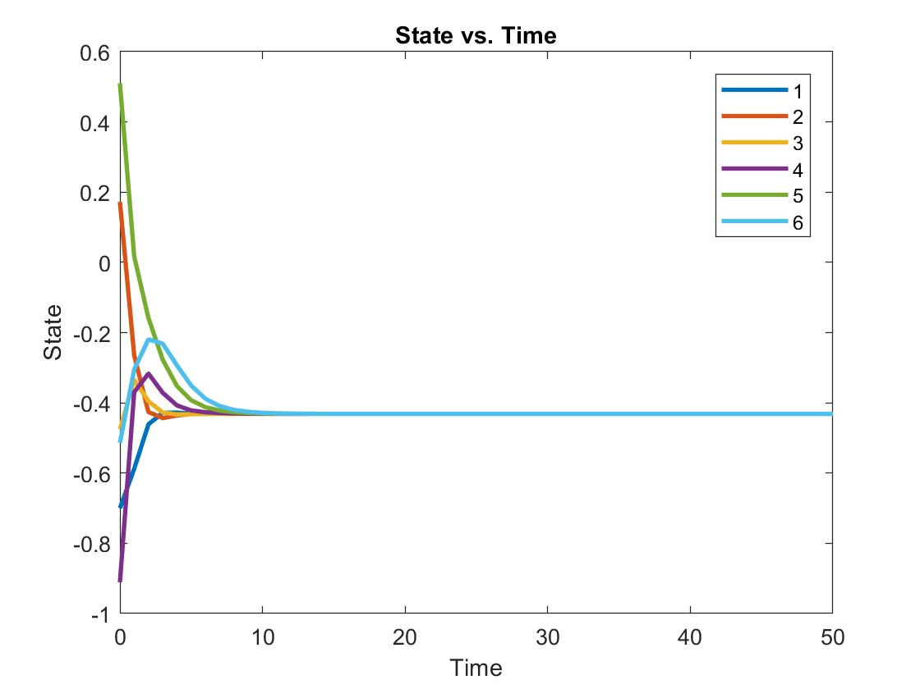

1. MATLAB CODE:

clear all;

close all;

clc;

%% Adjacency Matrix for the given problem

a1 = [0 0 0 0 0 0;

0 0 0 0 0 0;

1 0 0 0 0 0;

0 1 0 0 0 0;

0 0 1 0 0 0;

0 0 0 1 0 0];

a2 = [0 0 1 0 0 0;

1 0 0 0 0 0;

0 0 0 0 0 0;

0 0 0 0 0 0;

0 0 0 0 0 0;

0 0 0 0 1 0];

a3 = [0 0 0 0 0 0;

0 0 0 0 0 1;

0 1 0 0 0 0;

0 1 0 0 0 0;

0 0 0 0 0 0;

0 0 0 0 0 0];

ak(:,:,1) = a1;

ak(:,:,2) = a2;

ak(:,:,3) = a3;

%% In degree matrix

d1 = diag([sum(a1(1,:));sum(a1(2,:));sum(a1(3,:));sum(a1(4,:));sum(a1(5,:));sum(a1(6,:))]);

d2 = diag([sum(a2(1,:));sum(a2(2,:));sum(a2(3,:));sum(a2(4,:));sum(a2(5,:));sum(a2(6,:))]);

d3 = diag([sum(a3(1,:));sum(a3(2,:));sum(a3(3,:));sum(a3(4,:));sum(a3(5,:));sum(a3(6,:))]);

dk(:,:,1) = d1;

dk(:,:,2) = d2;

dk(:,:,3) = d3;

%% Random initial values

x = (2)*rand(1,6)-1;

x1 =x;

j =1;

for k = 1:50

fk(:,:,j) = (inv(eye(6)+dk(:,:,j)))*(eye(6)+ ak(:,:,j));

x1(k+1,:) = fk(:,:,j)*x1(k,:)';

j = j+1;

if j == 3

j = 1;

end

end

%% Plotting states vs. time

figure;

plot (1:51,x1,'LineWidth',2)

legend('1','2','3','4','5','6')

title('States vs. Time ')

xlabel('Time');ylabel('Node States');

*Result:*

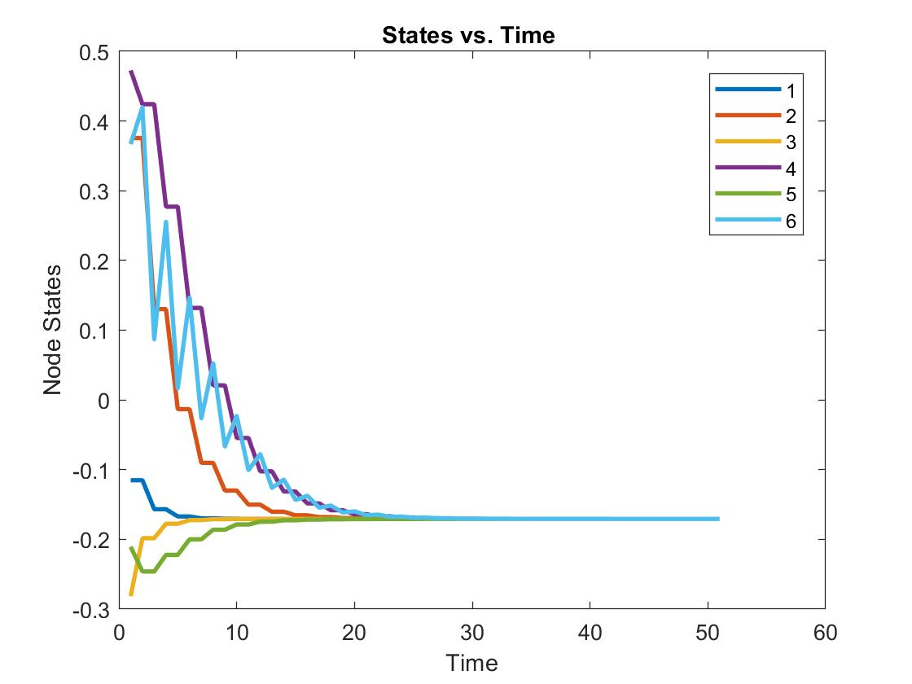

*The consensus is reached, but it occurs later than the complete graph. Also, the consensus values are different than the consensus value of compete graph.*

1. MATLAB CODE:

clear all;

close all;

clc;

%% Adjacency Matrix for the given problem

a1 = [0 0 0 0 0 0;

0 0 0 0 0 0;

1 0 0 0 0 0;

0 1 0 0 0 0;

0 0 1 0 0 0;

0 0 0 1 0 0];

a2 = [0 0 1 0 0 0;

1 0 0 0 0 0;

0 0 0 0 0 0;

0 0 0 0 0 0;

0 0 0 0 0 0;

0 0 0 0 1 0];

a3 = [0 0 0 0 0 0;

0 0 0 0 0 1;

0 1 0 0 0 0;

0 1 0 0 0 0;

0 0 0 0 0 0;

0 0 0 0 0 0];

ak(:,:,1) = a1;

ak(:,:,2) = a2;

ak(:,:,3) = a3;

%% In degree matrix

d1 = diag([sum(a1(1,:));sum(a1(2,:));sum(a1(3,:));sum(a1(4,:));sum(a1(5,:));sum(a1(6,:))]);

d2 = diag([sum(a2(1,:));sum(a2(2,:));sum(a2(3,:));sum(a2(4,:));sum(a2(5,:));sum(a2(6,:))]);

d3 = diag([sum(a3(1,:));sum(a3(2,:));sum(a3(3,:));sum(a3(4,:));sum(a3(5,:));sum(a3(6,:))]);

dk(:,:,1) = d1;

dk(:,:,2) = d2;

dk(:,:,3) = d3;

%% Random initial values

x = (2)*rand(1,6)-1;

x2 = x;

j = 1;

cnt = 0;

%% For 12222233333 12222233333 cycle

for k = 1:90

fk(:,:,j) = (inv(eye(6) + dk(:,:,j))) * (eye(6) + ak(:,:,j));

x2(k+1,:) = fk(:,:,j) *x2(k,:)';

if j == 1

j = j+1;

cnt = cnt +1;

else

if cnt == 5

j = j + 1;

cnt = 0;

end

cnt = cnt + 1;

if cnt == 5

j = 1;

cnt = 0;

end

end

end

%% Plotting states vs. time

figure;

plot (1:91,x2,'LineWidth',2)

legend('1','2','3','4','5','6')

title('States vs. Time ')

xlabel('Time');ylabel('Node States');

*Result:*

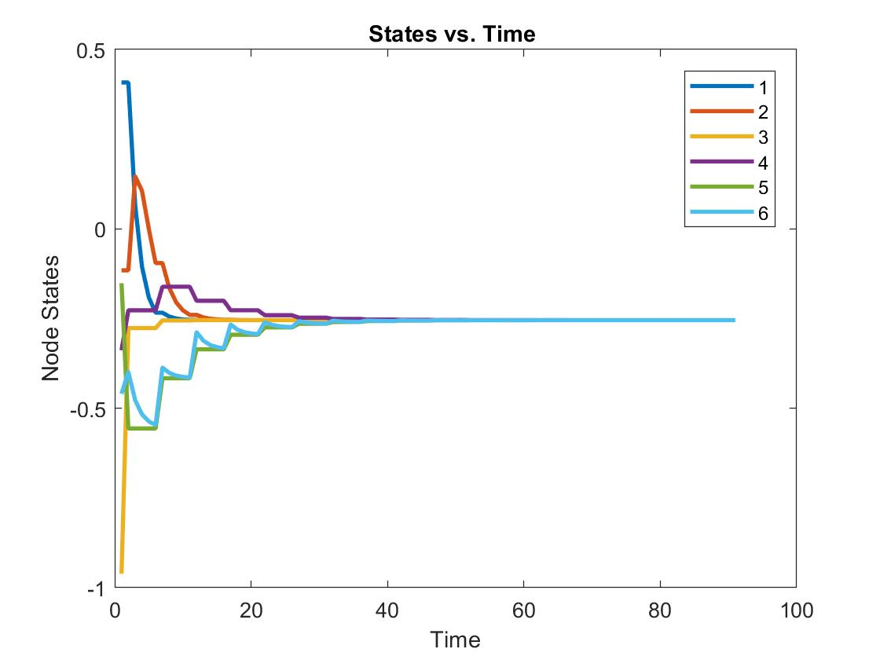

The consensus value of this specific cycle is different than the consensus value of the complete graph and the graph reaches consensus at a time later than that of the complete graph & part b as well. This is because of the Left Eigen vectors and the sequence in which the graphs are updated.

Problem 2:

MATLAB CODE-

clear all;

clc;

%% Random initial values

x3 = (2)*rand(1,6)-1;

for k = 1:120

edge = randi(9); % Randomly chosing edges

if edge == 1

x3(k+1,1) = x3(k,1) + (x3(k,2) - x3(k,1))/2;

x3(k+1,2) = x3(k,2) - (x3(k,2) - x3(k,1))/2;

x3(k+1,3) = x3(k,3);

x3(k+1,4) = x3(k,4);

x3(k+1,5) = x3(k,5);

x3(k+1,6) = x3(k,6);

elseif edge == 2

x3(k+1,2) = x3(k,2) + (x3(k,4) - x3(k,2))/2;

x3(k+1,4) = x3(k,4) - (x3(k,4) - x3(k,2))/2;

x3(k+1,1) = x3(k,1);

x3(k+1,3) = x3(k,3);

x3(k+1,5) = x3(k,5);

x3(k+1,6) = x3(k,6);

elseif edge == 3

x3(k+1,4) = x3(k,4) + (x3(k,6) - x3(k,4))/2;

x3(k+1,6) = x3(k,6) - (x3(k,6) - x3(k,4))/2;

x3(k+1,1) = x3(k,1);

x3(k+1,2) = x3(k,2);

x3(k+1,3) = x3(k,3);

x3(k+1,5) = x3(k,5);

elseif edge == 4

x3(k+1,6) = x3(k,6) + (x3(k,2) - x3(k,6))/2;

x3(k+1,2) = x3(k,2) - (x3(k,2) - x3(k,6))/2;

x3(k+1,3) = x3(k,3);

x3(k+1,4) = x3(k,4);

x3(k+1,5) = x3(k,5);

x3(k+1,1) = x3(k,1);

elseif edge == 5

x3(k+1,5) = x3(k,5) + (x3(k,6) - x3(k,5))/2;

x3(k+1,6) = x3(k,6) - (x3(k,6) - x3(k,5))/2;

x3(k+1,1) = x3(k,1);

x3(k+1,2) = x3(k,2);

x3(k+1,3) = x3(k,3);

x3(k+1,4) = x3(k,4);

elseif edge == 6

x3(k+1,3) = x3(k,3) + (x3(k,5) - x3(k,3))/2;

x3(k+1,5) = x3(k,5) - (x3(k,5) - x3(k,3))/2;

x3(k+1,1) = x3(k,1);

x3(k+1,2) = x3(k,2);

x3(k+1,4) = x3(k,4);

x3(k+1,6) = x3(k,6);

elseif edge == 7

x3(k+1,2) = x3(k,2) + (x3(k,3) - x3(k,2))/2;

x3(k+1,3) = x3(k,3) - (x3(k,3) - x3(k,2))/2;

x3(k+1,1) = x3(k,1);

x3(k+1,4) = x3(k,4);

x3(k+1,5) = x3(k,5);

x3(k+1,6) = x3(k,6);

elseif edge == 8

x3(k+1,1) = x3(k,1) + (x3(k,3) - x3(k,1))/2;

x3(k+1,3) = x3(k,3) - (x3(k,3) - x3(k,1))/2;

x3(k+1,2) = x3(k,2);

x3(k+1,4) = x3(k,4);

x3(k+1,5) = x3(k,5);

x3(k+1,6) = x3(k,6);

elseif edge == 9

x3(k+1,3) = x3(k,3) + (x3(k,1) - x3(k,3))/2;

x3(k+1,1) = x3(k,1) - (x3(k,1) - x3(k,3))/2;

x3(k+1,2) = x3(k,2);

x3(k+1,4) = x3(k,4);

x3(k+1,5) = x3(k,5);

x3(k+1,6) = x3(k,6);

end

end

%% Plotting states vs. time

figure;

plot (1:121,x3,'LineWidth',2)

legend('1','2','3','4','5','6')

title('States vs. Time ')

xlabel('Time');ylabel('Node States');

*Result:*

