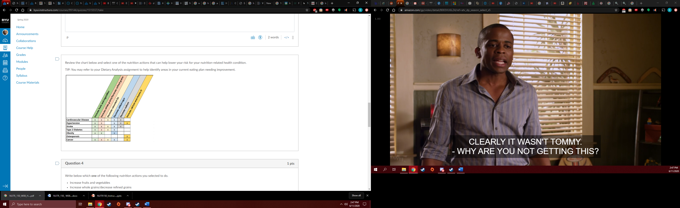

Grandma Kris: High Blood Pressure

Her Parents: -father: colon cancer – late life, -mother: high blood pressure, diabetes – late in life

Pop Turner: Prostrate Cancer – late life

His parents: not sure

My mom: High blood pressure, grave’s disease, thyroid eye disease?

My Dad: Asthma – allergic to cats

Rhys: - asthma young age only

Rob – allergic to cats

Bill – nothing?