INSTRUCTIONS:

1. Follow the format below.
2. Remember the maximum length for each section 3 pages.
3. Convert your proposal to pdf format (as specified in the course syllabus).
4. Delete these (3) instruction pages before submitting this assignment online.
5. This is the Grading Matrix applied to evaluate your submission. Each graded section is sub weighted by Technical Merit (70%), Organization/Clarity (15%), Spelling (5%), Punctuation & Grammar (5%) and Usage (5%).

|  |  |  |
| --- | --- | --- |
| Section | Weight | Score |
| Abstract | 10 |  |
| I. Introduction | 10 |  |
| II.* Conceptual Sub-System Design | 75 |  |
| References | 5 |  |

*If you are primarily responsible for more than one subsystem, then include additional sections for each additional sub-system.

This is the rubric and descriptors used to evaluate each section of this assignment.

|  |  |  |  |  |
| --- | --- | --- | --- | --- |
|  | Poor | Fair | Good | Excellent |
| Technical Merit | 28 | 42 | 56 | 70 |
| Organization/Clarity | 6 | 9 | 12 | 15 |
| Spelling | 2 | 3 | 4 | 5 |
| Punctuation & Grammar | 2 | 3 | 4 | 5 |
| Useage | 2 | 3 | 4 | 5 |

**Technical Merit***Excellent:* The technical points or claims are fully explained and supported. This project has great technical value, regardless of how well it is explained.  
*Good:* All important technical points or claims are adequately explained and supported with some extra detail. This project has great technical value, regardless of how well it is explained.  
*Fair:* Most technical points or claims are adequately explained and supported but with minimal detail. This project has some technical value.  
*Poor:* Many of the technical points are unexplained or unsupported, or inadequately explained or supported. This project has little technical value.

**Organization/Clarity***Excellent:* The whole document has a clear and obvious principle of organization which makes it easy to read and understand; in longer documents, headings or topic sentences aid in skimming. Paragraphs have a clear topic or function and are of an appropriate length. All parts of the document support the thesis or main point.  
*Good:* Most of the document has a clear and obvious principle of organization which makes it easy to read and understand; the document can be skimmed easily. Most paragraphs have a clear topic or function and are of an appropriate length.  
*Fair:* The principle of organization may not always be clear, or there may be some straying from the thesis or main point. There may be some paragraphs which are very long or very short for no obvious reason.  
*Poor:* There is no clear principle of organization; most paragraphs are very long or very short for no

**Spelling***Excellent:* No spelling errors.  
*Good:* One or two spelling errors, but not of the type to make meaning obscure, and not of basic or common words. The error may be the result of the writer taking risks and trying new vocabulary. or it may be a common error that is not always recognized as such (for example “thru” for “through”).  
*Fair:* A few minor spelling errors (more than two) but not enough to harm the writer’s ethos seriously or impede the reader’s comprehension.  
*Poor:* A major misspelling of important or common words, or a number of minor errors which interfere with easy reading or comprehension.

**Punctuation, & Grammar***Excellent:* Punctuation and grammar are appropriate to the audience and genre and in fact enhance the style. They conform to the conventions for edited American English, or, if they do not, the reason is rhetorical and stylistic. Errors may occur but are few and do not markedly distract the reader.  
*Good:* Punctuation and grammar are appropriate to the audience and genre. They conform to the conventions for edited American English. Errors may occur but are few and do not markedly distract the reader.  
*Fair:* Punctuation and grammar errors may occur but are few; while they occasionally distract the reader and cause less fluency, they do not detract from comprehension.  
*Poor:* Errors occur frequently and mar the writer’s ethos and the reader’s comprehension. Reading is frequently interrupted by error. The writer has not proofread.

**Usage***Excellent:* Usage is in accordance with edited American English and sounds right for the audience. There is no inappropriate use of slang or jargon. Words and expressions seem carefully selected for the genre and audience.  
*Good:* Usage is in accordance with edited American English and sounds right for the audience and gene. There may be a few clichés included, but they are used correctly.  
*Fair:* Usage is sometimes wrong, or too formal or informal for the audience and genre, but this does not impede comprehension.  
*Poor:* Improper usage and errors in usage are frequent and mar the writer’s ethos and the reader’s comprehension.

Pre-Proposal

03/01/15

ECEN 403 – Capstone (Senior) Design

Texas A&M University, College Station, TX

Team 12

Cameron Chollett

Subterranean Mapping with Ground Penetrating Radar

Abstract

Single-space, justified text. Provide an extract of the entire document here.

# INTRODUCTION

A. Need Statement

Radar systems are similar in implementation but vary in application. Ground penetrating radar, similar to synthetic aperture radar, transmits pulses of radio frequency signals and records the time difference and the amplitude of a signal when it returns. The signals are reflected when they arrive at a material with different electrical conduction properties. Depending on the difference in the dielectric constants of the different materials, the strength of the signal will change. Ground penetrating radar systems are composed of four different subsystems: a system to supply power and recharge the batteries, the antenna system to generate and transmit radio frequency waves, the data collection unit to receive the reflected signals and upload the data to a server, and finally an image processing subsystem to process the data and create a 3D image of the subsurface terrain. GPR is mainly used to locate near-surface interfaces in soil, such as underground pipes, different types of rock, or groundwater. Commonly, ground penetrating radar is used for utility mapping before excavation, buried void detection, concrete evaluations, and environmental investigations. With large requests from the agricultural department at Texas A&M, there becomes a need for a ground penetrating radar device to map the root growth of trees on campus and in different studies being conducted. Numerous different researchers are trying to develop an idea of why tree roots grow in certain directions and how the root’s locations affect the crops surrounding the tree. By monitoring and locating the growing roots, agriculture specialists are able to isolate certain foundations from damage by the invasive roots, determine the tree’s stability by analysis of the root depth and density, and much more.

B. Proposed System

A ground penetrating radar system will require antennas for transmitting the RF signals, a receiver and nuke for collection of the backscatter, a computer to reconstruct the data points to form a 3D image, and a recharging station to optimize the battery efficiency. To generate more powerful signals to penetrate the ground, larger antennas will be required. To move the system around to different GPS points will require a vehicle to carry the radar system around. The overall design of the GPR system can be seen in Fig. 1.

<place figure here>

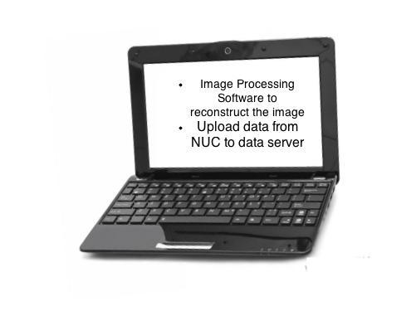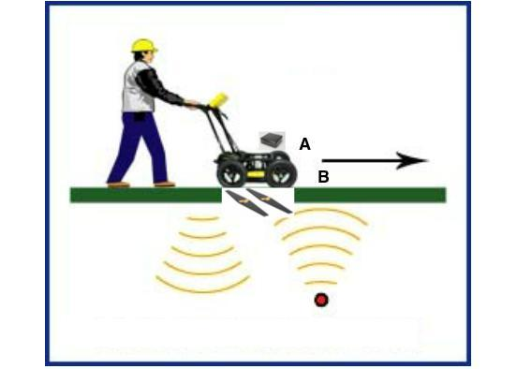

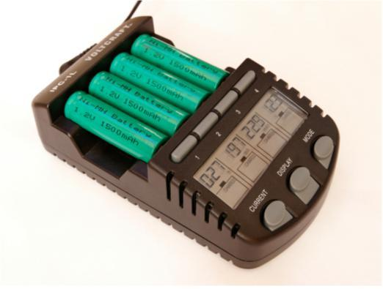

Fig. 2. Physical Sketch of the System.

In Fig. 2, point (A) is the computer NUC where the data will be stored while the RF antennas(B) transmit and receive signals. Once the vehicle is finished attaining data, the data will be offloaded from the NUC onto a server and then processed to form an image of the subsurface.

# Conceptual Design Description

A. Implementation *(describe how you propose to implement this sub-system)*

B. Analysis *(use computations, published data and/or simulated data to* ***describe quantitatively*** *how and why this subsystem works)*

Describe the implementation of each sub-system (block of the block diagram).

**Justify all text**. Cite references as follows: Number citations consecutively in square brackets [1]. The sentence punctuation follows the brackets [2]. Multiple references [2], [3] are each numbered with separate brackets [1]–[3]. When citing a section in a book, please give the relevant page numbers [2]. In sentences, refer simply to the reference number, as in [3]. Do not use “Ref. [3]” or “reference [3]” except at the beginning of a sentence: “Reference [3] shows ... .”

Sample Eqn:

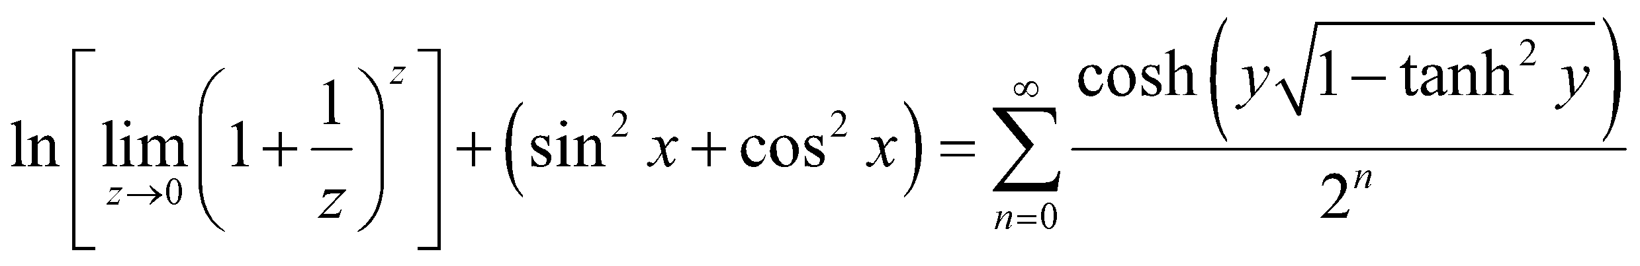 (1)

Citing equations: Refer to “(1),” not “Eq. (1)” or “equation (1),” except at the beginning of a sentence: “Equation (1) is ... .”

TABLE I

Low-Pass Filter Design

|  |  |  |
| --- | --- | --- |
| Parameter | Specification | Simulation results |
| Gain | 60 dB | 62 dB |
| Bandwidth | 1 MHz | 1.05 MHz |
| HD3 | -70 dB | -66 dB |

NOTE: No vertical lines in table.

# References

1. G. O. Young, “Synthetic structure of industrial plastics (Book style with paper title and editor),” in *Plastics*, 2nd ed. vol. 3, J. Peters, Ed. New York: McGraw-Hill, 1964, pp. 15–64.
2. W.-K. Chen, *Linear Networks and Systems* (Book style)*.* Belmont, CA: Wadsworth, 1993, pp. 123–135.
3. H. Poor, *An Introduction to Signal Detection and Estimation*. New York: Springer-Verlag, 1985, ch. 4.
4. E. H. Miller, “A note on reflector arrays (Periodical style—Accepted for publication),” *IEEE Trans. Antennas Propagat.*, to be published.
5. J. Wang, “Fundamentals of erbium-doped fiber amplifiers arrays (Periodical style—Submitted for publication),” *IEEE J. Quantum Electron.*, submitted for publication.
6. C. J. Kaufman, Rocky Mountain Research Lab., Boulder, CO, private communication, May 1995.
7. Y. Yorozu, M. Hirano, K. Oka, and Y. Tagawa, “Electron spectroscopy studies on magneto-optical media and plastic substrate interfaces(Translation Journals style),” *IEEE Transl. J. Magn.Jpn.*, vol. 2, Aug. 1987, pp. 740–741 [*Dig. 9th Annu. Conf. Magnetics* Japan, 1982, p. 301].

NOTE: Replace the sample references above with yours. Upon hitting “Enter” on the keyboard after entering a reference, a new number will be created automatically for you to enter the next one below