VANIER COLLEGE
COMPUTER SCIENCE DEPARTMENT

USER MANUAL

JOEFFREY BRIONES, THOMAS CASTANO PEREZ AND DANUSH SOOSAI
420-331-VA : APPLICATION DEVELOPMENT 1 (DESKTOP)
TEACHER: SYED NASEEM AFZAL
May 17, 2026
TABLE OF CONTENTS
Introduction ....................................................................................................... 3
Interactive Features ............................................................................................... 3
Graphical User Interface ........................................................................................... 4
Basic UI ........................................................................................................... 4
Application Features ............................................................................................... 5
Main Menu .......................................................................................................... 5
Reservations ....................................................................................................... 6
Exception Handling ................................................................................................. 7
Tables ............................................................................................................. 8
Exception Handling ................................................................................................. 9
Billing ............................................................................................................ 10
Internationalization ............................................................................................... 11
Database and Output ................................................................................................ 12
Previous Versions .................................................................................................. 13

INTRODUCTION
RSBM RestaurantMGR is a desktop restaurant management application designed for a Korean BBQ restaurant. The program helps staff manage reservations, track table availability, and prepare customer billing from a single Windows Forms interface.
This user manual explains the main screens and day-to-day features of the application. It is written for restaurant staff who need a quick reference while seating guests, updating table statuses, and preparing bills.

INTERACTIVE FEATURES
- Language selector for English, French, and Spanish interface text.
- Navigation buttons for Reservations, Tables, and Billing.
- Reservation form for customer details, party size, date, time, table, and reservation status.
- One-hour reservation blocks that prevent overlapping reservations for the same table.
- Unavailable reservation time slots shown in red in the time picker.

- Table manager with a date picker for viewing table availability on a selected reservation date.
- Billing screen that connects each bill to a reservation and opens a receipt window after generating the bill.

GRAPHICAL USER INTERFACE
Area | User Action / Result
Header | Displays the Restaurant Manager System title.
Sidebar Navigation | Opens the Reservations, Tables, or Billing screen.
Language Selector | Changes the displayed labels and messages to English, French, or Spanish.
Main Panel | Displays the selected feature form without opening a separate application window.
Quit Button | Closes the application when the user is finished.

BASIC UI
The application uses a simple dashboard layout with a dark header and sidebar. The user selects a feature from the left navigation area, and the selected form is loaded into the main content panel. This keeps the workflow consistent across the restaurant management screens.
The language selector is located on the sidebar so staff can switch interface language without leaving the current workflow. When a language is selected, the main form and the currently opened child form refresh their displayed text.
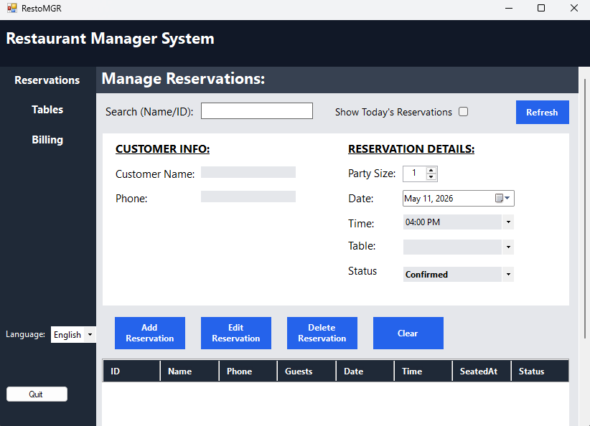

APPLICATION FEATURES

MAIN MENU
Area | User Action / Result
Reservations | Opens the reservation management screen.
Tables | Opens the Korean BBQ table management screen.
Billing | Opens the billing and payment screen.
Language | Stores the selected language preference for the next time the program runs.

The main menu is intended to be the central starting point for restaurant staff. It displays a dashboard containing useful info such as customer count, today’s date, and time.
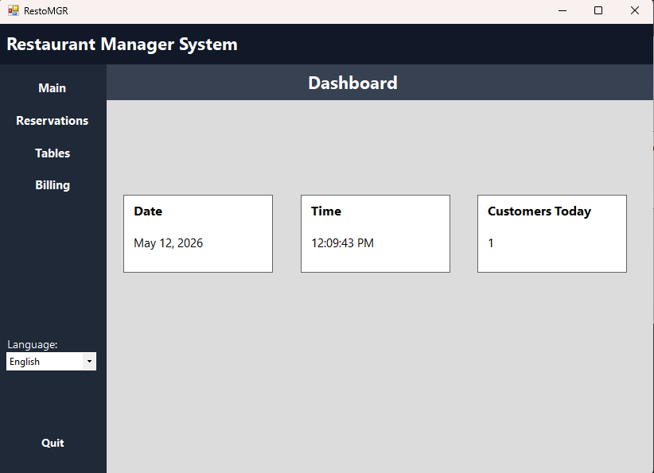

RESERVATIONS
The Reservations screen allows staff to enter customer information and reserve a table for a specific date and time. Each reservation blocks the selected table for a maximum one-hour interval. For example, a 7:00 PM reservation blocks 7:00 PM to 8:00 PM for that table, while allowing the table to become available again at 8:00 PM if there is no overlap. The time picker highlights unavailable time slots in red, and the table dropdown refreshes based on the selected date and time.
Area | User Action / Result
Customer Info | Stores the customer name and phone number.
Reservation Details | Stores party size, date, time, table, and status.
Time Picker | Shows unavailable one-hour time blocks in red.
Table Dropdown | Displays only tables available for the selected date and one-hour time interval.
Validation | Prevents overlapping reservations for the same table during the one-hour reservation block.

EXCEPTION HANDLING
- If no reservation is selected, the Edit and Delete actions display a message asking the user to select a reservation.
- Before deleting a reservation, the program asks for confirmation.
- The system prevents overlapping reservations for the same table within a one-hour block.
- Unavailable time slots are shown in red so staff can quickly identify conflicts before saving.
When a reservation is added, updated, or deleted, a message box confirms the result.
Database errors are shown through message boxes so the user knows that the action did not complete.
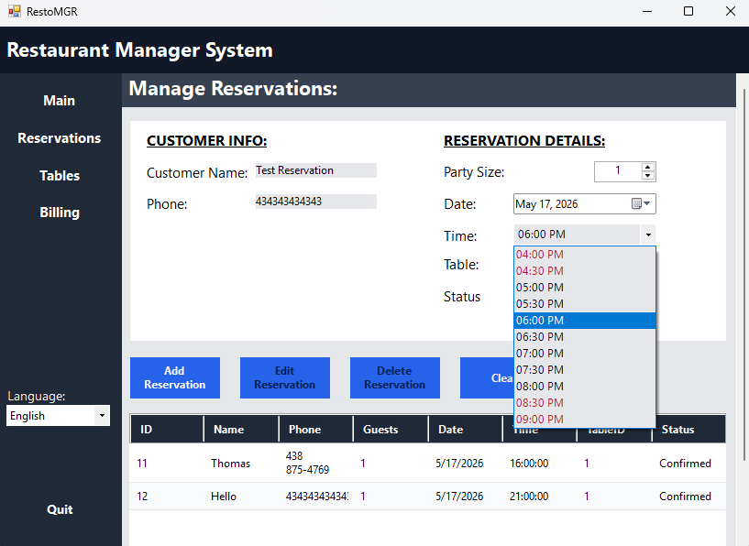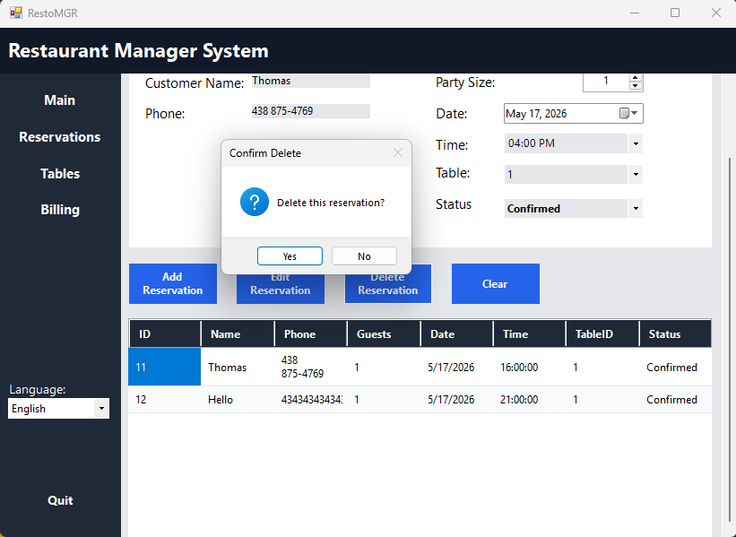

TABLES
The Tables screen is used to manage Korean BBQ seating. Each table has a table number, capacity, Korean BBQ table type, and status. Staff can use the table date picker to view whether tables are available, reserved, or occupied for a selected date. This prevents future reservations from permanently locking a table while still showing the correct reserved status for the chosen day.
Area | User Action / Result
Table Grid | Displays table number, seat capacity, Korean BBQ table type, and status.
Date Picker | Shows table availability for the selected reservation date.
Selected Table | Shows the table number selected from the grid.
Status | Displays Available, Reserved, or Occupied using localized text.
Update Table | Saves changes to capacity and base table status.

EXCEPTION HANDLING
- The user must select a table before pressing Update Table.
- The user must choose both a status and a table type.
- The table status is stored using valid database values only: Available, Reserved, and Occupied.
- If the table list cannot be loaded or saved, the application displays an error message. If no changes were made, it displays “No changes were made” based on the selected language.
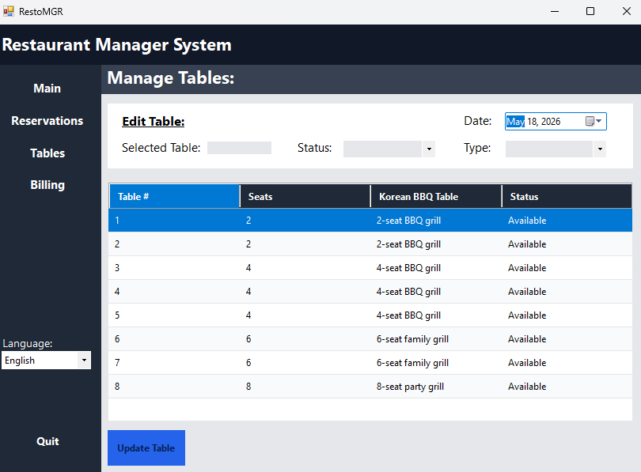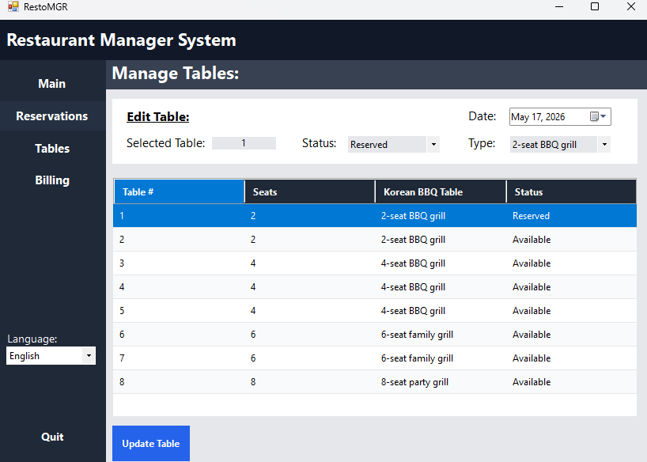
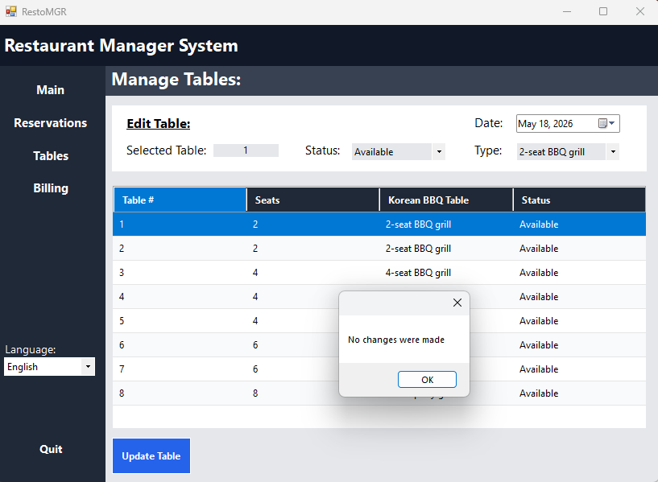

BILLING
The Billing screen helps staff prepare a bill for a selected reservation. Staff choose the reservation, enter the number of guests, select optional Korean BBQ extras, choose a payment method, and generate the bill. The bill is saved with the matching ReservationID, and a separate receipt window opens with the subtotal, tax, tip, total, per-person price, payment method, and payment status.
Area | User Action / Result
Reservation | Selects the reservation that the bill belongs to.
Pricing | Calculates AYCE pricing from the number of guests.
Extras | Adds drinks or premium meat options to the subtotal.
Payment | Records payment method and payment status.
Receipt Window | Displays the generated receipt in a new window after saving the bill.

EXCEPTION HANDLING
- The user must select a reservation before generating a bill.
- The user must select a payment method before saving the bill.
- The bill is connected to the selected ReservationID so it can be tracked in the database.
After the bill is generated, the application opens a separate receipt window.
Billing, deletion, and payment status errors are shown through localized message boxes.
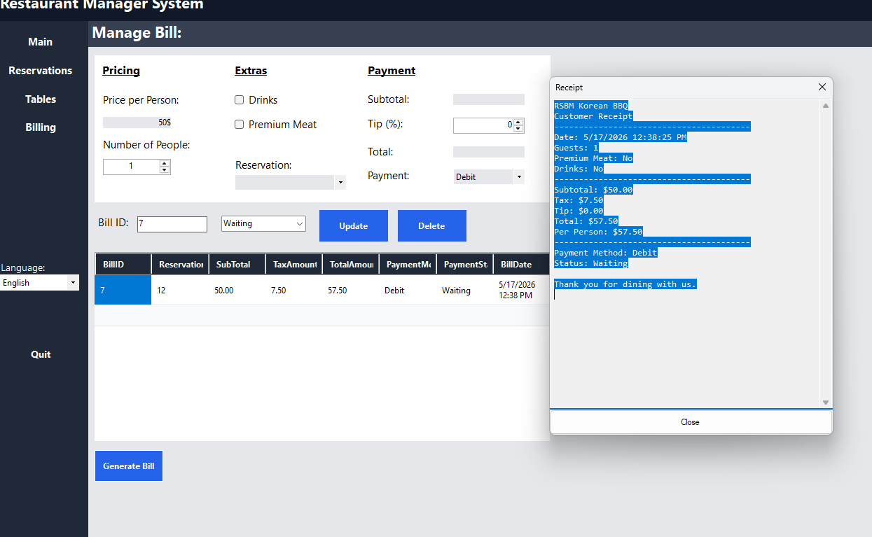

INTERNATIONALIZATION
The application supports English, French, and Spanish text through resource files. When the user changes the language selector, labels, buttons, messages, table status text, reservation conflict messages, billing validation messages, and receipt labels update to the selected language.
Area | User Action / Result
English | Default application language.
French | Displays translated labels, buttons, messages, and table values.
Spanish | Displays translated labels, buttons, messages, and table values.
Saved Preference | Stores the user's last selected language in application settings.

DATABASE AND OUTPUT
The project uses a LocalDB database named RestaurantDB. The database stores customers, restaurant tables, reservations, and bills. Reservation records include date and time values used to prevent one-hour booking overlaps. Bill records are connected to reservations through ReservationID and are displayed in the billing grid after generation.
- Customers stores customer name and phone number.
- RestaurantTables stores table number, capacity, and status.
- Reservations connects customers to restaurant tables for a date and time.
- Bills stores ReservationID, subtotal, tax, total amount, payment method, payment status, and bill date.
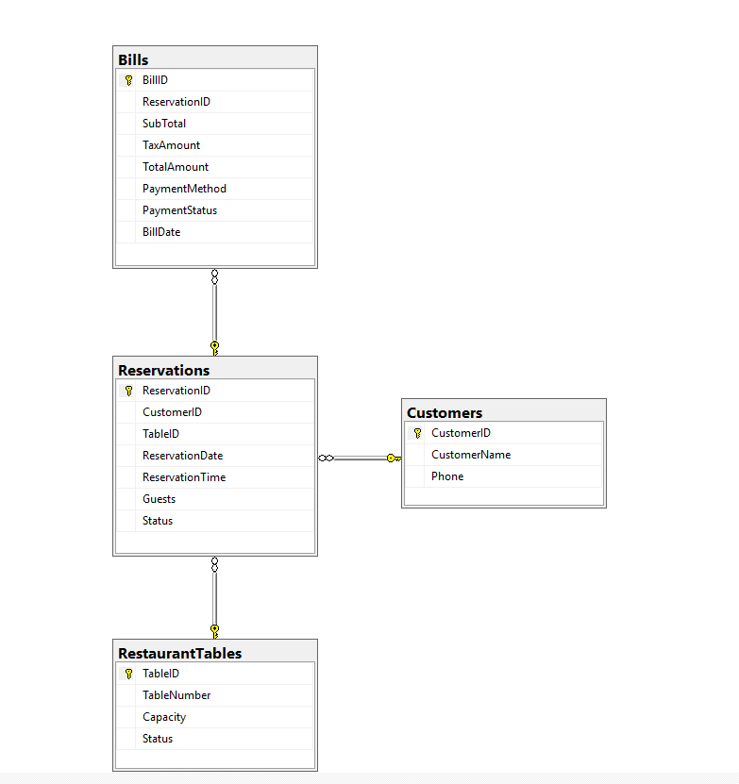

PREVIOUS VERSIONS

VERSION 1.0.0
Initial restaurant management interface with Reservations, Tables, and Billing navigation.

VERSION 1.0.1
Added English, French, and Spanish internationalization support.

VERSION 1.0.2
Completed Korean BBQ table management with localized table statuses and table types.

VERSION 1.0.3
Added one-hour reservation blocking, red unavailable time slots, date-based table availability, reservation-linked billing, and receipt window output.

