**RESUME**

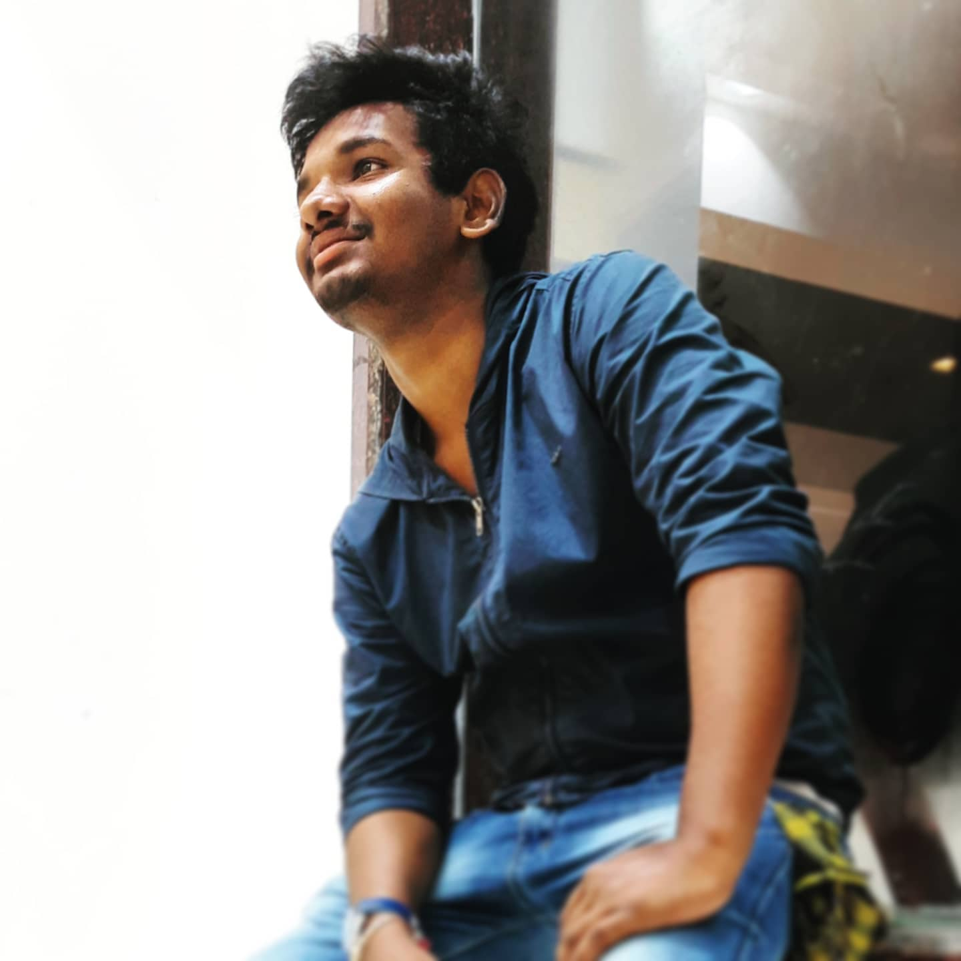NAME : Boddapati Ravi

FATHER’S NAME : Boddapati Ramana

MOTHER’S NAME : Boddapati Satyavathi

ADDRESS : 46-16-7/1, Ganuga Street, Danavaipeta, RJY

PHONE : 9010076453

Personal EMAIL : [boddapatiravi447@gmail.com](mailto:boddapatiravi447@gmail.com)

**OBJECTIVE:-**

a good position as a employ in your organization.

**EDUCATION:-**

|  |  |  |  |
| --- | --- | --- | --- |
| **Course** | **Institute name** | **City** | **Academic year** |
| **Btech CSE(AIML)** | Vishnu Institute of Technology | Bhimavaram | **2022 - current** |
| **Intermediate** | Narayana Junior College | Rajahmundry | 2020 - 2022 |
| **SSC** | S.K.V.T(E.M) Govt High School | Rajahmundry | 2019 - 2020 |

**PROGRAMMING LANGUAGES KNOWN:-**

Learnt Basics in following languages

1. HTML and CSS

2. JS

3. MATLAB

3. Python

4. Basics of Data Structures using C

5. Object Oriented Programming through Java

6. SQL

7. Problem Solving Using C

**STRENGTHS:-**

Good communication skills, managerical skills, punctual and hardworking with dedication.

**ADDITIONAL DETAILS:-**

Languages known : Telugu, English

Hobbies : Listening to music, Playing Basketball and Learning something new.

**REFERENCE**  : available on request

**DECLARATION**

I hereby declare that the information furnished above are the true and correct in my best of my knowledge. I undertake to inform you of any changes therein, immediately.



**Signature.**