It is a group assignment. Each group consists of 7-8 students.
Common task for all groups:
Download jflap from address www.jflap.org/
Install the software following this direction
https://www.youtube.com/watch?v=-KNnBBUPX2k
https://www.youtube.com/watch?v=4UDWyW5m73I

Group 1
1/Overview of DFA, NFA
2/ Create the following NFA N1 using Jflap
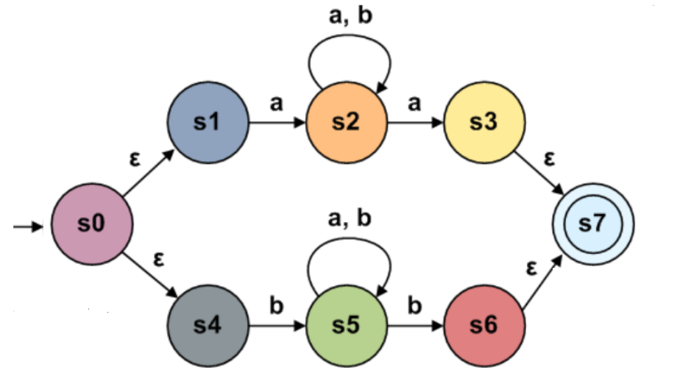
3/Test NFA on strings: abaabba and abbbbb
4/Explain why a string is/is not accepted by N1
5/Convert the following NFA N2 to the equivalent DFA D2
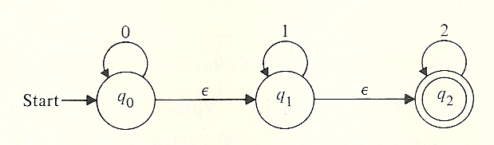
6/Test DFA D2 on the strings 0112 and 01201
7/ Save DFA D2 to a file. Describe how jflap stores the set of states and distinguishes the set of final states
8/ Show the difference between the file of NFA N1 and the file of DFA D2
Videos:
https://www.youtube.com/watch?v=e0jHJOdR3cw
https://www.youtube.com/watch?v=f54ISUVE0p0&list=PLeaAjeNjt7tTAH3LvvMVeR_rOVOgLLx6D&index=4

Group 2
1/Overview the pumping lemma for regular languages and context free languages. Script of Jflap
Use the pumping lemma for regular languages to prove that the following languages are not regular
2/ {a^{n} | n is a prime number}
3/{(ab)^{n}a^{k} | n > k, k ≥ 0}
Use the pumping lemma for regular languages to prove that the following languages are not context free
4/ {a^{n}b^{n}c^{n} | n≥1}
5/ {ww | w∈{0,1}*}
6/ {a^{m} | m is a proper square of an integer}
7/ Is it possible to prove that a new language (not in the list of jflap) is not regular?
Videos:
https://www.jflap.org/tutorial/pumpinglemma/regular/index.html
https://www.jflap.org/tutorial/pumpinglemma/context_free/index.html
https://www.youtube.com/watch?v=IsNOCTyymTI

Group 3
1/ Overview of Regular expression
2/ Enter regular expression (a + b) * aaa (a + b) * and 01(0+1)*()
3/ What kind of syntax errors does jflap detect in a regular expression syntax?
4/ Convert the regular expression a(a+b)* to the equivalent NFA by using the algorithm in my slides.
5/ Convert the regular expression a(a+b)* to their equivalent NFA using jflap. Compare with the result of 4/
6/ Convert the regular expression a*b⁺ to their equivalent DFA:
7/ Save a received NFA of 5/ to a file. Describe how jflap stores the set states and the ε-transitions of the NFA?

Group 4:

1/ Overview of context free grammars.
Given the context free grammar G with the following set of productions:
S → aB | bA
A → a | aS | bAA
B → b | bS | aBB
Use jflap to
2 Enter productions of G
3/ Draw a parse tree for string aaabbabbba
4/ Prove that G is ambiguous
5/ Convert G to Chomsky Normal Form (CNF). Name the result grammar G1
6/ Check if string aaabbabbba is generated by G1
8/ Remove λ(epsilon) from the following grammar:
S->XYX
X->0X| λ
Y->1Y| λ

Notice: Video for creating a grammar and testing on strings
https://www.youtube.com/watch?v=GPG1-s7HJmU&index=11&list=PLeaAjeNjt7tTAH3LvvMVeR_rOVOgLLx6D

Group 5:
1/ Overview of PDA and the equivalence of PDA and CFG
Given the PDA P
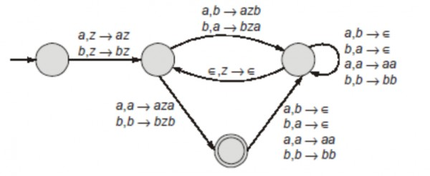
2/Write the computation of the PDA with string aababaa without using Jflap
3/ Create the PDA using jflap and test with string aababaa
3/ Give an example of a string over {a, b} that is not accepted by P. Explain why?
4/ Save the PDA in a file and describe how it is stored
6/ Convert P to its equivalent grammar
7/ Convert Grammar G with the following production rules to its equivalent push down automaton.
S → aB | bA
A → a | aS | bAA
B → b | bS | aBB

8/ Show the computation of the PDA with string aaabbabbba

Video: Create a PDA
https://www.youtube.com/watch?v=rN-kjnCokwY

Group 6
1/ Overview of the model of Deterministic Turing machines and another variant: model of 2-tape Turing machines
Given a deterministic Turing Machine M:
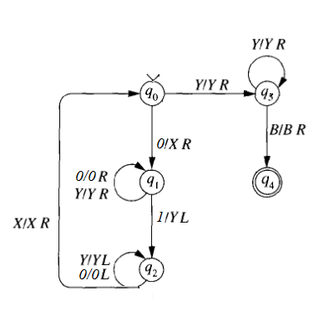
2/ Write the computation of M with string 000111 following my slides
3/ Use jflap to enter M and test with string 000111. Compare with the computations made manually.
4/ Give an example of a string over {a, b} that is not accepted by M. Explain why?
5/ Use jflap to enter the following 2-tape TM (named N)
6/Test N with string abababab
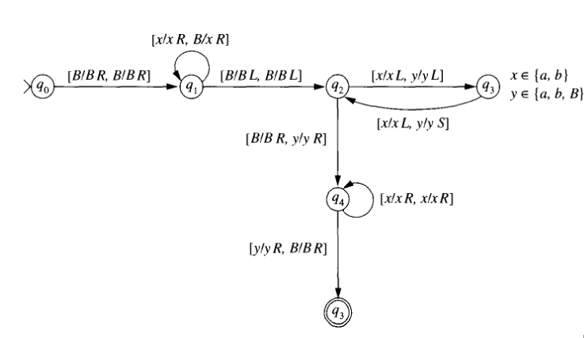
7/ Give an example of a string over {a, b}that is not accepted by N. Explain why?
8/Save the Turing machines to files. Distinguish between 1-tape Turing machine and 2-tape Turing machine in file.
Video: create a Turing machine and test on strings
https://www.youtube.com/watch?v=SA2o7UnYqbw&t=4192s

