Fine-scale locomotor actuation reveals ecologically meaningful hydrodynamic cues in fish wakes

Bastien Lagneaux¹, Corentin Porcon¹, Michael Mabelle², Thomas Omarini¹, Boai Sun¹, Nadia Maria Hamilton³, Florence Razan¹, James Herbert-Read³, Gurvan Jodin¹
¹ Univ Rennes, ENS Rennes, CNRS IETR – UMR 6164, Rennes, France
² AMIAD, France
³ Department of Zoology, Cambridge University, Cambridge, United Kingdom

Abstract
Fish can sense hydrodynamic information left by other swimmers, but how such information contributes to behavioural decisions, including predator–prey interactions or conspecific following, remains unclear. Wake structure and the swimming parameters that shape it are difficult to characterize experimentally because the complete flow field cannot usually be measured non-invasively around freely swimming animals. Here, sparse wall-mounted pressure measurements were combined with numerical wake reconstruction. A deforming, fish-shaped digital twin and a cylinder surrogate were driven by the same measured trajectories. Simulated pressure segments associated with tracked vortices were compared with measured signals. Measured segments were more consistently associated with the fish-shaped digital twin than with the cylinder, particularly when streamwise body-surface deformation was included in the moving boundary condition. Vortex-based interpretation showed the strongest fish-specific information was carried not simply by vortex size or intensity, but by vortex persistence, displacement, trajectory geometry and spatial position. Simplified bodies reproduced some short-lived local disturbances near the swimmer, whereas realistic fish kinematics became increasingly important for vortices persisting downstream. These results suggest that fine-scale body deformation contributes substantially to hydrodynamic information in fish wakes, with implications for lateral-line sensing, individuality in wake signature and hydrodynamic communication.
Keywords: fish wake; lateral line; hydrodynamic communication; digital twin; vortex persistence; computational fluid dynamics; wake sensing

Introduction
In aquatic environments, swimming bodies generate hydrodynamic wakes, spatio-temporal flow structures that encode information about their size, trajectory and motion history [1]. These flow signatures can be sensed by fish through sensory organs, such as the lateral line system, which detects pressure gradients and velocity fluctuations associated with vortical structures [2-4]. Such hydrodynamic cues have been shown to contribute to behaviours including schooling and have been associated with energetic benefits in collective motion [5].
Yet, the way in which these cues are structured in the wake of a freely swimming fish remains difficult to study directly. In particular, the complete wake should ideally be measured without disturbing the animal, while retaining enough spatial and temporal resolution to preserve structures that may later be encountered by a trailing fish. In practice, experimental access is often sparse. A common strategy in fluid mechanics is therefore to replace the swimming animal with a simplified body, such as a cylinder or other canonical bluff geometry. Such surrogates are valuable because they isolate elementary wake mechanisms and make simulation or experimental control tractable. However, their biological validity depends on the question being asked.
A following fish is unlikely to experience only a generic wake signature. It may instead encounter hydrodynamic structures shaped by the detailed body kinematics of the leading fish. It is therefore necessary to ask which swimming parameters are responsible for the information preserved in the wake, and whether simplified surrogates retain or erase this information.
Here, this question was addressed by comparing a fish-shaped, deforming computational digital twin with a cylinder surrogate driven by the same experimentally observed centre-of-mass trajectory. The comparison was made against measured pressure signals from physical sensors. Because the wake itself was not measured directly, the study was designed to use the available pressure data as a proxy. Simulated pressure segments associated with tracked vortices were used to train a classifier that distinguished fish-generated from cylinder-generated signals. Measured pressure segments were then projected into the same representation to determine whether real signals were more consistent with the fish-shaped model or with the cylinder surrogate.
This study focuses on three biological questions. First, do measured pressure signals resemble wakes generated by a deforming fish-shaped body more than wakes generated by a cylinder moving along the same path? Second, what are the kinematic parameters accounting for the wake realism? Third, which vortex features carry the strongest fish-specific information, and how do they translate into both the choice of simulation model and insights on the behavioural decision-making process of freely swimming fish?

Materials and methods

Experimental data and wake models
The data used in this work originated from infrared video recordings of fish swimming in an experimental water tank equipped with wall-mounted pressure sensors. The recordings were obtained at 100 frames per second with an image resolution of 2000 x 1200 pixels. The fish body and sensor locations were visible in the same view, allowing fish motion to be related to the pressure signals measured at the wall.
Fish body contours were extracted from the video sequence using the HAACHAMA pipeline [6, 7], summarised in Figure 1. Each frame was represented by a closed contour, and each sequence therefore described both displacement and deformation of the fish body through time. These contours were used to generate a deforming, fish-shaped computational digital twin in LyliPad [8]. The same contours were also used to compute the fish centre-of-mass trajectory, which drove a cylindrical surrogate with a diameter set by fish body width. The comparison was therefore controlled: the digital twin and the cylinder shared the same observed path but differed in body shape and deformability.
Four variants were considered to test which aspects of kinematic fidelity mattered most. The baseline, or raw, digital twin used the original sequence. A size-constrained variant enforced contour length to reduce frame-to-frame segmentation variability. A streamwise-deformation variant modified the moving boundary forcing so that both streamwise and transverse components of body surface motion contributed to the fluid forcing. A full variant combined the size constraint and the streamwise-deformation addition. For the cylinder surrogate, the size constraint had no effect because the geometry was already fixed; the size constraint variant of the cylinder was thus identical to the raw variant, as well as the streamwise-deformation to the full variant.
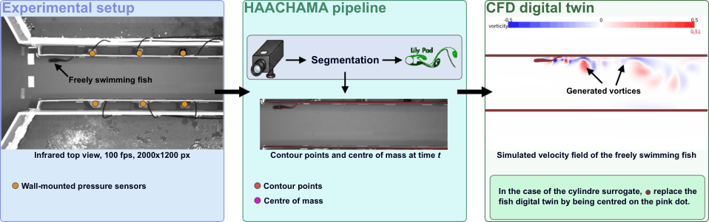
Figure 1. Overview of the HAACHAMA pipeline used to generate a deforming fish-shaped digital twin and a cylinder surrogate. Infrared video recordings provided the fish trajectory and body contour, and wall-mounted pressure sensors provided the only direct experimental access to the wake. The fish-shaped digital twin and the cylinder surrogate were driven by the same centre-of-mass trajectory

Using sparse pressure measurements to evaluate wake realism
Direct experimental access to the full wake was not available, so wake realism was evaluated through the pressure signals measured at the wall. Simulated pressure signals were extracted at sensor locations during the passage of tracked vortices. Vortices were identified from the simulated velocity fields using the Q-criterion. The Q-criterion is defined as
$Q=\frac{1}{2}(∥Ω∥^{2}-∥S∥^{2})$,
where $Ω$and $S$ are the antisymmetric (rotation) and symmetric (strain) parts of the velocity gradient tensor, respectively. Positive values of $Q$ therefore correspond to regions where rotational motion dominates over deformation, and are commonly used to detect coherent vortices in fluid flows [9, 10]. Vortex trajectories were retained only when they passed through a sensor-sensitive region and remained sufficiently far from the generating body to reduce contamination by immediate body passage.
Pressure values at the sensor locations were then extracted at every time step for which at least one valid vortex was present. The resulting pressure segments were labelled according to the model that generate them, fish-shaped digital twin or cylinder.
Segments were normalized, mean-centred and resampled to a common length. Singular value decomposition (SVD) [11] was used to construct reduced representations of the signals, retaining 75%, 95% or 99% of simulated variance. A deliberately simple linear classifier was then trained to distinguish fish-generated from cylinder-generated simulated pressure segments. The purpose of the classifier was not to introduce a new machine-learning method, but to provide a task-specific similarity estimator [12-14] in a setting where standard analytic metrics such as Fréchet distance [15], correlation or dynamic time warping [16] were not sufficient to capture the relevant signal differences.
Measured pressure segments were processed in the same way and projected into the same reduced feature space. Because the classifier had only learned the difference between two simulated model classes, its output was interpreted comparatively: a measured signal classified as fish-like was considered more consistent with the fish-shaped digital twin than with the cylinder surrogate in the learned signal space. Low-confidence outputs were assigned to an undetermined class. Confidence thresholds from 0.50 to 0.99 were analysed.
The key points of this method are illustrated in Figure 2.
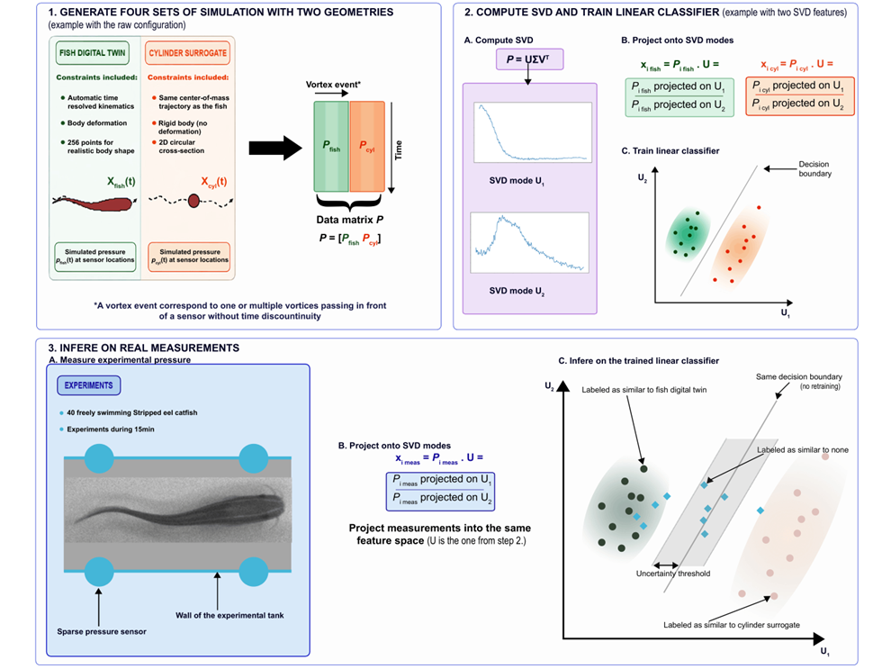
Figure 2. Schematic representation of the methodology. (1) Simulation stage: dynamic fish digital twins and cylinder surrogates are generated under different kinematic configurations (raw, size-constrained, streamwise deformation, and combined). Pressure signals are extracted from vortex tracking and assembled into a data matrix. (2) Dimensionality reduction and classification training: singular value decomposition (SVD) is applied to construct a reduced basis capturing most of the signal variance. Pressure signals are projected onto this basis to form feature vectors, used to train a linear classifier into distinguishing fish and cylinder simulations, hence defining a learned similarity metric. (3) Inference: experimental pressure signals are projected onto the same feature space and evaluated with this metric. This schematic illustrates the general methodology and its potential applicability to other domains.

Interpreting which vortex features carry fish-specific information
To relate the pressure-based results back to wake structure, labels from the pressure classifier were propagated to the vortices associated with each signal segment. A second linear classifier was trained using interpretable vortex descriptors. These descriptors included vortex duration, displacement, path length, distance to the body, distance to the sensor, speed, radius, area, Q-criterion magnitude and mean x- and y-position. SHAP (SHapeley Additive exPlanations) values [17] were used to estimate which features contributed most to the classification of a vortex as fish-like or cylinder-like. This step was used to interpret the biological content of the classifier decision: whether fish-specific information was associated with vortex strength, spatial position, trajectory geometry or persistence.

Results

Measured pressure signals consistency to fish-shaped digital twin
Across most model variants and confidence thresholds, measured pressure segments were classified more often as fish-like than as cylinder-like. This indicates that the deforming fish-shaped digital twin preserved pressure features of the real wake that were not captured by a cylinder following the same centre-of-mass trajectory. The result is strongest when interpreted biologically: matching the path of the fish was not sufficient. Though the fish-shaped digital twin should not be considered a perfect reconstruction of the real wake, this is evidence that body shape and deformation contributed information that was present in the experimental pressure measurements.
The strongest separation was obtained when streamwise deformation was included. For this x-deformation model, measured signals classified with 95% retained variance basis (Figure 3) showed a fish-cylinder difference of approximately 30% at 99% confidence. The 75% (Figure 4) and 99% (Figure 5) retained variance bases showed the same qualitative pattern, with differences of the order of 20%. This consistency suggests that the effect was not an artefact of a single dimensionality reduction choice. This also indicates that the most discriminative pressure information was not restricted only to the highest energy modes but was also present in intermediate signal components.
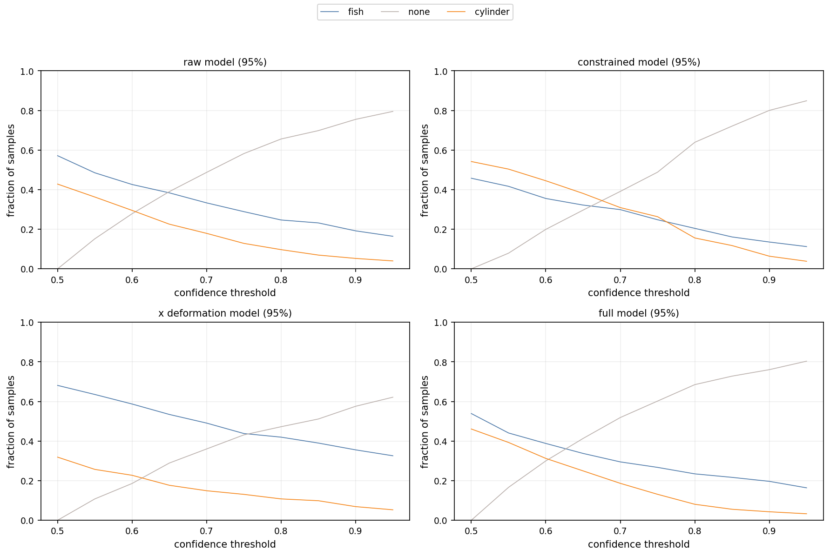
Figure 3. Fractions of measured pressure-signal segments classified as fish, cylinder or undetermined when 95% of the simulated variance was retained. Across most configurations, measured signals were more frequently associated with the fish-shaped model than with the cylinder surrogate.
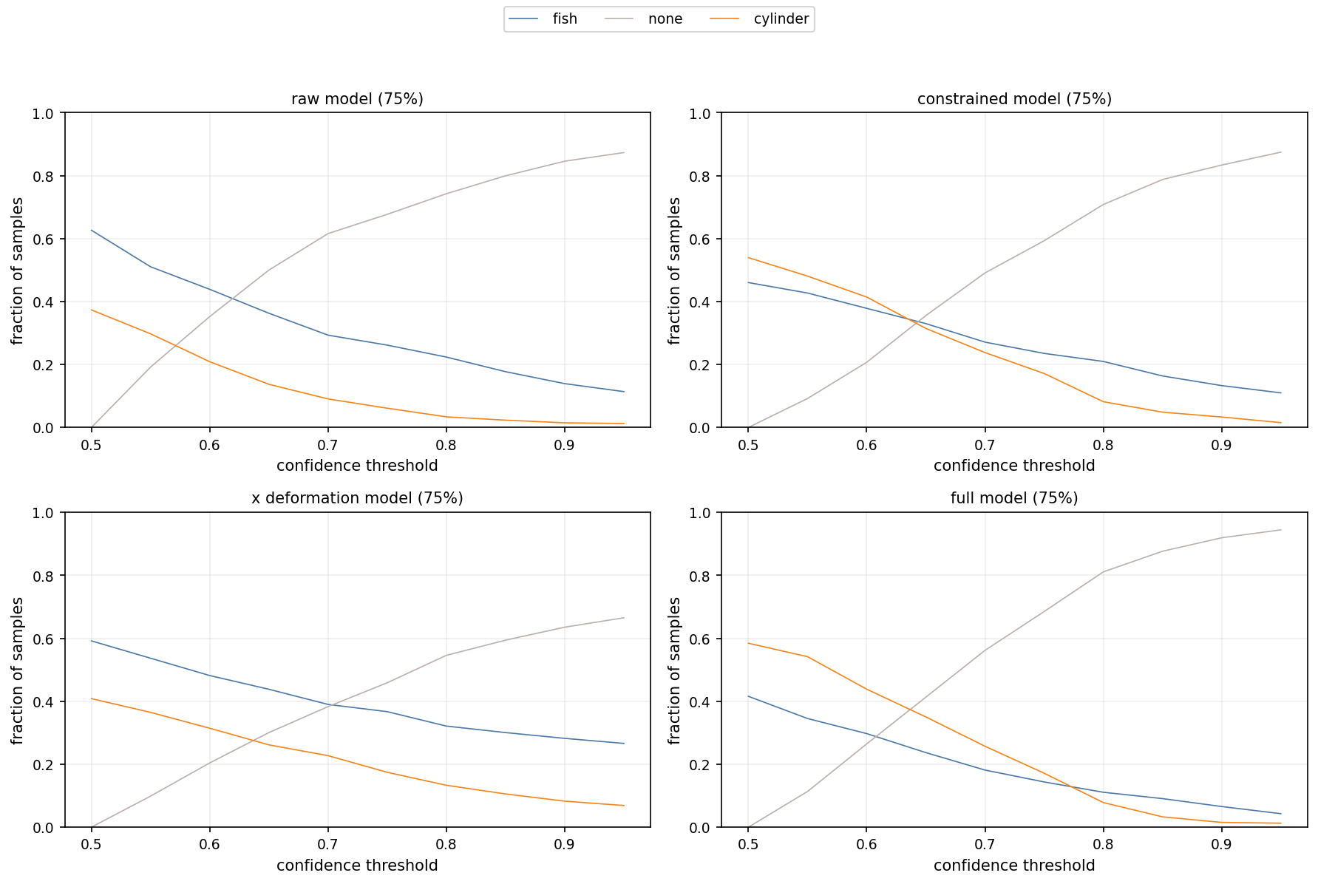
Figure 4. Fractions of measured pressure-signal segments classified as fish, cylinder or undetermined when 75% of the simulated variance was retained. Across most configurations, measured signals were more frequently associated with the fish-shaped model than with the cylinder surrogate.
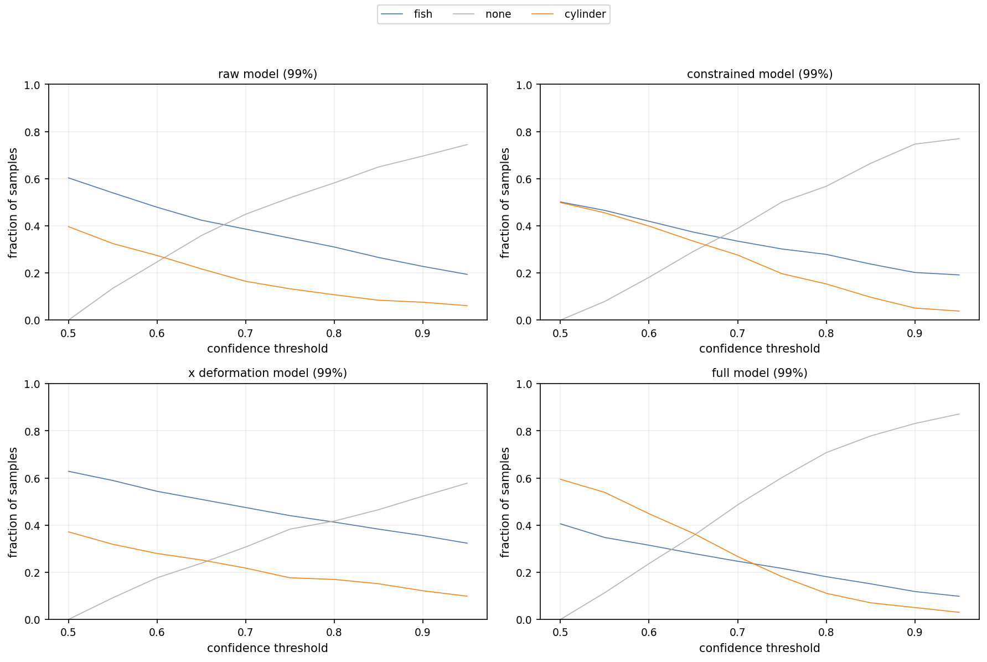
Figure 5. Fractions of measured pressure-signal segments classified as fish, cylinder or undetermined when 99% of the simulated variance was retained. Across most configurations, measured signals were more frequently associated with the fish-shaped model than with the cylinder surrogate.

Kinematic parameters for preserving wake realism

Streamwise body deformation
The most consistent improvement in similarity to measured pressure signals came from allowing streamwise as well as transverse body deformation to force the fluid. This modification did not alter the input contour sequence; it changed how the measured local motion of the body was imposed on the fluid. Its effect therefore points to a physical conclusion: longitudinal redistribution of the body surface, local stretching and compression, and other in-plane components of the body deformation contribute measurably to the wake signals that reach the sensors.
This is important because fish locomotion is often described primarily in terms of lateral body undulation and centre-of-mass motion [18, 19]. The present results suggest that, for wake cues, streamwise components of the body-surface motion should not be treated as negligible implementation details. They can influence the hydrodynamic signature left behind the swimmer and may therefore affect the information available to downstream receivers.

Size consistency constraint
The size-constrained model was introduced to remove frame-to-frame variability in the segmented contour, which could plausibly arise from segmentation noise. However, this constraint did not improve similarity to measured signals. Instead, the constrained model made fish and cylinder simulations harder to distinguish, and measured signal classifications became less stable. The combined full model, which included the size constraint as well as streamwise deformation, also failed to improve over the streamwise deformation model alone.
A likely interpretation is that apparent contour variability in the two-dimensional video was not purely noise. Because the fish was a three-dimensional swimmer recorded from a single view, changes in projected contour size may have carried indirect information about out-of-plane motion, body roll or posture-dependent shape changes. Removing this variability may therefore have filtered out biologically meaningful information along with segmentation artefacts. The size-constrained model may consequently have simplified the digital twin rather than making it more realistic, once again demonstrating how small body surface motion should not be treated as negligible.

Fish-specific information in structured vortices

SHAP analysis
The vortex-feature analysis focused on the streamwise deformation model with 95% retained variance, because this condition gave the clearest pressure-based separation. SHAP analysis showed that the most influential descriptors were vortex displacement (the length of the straight line between the initial and final position of the vortex), mean distance to the body which is responsible for the generation of the vortex, mean core x-position, path length (the total length travelled by the vortex) and lasting duration in number of frames. Thus, fish-specific information was not explained simply by vortex size, speed or intensity.
It was associated primarily with where vortices travelled, how far they moved, how their trajectories developed and how they were positioned relative to the body. In the analysed subset, cylinder-associated vortices (positive values) tended to be shorted-lived, with shorter (blue points) duration values and smaller average positions, more intense at their generation but decaying more quickly, as shown by the combination of the mean and max radius values and by the average speed, and more rectilinear, as demonstrated by the displacement and path length ratio. On the other hand, fish-associated vortices were generally longer-lived, weaker, hence slower to decay, and followed more curved and spatially distributed paths.
These results are summarised in Figure 6, showing the SHAP values for each sample of the subset. The pattern found in these results suggested that some cylinder associated vortices were driven by near-body transient rather than by persistent wake structures.
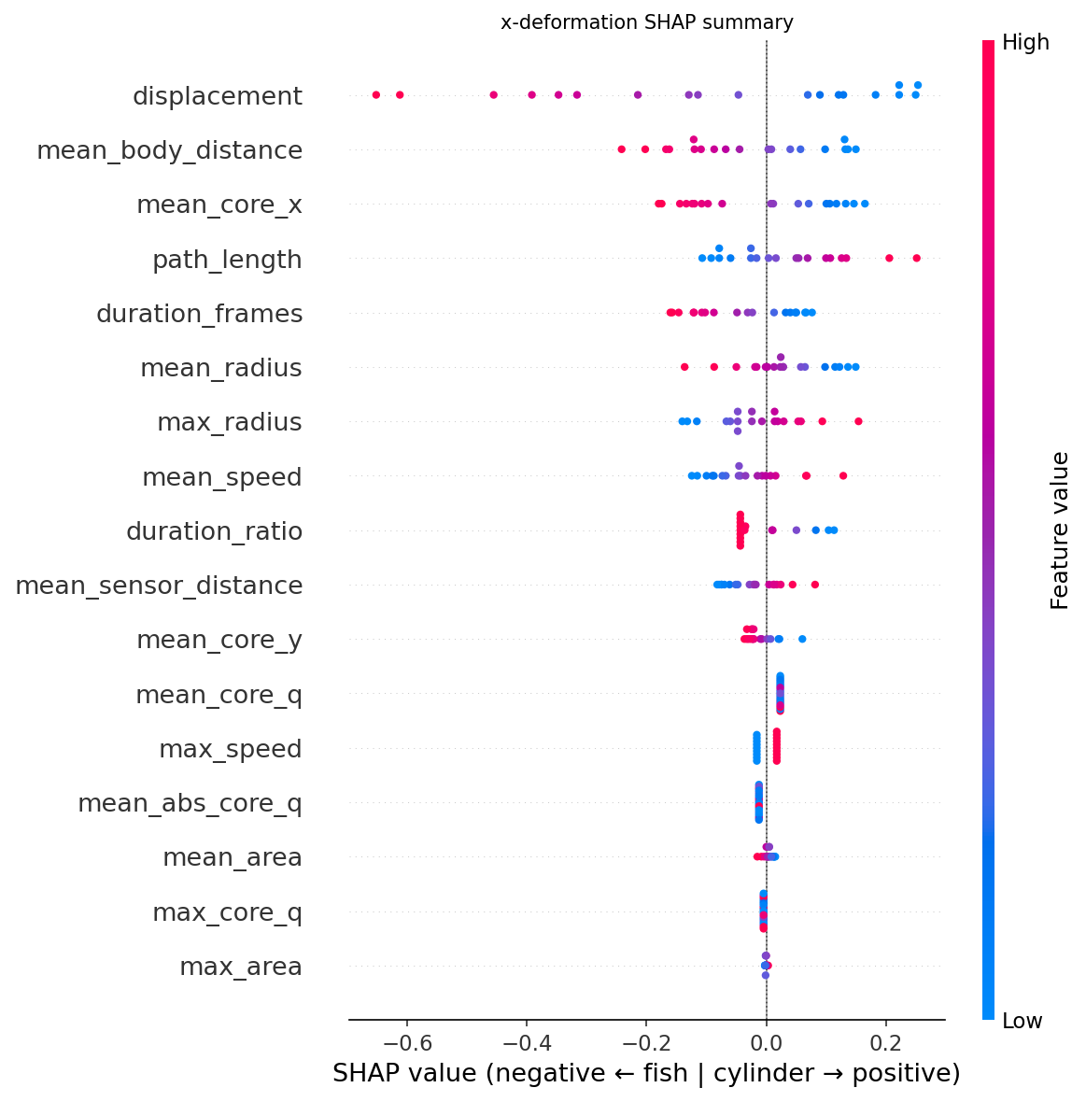
Figure 6. SHAP summary plot for the second stage vortex-feature classifier. The most informative descriptors were related to vortex displacement, distance from the body, streamwise position, travelled path and duration, indicating that fish-specific information was expressed primarily through the spatial organisation and persistence of vortical structures.

Near-body disturbances VS persistent wake structures
To test whether cylinder-like classifications were driven by transient near-body events, the minimum allowed distance between vortex and the body that generated it was varied. In the streamwise deformation subset, the baseline distance filter gave 30.3% of fish-like and 4.4% cylinder-like measured segments at 99% confidence (Figure 7). When the minimum distance was halved, the fish-like fraction decreased to 24.8% and the cylinder-like fraction increased to 10.6%. When the minimum distance was doubled, the fish-like fraction increased to 37.9%, while the cylinder-like fraction was 7.2%.
These trends support the interpretation that the cylinder surrogate can reproduce some immediate pressure disturbances associated with body passage, especially near the swimmer. However, when the analysis emphasises structures that are farther from the body and therefore more likely to represent the persistent wake, the advantage of the fish-shaped digital twin increases. This distinction is biologically important because a trailing fish is unlikely to respond on to the instantaneous disturbance produced at the body surface of a leader. It is more likely to encounter vortical structures that have survived downstream transport.
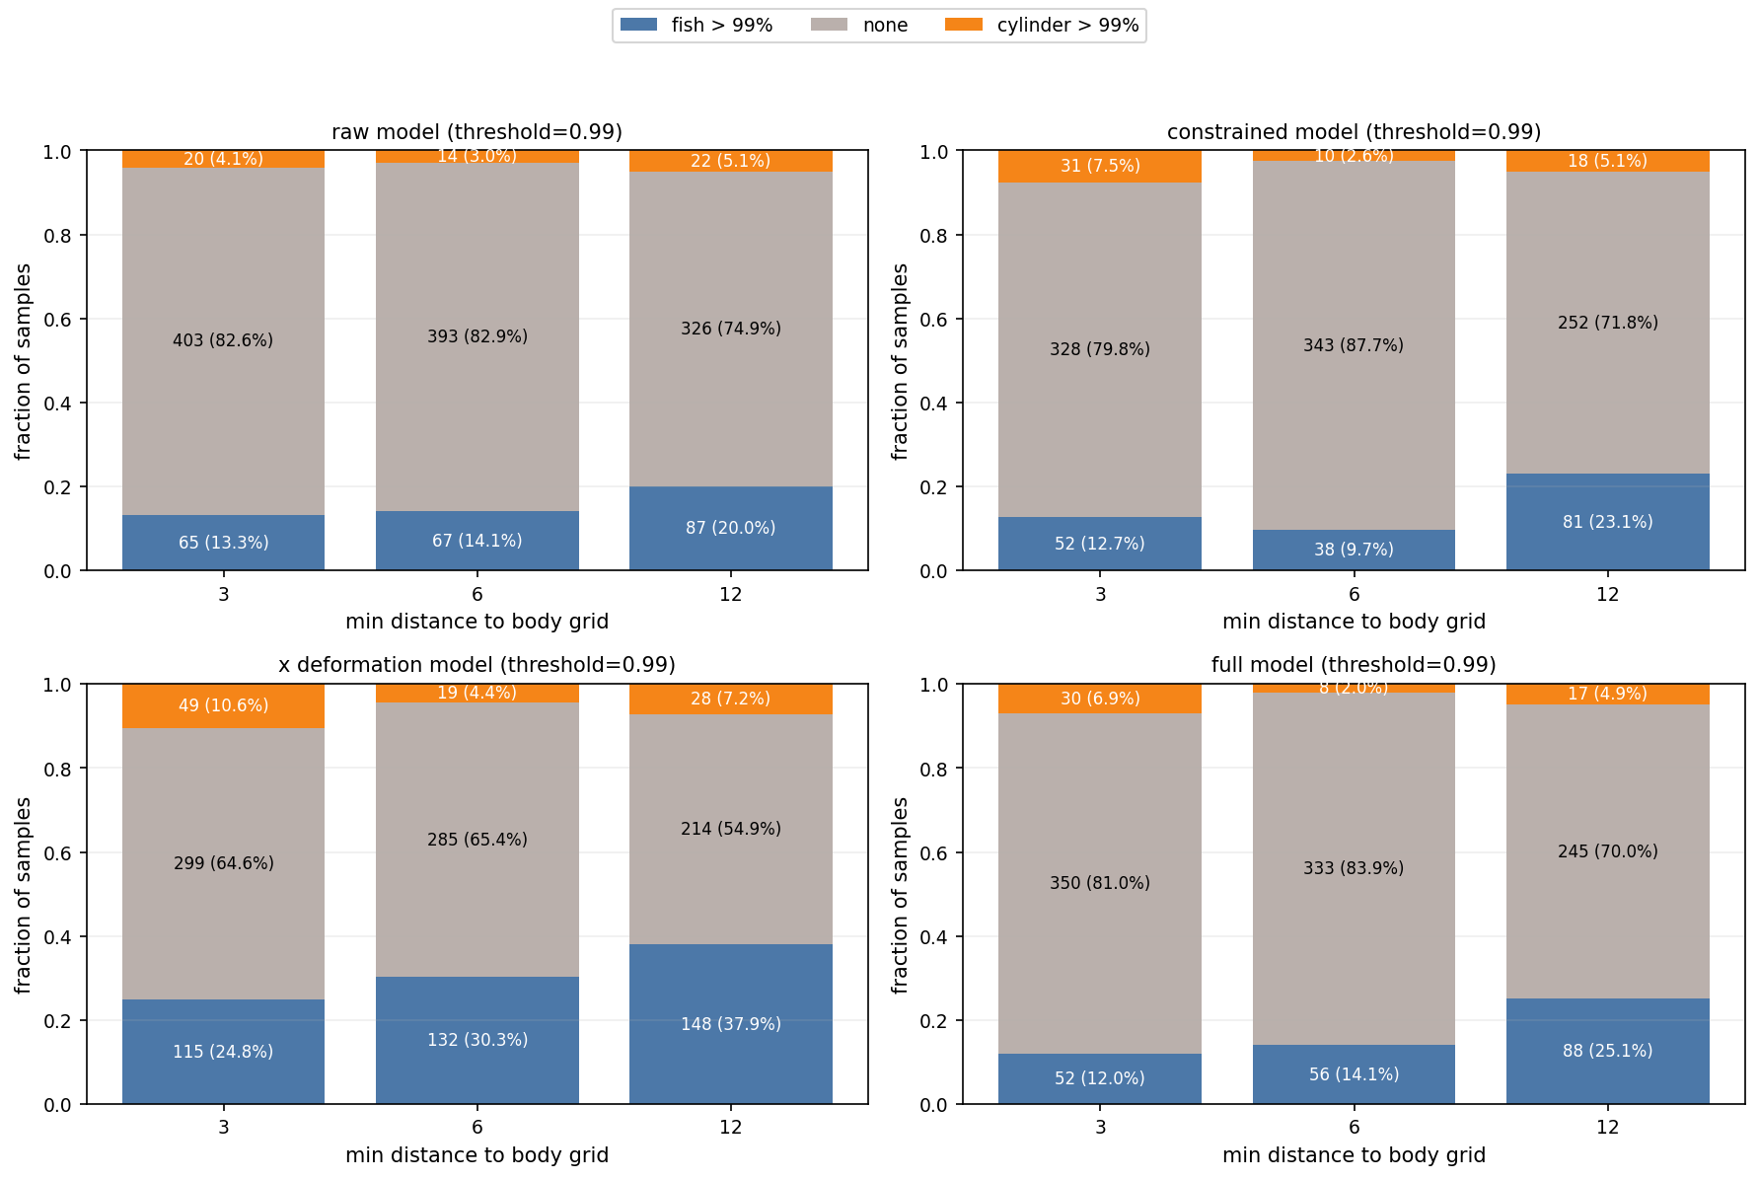
Figure 7. Effect of the minimum body-distance filter on measured signal classifications at 99% confidence. Increasing the exclusion of near-body vortices strengthened the association between measured pressure signals and the fish-shaped digital twin, supporting the hypothesis that persistent wake structures contained the strongest fish-specific information.

Discussion

Fine scale body deformation implementation for biological realism of wake cues
The main result is that a fish-shaped, deforming digital twin reproduced measured hydrodynamic signals more consistently than a cylinder surrogate following the same path. This shows that centre-of-mass trajectory alone does not preserve all wake information generated by a swimming fish. Realistic body kinematics, particularly streamwise deformation, contribute to pressure and vortex structures that remain detectable away from the body. For studies of lateral line sensing and behavioural decision making, this matters because the sensory variable of interest is not merely whether another body has passed, but what hydrodynamic information persists in the wake and can be sampled by another fish.
Because the wake depends on fine-scale kinematics, differences in swimming style, behavioural state, acceleration, manoeuvring, body roll or individual morphology could alter the downstream hydrodynamic signature. This raises the possibility that wakes contain information about individual identity or intent, even when such information is not explicitly represented in simplified models.
The present study does not demonstrate hydrodynamic communication directly. It does, however, show that removing kinematic detail, which might correspond to the intermediate energy modes that appeared to be needed to capture the full variance of the flow when computing the SVD, can remove information from the wake. This supports the broader hypothesis that natural fish wakes may be richer sensory environments than canonical body models suggest and therefore refine the role of simplified surrogates. Cylinders and other such bodies remain useful for isolating fundamental wake mechanisms, and in the present study, they could account for some short-lived local disturbances, however, the fish-shaped digital twin became increasingly important when the analysis focused on persistent vortical structures.
The vortex analysis indeed suggests that biologically relevant wake information is carried less by local intensity alone than by trajectory geometry and persistence. This is consistent with the ecological setting in which a follower samples the wake after the leader has moved on. A near-body pressure fluctuation may indicate immediate body passage, but a persistent vortex can carry information downstream, remain available over a longer time window and influence how a trailing fish positions itself or exploits the wake energetically. This interpretation also links the present results to schooling, vortex exploitation and collective navigation. In such behaviours, fish benefit from detecting coherent structures produced by neighbours rather than only responding to the instantaneous location of the body. If realistic body deformation changes the persistence, curvature and spatial distribution of vortices, then subtle differences in swimming kinematics could alter the hydrodynamic information available to other fish.
Future experiments that combine multiple camera views, direct behavioural observations of followers and pressure or flow measurements could test whether fish actually use these fine-scale differences.

Methodological role of the classifiers
The machine-learning components should be interpreted as tools for biological inference: the first classifier provided a supervised way to compare sparse measured pressure signals with two competing simulated wake models when no single predefined time-series metric was adequate; the second classifier and SHAP analysis then translated the pressure-based labels back into interpretable vortex features. This combination is useful because it connects indirect experimental measurements to physical wake structures, while keeping the biological question – which wake model better preserves realistic information and how does this information translate into vortex behaviour – at the centre of the analysis.
Detailed architecture choices, hyperparameter optimisations and training tables can be found in the supplementary materials. Details about the data base used in this study are also available in the supplementary materials, and all the needed files to reproduce the results presented here can be found in the Zenodo repository [20].

Limitations and future directions
Several limitations should be acknowledged. First, both the video reconstruction and the simulations were two-dimensional. A second camera view would be required to reconstruct the three-dimensional body motion and to distinguish segmentation noise from projected out-of-plane kinematics. Second, wall-mounted pressure sensors provide sparse indirect measurements. They are valuable because they are non-invasive, but they cannot fully resolve the wake. Third, the classifier estimates comparative consistency with two simulated model classes: it does not prove that either model exactly reproduces the real wake. Finally, distance from the body was used as a practical proxy for wake persistence. Future work should analyse vortex survival time relative to behaviourally relevant follower arrival times more directly.

Conclusion
This study shows that the biological value of a fish digital twin lies not simply in geometric complexity, but in preserving the kinematic mechanisms that generate wake information. Measured pressure signals were more consistently associated with a deforming fish-shaped model than with a cylinder following the same path, and this advantage was strongest when streamwise body deformation was included. Vortex-level interpretation showed that persistent, spatially structured vortices carried the strongest fish-specific information, whereas simplified bodies mainly reproduced short-lived local disturbances. These findings suggest that realistic body deformation contributes substantially to the hydrodynamic cues available in fish wake. For questions involving lateral line sensing, schooling, vortex exploitation and wake-mediated interactions, simplified surrogates may therefore miss biologically meaningful information that persists downstream. The implications extend beyond the study of fish and could benefit the design of bioinspired sensing and control strategies for underwater robotics, or human or any other complex body swimming analysis.
The next step is to combine three-dimensional kinematic reconstruction, richer sensing and data assimilation between measurements and simulations. This would allow digital twins to move beyond model comparison toward direct inference of the hydrodynamic cues available to fish during following and predator-prey interactions.

References
[1] Weihs D. Some hydrodynamical aspects of fish schooling. In Swimming and Flying in Nature: Volume 2 1975 (pp. 703-718). Boston, MA: Springer US.
[2] Drucker EG, Lauder GV. A hydrodynamic analysis of fish swimming speed: wake structure and locomotor force in slow and fast labriform swimmers. Journal of Experimental Biology. 2000 Aug 15;203(16):2379-93.
[3] Videler JJ, Stamhuis EJ, Müller UK, van Duren LA. The scaling and structure of aquatic animal wakes. Integrative and comparative biology. 2002 Nov 1;42(5):988-96.
[4] Coombs S, Janssen J, Webb JF. Diversity of lateral line systems: evolutionary and functional considerations. InSensory biology of aquatic animals 1988 (pp. 553-593). New York, NY: Springer New York.
[5] Liao JC, Beal DN, Lauder GV, Triantafyllou MS. Fish exploiting vortices decrease muscle activity. Science. 2003 Nov 28;302(5650):1566-9.
[6] Lagneaux B, Jodin G, Fan D, Herbert-Read J, Porcon C, Razan F. An automatic highly dynamical digital twin design with YOLOv8 for hydrodynamic studies on living animals. In2024 International Conference on Artificial Intelligence, Computer, Data Sciences and Applications (ACDSA) 2024 Feb 1 (pp. 1-7). IEEE.
[7] Lagneaux B, Porcon C, Keribin J, Fan D, Razan F, Jodin G. From Realistic and Automated Fish Digital Twin to Data Ethics: Building Reproducible Pipelines and Dataset for Biological AI. InDebConf25 2025 Jul 15 (p. 12).
[8] Maertens AP, Weymouth GD. Accurate Cartesian-grid simulations of near-body flows at intermediate Reynolds numbers. Computer Methods in Applied Mechanics and Engineering. 2015 Jan 1;283:106-29.
[9] Hunt JC, Wray AA, Moin P. Eddies, streams, and convergence zones in turbulent flows. Studying turbulence using numerical simulation databases, 2. Proceedings of the 1988 summer program. 1988 Dec 1.
[10] Kolář V. Vortex identification: New requirements and limitations. International journal of heat and fluid flow. 2007 Aug 1;28(4):638-52.
[11] Klema V, Laub A. The singular value decomposition: Its computation and some applications. IEEE Transactions on automatic control. 1980 Apr 30;25(2):164-76.
[12] Hadsell R, Chopra S, LeCun Y. Dimensionality reduction by learning an invariant mapping. In2006 IEEE computer society conference on computer vision and pattern recognition (CVPR'06) 2006 Jun 17 (Vol. 2, pp. 1735-1742). IEEE.
[13] Pacchiardi L, Künzli P, Schöngens M, Chopard B, Dutta R. Distance-learning for approximate Bayesian computation to model a volcanic eruption. Sankhya B. 2021 May;83(1):288-317.
[14] Tkachev G, Frey S, Ertl T. S4: Self-supervised learning of spatiotemporal similarity. IEEE Transactions on Visualization and Computer Graphics. 2021 Aug 2;28(12):4713-27.
[15] Fréchet MM. Sur quelques points du calcul fonctionnel. Rendiconti del Circolo Matematico di Palermo (1884-1940). 1906 Dec;22(1):1-72.
[16] Bellman R, Kalaba R. On adaptive control processes. IRE Transactions on Automatic Control. 2003 Jan 6;4(2):1-9.
[17] Lundberg SM, Lee SI. A unified approach to interpreting model predictions. Advances in neural information processing systems. 2017;30.
[18] Li L, Ravi S, Xie G, Couzin ID. Using a robotic platform to study the influence of relative tailbeat phase on the energetic costs of side-by-side swimming in fish. Proceedings of the Royal Society A: Mathematical, Physical and Engineering Sciences. 2021 May 1;477(2249). https://doi.org/10.1098/rspa.2020.0810
[19] Sfakiotakis M, Lane DM, Davies JB. Review of fish swimming modes for aquatic locomotion. IEEE Journal of oceanic engineering. 1999 Apr 30;24(2):237-52.
[20] Lagneaux B, Porcon C, OMARINI T, Sun B, Hamilton NM, Florence R, et al. How fishes use historical hydrodynamic motion cues in search and navigation tasks: measured and simulated pressure for vortex extraction and analysis. Zenodo; 2026. https://doi.org/10.5281/zenodo.19224933

