Supplementary material for: Fine-scale locomotor actuation reveals ecologically meaningful hydrodynamic cues in fish wakes

S1. Assessment of fish-identity dependence among retained pressure samples
Because several retained pressure segments can originate from the same recording, we evaluated whether measured wall-pressure samples showed strong dependence on recording identity before interpreting segment-level classifications. The current metadata do not contain a separate fish identifier, so video identity, stored as ‘experiment’ in the pressure metadata, was used as the available proxy for fish identity. The diagnostic was restricted to videos with at least five retained measured-pressure segments.
For this diagnostic, measured pressure segments were transformed with the same preprocessing later used for pressure classification: missing values were interpolated, segments were resampled to a common length, mean-centred and amplitude-normalized. A SVD basis was then computed from the retained measured-pressure matrix alone, and samples were represented by the coefficients of the modes explaining 99% of measured-signal variance. We quantified video-level dependence in two complementary ways. First, for each SVD coefficient, the fraction of variance explained by video identity was estimated as SSbetween video/SStotal, with an ICC(1)-style estimate used as a companion grouping metric [shrout1979]. Second, pairwise Euclidean distances in standardized measured-SVD coefficient space were compared between same-video and different-video sample pairs, with group-level bootstrap intervals and a label-permutation test used to assess whether same-video samples were systematically closer [anderson2001].
The measured-pressure video-identity analysis retained [INSERT NUMBER OF MEASURED PRESSURE SEGMENTS] segments from [INSERT NUMBER OF VIDEOS] videos and projected them onto [INSERT NUMBER OF MODES] measured-pressure POD modes explaining 99\% of variance. The variance-weighted video-identity fraction was [INSERT VALUE], and the median per-mode identity fraction was [INSERT VALUE]. The ICC(1)-style estimates were [INSERT SUMMARY].
In standardized measured-POD space, the median same-video distance was [INSERT VALUE] and the median different-video distance was [INSERT VALUE]. The distance contrast was [INSERT VALUE], with [INSERT UNCERTAINTY OR PERMUTATION RESULT]. Thus, [INSERT INTERPRETATION OF WHETHER RETAINED MEASURED PRESSURE SEGMENTS SHOW STRONG VIDEO-LEVEL CLUSTERING]. This diagnostic was used to decide whether segment-level classification results should be supported by grouped-by-video validation or discussed as a limitation.

S1. Dataset composition and dimensionality reduction
The following table reports the number of retained pressure segments and the size of the reduced bases used for the pressure-signal classifier. These details were moved from the main text to keep the manuscript centred on the biological interpretation while preserving reproducibility.
Table S1. Dataset composition and dimensionality reduction for the four simulation configurations. Raw configuration corresponds to the baseline pipeline. Constrained corresponds to the size-constrained model, where the length of the contour of the digital twin is fixed for the whole simulation. X-deformation corresponds to the model using both the streamwise and transverse deformation of the contour of the digital twin instead of only the transverse deformation. Full corresponds to the model implementing both the size-constrained contour and using the streamwise deformation of the contour.

 | Raw | Constrained | X-deformation | Full
Samples (fish/cylinder) | 163/162 | 159/161 | 161/162 | 162/161
Pressure segments extracted | 956/797 | 796/723 | 1009/798 | 702/723
After minimum-length filter | 238/236 | 186/205 | 200/236 | 192/205
After divergence filter | 238/233 | 171/202 | 189/233 | 186/202
Balanced segments | 233/233 | 171/171 | 189/189 | 186/186
Resampled signal length | 682 | 564 | 580 | 573
Modes for 75% variance | 5 | 5 | 23 | 6
Modes for 95% variance | 34 | 32 | 92 | 51
Modes for 99% variance | 103 | 94 | 153 | 114

S2. Pressure-signal classifier settings
The pressure-signal classifier was trained after normalization of the amplitude, mean-centring, resampling to a common number of points defined by the longest segment in the relevant subset and projection of pressure segments onto SVD modes retaining 75%, 95% or 99% of the simulated variance. The data was split into training, validation and test subsets in a 70/15/15 ratio. Hyperparameters for a linear classifier with a single layer and a Mean Square Error loss were selected independently for each model and retained-variance level.
Although optimisation was performed using neural-network tooling, no hidden nonlinearity was introduced, so that the model remained strictly linear. This choice was motivated by the need to maximise interpretability and to limit overfitting given the relatively small dataset. The use of neural-network frameworks was nevertheless retained for implementation, as it provides access to efficient optimisation routines and allows straightforward extension to more complex architectures should larger datasets become available in future.
Table S2. Hyperparameters selected independently for each model and retained-variance level.
Model | Hidden size | Learning rate | Weight decay | Epochs | Batch size
Raw 75 | 32 | 0.0002 | 0.0002 | 200 | 64
Constrained 75 | 16 | 0.0006 | 0.0005 | 50 | 16
X-deformation 75 | 32 | 0.0002 | 0.0010 | 200 | 64
Full 75 | 32 | 0.0010 | 0.0006 | 200 | 64
Raw 95 | 4 | 0.0003 | 0.0009 | 200 | 64
Constrained 95 | 8 | 0.0009 | 0.0008 | 200 | 64
X-deformation 95 | 4 | 0.0010 | 3.8626 | 100 | 64
Full 95 | 16 | 0.0006 | 0.0002 | 50 | 16
Raw 99 | 4 | 0.0010 | 0.0002 | 200 | 64
Constrained 99 | 16 | 0.0010 | 0.0009 | 100 | 16
X-deformation 99 | 32 | 0.0010 | 0.0008 | 200 | 64
Full 99 | 4 | 0.0006 | 0.0006 | 200 | 64

S3. Pressure-signal classifier performance
The following accuracies describe how well the classifier separated fish-generated and cylinder-generated simulated pressure signals. These values were used to assess whether the two simulated model classes were distinguishable before measured pressure signals were projected into the same feature spaces.
These values remained moderate rather than near perfect, but this was not unexpected. The fish and cylinder models can generate partially overlapping pressure signatures in some kinematic situations, particularly when the body turns sharply and presents a locally bluff geometry to the sensor. Perfect separability should therefore not be expected from sparse wall-pressure measurements alone.
Table S3. Classification accuracies for the first-stage pressure-signal classifier.
 | Raw | Constrained | X-deformation | Full
Training accuracy (75%) | 0.67 | 0.68 | 0.75 | 0.67
Validation accuracy (75%) | 0.69 | 0.65 | 0.81 | 0.82
Test accuracy (75%) | 0.74 | 0.63 | 0.84 | 0.61
Training accuracy (95%) | 0.70 | 0.74 | 0.74 | 0.71
Validation accuracy (95%) | 0.70 | 0.65 | 0.77 | 0.73
Test accuracy (95%) | 0.76 | 0.65 | 0.84 | 0.57
Training accuracy (99%) | 0.78 | 0.75 | 0.80 | 0.75
Validation accuracy (99%) | 0.64 | 0.65 | 0.84 | 0.66
Test accuracy (99%) | 0.67 | 0.60 | 0.79 | 0.55

Uncertainty:
The first-stage classifier showed that fish and cylinder simulations were separable but overlapping. At 95\% retained variance, test accuracies were 0.757 for the raw model (95\% Wilson CI 0.645--0.842, $n=70$), 0.654 for the size-constrained model (0.518--0.768, $n=52$), 0.839 for the x-deformation model (0.722--0.913, $n=56$) and 0.571 for the full model (0.441--0.692, $n=56$). These moderate accuracies support comparative use of the classifier but do not justify treating classification as direct wake reconstruction.

S4. Details of contour-size consistency
The contour extracted from each video frame was treated independently in the original pipeline. To reduce frame-to-frame segmentation variability, a contour-length consistency constraint was introduced. The fish centreline, termed the spine, was first estimated from the raw contour by partitioning the body into upper and lower regions of equal area. The spine was then extrapolated at the snout and tail tips. Finally, a fish template whose length was fixed from the first video frame was placed along the spine and optimised against the raw detection by minimising the intersection-over-union mismatch.
The size-constrained sequence preserved a constant contour length while leaving the subsequent stages of the pipeline unchanged. In the main text, this variant was interpreted with caution because it may have removed not only segmentation artefacts but also projected signatures of three-dimensional body motion.

S5. Details of streamwise deformation in the CFD twin
LilyPad represents fluid-structure interaction through functions that describe distance to the body, temporal variation of the contour and spatial variation of the contour. In the original implementation, body kinematics were imposed through a scalar transverse-deformation model. Boundary coordinates were updated from imported point clouds, but the wall velocity entering the solver was still reconstructed from a filtered transverse signal together with the local boundary slope. As a result, the moving-boundary forcing was not fully consistent with the imposed motion when individual boundary points also moved in the streamwise direction. This limitation arose because the initial implementation was designed primarily for spanwise deformation. In the present experiments, where the tank was much longer than it was wide and fish trajectories were mostly aligned with its length, this approximation remained acceptable for the raw reference model, but it did not provide a fully physical description of local boundary motion.
In the updated implementation, boundary motion was reformulated in a fully Lagrangian two-component form. At each time step, the current and previous boundary coordinates were stored, and boundary velocities were estimated directly from the discrete trajectories of the boundary points using temporal finite differences in both coordinates, with local averaging over neighbouring boundary nodes. This modification allowed both streamwise and transverse deformation to contribute to the moving-boundary condition. The contour input itself was not altered by this change; only the CFD forcing was modified.

S6. Vortex descriptors used for interpretation
The second-stage classifier used 17 physically interpretable vortex descriptors: maximum area, mean area, displacement, path length, duration in frames, duration ratio, mean distance to the body, mean distance to the sensor, maximum speed, mean speed, maximum radius, mean radius, maximum core Q-criterion value, mean core Q-criterion value, mean absolute core Q-criterion value, mean core x-position and mean core y-position.
Vortices were retained only if they were present for at least 10% of the duration of the linked pressure segment. The two classes were balanced, each feature was normalised and mean-centred, and the same 70/15/15 data split strategy was used again.
Because the streamwise deformation model with 95% retained variance provided the clearest separation in the first-stage analysis, this subset was selected for vortex-based interpretation. At a 99% confidence threshold, 63 fish-labelled and 63 cylinder-labelled vortices were available for the second-stage training set. The final hyperparameters were a learning rate of 0.0069, weight decay of 2 × 10-6, 75 training epochs and a batch size of 8. On the test set, the second classifier achieved an F1 score of approximately 0.80 for both classes.

S7. Results for 75% and 99%
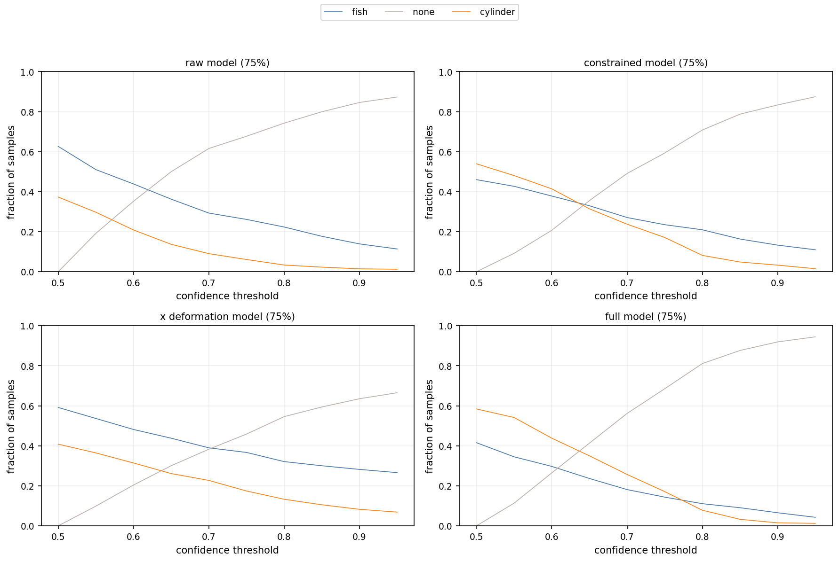
Figure 4. Fractions of measured pressure-signal segments classified as fish, cylinder or undetermined when 75% of the simulated variance was retained. Across most configurations, measured signals were more frequently associated with the fish-shaped model than with the cylinder surrogate.
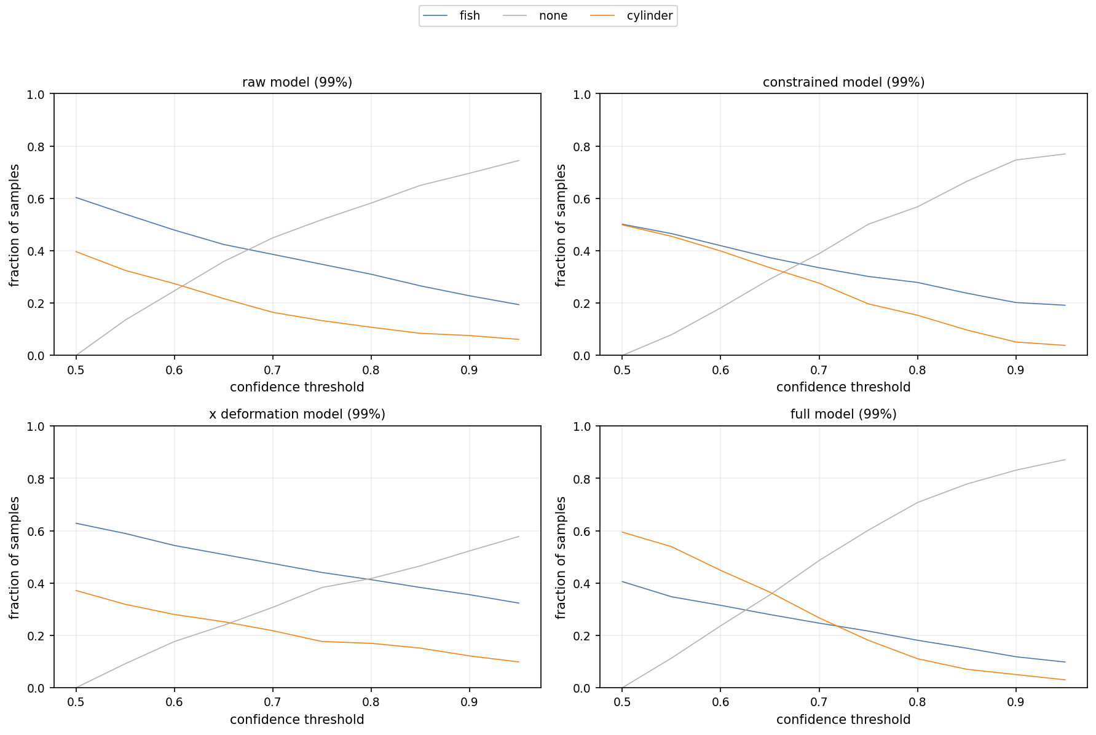
Figure 5. Fractions of measured pressure-signal segments classified as fish, cylinder or undetermined when 99% of the simulated variance was retained. Across most configurations, measured signals were more frequently associated with the fish-shaped model than with the cylinder surrogate.

