Table of Contents

2021/09/10 Data 2

Methods 2

Data Acquisition 2

Download from NextStrain 2

Extract the GISAID accession IDs of the NextStrain subsamples 2

Download NextStrain subsample sequence from GISAID 2

Multiple sequence alignment and mutation calling via NextClade 2

Other… 2

Data Analysis 3

Sample Characteristic 3

Clade Identification 3

Clade Parameters Calculation 3

Survival Analysis Sample Acquisition 3

Results 5

All sequence samples 5

Time span 5

Phylogenetic tree 5

Frequency of substitutions in tips (samples) 5

E484 5

N501Y 5

Frequency of substitutions in ancestral nodes (ASR) 5

E484 5

N501 5

E484-mutate clades characteristics – raw 5

Size 5

Duration 6

Time distribution of samples in each clade 6

Time distribution of clade emergence (by earliest sample) 6

Clade duration and size vs. time of emergence (by earliest sample) 7

E484-mutate clades genetic background 8

Proportion of potential epistatic mutations among all E484K sequences (≥ 10%) 8

Proportion of potential epistatic mutations in each E484K clade (≥ 10%) 8

E484-mutate clade emergence association with time (epidemiology: level of immunity) 9

Standardized emergence by time (unit = 2-week) 9

Standardized emergence by time - 1006 Data 9

Logistic regression by continuous time (unit = day) 10

Logistic regression by continuous time (unit = week) 10

Logistic regression by continuous time (unit = month) 10

E484-mutate clade emergence association with N501Y (epistasis) 11

Proportion of N501 state at ancestral nodes of all E484 clades 11

Logistic regression of E484K emergence by N501 state at ancestral node 12

Survival analysis of E484K emergence by N501 state at parent of ancestral node 12

Survival analysis of N501Y emergence by E484 state at parent of ancestral node 12

# **2021/09/10 Data**

## **Methods**

### Data Acquisition

Folder: /Users/blahblah/Now/Harvard/E484K-20210910

#### Download from NextStrain

LINK: https://nextstrain.org/ncov/gisaid/global

> Go to bottom > DOWNLOAD DATA

> TIMETREE (NEWICK), ACKNOWLEDGEMENTS (TSV),

SCREENSHOT (SVG)

Outputs: subsample tree (nextstrain_timetree_210910.nwk)

sequence source information (nextstrain_210910.tsv)

Date: 09/10/2021

#### Extract the GISAID accession IDs of the NextStrain subsamples

Command line: cut -f 2 nextstrain_210910.tsv > nextstrain_id_210910.tsv

Outputs: nextstrain_id_210910.tsv

#### Download NextStrain subsample sequence from GISAID

LINK: https://www.gisaid.org/

> Search > Select > Upload nextstrain_id_210910.csv > OK > Download

Outputs: raw sequence (nextstrain_210910.fasta)

time & location information (nextstrain_time_location_210910.tsv)

patient metadata (nextstrain_patient_meta_210910.tsv)

Date: 03/20/2022 (03/20/2022 metadata)

#### Multiple sequence alignment and mutation calling via NextClade

LINK: https://clades.nextstrain.org/

Select Pathogen: SARS-CoV-2 > Upload nextstrain_210910.fasta

Outputs: aligned sequences (nextstrain_nextclade_aligned_210910.fasta)

mutation calling (nextclade_210910.csv)

Date: 03/20/2022

#### Other…

### Data Analysis

All data analysis performed using R version 4.0.2 (2020-06-22)

#### Sample Characteristic

Phylogenetic tree built using “ggtree” package

#### Clade Identification

Ancestral state reconstruction built using “castor” package

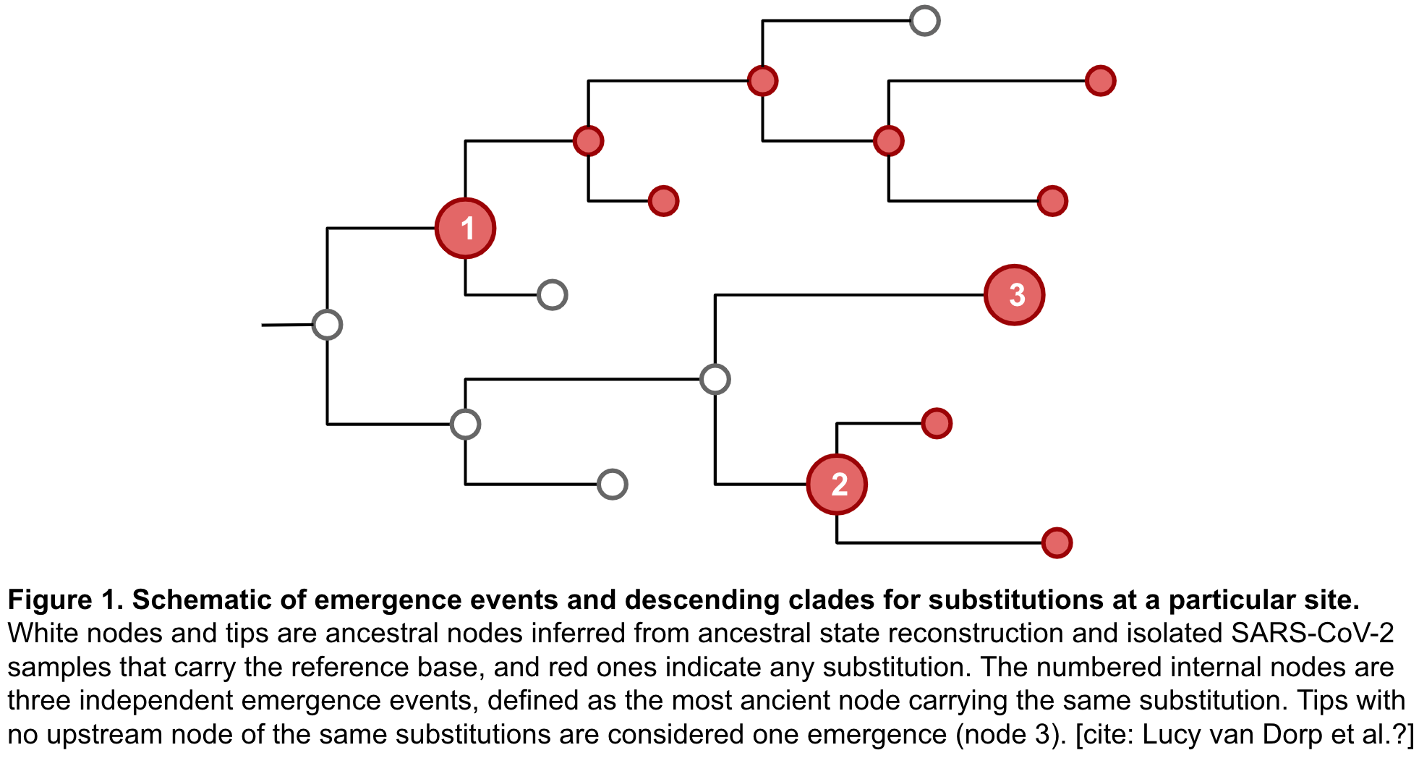

#### Clade Parameters Calculation

#### Survival Analysis Sample Acquisition

Survival analysis performed using “survival” package

**QUESTION: if interested in E484K emergence following N501Y (parent of ancestral**

**node), neglect N501 status at the ancestral node?**

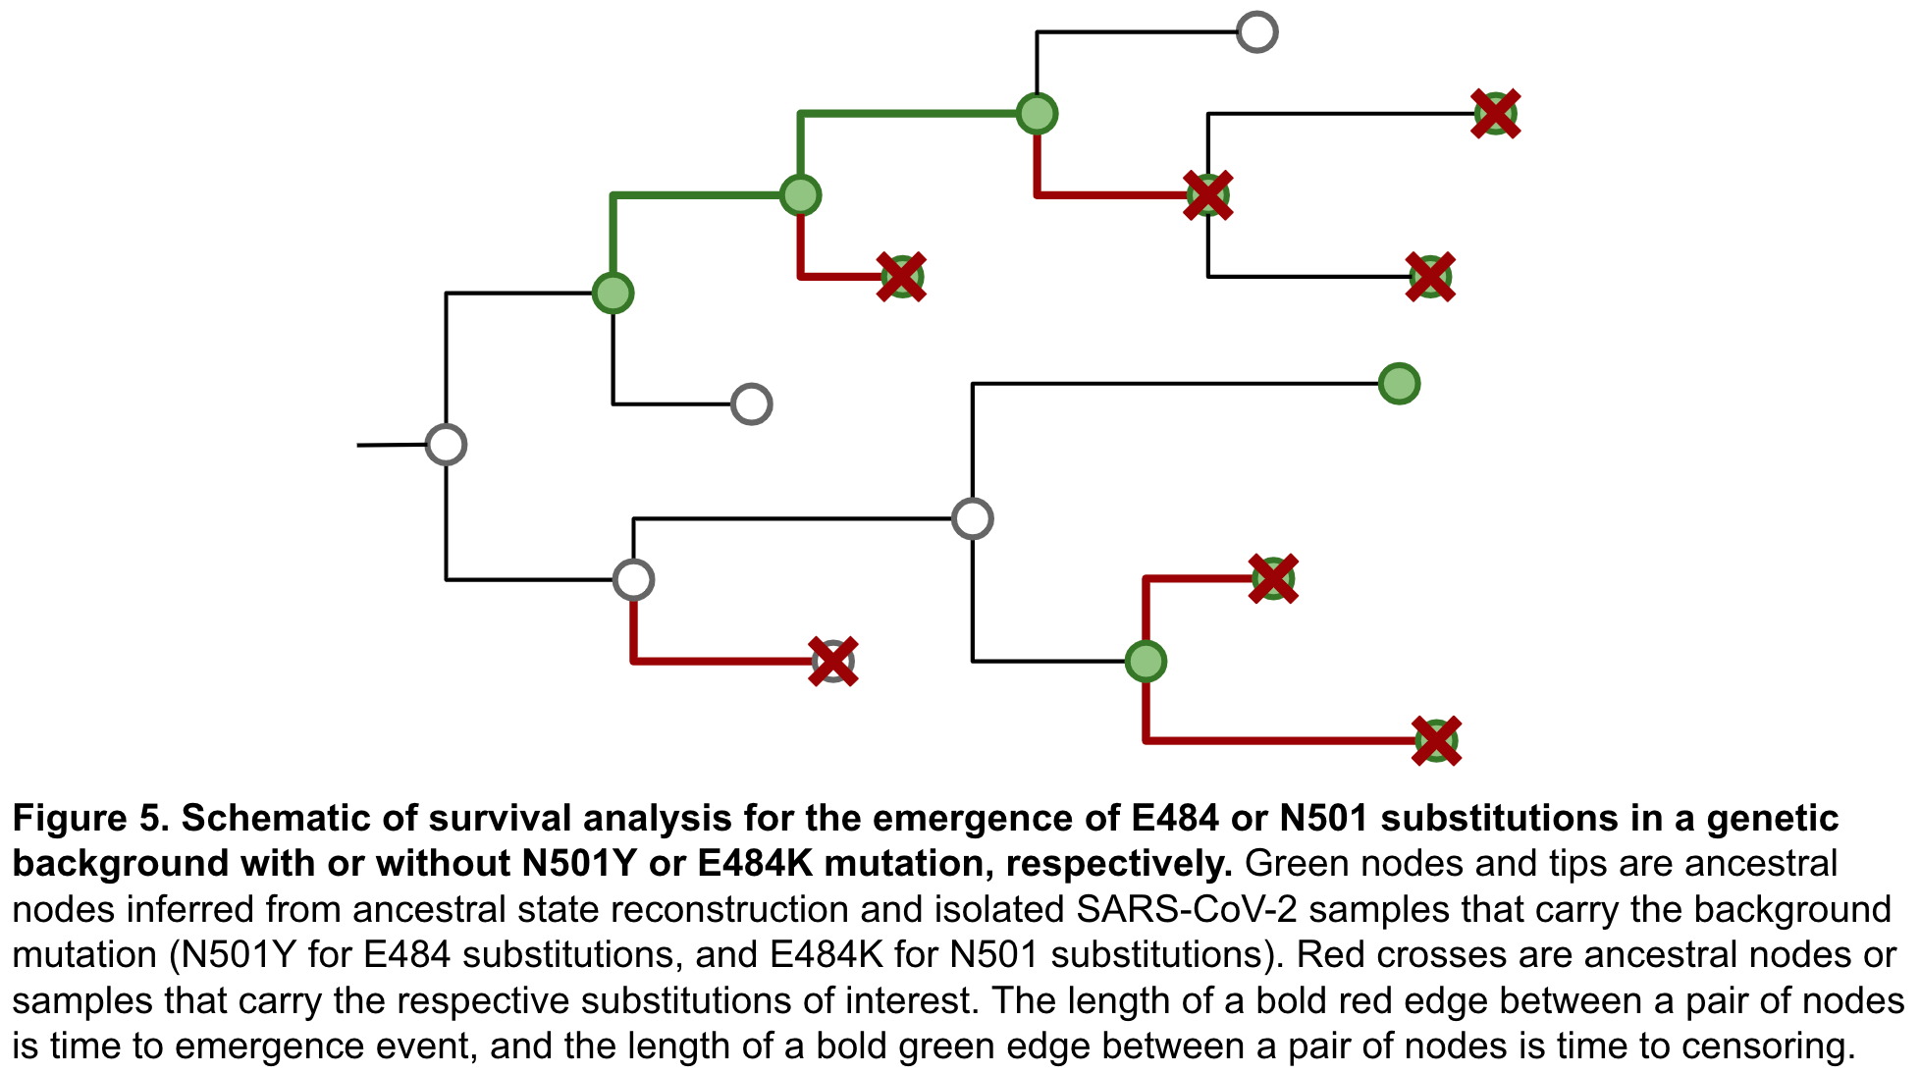

## **Results**

### All sequence samples

#### Time span

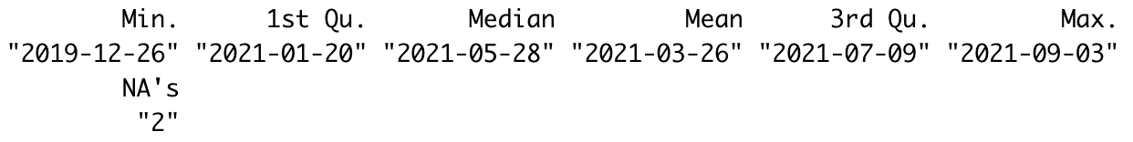

#### Phylogenetic tree

### Frequency of substitutions in tips (samples)

#### E484

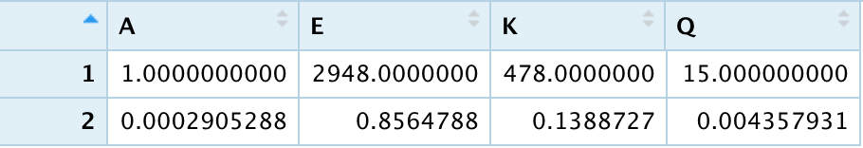

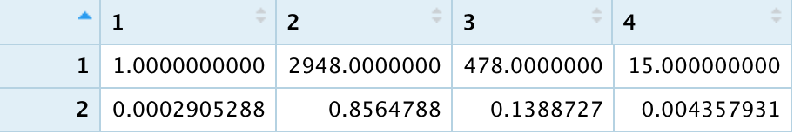

#### N501Y

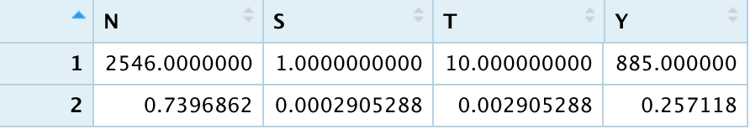

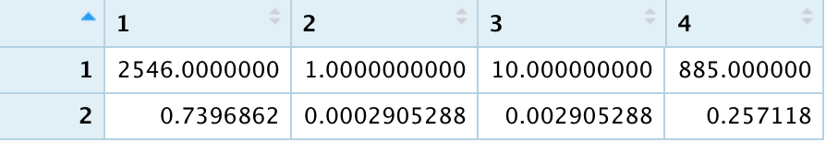

### Frequency of substitutions in ancestral nodes (ASR)

#### E484

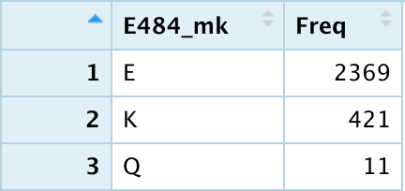

#### N501

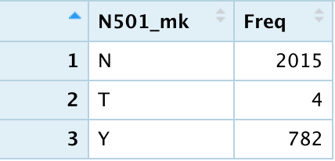

### E484-mutate clades characteristics – raw

#### Size

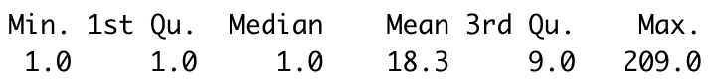

#### Duration

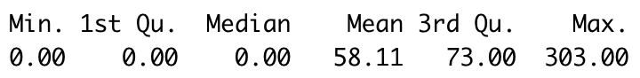

#### Time distribution of samples in each clade

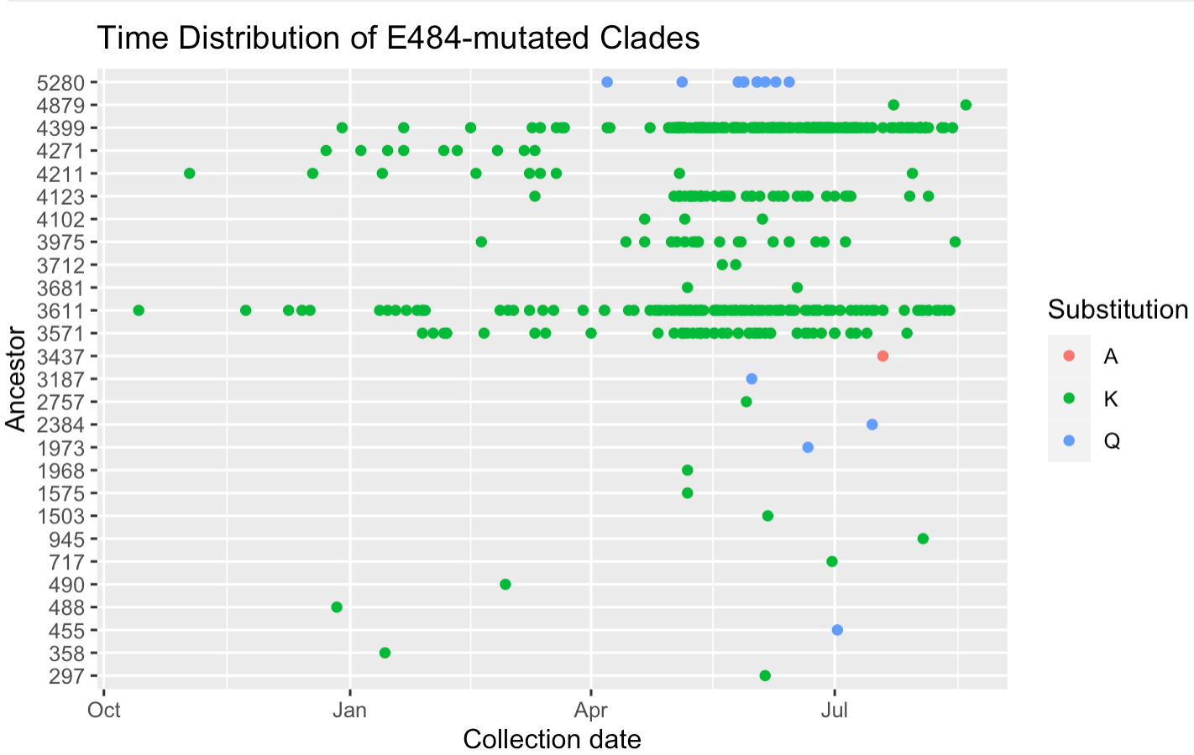

#### Time distribution of clade emergence (by earliest sample)

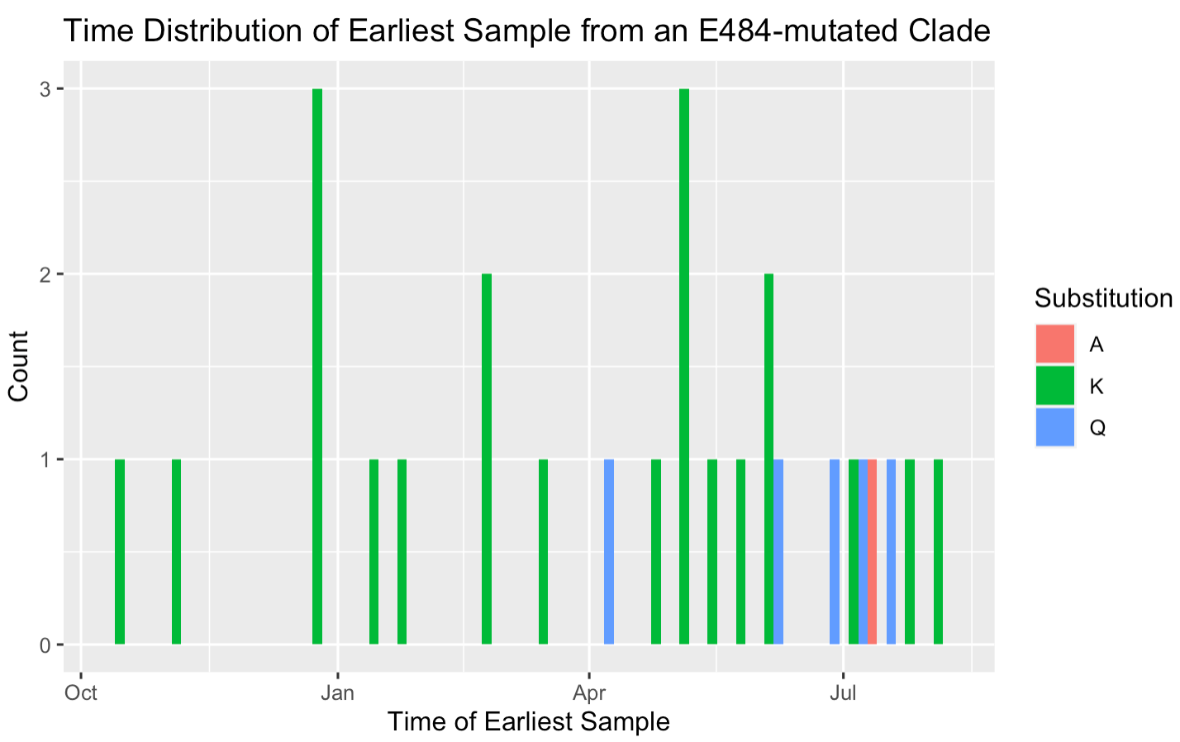

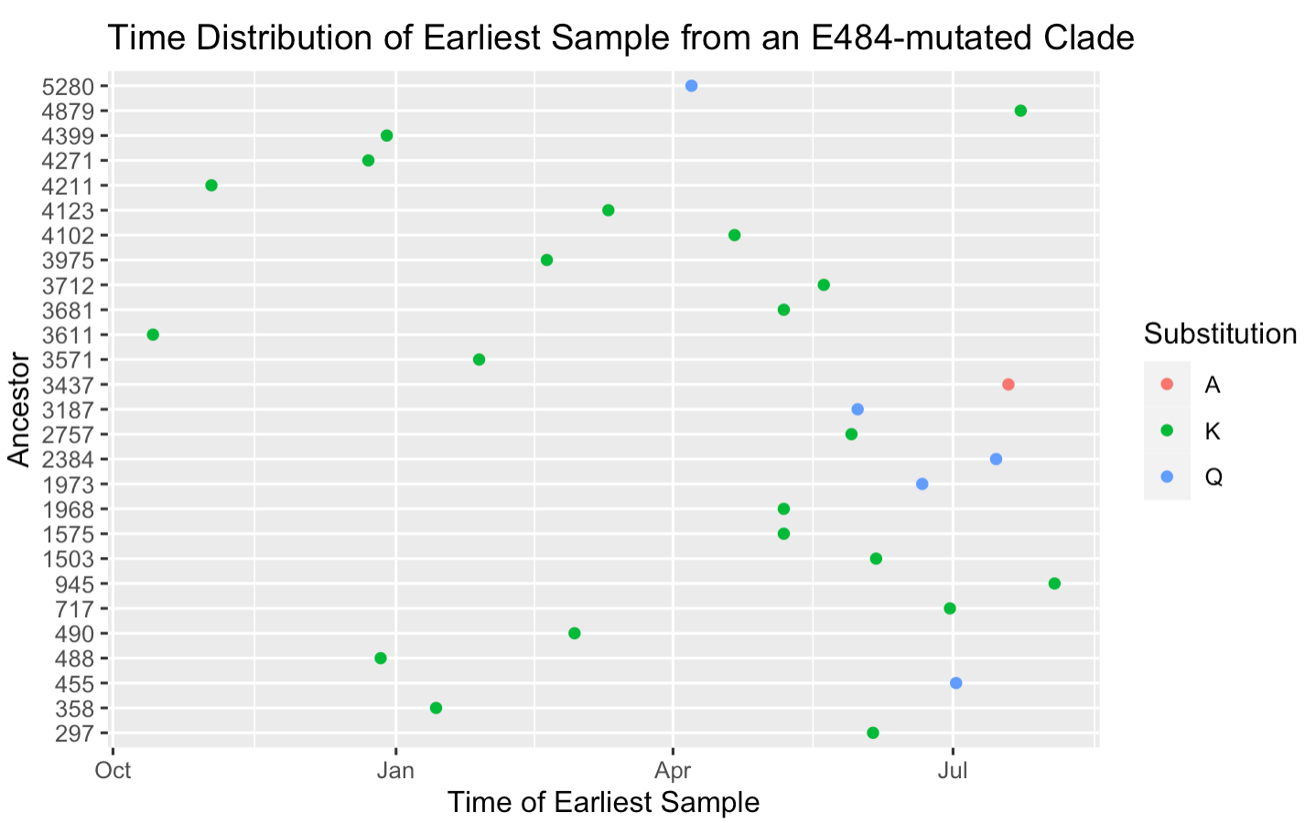

#### Clade duration and size vs. time of emergence (by earliest sample)

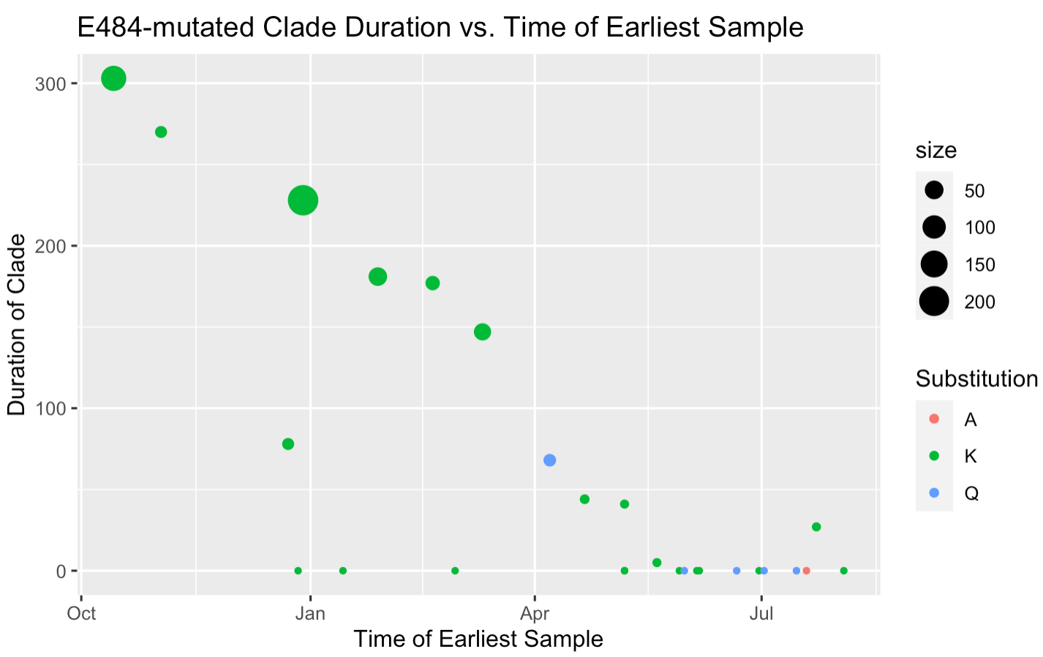

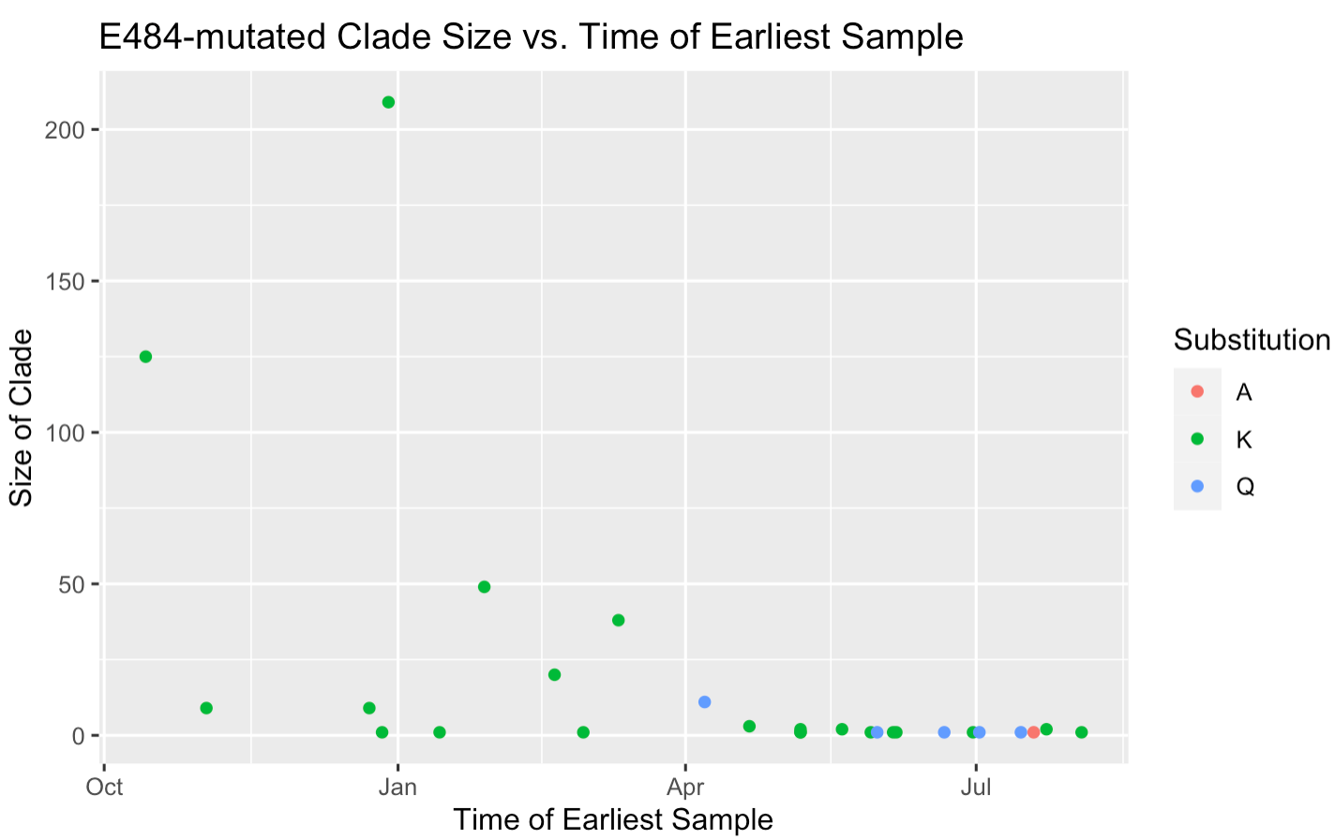

### E484-mutate clades genetic background

#### Proportion of potential epistatic mutations among all E484K sequences (≥ 10%)

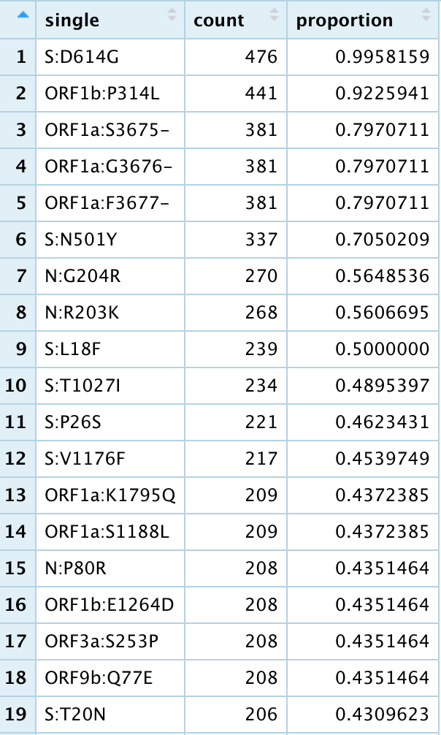 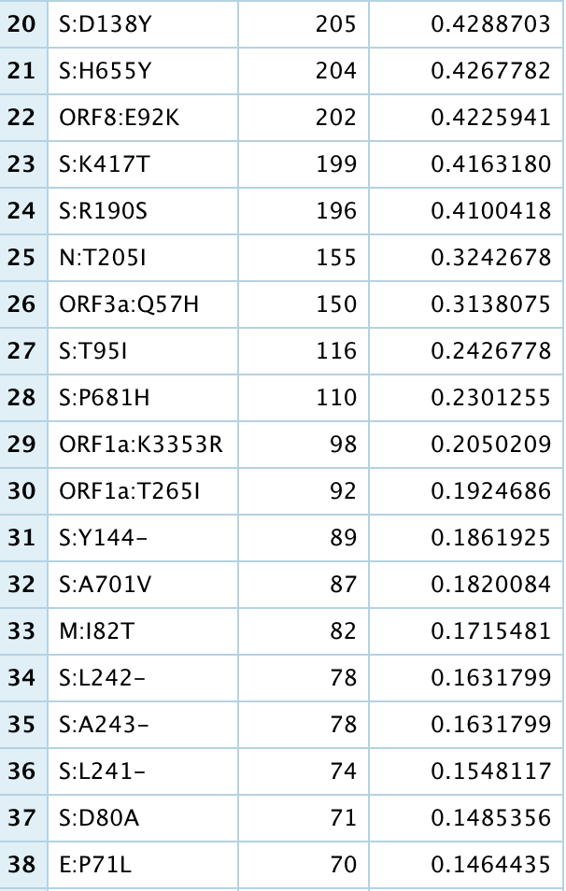 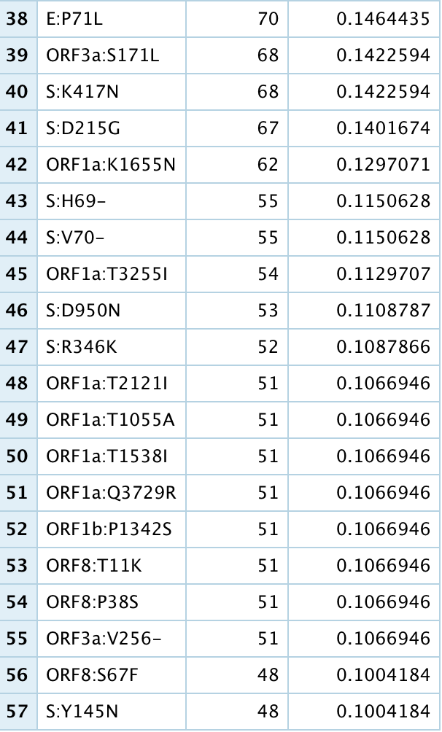

#### Proportion of potential epistatic mutations in each E484K clade (≥ 10%)

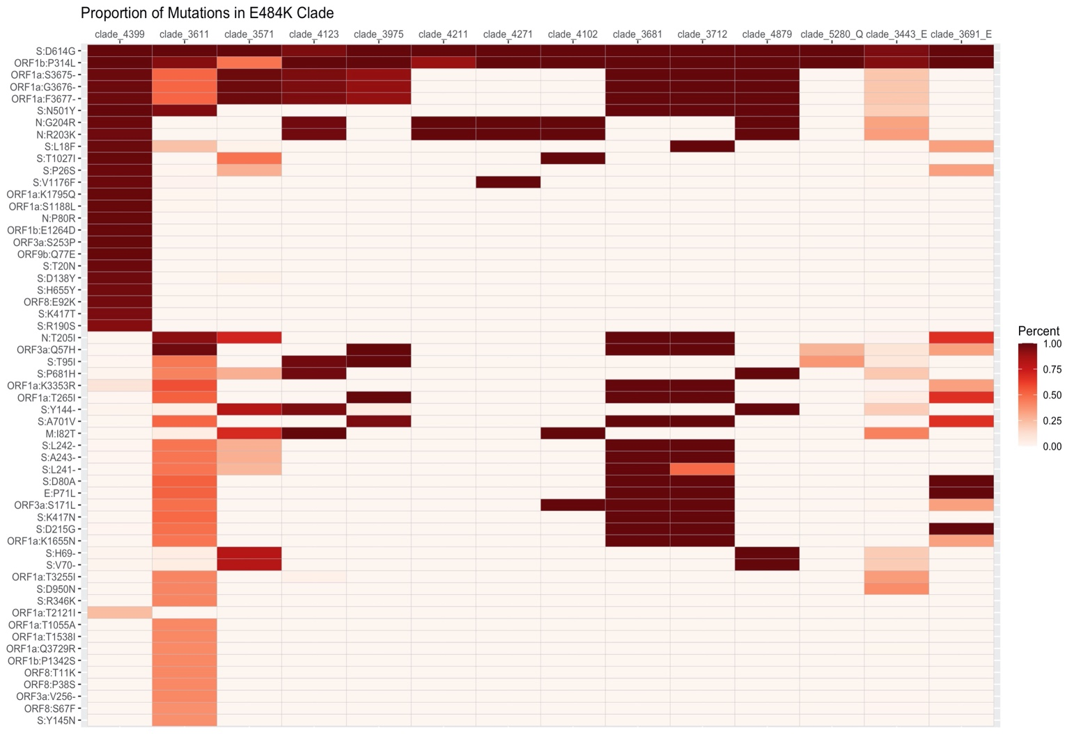

### E484-mutate clade emergence association with time (epidemiology: level of immunity)

#### Standardized emergence by time (unit = 2-week)

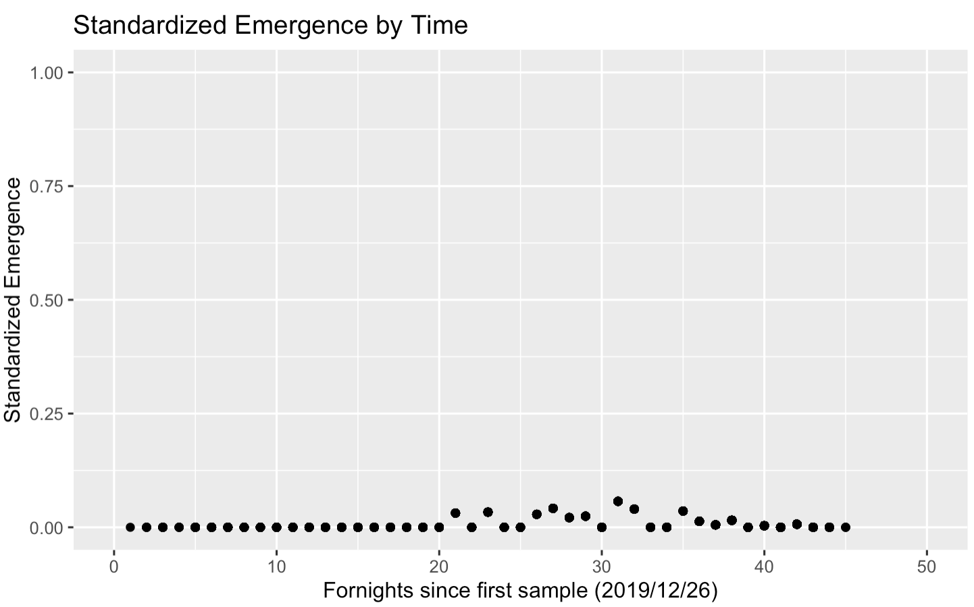

2020-09-21 ~ 2020-12-10

2020-12-10 ~ 2021-02-18

2021-02-18 ~ 2021-04-28

#### Standardized emergence by time - 1006 Data

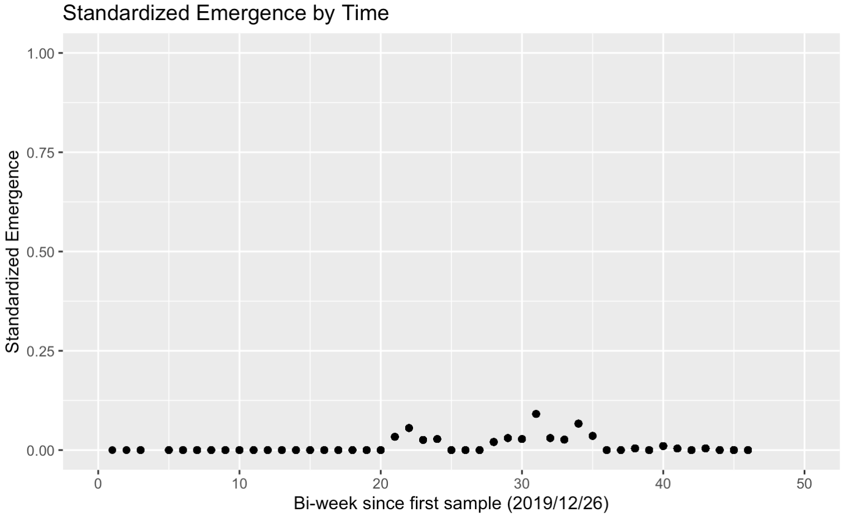

2020-09-18 ~ 2020-12-10

2020-12-10 ~ 2021-04-29

#### Logistic regression by continuous time (unit = day)

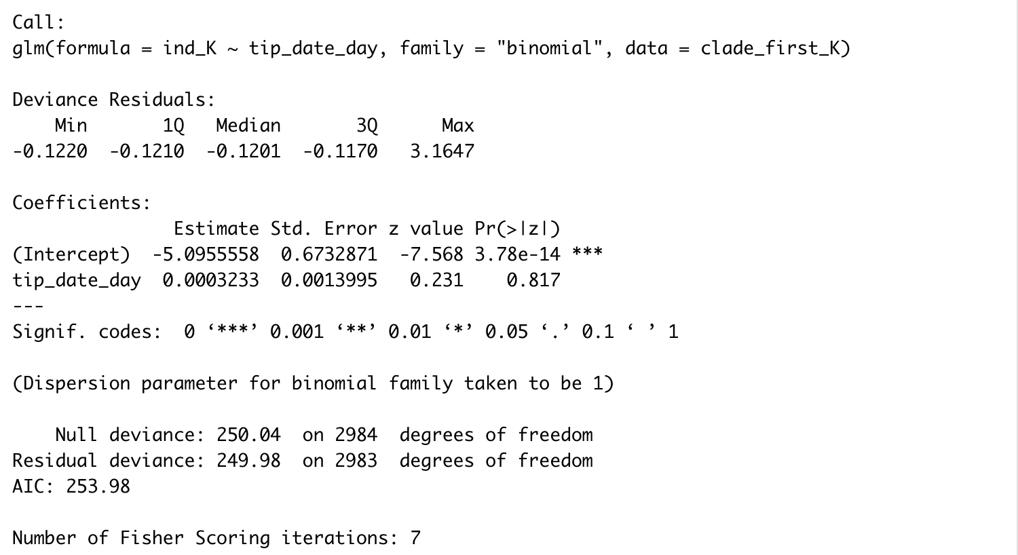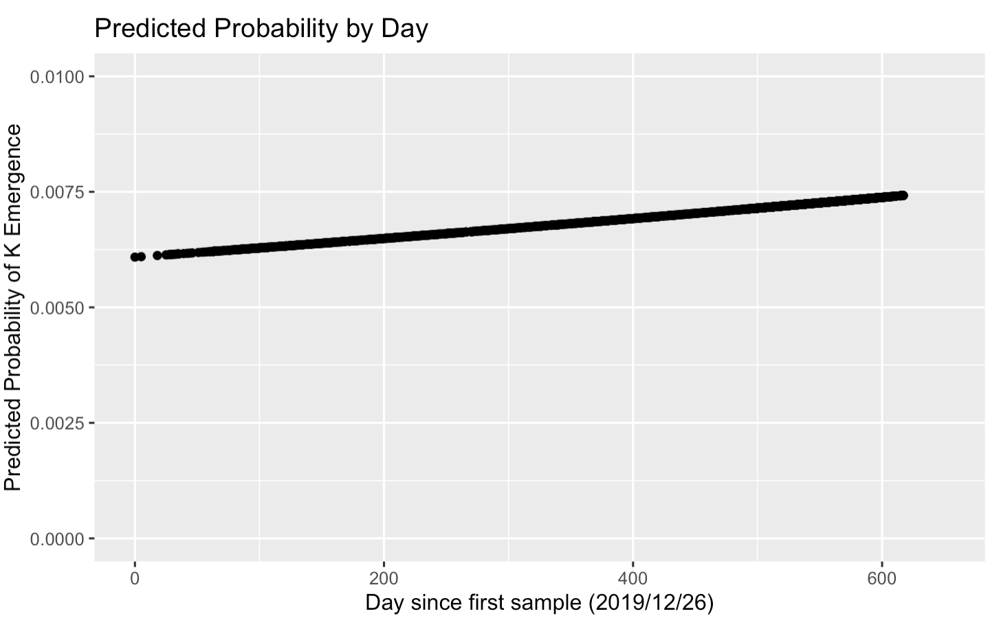

#### Logistic regression by continuous time (unit = week)

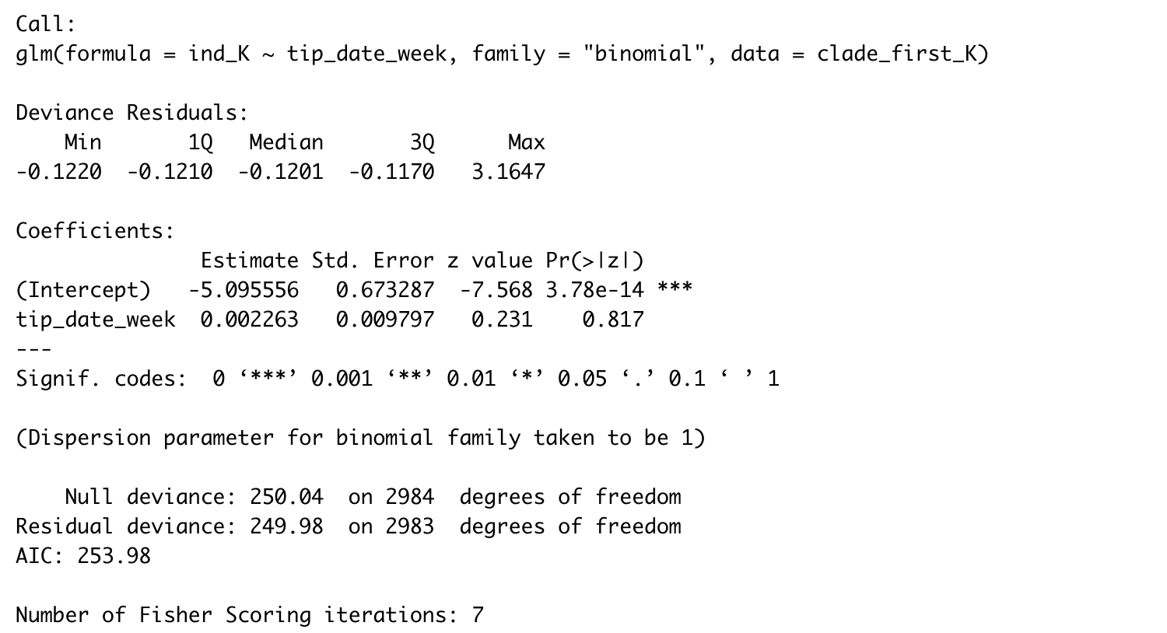 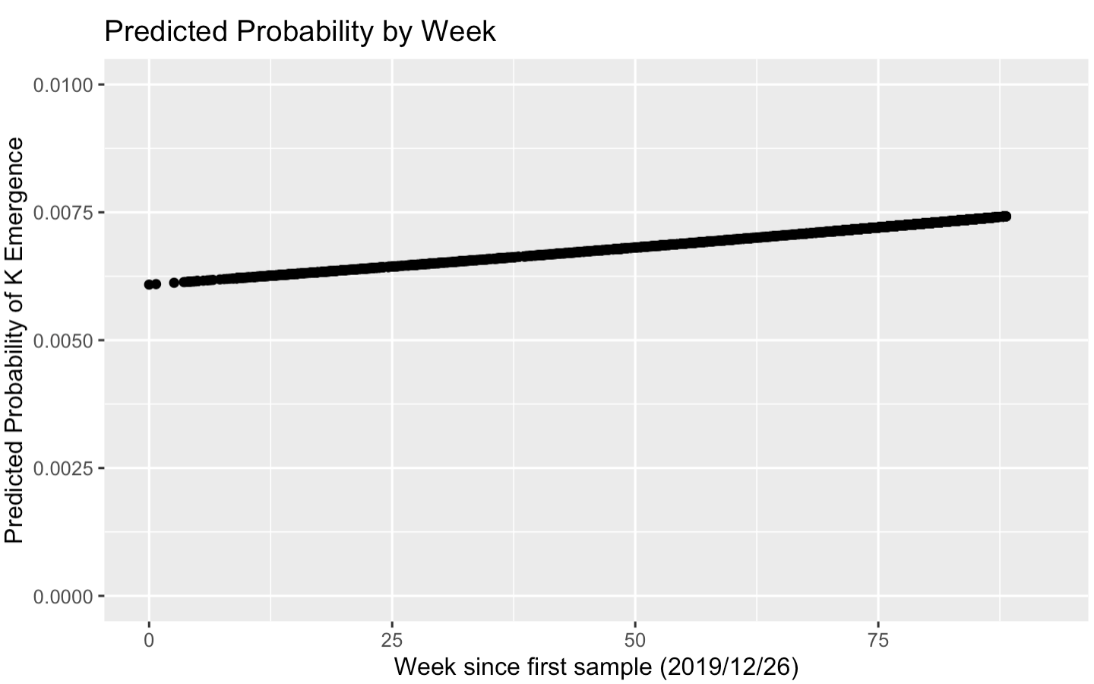

#### Logistic regression by continuous time (unit = month)

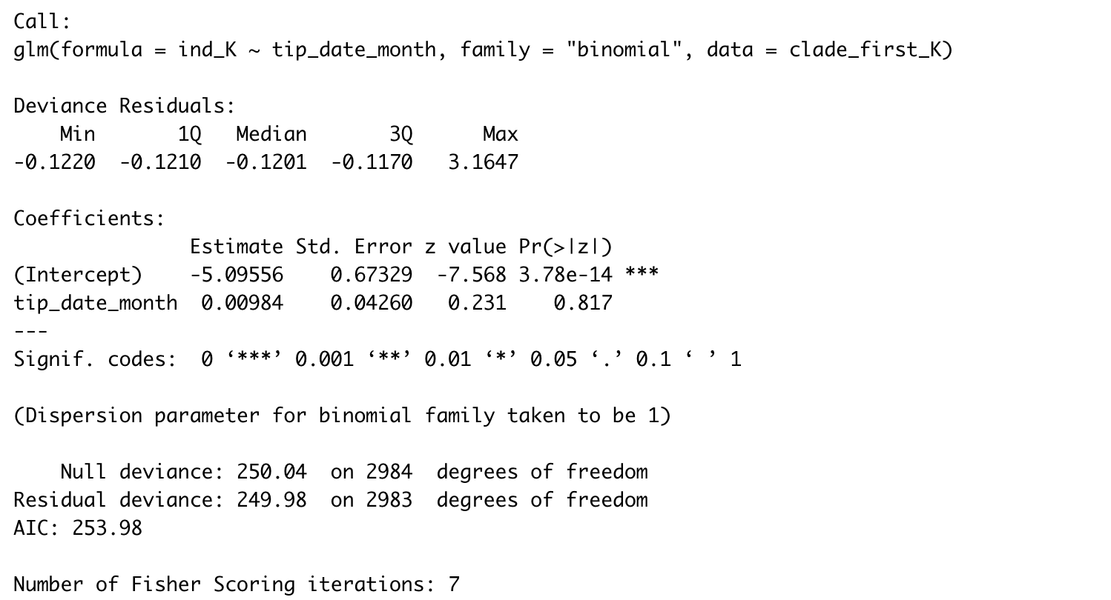 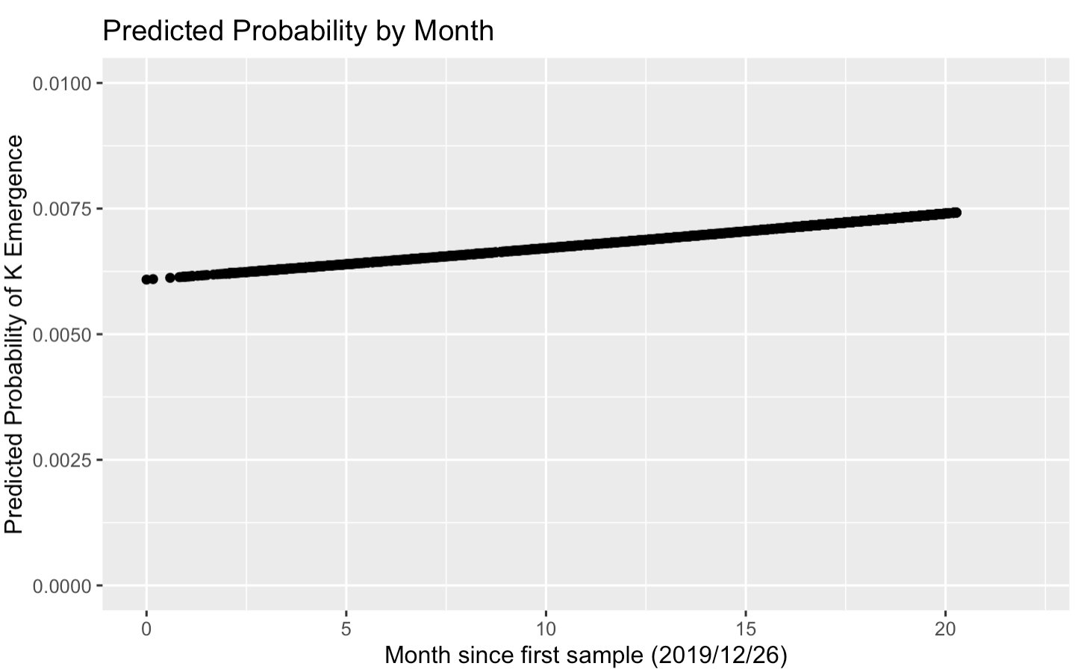

### E484-mutate clade emergence association with N501Y (epistasis)

#### Proportion of N501 state at ancestral nodes of all E484 clades

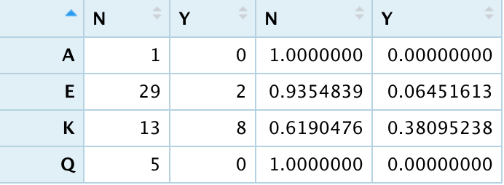

data set “emerge”:

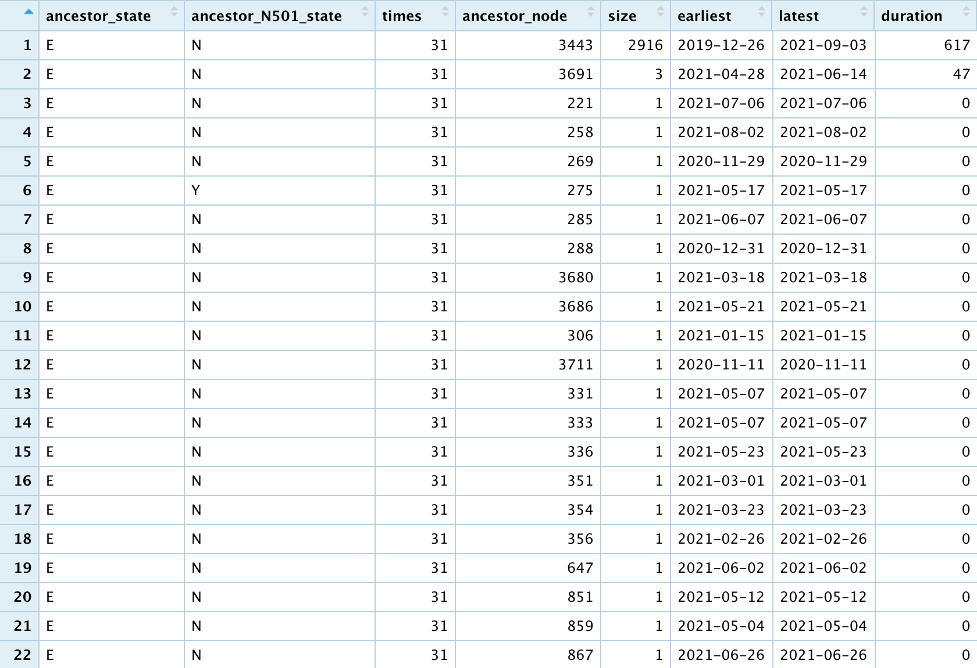

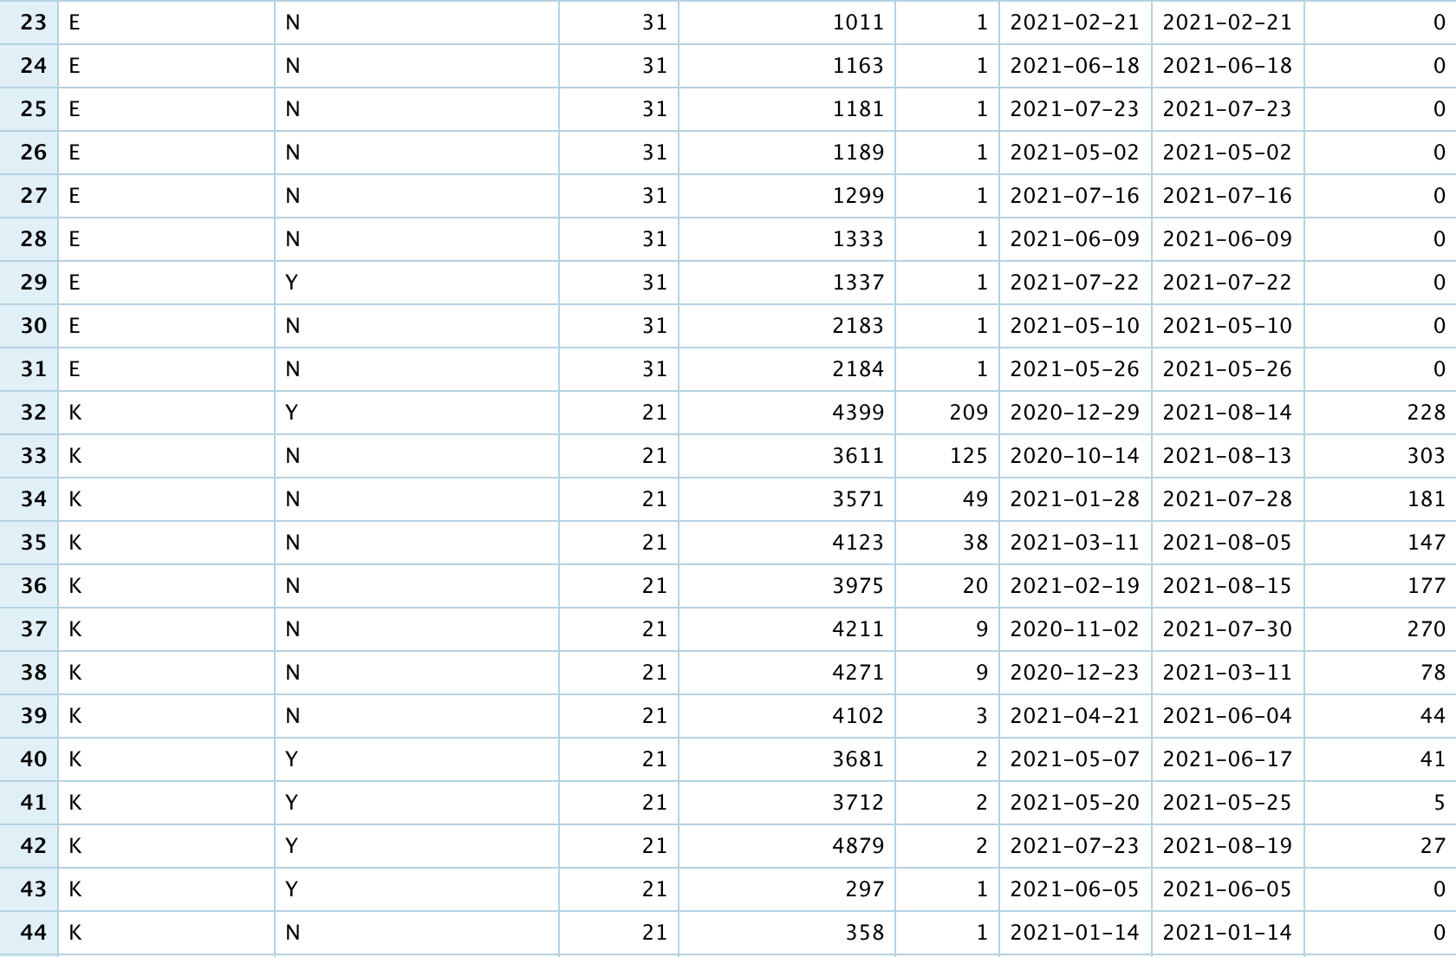

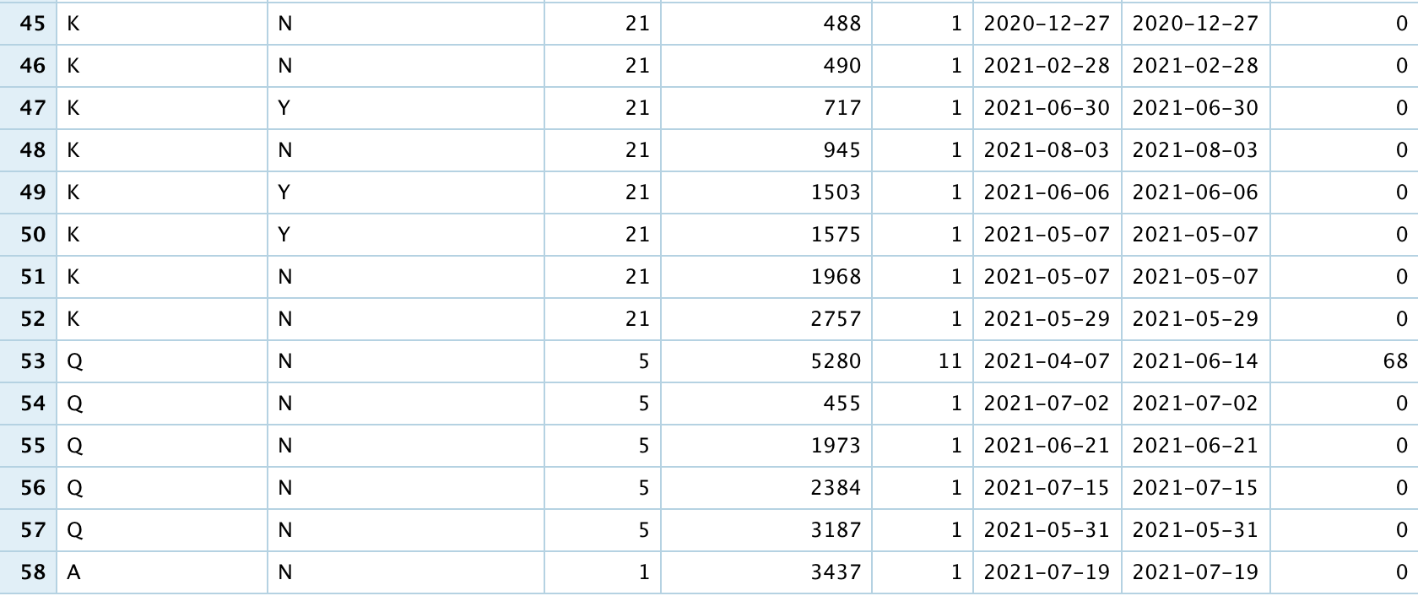

#### Logistic regression of E484K emergence by N501 state at ancestral node

#### Survival analysis of E484K emergence by N501 state at parent of ancestral node

**QUESTION: negative and zero branch lengths set to 0.0000000001???**

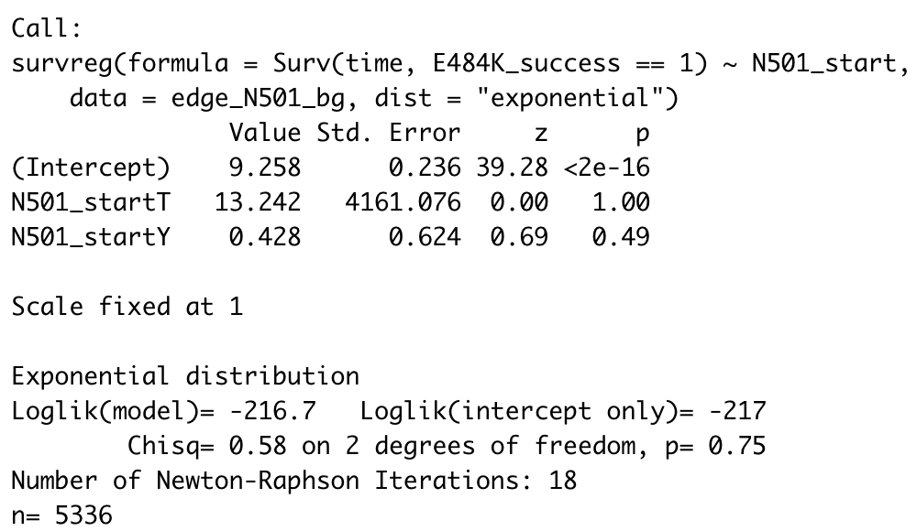

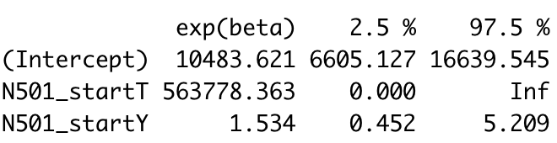

🡪 insig: if parent node has N501Y, longer survival time (E484K occurs slower)

🡪 if N501Y is already present, E484K is less favored?

#### Survival analysis of N501Y emergence by E484 state at parent of ancestral node

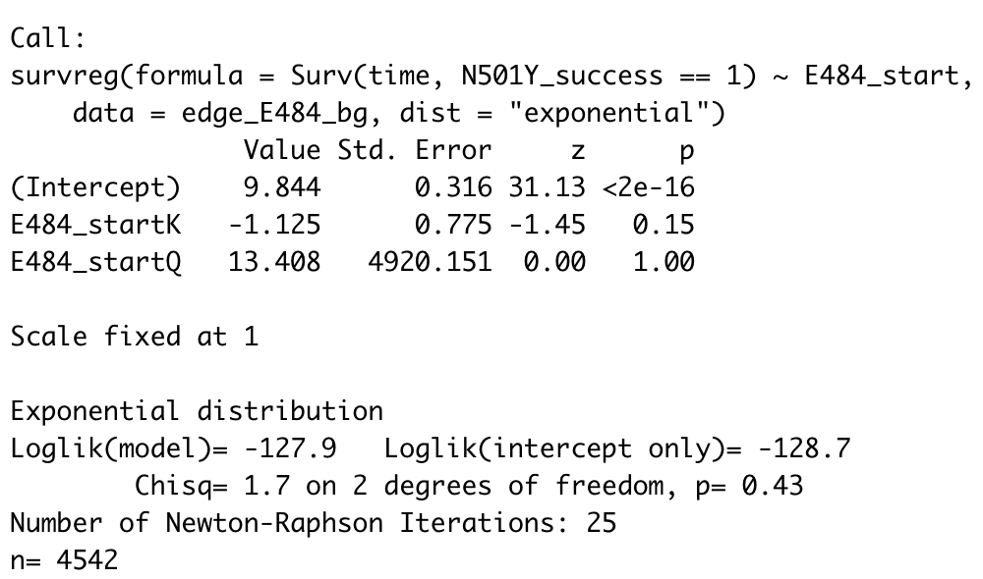

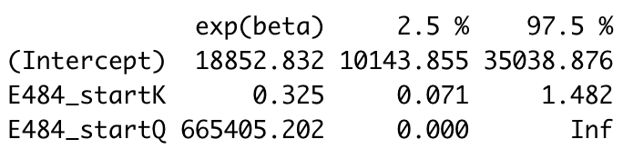

🡪 insig: if parent node has E484K, shorter survival time (N501Y occurs faster)

🡪 N501Y subsequently stabilizes E484K rather than promoting it to occur?