**Business Exploration Notes**

**Monday, 6-5-17**

* Needs - things necessary for survival.(Water, food, shelter)
* Wants - things we desire to have.(Internet, Clothes, Car, Fidget Spinners)
* Goods - tangible things you can see & touch.
* Services - when someone or something does something for you.
* Producer - One who creates goods and services.
* Consumers - One who uses goods and services.
* **The Basic Economic Problem**
  + Our needs & wants are naturally unlimited
  + In the form of natural resources, goods, and services.
* **Economic Resources - Factors of Production**
  + Means through which goods and services are produced.
  + Also called three kinds of economic resources
    - Natural Resources - Raw materials found in nature that can be used for economic gain.(Water, trees, oil)
    - Human Resources - The personnel of a business, especially when regarded as a major asset.(Labor, entrepreneurs, workers, teachers, doctors, carpenters)
    - Capital Resources - (Tools, equipment, land, factories, money) used to produce things. These are things and money that are used to make more money.
    - Entrepreneurship - People who supply product to markets for profit.
* **Economic Resources - Scarcity**
  + Resources are limited by nature. Scarcity necessitates choice in terms of what is produced.
* **Economic Choices - Opportunity Cost**
  + A decision to give up buying something NOW in order to buy something LATER.
  + Economic Choices - Different cultures and countries have different priorities, goals, & values. Economic decision making will reflect these values.
* **The Decision Making Process**
  + Define the problem
  + Identify the Choices
  + Evaluate the Advantages and Disadvantages of each choice
  + Choose and act on your choice
  + Review your decision
* **Economic Systems - 3 questions**
  + All economies or nations need to decide the answers to the economic questions
    - What goods or services will be produced?
    - How will the goods and services be produced?
    - What needs and wants will be satisfied with the goods and services produced?
* **Economic Systems**
  + Traditional & Custom-Based - Goods are produced the way they have always been.
    - Customs and beliefs play a strong role in how things are done.
  + Command/Planned System (Directed) System
    - Resources are owned and controlled by the government.
      * Government makes all the decisions
  + Capitalistic/Market/Private Enterprise System
    - Operates in the opposite way the Command system functions
      * Consumers make economic decisions based on their own interests.
  + Mixed System
    - A combination of the command & capitalistic system.
      * Most economic systems are mixed.
* Five Characteristics of a Capitalist System
  + Private Enterprise
    - Individuals are free to own businesses for profit.
  + Private Property
    - Businesses are, generally, free to offer goods and services of their choice.
  + Freedom of Choice
    - Individuals have the right to enter a business or career of your choice.
  + Profit
    - Business owner have the right to make a profit
  + Competition
    - Business compete to get customers
* Supply and Demand

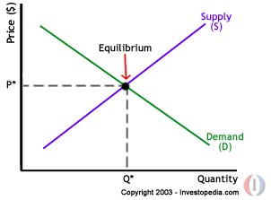

* + Supply - the quantity of a good or service that a business is willing to provide.
  + Demand - the quantity of a good or service that consumers will buy.
    - Consumers set demand
    - Once demand is high producers can raise the price
    - Once demand is low producers can lower the price
    - Once supply is low producers can raise the price
    - Once supply is high producers can lower the price
* **Factors Affecting Supply and Demand…**
  + Supply
    - The actual supply available to sell.
    - Competitors with a viable alternative product
  + Demand
    - Seasonal(Christmas Trees)
    - Location(Exotic locations, like coffee)
    - Alternative Product(iPhones and Android phones)
* **Determining Market Price**
  + The point where the demand curve crosses the supply curve is the market price. (Equilibrium)
  + Supply, demand, and competition determining the market price for a produce or a service.
* **GDP**
  + Gross Domestic Product - Measures total value of all final goods/services produced in the US in 1 year. Everything we produce.
* **CPI**
  + Consumer Price Index - It is the change in price of a specific group of goods and services that the average household uses.
* **Measuring Income**
  + The health of the economy can be measured by income levels.
  + The more money individuals earn & receive…
  + The more they can spend.
* **Unemployment**
  + Work age people actively looking for a full time job but can not find one.
* **Balance of Trade**
  + It is the difference between the nation’s exports and imports.
    - Exports > Imports is a positive balance of trade.
    - Imports < Exports is a negative balance of trade.
* **National Debt**
  + If US government spends more than it takes in.
  + To help pay for this they sell government bonds which require being paid back with interest.
    - US National Debt - 19 Trillion Dollars
    - Illinois State Debt - 14 Billion Dollars
* **Emerging Market Economies**
  + The weaknesses of controlled economies have caused many nations to change to market or mixed economies. Most countries such as China, Communist Gov - Capitalist Economy.
  + Most notable is the collapse of communism in the Soviet Union.
* **Game**
  + 4 out of 5 millionaires are college grads
  + ⅔ of millionaires work 45-55 hours a week.
  + Only 19% of millionaires received any income or wealth of any kind from a trust fund or an estate
  + Most millionaires attended public schools.
  + Most millionaires spend under 30,000 dollars on a car.
  + Only 23% of Millionaires drive a current year
  + Most millionaires work in ordinary industries and jobs.
  + High school diplomas are really important.
  + Millionaires go into the stock market to grow their money.
  + 1.50 a day at 18 can become 300K at 67.
  + Most millionaires are married and stay married.

**Tuesday, 6/6/17**

* **Economic Indicators**
  + **Why it’s Important**
    - Economic activity affects everyday life
    - The history of the economy affects industries and people of today and tomorrow.
  + **Economic indicators measure things like:**
    - How much a country is producing
    - Whether a country is growing
    - How it compares to other countries
  + **Unemployment Rate**
    - When the unemployment rate exceeds 5.5%, we are not doing ok. Under 5.5 is ok.
    - Unemployment can be:
      * Temporary
        + Maternity Leave
      * Seasonal
        + Summer job
      * Changes in Industry
        + Robots taking jobs
      * Economic slowdown
        + Great Depression
  + **Standard of Living**
    - The amount of goods and services the average citizen can buy
  + **The Business Cycle**
    - The rise and fall of economic activity over time is the business cycle. The four phases are:
      * Prosperity
      * Recession
      * Depression
      * Recovery
    - 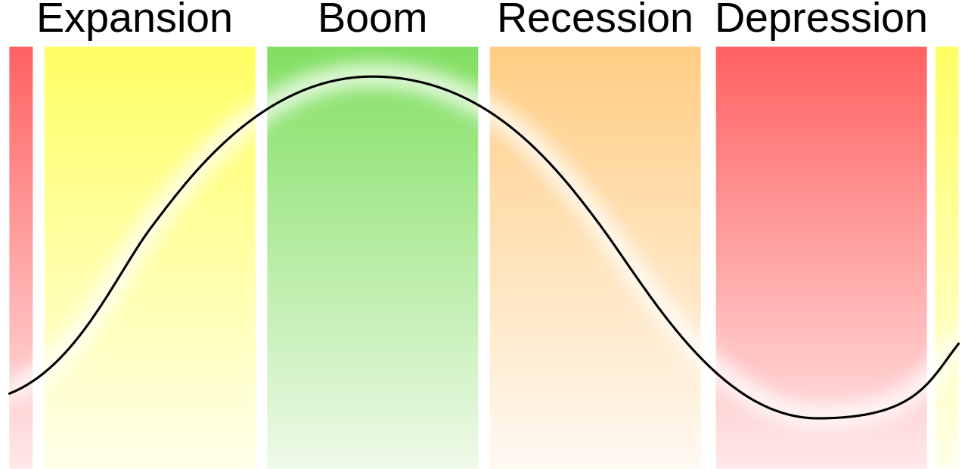
    - Prosperity
      * Low Unemployment
      * High production
      * New businesses
    - Recession
      * Spending decreases
      * Demand increases
      * Unemployment rate increases
      * A drop in the total production of goods and services, so the GDP declines.
        + Businesses close and people are laid off
    - Depression
      * High unemployment
      * Low productivity
    - Recovery
      * Production starts to increase
      * People go back to work
      * Spending increases
  + **Inflation**
    - Inflation is a general increase in the cost of goods and services.
  + **Deflation**
    - Deflation is a general decrease in the cost of goods and services. It’s the opposite of inflation.
  + **National Debt**
    - Budget surplus
      * If a nation spends less than its income, it has a budget surplus
    - Budget deficit
      * If a nation spends more on programs than it collects in taxes
* **Businesses**
  + **Ways to own a business:**
    - Sole proprietorship - 1 person
    - Partnership - 2 or more
    - Incorporation (corporation) - owned by many people, but treated by law as 1 person.
  + **Sole proprietorship**
    - Advantages
      * Easy to start
      * You are your own boss
    - Disadvantages
      * You pay for everything yourself
      * You use your savings
  + **Partnership**
    - Advantages
      * You might need only a license to start and have to pay taxes only on your personal profits.
      * Each of your partners can contribute money to start the business.
    - Disadvantages
      * Share the risks and the profits
      * If your partners disagree with you, the majority rules.
  + **Corporation**
    - You need to get a corporate charter from the state your headquarters is in and create board of directors.
    - Advantages
      * Limited liability
    - Disadvantages
      * Very regulated
      * More taxes
  + **Providing classification**
    - Producing raw goods
    - Processing raw goods
    - Manufacturing goods from raw or processed goods
    - Distributing goods
    - Providing services
  + **Producer**
    - Business that gathers raw products in their natural state.
  + **Processors**
    - Make raw materials into refined things
  + **Manufacturer**
    - Make finished products out of processed goods
  + **Intermediary**
    - Moves goods from one business to the other
  + **Wholesaler**
    - Also distributor. Distributes goods
  + **Retailer**
    - Purchases goods from a wholesaler and resells them ot the consumer, or the final buyer of the goods
* **Entrepreneurship**
  + **A business started by someone who notices a need for a product or service**
  + **Advantages**
    - Satisfaction from taking a risk and becoming a success
  + **Disadvantages**
    - Total responsibility for the business

Page 42 Questions:

1. How does the section define an entrepreneur?
   1. An entrepreneur is a person who brings together productive resources to produce a good or service and then assumes the risk of taking that product or service to the marketplace.
2. How does our economy benefit from entrepreneurs?
   1. Well, the article states, “As a result of the companies they[entrepreneurs] built, incomes rose, new investment opportunities were offered and a multitude of jobs were created.”
3. How do we measure the production or success of an economy?
   1. The GDP, or the market value of all the final goods and services produced within the country’s borders in a given year.
4. What is the PPC, or production possibility curve/frontier?
   1. The PPC simplifies the economy by imagining a society that produces only two goods. Both require all four types of resources. All of these resources are scarce, so production is limited to some combination of cars and coffee that falls on the production possibility curve. As long as the curve is fixed, the society cannot produce combinations beyond the curve.
5. How does a society become more productive?
   1. Building capital stock, like more machines
   2. Upgrading worker skills, like with education and training
   3. Innovating and introducing new technologies that increase output and improve efficiency.
6. How can a government discourage entrepreneurship?
   1. A government can impose regulations that make it more difficult to open and run a business.
7. How can a government encourage and protect entrepreneurship?
   1. Lowering taxes and regulations so that it’s easier to start a business.
8. Give an example of a:
   1. Trademark
   2. Copyright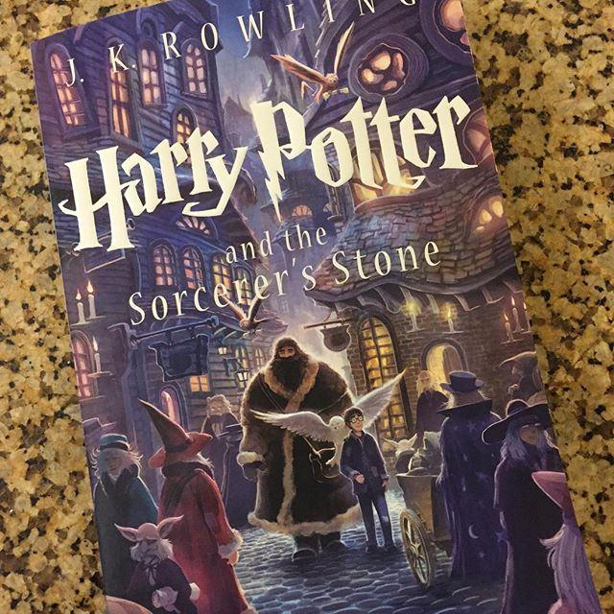
   3. Patent
9. What are the 3 types of businesses that exist today? Sole Proprietorship, Partnership, and Corporation
   1. What are the characteristics of each?
      1. Sole proprietorships
         1. Owned by one person
         2. One person bears all responsibility
         3. Unincorporated
      2. Partnerships
         1. Owned by 2 or more people
         2. Unincorporated
         3. Share profits and losses
      3. Corporation
         1. Separate legal entity
         2. Right to buy and sell, incur debt and sign contracts
         3. Owners, called shareholders, have limits on their liability for the debts or losses but also may have less ability to affect the actions or direction of the company.
   2. Provide a real example of each
      1. Sole proprietorships
         1. Doctor’s practices.
      2. Partnerships
         1. Lawyer’s practices.
      3. Corporation
         1. Apple, Inc.
   3. When you consider the number of each type of firm from page 10, why is it important for our economy to keep encouraging entrepreneurship?
      1. Entrepreneurs running corporations account for most of the sales in the US. They are important to the health of our economy.
10. What is globalization? The increasing integration of the world’s economies through the flow of goods, services, financial capital and people across national borders.
    1. It opens new markets overseas where resources are available and goods and services can be sold.

**Wednesday, 6/7/17**

**Money**

* **The history of money**
  + Money can be anything that people accept as a standard for payment.
* **Functions of money**
  + Medium of exchange
  + Standard of Value
  + Store of Value
* **Characteristics of money**
  + Stable
  + Scarce
  + Accepted
  + Divisible
  + Portable
  + Durable
* **Banking**
  + The banking system is the main type of **financial institution**.
  + A bank account is a record of how much money a customer has in the bank.
  + Storing money
    - Deposit-put money in the bank
    - Withdrawal-take money out of the bankg
  + Interest
    - Rate the bank pays you for keeping your money there
    - If a bank pays you 5 percent interest per year on a $1000 savings account, you’ll have earned $50 in a year.
  + Simple interest compounded annually is a percent of the amount borrowed. It doesn’t increase. Compound interest increases every compound.
  + Collateral
    - Something valuable you put up for a loan.
  + S&L associations
    - Encourage people to save money easier to buy a home and start a business.
  + Credit unions
    - Non for profit bank
    - Made to serve its members
  + Brokerage Firms
    - Sell stocks and bonds
  + The federal reserve
    - Central bank in US
    - 12 private banks that the government trusts
    - Decides interest rates and inflation rates
    - Functions of the fed
      * Clearing checks
      * Acting as the federal government’s fiscal agent
      * Supervising member banks
      * Regulating the money supply
      * Setting reserve liquidity requirements
      * Supplying paper currency

1. How will you determine what goods and services are produced?
   1. One determination will be the natural resources available to the settlers. The nation is next to an ocean, and most of the cities are near the main river or the ocean due to the lack of food other than fish from the ocean and crops from Rohan Valley. There are products and brands for the higher income places such as the River City and Beach City moguls. Luxuryville produces these products using the steel, gold, and aluminum from the twin city mines. All of the cars run on lumber from Autinville.
2. What four types of resources will you use?
   1. Natural Resources-Drinking water from rivers, iron, gold, and aluminum from the Twin Cities Mines, fish from the ocean.
   2. Capital Resources-The tools imported into the biosphere are used to mine and build the cities. New tools are eventually created, as well as machinery running on steam engines.
   3. Human Resources-The biosphere has a population of 7 million. In the beginning, many will be laborers creating the cities and mining the Twin Cities Mines. These laborers will all be human resources.
   4. Entrepreneurial Resources-The corporate moguls that create the brands of Luxuryville use their unique creativity and business insight to sell luxury products to River and Beach Cities. They have connections to sell to retail in both cities. Those connections are entrepreneurial resources.
3. What goods and services will you produce?
   1. Lumber, canned fish, and cars are a big focus of this economy. Eventually steel and iron will prevail, once the bigger mines are discovered. The lumber is useful for creating cities and early walkers/cars(think Flintstones). The fish needs to be canned for its long journey. It feeds the entire biosphere. Cars have to be used for easy transportation, as the rivers will eventually be clogged.
4. How will you select your leader? What personality traits must she or he possess?
   1. The leader must be an intelligent manager of resources, as the large population needs to be supplied with all of the natural resources quickly. The leader therefore must have economic acumen. The leader must also be strict, as many must be put to work in order for the biosphere to survive.

**Monday, 6/12/17**

* **Brand and generic**
  + Brand products are manufactured under a name.
  + Generic products cost 40% less than brand-name products
  + They cost less because people are willing to pay extra for the name.
  + They also don’t spend as much on marketing and advertising.
* **Purchase planning**
  + Buy the Galaxy S8 when the S9 is coming out.
  + The best time to buy a winter coat is spring.
* **Types of stores**
  + A well known department store?
    - Bad prices.
  + An outlet store?
    - OK, because they are trying to get rid of products.
  + A warehouse store?
    - Warehouse is good, too.
  + Online?
    - Online is best.
* **Consumers shop based on…**
  + Kinds of goods and services
  + The prices
  + The convenience
* **Department stores**
  + Examples:
    - Macy’s
    - JC Penney’s
  + Offer name brands and customer services.
  + Higher prices than outlets or other retail stores.
* **Discount stores**
  + Examples:
    - Walmart
  + Less services, cheaper prices.
* **Outlet stores**
  + Example: TJ Maxx
  + Offer well-known brand names at discount prices
  + Items may have minor flaws, are out of season, or have been discounted.
* **Warehouse stores**
  + Example: Costco
  + Huge selection of food and nonfood items at low prices and in bulk
  + Sometimes require memberships.
    - Annual fees
    - Minimum spending
* **Home shopping**
  + HSN
  + Mail-order catalogs
  + Online
  + Upside:
    - Convenience
    - Don’t have to leave your home
    - Can have it shipped to someone else’s house
  + Downside:
    - Shipping costs
    - Can’t try on/handle item before purchase
    - Return policies
* **Shopping techniques**
  + Comparison Shopping
    - Checklist for Comparison Shopping
      * Price
      * Quality
      * Features
      * Convenience
      * Warranty
  + Cheaper to buy in large quantities
    - Do you need it bulk?
* **Advertisements**
  + Rational Advertising: attempts to convince you with facts and information.
    - World’s Best Cup of Coffee
  + Emotional advertising: appeals to your feelings
    - Puppies
* **Reports magazines**
  + Consumer Reports
  + Consumer Research Magazine
  + Ratings, Reviews, What is the Best Buy?
* **Sales**
  + Promotional sale:
    - Gives you a special buy on a new product or a product that’s in season.
      * T-shirts
  + Clearance sale
    - Get rid of products that are out of season or aren’t profitable
  + Sales bring customers into the store for one thing in hopes they’ll buy something else not on sale
  + Coupons.
  + Salespersons tactics
    - It’s their job to sell you items
  + Commission
  + Gimmicks
* **What is a warranty?**
  + A legal document that states the rights and responsibilities agreed to by the consumer and the store or the manufacturer.
  + Full warranty: Seller will repair a product that doesn’t work, usually free of charge
  + Limited Warranty: covers only certain parts of the product.

**Tuesday, 6/13/17**

* **Chapter 22 Notes**
  + Brand names
    - Word or name on a product that helps consumers distinguish it from other products.
  + Generic products
    - Plainly labeled
    - Unadvertised
    - Sold at lower prices
  + Types of stores
    - Department stores
      * Sell a wide variety of goods.
      * Higher prices than other stores
      * Macy’s.
    - Discount stores
      * Same as department stores but for lower prices.
      * Offer in large quantities.
      * Kmart
    - Outlet stores
      * Carry brand names at lower prices
      * Minor flaws or out of style
      * T.J. Maxx
    - Limited-line stores
      * Large assortment of goods in one or a few product lines.
      * Foot Locker.
    - Superstores and Hypermarkets
      * Like supermarkets, but sell books, hardware, and clothing as well as groceries.
      * Meijer, Safeway
    - Showroom Retailers
      * Sell from showrooms.
    - Home shopping
      * Mail order catalog
      * Online shopping
      * HSN
  + Comparison Shopping
    - Checking price and quality in multiple stores.
  + Unit price
    - The cost of an item for a standard unit of measurement
  + Promotional sale
    - Special buy on new products or seasonal products.
  + Clearance sales
    - Clear out goods that the store wants to get rid of.
  + Loss leaders
    - Selling items at a loss to bring shoppers into the store.
  + Impulse buying
    - Purchasing things on the spur of the moment
  + Warranty
    - Legal document that states the rights and responsibilities agreed to by the consumer and the store or the manufacturer.
* **Consumer Bill of Rights**
  + In 1962, JFK outlined the Consumer Bill of Rights.
    - The right to be informed
    - The right to choose
    - The right to safety
    - The right to be heard
  + Consumer movement
    - Before the movement, product information was very opaque
  + More rights added
    - The right to have problems corrected
    - The right to consumer education
    - The right to service
  + Right to be informed
    - Consumers can make wise decisions only if they have the information they need.
  + Right to choose
    - Consumers can choose from a wide variety of goods and services
      * Keeps prices down and quality up
  + Right to safety
    - The legal responsibility that manufacturers have to make a safe product is called product liability.
    - Products that might be dangerous if used improperly must have instructions for correct and safe operation
  + Right to be heard
    - Bait and switch consists of advertising an item at a low price to lure you into the store.
    - Laws preventing fraud
  + The right to have problems corrected
    - Usually if you take a defective item back to the store with your receipt, the business will replace the item or refund your money.
  + The right to consumer education
    - Labels and fact sheets
    - Comparison shopping
  + Right to service
    - You have the right to be served without discrimination on the basis of your race, gender, income, or age.
  + Your responsibilities as a consumer
    - As a consumer, you have the responsibility to educate yourself.
  + Responsibility to choose carefully
    - Responsible consumers make comparisons to find the best product or service at the best price.
  + Recycling
    - Collecting products for processing so that they can be used again.
  + The responsibility to speak out
    - You can boycott, or refuse to buy, a company’s goods or services