LINKEDIN POSTING
STANDARD OPERATING PROCEDURE
How (and why) the sales team posts on LinkedIn. Spoiler: it's once a week and takes about 20 minutes.
1. Purpose
We want every BDM posting on their own LinkedIn account once a week.
The Blaiklock page is one voice. Add six BDMs posting every week and we've got seven voices putting Blaiklock in front of people the company page will never reach. Along the way, you become the name people think of when freight gets tricky.
2. When This Process Applies
Every week. Yes, every week. Keep reposting Blaiklock's posts too: this is on top of that, not instead of it.
3. Responsibilities
Sales Team (that's you)
One post a week from your own account, written in your own words.
Marketing (that's me)
Images, flyers, carousels, topic ideas, and a quick read of your draft whenever you want one. Ready-made graphics live on the Marketing shared drive: [add shared drive link].
4. Procedure
Step 1 – Find your story
Look at what clients asked you this week, what's in the news (strikes, weather, outages), what's coming up (peak season, Chinese New Year, Christmas cut-offs) or a recent Blaiklock article. If one client asked you about it, plenty of other people are wondering too.
Step 2 – Let AI do the heavy lifting
Jot down rough notes, then paste them into Claude, ChatGPT or Gemini with this prompt:
Turn my notes into a LinkedIn storytelling post of 150 to 250 words. I'm a Business Development Manager at Blaiklock, a freight and logistics company. Start with a strong two-line hook, tell the story, explain the knock-on effect, give two or three practical tips and end with one genuine question. Plain British English, short paragraphs, no emojis, no buzzwords. Give me two hook options. My notes: [paste here]
Step 3 – Make it sound like you
Read it out loud. If you wouldn't say it to a client, change it. Add one detail only you would know. People can spot AI-written posts a mile off, and they scroll straight past them.
Step 4 – Add an image
Use your own photo, an AI image (ask for no text in it), something from the shared drive, or ask Marketing.
Step 5 – Post it and stick around
Monday or Wednesday, 8–11am, is ideal, because Blaiklock posts on Tuesdays and Thursdays. Another day or time that suits you is fine too, as long as you stick to it every week. Reply to comments in the first few hours, and put any links in the first comment rather than in the post.
5. What a Good Post Looks Like
The winning formula is simple:  - Hook. Two lines that make people tap "see more". A number, a surprise or a strong opinion.  - Story. What happened? Keep it real and specific.  - Knock-on. What happens next that most people miss? This is where your expertise shows.  - Lesson. What should the reader do about it?  - Question. One genuine question to get people talking.  The image can be simple, like a photo or a branded graphic. The words do the heavy lifting.  The example on the right was written for this guide. Use your own real stories (and keep client names out unless they're happy to be mentioned). | 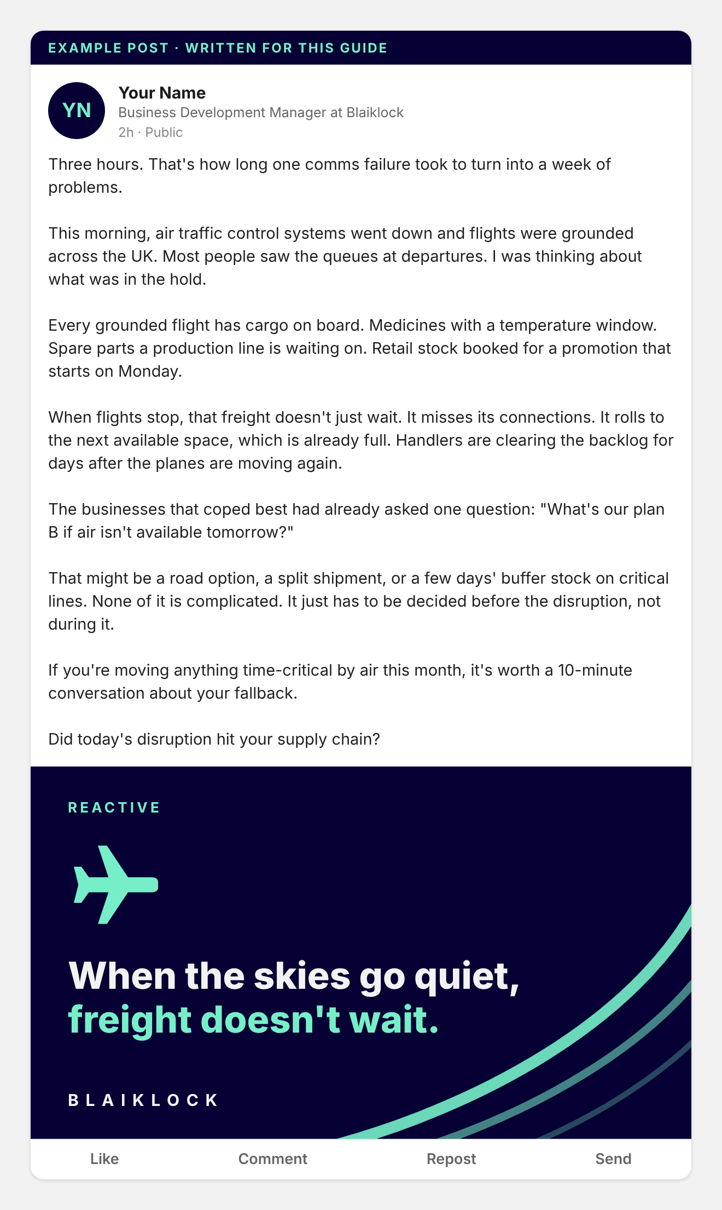
6. "But My Last Post Only Got 12 Likes…"
Totally normal. The posts you see with hundreds of reactions come from people who post every single week. Most of their posts get a handful of likes too. Keep showing up, and eventually the right hook meets the right story and one post takes off. Even a quiet post puts your name in front of clients and prospects.
Still not convinced? The research says:
- 73% of B2B decision-makers trust thought leadership more than marketing materials (Edelman and LinkedIn, 2024).
- 45% more sales opportunities for salespeople who are active on LinkedIn (LinkedIn Sales Solutions).
- 2x the click-through rate when content is shared by employees rather than the company page (LinkedIn).
- 45% less engagement for posts that read as AI-generated (Originality.ai, 2024), so Step 3 matters.
7. Quick Reference – Your Weekly LinkedIn Routine
Find a story → AI writes the first draft → Make it sound like you → Add an image → Post on Monday or Wednesday morning → Reply to comments → Repeat next week.
8. Key Principle
Done beats perfect. One post a week, telling a real story, in your own voice. The post that takes off comes to the people who keep showing up.
End of SOP. Now go and post something.

