**Introductory Research to Gun Control and Firearm Sales**

Blaine Bristow

Department of Data Science, Bellevue University

DSC 500: Introduction to Data Science

Professor Matthew Metzger

October 30, 2022

**Introductory Research to Gun Control and Firearm Sales**

Gun control is a widely debated topic in the United States, and every so often, a new law is introduced that would restrict the guns that the average citizen has access to. Due to the nature of the U.S. Government, there is a period between the introduction and passing of any bills where citizens would have the opportunity to purchase a gun that doesn’t meet the proposed restrictions in hopes of being grandfathered in. That leads to an interesting question: Are gun sales affected by the proposal of new gun control laws?

Google Trends can be used to see what the public is searching for and gain some insight into their interest in purchasing a firearm. To best understand the issue, it can be broken down further into the following list of questions that will be researched further:

* Are people more likely to buy a gun when gun control is in the news?
* Do people attempt to stockpile ammunition prior to potential new gun laws?
* Do people purchase additional accessories for their guns (sights, grips, etc.) before gun laws pass?
* If there’s a proposed ban on rifles, do handguns become more popular than rifles?
* Are people more likely to attempt to 3D print a gun in the event of a ban?

To begin, basic searches are compared using Google Trends to determine if searches indicating that gun control is a popular topic occur frequently at the same time as searches indicating that people are intending to purchase firearms or ammunition. The results of the following searches are displayed in Figure 1 below: “gun bill”, “gun control bill”, “buy a gun”, “gun store”, and “buy ammo”.

Figure 1. Chart of google search results in the US since 2004 for terms related to both gun control bills and purchasing firearms (Google, n.d.).

From the chart, it is evident that spikes in searches for gun control bills are often accompanied by spikes in searches for purchasing firearms, but the opposite is not always true (as seen in the largest spike on Figure 1 in early 2020, where the spike can likely be attributed to outside factors, such as public uncertainty due to COVID-19). However, it does not appear that ammunition sales are heavily impacted by upcoming gun control bills, as the search rates don’t appear to increase dramatically with the other searches, apart from the spike in early 2013.

From Figure 2, below, it can be determined that gun accessories are similar to ammunition, in that they seem to be tied somewhat to gun sales, but don’t experience the same spikes around bills.

Figure 2. Chart of Google search results in the US since 2004 for terms related to gun control bills, purchasing firearms, and firearm accessories (Google, n.d.).

In Figure 3, rifle and handgun searches appear to be generally similar. There are periods where one becomes much more popular than the other, but it can’t be determined from Google Trends if this is the cause of legislation targeting specifically one or the other. Further research would be required.

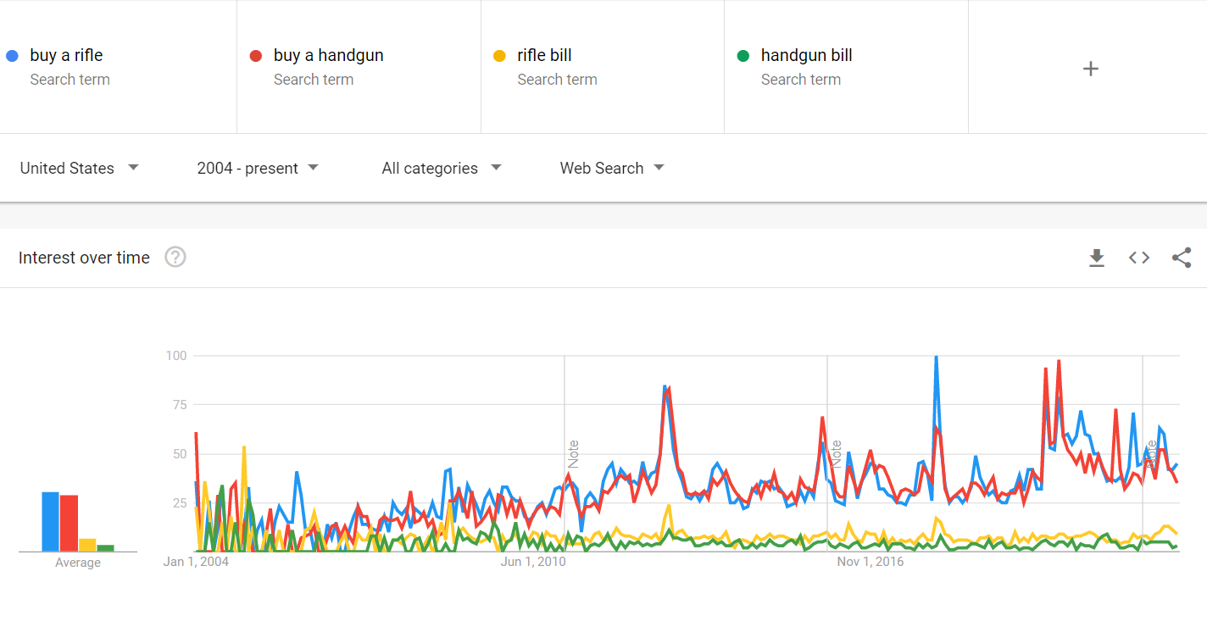

Figure 3. Chart of Google search results in the US since 2004 for terms related to purchasing rifles, purchasing handguns, as well as specific legislation targeting each (Google, n.d.).

Finally, from Figure 4, it doesn’t appear that interest in 3D printed guns is correlated with gun control legislation. However, the results could be completely unrelated to actual interest in printing guns and tied to events in the news related to printed guns. Since 3D printed guns are created by purchasing a 3D printer and downloading a file online, it would be difficult to gather further data on how many guns have been printed. Short of getting the number of downloads of a file, it is unlikely more data can be found beyond these Google Trends results.

Figure 4. Chart of Google search results in the US since 2004 for terms related to gun control bills and 3D printed firearms (Google, n.d.).

Beyond Google Trend analysis, further research can be done on the actual data behind firearms purchases, which can then be compared to bills in the United States House and Senate, comparing any spikes with dates when any progress is made in bills mentioning firearms. The data available to the public around the sale of firearms isn’t very exact. As mentioned by Joe Walsh in his article on 2021 firearms sales, Small Arms Analytics and Forecasting is one company that analyzes the data available to get a more accurate measure of the number of firearms sold in the United States (Walsh, 2022). However, the data from Small Arms Analytics and Forecasting requires payment to access, so for the purpose of this introductory research, free government-released data will be used. The FBI releases information on the number of background checks they perform every month (Figure 5), but this can’t be used as a measure of firearms sold, as not all background checks will pass (Federal Bureau of Investigation). The ATF releases information on the manufacture and importation of firearms in the United States, but once again, this can’t be used as a direct measure of purchases, as those numbers correlate more to the supply held by dealers (Bureau of Alcohol, Tobacco, Firearms and Explosives). The numbers released by the ATF are also displayed on a per-year basis, which is not as helpful to the purpose of this research as the per-month basis data released by the FB. However, both data sets can be used as measures of public interest in the purchase of firearms, as more background checks means more citizens attempting to purchase, and more supply to dealers could be a response to more demand from citizens.

Figure 5. Number of background checks prior to firearm purchase performed by the FBI, broken down by month.

To determine when gun control bills are at the peak of public discussion, Google Trend analysis could be a strong source, as public interest will likely drive search traffic. However, there may be false positives within this data, as the searches may not be driven by a new bill that may cause panic purchasing, but instead are driven by nothing but public outcry for more strict regulations in response to a tragedy. To get a more accurate representation of when an actual bill is the driving force, a site like LegiScan can be used to find dates where bills mentioning firearms made progress in the US House or Senate (LegiScan). LegiScan can be helpful, as bills can be searched based on text contained (such as “firearm”) and sorted based on the date of the last action the bill underwent. The bill summaries provided on the site could be read to determine which bills are most relevant to firearm regulations, then compare the dates that those bills appeared in the house or senate, or dates that the bills were voted on, to the background check data provided by the FBI. Given the Google Trends data seen in Figure 2, it is expected that the FBI will perform more firearm background checks in periods of higher firearm bill activity.

Another facet of this topic that would be interesting to research further is the somewhat unexpected behavior of the trend of ammunition and firearm accessories seen in Figures 1 and 2. As difficult as it may be to find data on the sales of firearms, there is at least some hard data tied to attempted transactions. Ammunition and accessories are not as regulated, and it may be difficult to find any good data on month-to-month sales. The best solution would likely be to partner with a handful of larger chain stores that sell firearms, such as Scheels or Bass Pro Shops, that would be willing to sell some of their data on their sales. Multiple companies should be used to make sure the data is a representation of the product, and not necessarily a representation of company sales.

Overall, concrete data around the sale of firearms seems to be somewhat difficult for citizens to obtain. Inferences can be made from the data provided by various governmental agencies, but those would be inferences based on data that is only correlated to the desired data. If this project is to be pursued further, it is recommended that sales data is purchased from companies that would be willing to participate in the study, as that would likely be the easiest way to get more accurate information.

Given the lack of data around firearm sales, Google trends was a main source of data in this research. One big assumption being made from this data is that as the interest indicated by google searches increases, purchases would increase as well. There was an attempt to mitigate this by using searches believed to be more likely to indicate intent to purchase, such as “buy a gun”. However, the data from Google searches should not be taken as absolute, as interest does not indicate an actual purchase. There are likely some users making searches like “buy a gun” at the time when gun control is being widely discussed, not with the intent to purchase, but to research the current process when forming their opinion on the potential new legislation.

There aren’t many ethical concerns in this line of research. The data collected here would be information regarding the purchasing of firearms across the nation and shouldn’t ever be focused in enough that any one individual’s information would be required. As always, efforts should be made to ensure that findings from analyzing the data are not mis-represented.

One of the largest challenges in this research is finding a reliable source of data on firearm sales. Beyond paying Small Arms Analytics for their data research, the best data available would be the FBI-released Firearm Background Checks. It doesn’t account for failed or canceled purchases, but it does give a good idea of the interest month-to-month. Unfortunately, a month is quite a while in today’s news cycle, and it doesn’t appear the FBI releases data with shorter intervals, so it may be difficult to find strong correlations.

Based on the preliminary research from various sources outlined above, there is likely enough data available to perform analysis and draw conclusions, but better data would be preferable, and may be accessible if third parties would be willing to cooperate. Actual sales data from a third party would likely make performing analysis sales much more accurate, as well as provide data and more insight into ammunition and gun accessory sales. Even without true sales data, there is enough data that can be gathered from government sources and sites that organize activity on bills to determine whether activity in bills related to gun control promote short term panic buying of firearms.

**References**

Bureau of Alcohol, Tobacco, Firearms and Explosives. (n.d.). *Firearms Commerce in the United States Annual Statistical Update 2021.* ATF. Retrieved October 8, 2022. <https://www.atf.gov/firearms/docs/report/2021-firearms-commerce-report/download>

Federal Bureau of Investigation. (n.d.). *NICS Firearm Checks: Month/Year.* FBI. Retrieved October 8, 2022. <https://www.fbi.gov/file-repository/nics_firearm_checks_-_month_year.pdf/view>

Google. (n.d.). *Google Trends*. Retrieved September 18, 2022. <https://trends.google.com/trends/explore?date=all&geo=US&q=gun%20bill,gun%20control%20bill,buy%20a%20gun,gun%20store,buy%20ammo>

Google. (n.d.). *Google Trends*. Retrieved September 18, 2022. <https://trends.google.com/trends/explore?date=all&geo=US&q=gun%20control%20bill,buy%20a%20gun,gun%20accessories,gun%20sight,gun%20grip>

Google. (n.d.). *Google Trends*. Retrieved September 18, 2022. <https://trends.google.com/trends/explore?date=all&geo=US&q=buy%20a%20rifle,buy%20a%20handgun,rifle%20bill,handgun%20bill>

Google. (n.d.). *Google Trends*. Retrieved September 18, 2022. <https://trends.google.com/trends/explore?date=all&geo=US&q=gun%20control%20bill,3d%20printed%20gun,print%20a%20gun,how%20to%20print%20a%20gun>

LegiScan. (n.d.). *Search Results (US legislative search about firearm).* LegiScan. Retrieved October 8, 2022. <https://legiscan.com/gaits/search?state=US&keyword=firearm>

Walsh J. (2022, January 5). *U.S. Bought Almost 20 Million Guns Last Year — Second-Highest Year On Record.* Forbes. Retrieved October 8, 2022. <https://www.forbes.com/sites/joewalsh/2022/01/05/us-bought-almost-20-million-guns-last-year---second-highest-year-on-record/?sh=4958763813bb>