Blaine McMahon, Jacob Sword, Nicholas Yameen

Phase 2

2/14/19

**GUI.py**

This file is the main GUI for the program. It uses tkinter to create the GUI. First, the GUI window will open and display three buttons and a place to enter text. The user can either write the path to the file to be sent or leave it blank to use our default image. The user then has to click Start Server first. This will start the *run_server()* function. This function will call *Server()* to start the UDPserver.py as a new thread. Next, the user can click Start Client button. This will call *start_client()* which then calls the *client()* function to start a UDPclient.py thread. The two scripts are run, as described below.

**UDPserver.py**

In the UDP server file, there is a class called UDPserver. The init function will first either use the file path given at the start or use the default if not specified by the user. It will then open a UDP socket and bind to it. It will then move to the *listen()* function.

The listen will continually run, where it will listen for incoming connections. The sever will first receive the filename being sent from the client. It will take that name and open the file for writing binary. It will then preform a *rdt_rcv()* where it will continually receive packets from the client and write them to the file. Once the full image is received it will then close the file and send an image back to the client.

The *send_img()* function will first open the file specified or the default one for reading binary. It will then send the image name to the client. Finally, it will send the image using the *rdt_send()* function.

**UDPclient.py**

The UDPclient has a class which defines four functions. First, the client will initialize similar to the UDP server. It will connect to the server on the UDP socket. Then it will go into *start_send()* function. It will first call *send_img()* function to send the server an image.

The *send_img()* function will first either use the path given by the user or the default one. It will open that image for reading binary. The client will send the server the image name. Then it preforms RDT send by calling the *rdt_send()* function. Once it has finished it will close that file.

Next, the *start_send()* will call the *wait_and_receive()* function. Here the client will receive the response image name from the server. It will open that file for writing binary. After which it will call *rdt_rcv()*  to receive all the packets of the image. After which, the file will close, and the callback function will be called. This function just prints it has finished. The client will then close the socket and be finished.

**rtd.py**

In the file, there are six functions defined. The server and client will use these functions to send RTD 1.0 over a socket. The sender will use *rdt_send()* function. This function will take in a file, endpoint, and the socket. It will make packets using the *make_pkt()* function by reading 1024 bytes at a time. It will go into a while loop, which will run while there is a packet to be sent. The *udt_send()­­* function will send the packet to the endpoint over the socket. It returns the number of bytes sent, then make a new packet. It will continue to send packets until the whole file has been sent.

The *rdt_rcv()* function will receive a packet. It will be called with the filename that is being received, the file, and the socket. It will go into a while True loop where it will first call *extract()* function. *Extract()* will wait for thread to be ready I/O with the select.select() line. If it is not, it will timeout, which means there is no data to receive on the socket. If the thread is ready, it will receive 1024 bytes on the socket and return the packet. In the *rdt_rcv()* will then call *deliver_data()* which will take the data and file. This function will write the file. The receive function will continue to extract and write packets until it has reached the end. At that time, the file will be closed and will be broken out of the while loop.

**How to Run**

1. Make sure the files are setup as so  
   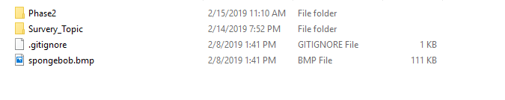  
   Here the python scripts are in the Phase2 folder and the default image is in the folder before Phase2.
2. Go into the Phase2 folder and issue the command “python GUI.py” on the command line. The following GUI will appear.  
   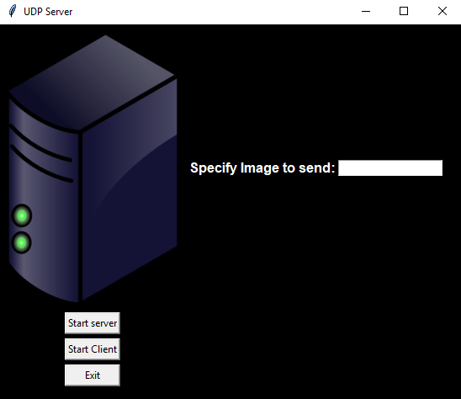
3. Leave file to send blank to use default or specify path to your own picture. Click server  
   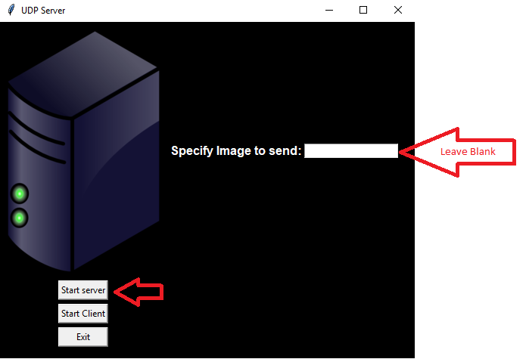
4. Again, leave image blank to use default, or specify a different image. Then click client.  
   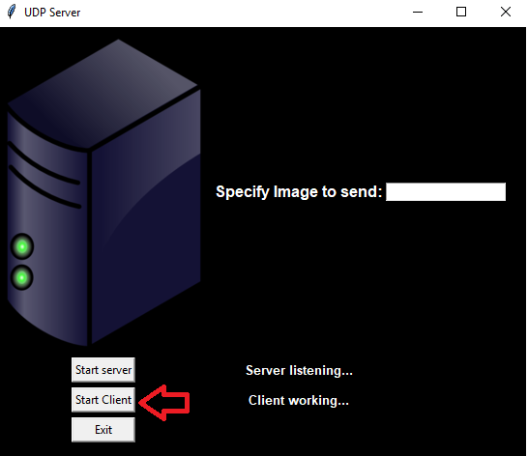
5. You will see messages on the GUI, as seen in the image above. In the terminal messages will appear of what is happening as seen below.  
   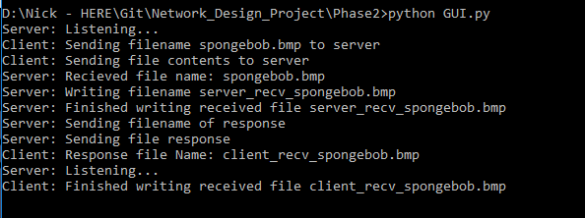
6. New files will be in the directory called “client_recv_{name}” and “server_recv{name}”
7. Click client again to re-run the client or click exit to stop.