GDD Advance Programming Assignment 3:
Match 3 Game:
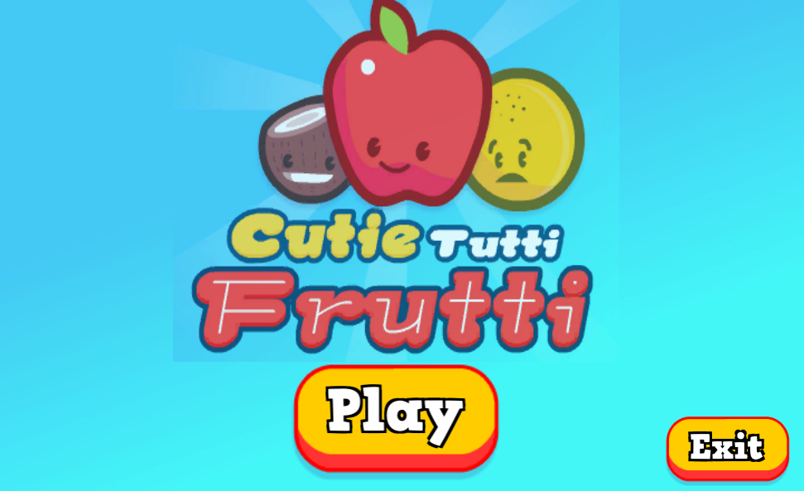
Outline / Theme of the Game:
Basic Candy crush Type of match 3 Game where player has limited moves. Select the first item and then second to switch the places and both the items should be beside each other. Player can still move the item even if there are not making 3 matches, but their move will get spend so need to be careful.

Input and Overall System:
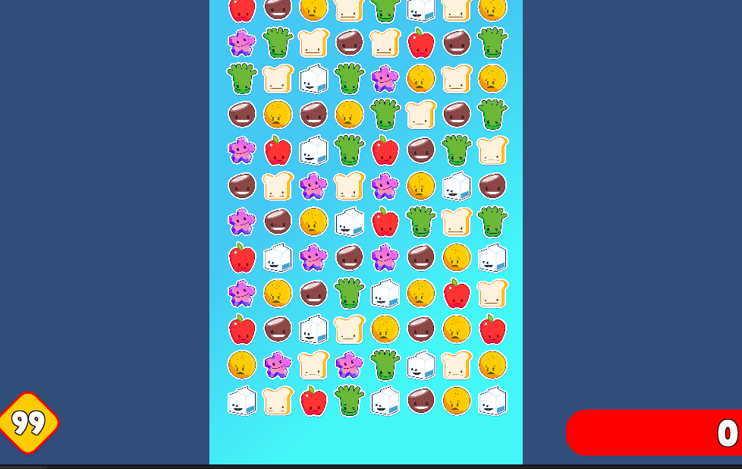
Mouse based game: Left click to select the first item and left click on the second item to swap.

Level of Difficulties:
As the Game progresses it will be tougher for the player to find matches. Because the game will get more tough, we have added the feature even when there is not a 3-match condition present, player can move the candy.

Player’s Skill affects the system:
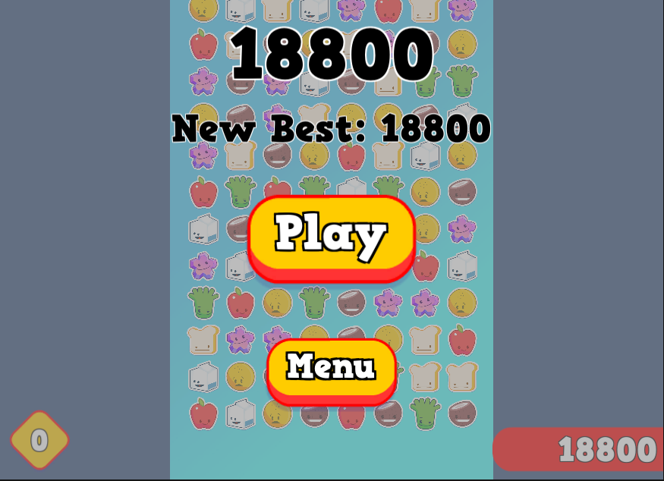
When the intensity of the game increases as the time passes and player chooses their move, the game starts.
to become more tougher as there are less matches to be found.

Bonus:
Game Saves one best attempt and shows that as the High score which player can break every time they play.

