**GDD Advance Programming Assignment 4:**

**Hacking Game:**

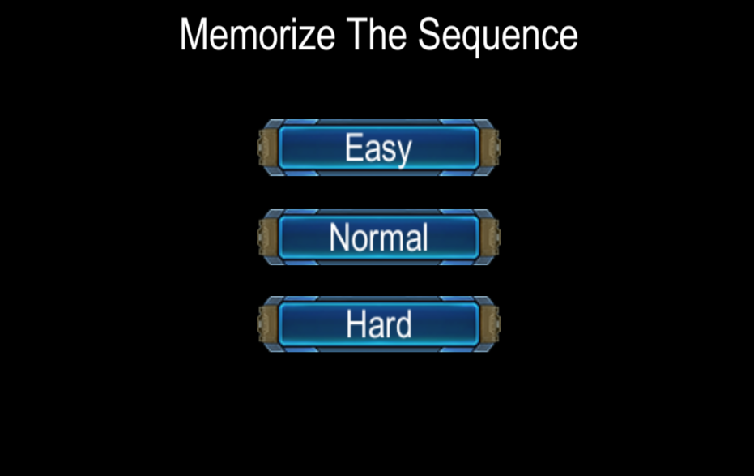

**Outline / Theme of the Game:**

Basic watch the buttons that are being pressed and remember the order. After the buttons are pressed replay in the same order to pass. Repeat the same process four times and You Win! Forget any of the order and you lose.

**Input and Overall System:**

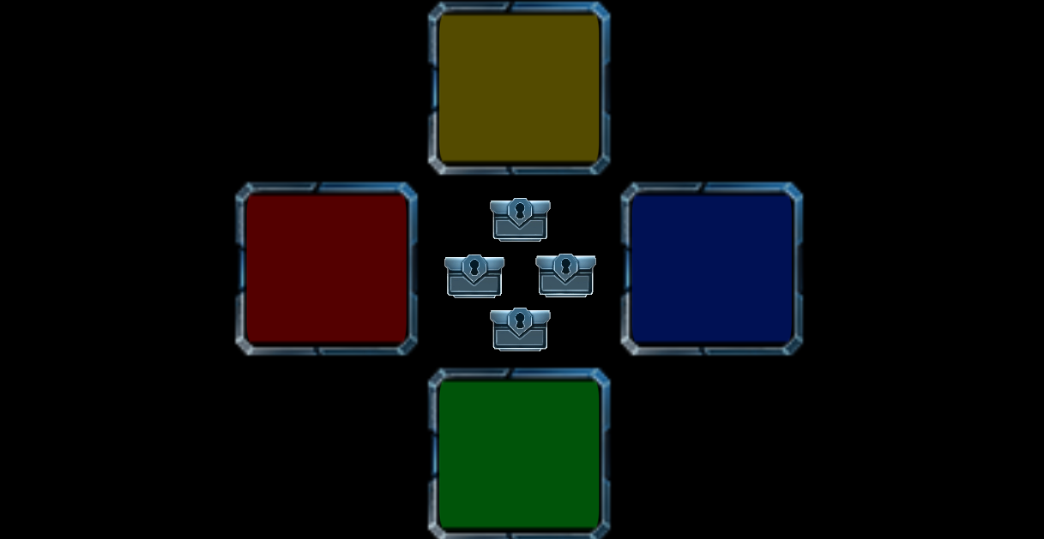Mouse based game: Left click to select the Button.

**Level of Difficulties:**

There are three levels. Easy Medium and Hard. Easy starts with only two button orders to remember. Medium with 3 and Hard 4 in the first round.

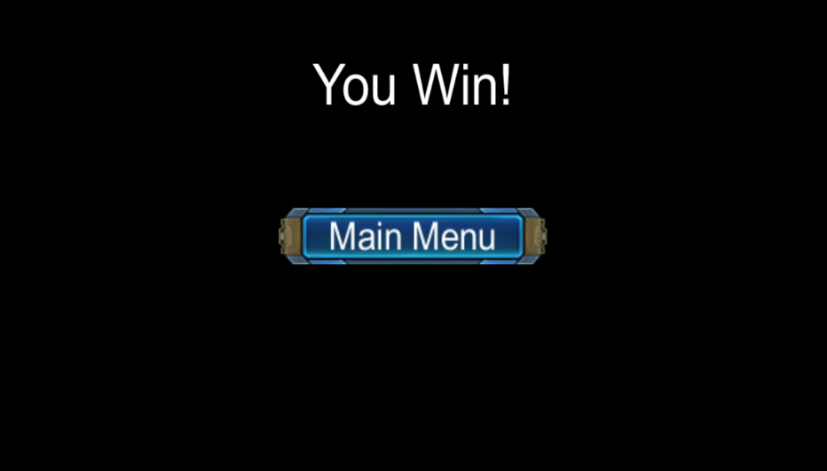

**Player’s Skill affects the system:**

There are 4 rounds in each mode. After every round, the number of buttons to remember increases and game becomes harder to play.

