**GDD Advance Programming Assignment 2**

**Lockpicking Game**

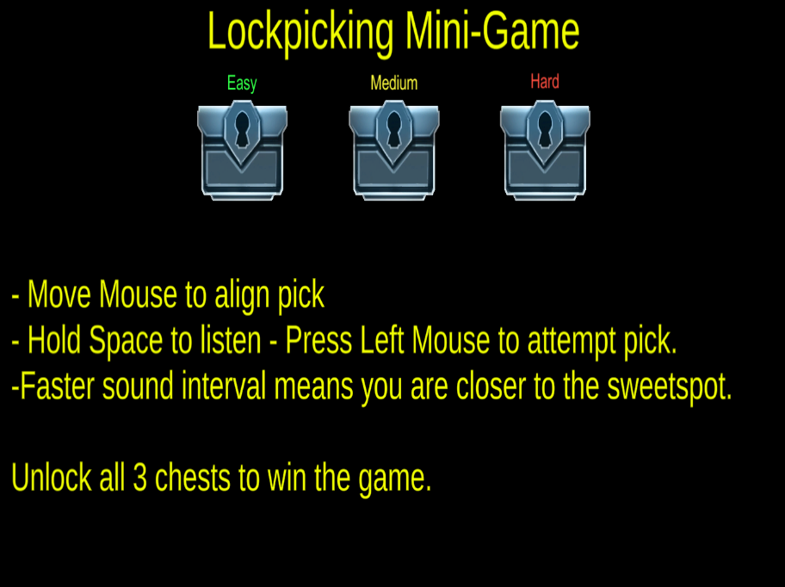**Outline/Theme of The Game:**

Basic lockpicking Side game where you listen to the cracking sound and then press a key to open the Chest.

**Inputs and Overall System:**

Mouse to move around the pick and space to the audio ques. When you hear the sound press left mouse click and chest Opens!!!

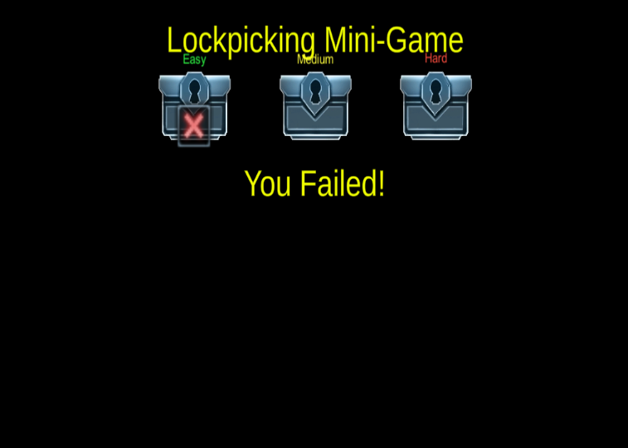**Level of Difficulties:**

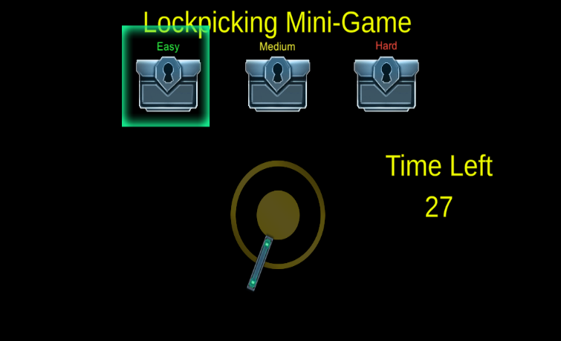Three Level of difficulties. Player gets the chance to open all three-chest weather he opens the first one or not but if the player runs out in time before opening the first chest, the game is lost, and he does not get another chance to open other chest. If player presses left mouse button on the wrong spot, he still gets the chance to open other chests.

**Player’s skill affects the system:**

When the intensity of the game increases player gets less time to open chest as well as the spot where player can unlock the chest gets smaller as well.