INSURANCE CLAIM QUERY

KPI's
-- Total Policy
SELECT COUNT(id) AS Total_Policies
FROM insurance_policies;
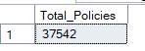

-- Total Claim Amount
SELECT CAST(SUM(claim_amount) AS DECIMAL(18,2)) AS Total_Claim_Amount
FROM insurance_policies;
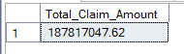

-- Average Claim Frequency per Policy
SELECT CAST(AVG(Claim_Freq * 1.0) AS DECIMAL(10,4)) AS Avg_Claim_Frequency
FROM insurance_policies;
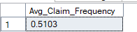

-- Average Claim Amount
SELECT CAST(AVG(claim_amount) AS DECIMAL(18,2)) AS Avg_Claim_Amount
FROM insurance_policies
WHERE claim_amount > 0;
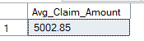

-- Gender-wise Total Policies
SELECT gender, COUNT(id) AS TotalPolicies
FROM insurance_policies
GROUP BY gender;
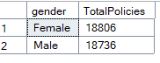

INSIGHTS / OVERVIEW QUERIES(INSURANCE CLAIM REPORT)

-- Policies and Claims grouped by Car Use and % of total

SELECT
Car_Use,
COUNT(id) AS TotalPolicies,
CAST(SUM(claim_amount) AS DECIMAL(18,2)) AS Total_Claim_Amount,
CAST(COUNT(id) * 100.0 / SUM(COUNT(id)) OVER() AS DECIMAL(5,2)) AS Policy_Percentage,
CAST(SUM(claim_amount) * 100.0 / SUM(SUM(claim_amount)) OVER() AS DECIMAL(5,2)) AS Claim_Percentage
FROM insurance_policies
GROUP BY Car_Use
ORDER BY TotalPolicies DESC;
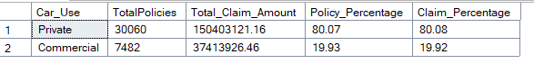

-- Policies and Claims grouped by Car Make
SELECT car_make,
COUNT(*) AS total_policies,
SUM(claim_amount) AS total_claim_amount
FROM insurance_policies
GROUP BY car_make
ORDER BY total_claim_amount DESC;
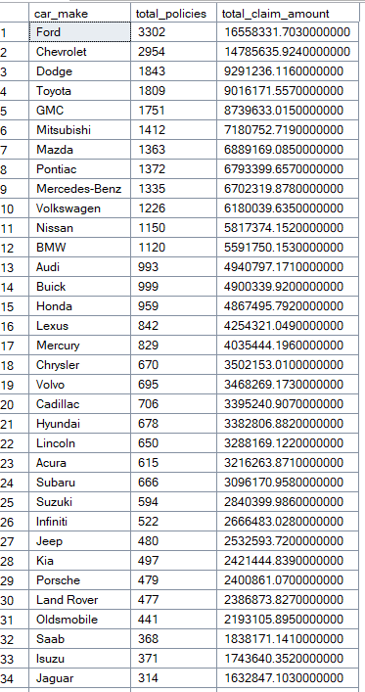

-- By Coverage Zone
SELECT coverage_zone,
COUNT(*) AS total_policies,
CAST(SUM(claim_amount) AS DECIMAL(18,2)) AS total_claim_amount
FROM insurance_policies
GROUP BY coverage_zone
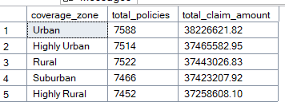
ORDER BY total_claim_amount DESC;

-- Age Group Analysis (Policies + Claims)
SELECT
CASE
WHEN DATEDIFF(YEAR, Birthdate, GETDATE()) BETWEEN 15 AND 25 THEN '15-25'
WHEN DATEDIFF(YEAR, Birthdate, GETDATE()) BETWEEN 26 AND 35 THEN '26-35'
WHEN DATEDIFF(YEAR, Birthdate, GETDATE()) BETWEEN 36 AND 45 THEN '36-45'
WHEN DATEDIFF(YEAR, Birthdate, GETDATE()) BETWEEN 46 AND 55 THEN '46-55'
WHEN DATEDIFF(YEAR, Birthdate, GETDATE()) BETWEEN 56 AND 65 THEN '56-65'
WHEN DATEDIFF(YEAR, Birthdate, GETDATE()) BETWEEN 66 AND 75 THEN '66-75'
WHEN DATEDIFF(YEAR, Birthdate, GETDATE()) > 75 THEN '76+'
ELSE 'Unknown'
END AS Age_Group,
COUNT(*) AS Total_Policies,
CAST(SUM(claim_amount) AS DECIMAL(18,2)) AS Total_Claim_Amount,
CAST(AVG(CAST(claim_freq AS FLOAT)) AS DECIMAL(10,2)) AS Avg_Claims_Per_Policy
FROM insurance_policies
GROUP BY
CASE
WHEN DATEDIFF(YEAR, Birthdate, GETDATE()) BETWEEN 15 AND 25 THEN '15-25'
WHEN DATEDIFF(YEAR, Birthdate, GETDATE()) BETWEEN 26 AND 35 THEN '26-35'
WHEN DATEDIFF(YEAR, Birthdate, GETDATE()) BETWEEN 36 AND 45 THEN '36-45'
WHEN DATEDIFF(YEAR, Birthdate, GETDATE()) BETWEEN 46 AND 55 THEN '46-55'
WHEN DATEDIFF(YEAR, Birthdate, GETDATE()) BETWEEN 56 AND 65 THEN '56-65'
WHEN DATEDIFF(YEAR, Birthdate, GETDATE()) BETWEEN 66 AND 75 THEN '66-75'
WHEN DATEDIFF(YEAR, Birthdate, GETDATE()) > 75 THEN '76+'
ELSE 'Unknown'
END
ORDER BY Age_Group;
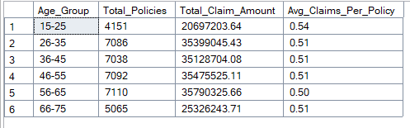

-- By Car Year
SELECT car_year,
COUNT(*) AS total_policies,
SUM(claim_amount) AS total_claim_amount
FROM insurance_policies
GROUP BY car_year
ORDER BY car_year
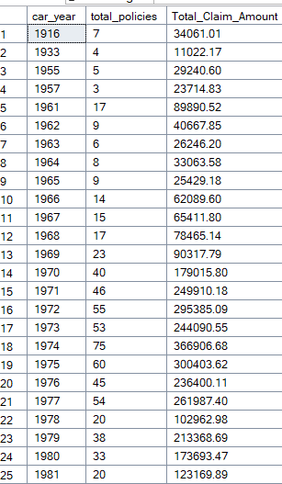

-- By Kids Driving
SELECT
CASE WHEN kids_driving = 1 THEN 'Kids Driving' ELSE 'No Kids Driving' END AS kids_driving_bucket,
COUNT(*) AS total_policies,
CAST(SUM(claim_amount) AS DECIMAL(18,2)) AS Total_Claim_Amount
FROM insurance_policies
GROUP BY CASE WHEN kids_driving = 1 THEN 'Kids Driving' ELSE 'No Kids Driving' END;
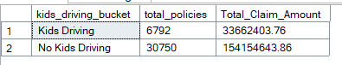

-- By Education
SELECT education,
COUNT(*) AS total_policies,
CAST(SUM(claim_amount) AS DECIMAL(18,2)) AS Total_Claim_Amount
FROM insurance_policies
GROUP BY education
ORDER BY total_policies DESC;
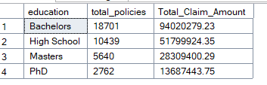

-- Policies and Claims by Education + Marital Status
SELECT
education,
marital_status,
COUNT(*) AS total_policies,
CAST(SUM(claim_amount) AS DECIMAL(18,2)) AS total_claim_amount,
CAST(AVG(CAST(claim_freq AS FLOAT)) AS DECIMAL(10,2)) AS avg_claims_per_policy
FROM insurance_policies
GROUP BY education, marital_status
ORDER BY education, marital_status;
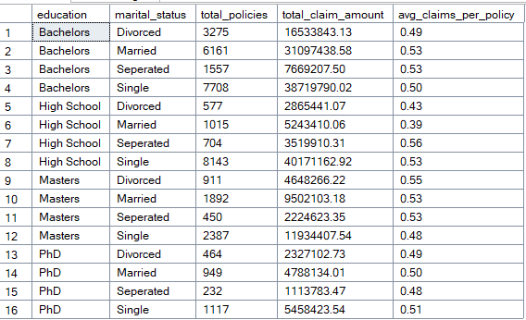

-- Claim Freq Bucket
SELECT CASE
WHEN claim_freq = 0 THEN 'No Claims'
WHEN claim_freq BETWEEN 1 AND 2 THEN '1-2 Claims'
ELSE '3+ Claims'
END AS claim_bucket,
COUNT(*) AS total_policies,
CAST(SUM(claim_amount) AS DECIMAL(18,2)) AS total_claim_amount

FROM insurance_policies
GROUP BY CASE
WHEN claim_freq = 0 THEN 'No Claims'
WHEN claim_freq BETWEEN 1 AND 2 THEN '1-2 Claims'
ELSE '3+ Claims'
END
ORDER BY total_policies DESC;
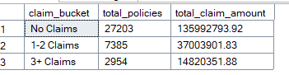

-- CROSS TABS
SELECT gender,
car_use,
COUNT(*) AS total_policies,
CAST(SUM(claim_amount) AS DECIMAL(18,2)) AS total_claim_amount
FROM insurance_policies
GROUP BY gender, car_use
ORDER BY gender, total_claim_amount DESC;
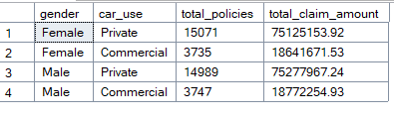
-- FINAL INSIGHTS
-- Claim Ratio = Total Claim Amount / Total Policies
SELECT
coverage_zone,
COUNT(*) AS total_policies,
CAST(SUM(claim_amount) AS DECIMAL(18,2)) AS total_claim_amount,
CAST(SUM(claim_amount) * 1.0 / COUNT(*) AS DECIMAL(18,2)) AS avg_claim_per_policy
FROM insurance_policies
GROUP BY coverage_zone
ORDER BY avg_claim_per_policy DESC;
