Blaise A. Johnosn

CSD325

August 10, 2025

Django install

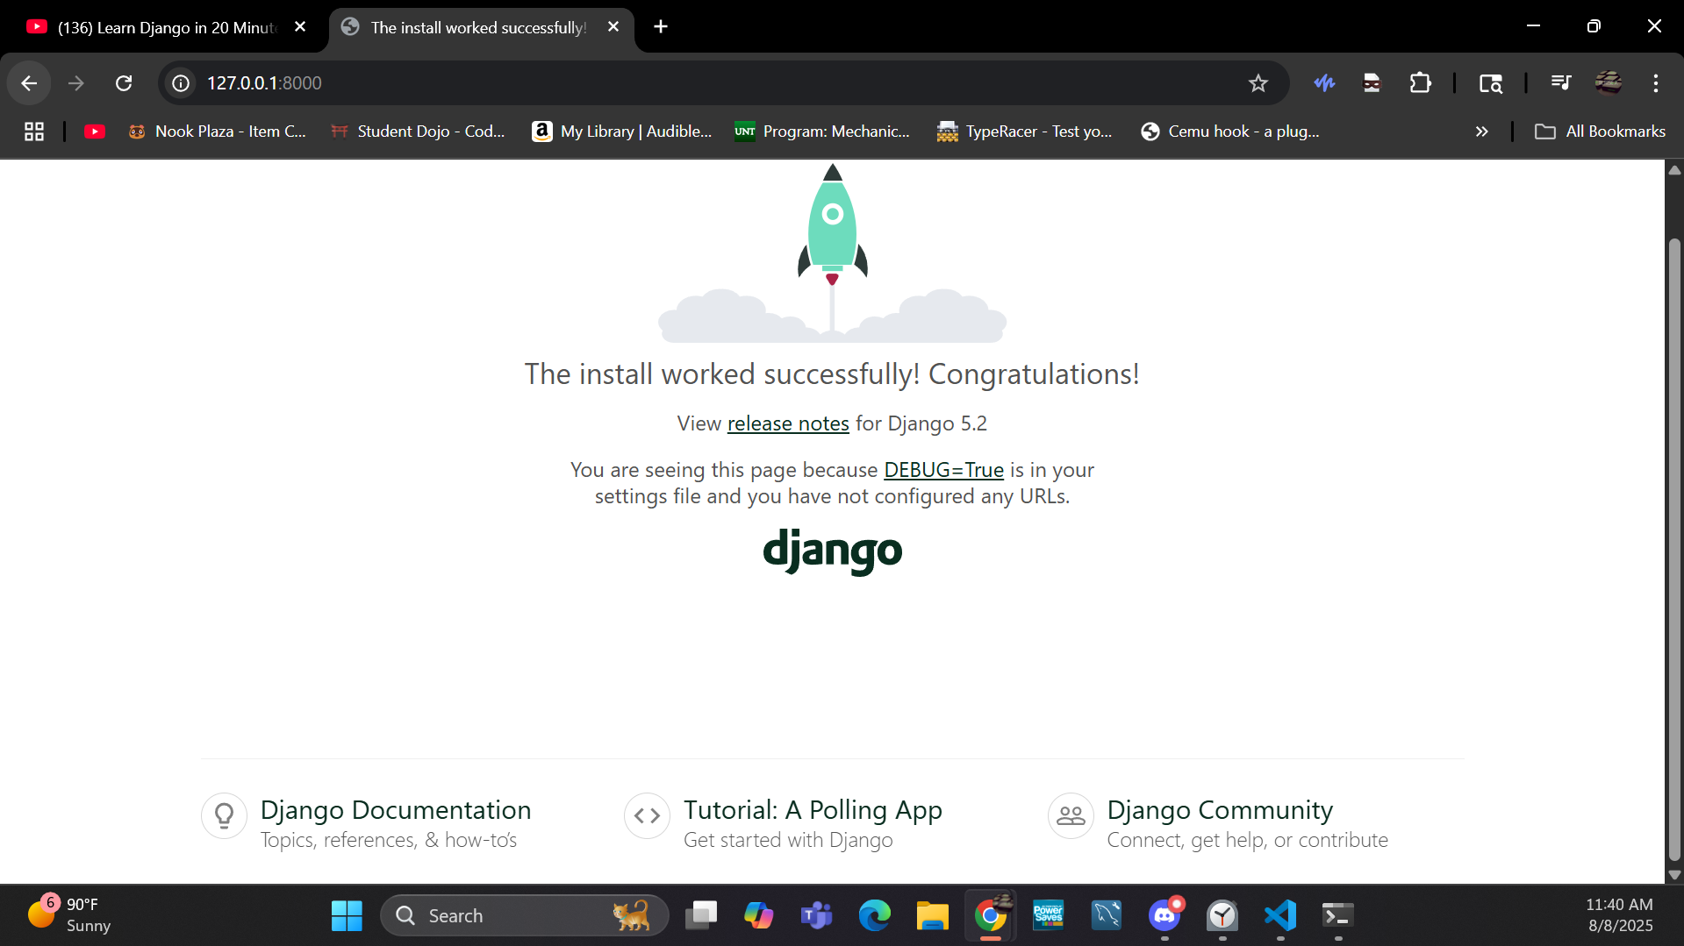

Hello world changed

