Blaise Johnson

Assignment 3.2 Chohan

Intro update:

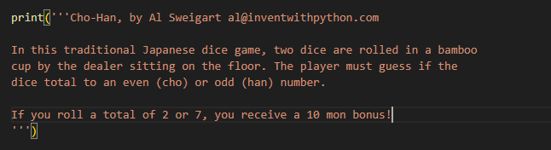

Input change:

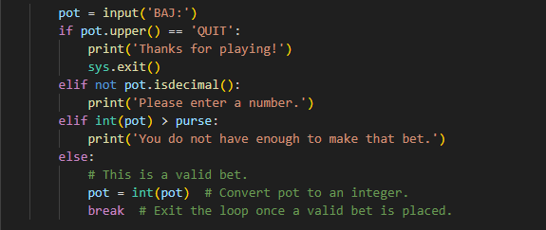

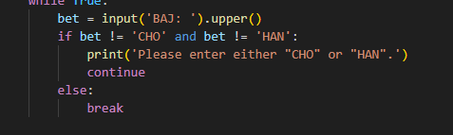

Percent changed to 12:

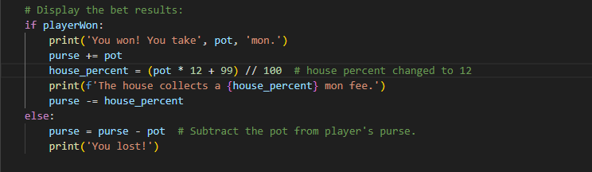Done this way because 12 does not divide by 100 as nicely as 10 does so by going (pot \* 12 + 99) // 100, I avoided the rounding error the prevented the house from getting a percentage.

Added bonus rule:

