Thank you for providing the briefing document from April 2026.
We would like to question some elements of this. Notably:
- Who the document is considering
- The assertion that a large speed spread is a safety risk
- Assumptions on economics
- Details of the data used
Who is this aimed at?
The review highlights that the speed limit is a primary concern to residents of the village and that temporary speed limits in past years were welcomed.
In the latest Government Road Safety Strategy, it emphasised that:
“Vulnerable road users, such as pedestrians, cyclists, motorcyclists, and children, remain disproportionately at risk of serious injuries and fatalities. Some of the most high-risk roads in the country are rural single carriageways, with high speeds and limited infrastructure. Nearby residents are overwhelmingly in favour of lower speed limits”.
This new strategy also emphasises that road safety should be proactive and not reactive. It should not take someone to die before measures are put in place. Locals have clearly stated their concerns, yet the the review concludes with statements mostly around speed limit compliance and dismissing locals concerns about safety because there haven’t been enough serious injuries/fatalities.
Circular 01/2013 para 33 requires authorities to consider:
“the composition of road users, including existing and potential levels of vulnerable road users.”
Like the latest government guidance, we are first and foremost concerned with people living in the village and vulnerable road users using the road for day-to-day activities like going to and from school. The document is written mostly from the perspective of motorists and the perceived (but not evidenced) disbenefit to them.
Assumption large speed spread is a safety risk
The data on page 4/5 shows that during the temporary 40mph speed limit in 2025 mean speed was drastically reduced. Whilst 85th%ile is indeed a metric for speed compliance it was based on a TRL report (421) from 2000 and was dropped in circular 01/2006. Circular 01/2013 paragraph 36 clearly states mean speed should be used as the basis for determining local speed limits. Paragraph 37 states that if the relationship between mean and 85th percentile is high then additional measures should be considered to reduce this. An example of this could be narrowing the road to install a protected cycle path as well as a continuous, high quality footpath (as recommended by the LCWIP Cycling and Walking strategy).
There is no up to date evidence or government guidance that discusses the impact of safety of difference in mean speed and 85th percentile, yet this is stated as a reason for rejecting a lower speed limit throughout the review.
Even if some drivers are not obeying the speed limit the data shows that if a vulnerable road user were in collision with a vehicle, statistically the speed of the vehicle would likely be lower and the outcome less severe.
Whilst 01/2013 says that speed limits should not be used to solve isolated hazards this discussion is about the entire stretch of road.
Assumptions on economics
It is stated that a lower limit would be “very poor value for money”, despite no economic assessment having been carried out. If the economic case is to be made then a full TAG appraisal should be carried out.
A reproducible analysis using Google Maps travel time data (which considers all occupants of vehicles with Androids phones sharing their location) is similar in nature to connected vehicle data. A link to the analysis is here. In summary it shows:
- journey times on the B3108 are dominated by queuing at each end, not mid link speeds
- reducing the limit on the 50mph section to 40mph produces almost identical journey times to the current situation
- reducing the limit to 30mph (Winsley) and 20mph (Bradford on Avon) produces negligible change in total travel time
- the change is consistent across peak and off peak periods
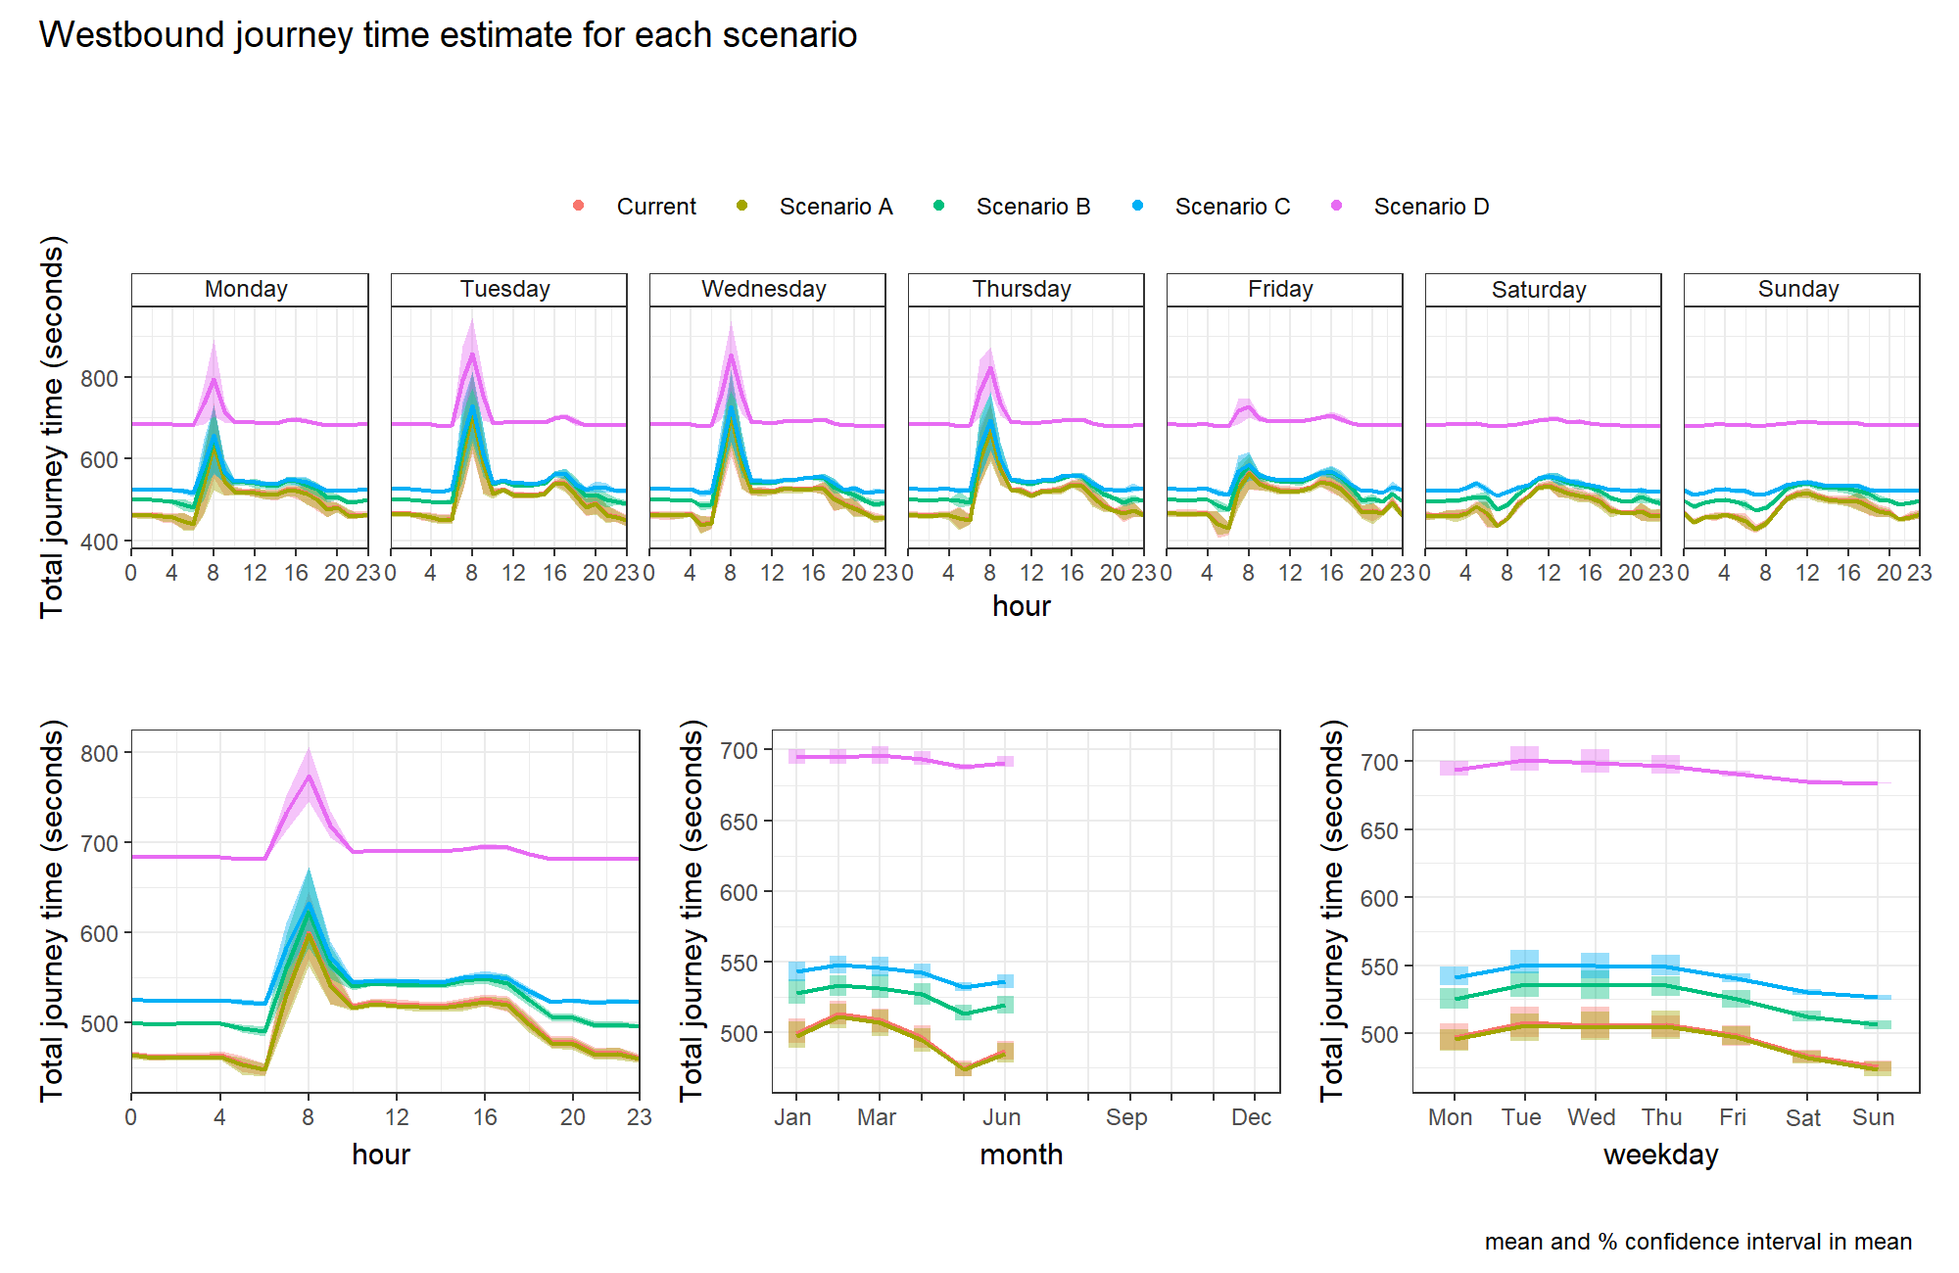
Figure 1 - Journey times for different scenarios on the B3108 in the Westbound direction, Scenario C is 30mph for the Winsley section of the B3108 and 20mph for the BoA section. Due to congestion at each end there is very little difference in journey time between the current situation and scenarios A-C
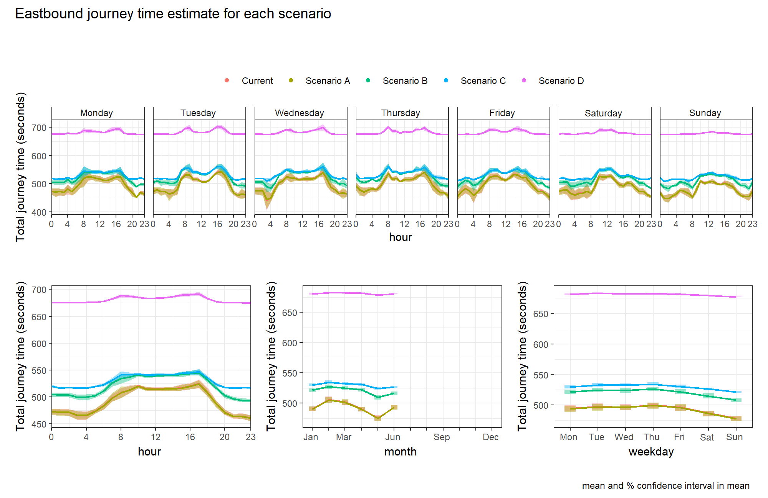
Figure 2 - Journey times for different scenarios on the B3108 in the Eastbound direction, Scenario C is 30mph for the Winsley section of the B3108 and 20mph for the BoA section. Due to congestion at each end there is very little difference in journey time between the current situation and scenarios A-C, in fact the current scenario is not visible on the plot as Scenario A is plotted in front of it.
It is also likely that by reducing the speed limit, HGV and other logistics route planning software is more likely to route vehicles via the much more appropriate (and higher speed limit) A roads in the area following the intention of the Highways Road Classification. This will not only reduce wear and tear on the B3108 surface, its infrastructure such as gas and water mains that run underneath and surrounding roads that aren’t designed for HGV traffic, but also reduces the number of bridge strikes that plague our community. These bridge strikes at Limpley Stoke result in regular and severe disruption to rail services, a factor driving car dependency in this area and therefore increase traffic flows on the B3108 and surrounding roads.
Data used
Figures calculated from the connected car data have been used in the review. We would also like to see the details of this data. For example:
- Sample size
- Vehicles included
- Time of day weighting

