Mantooth Report
Blaise Mazey

This report is of an image that comes from a Windows computer and is part of a criminal investigation. The suspicion is that the owner, Wes Mantooth, may be involved in multiple illicit activities. There are multiple artifacts relating to drug use and manufacturing, check and credit fraud, and ATM scams. Wes uses his device in spurts, with long periods of inactivity followed by bursts. On December 7th 2007 for example, over 130 search queries were recorded over the course of just a few hours. Evidence also shows that he used this device to communicate with others regarding illegal dealings. Many things found on the device would be relevant to an investigation. While the information on the device, especially related to drug use and manufacturing, is incriminating, it is not strictly illegal. The most illegal things on the device are things related to check washing, because they contain stolen information.
The analysis was performed using Autopsy, Windows Registry Viewer, FTK Imager, RegRipper, and screenshot tools (PicPick). The process involved mounting the E01 disk image, which was made using FTK Imager into Autopsy to examine file system contents, registry hives, and user data. RegRipper and Registry Viewer were used to extract user account details, operating system information, and time zone data. Verification was completed by comparing data across tools, and all timestamps were consistent between RegRipper, Registry Viewer, and Autopsy. The MD5 hash value of the image matched the value provided in the Mantooth.E01.txt file, confirming image integrity.
The md5 hash in Autopsy under the eo1 31217210a1a69f272079a3bde3d9d8fc, the provided md5 in the text document is 31217210a1a69f272079a3bde3d9d8fc, which match. Figure 1: MD5 hash verification in Autopsy.
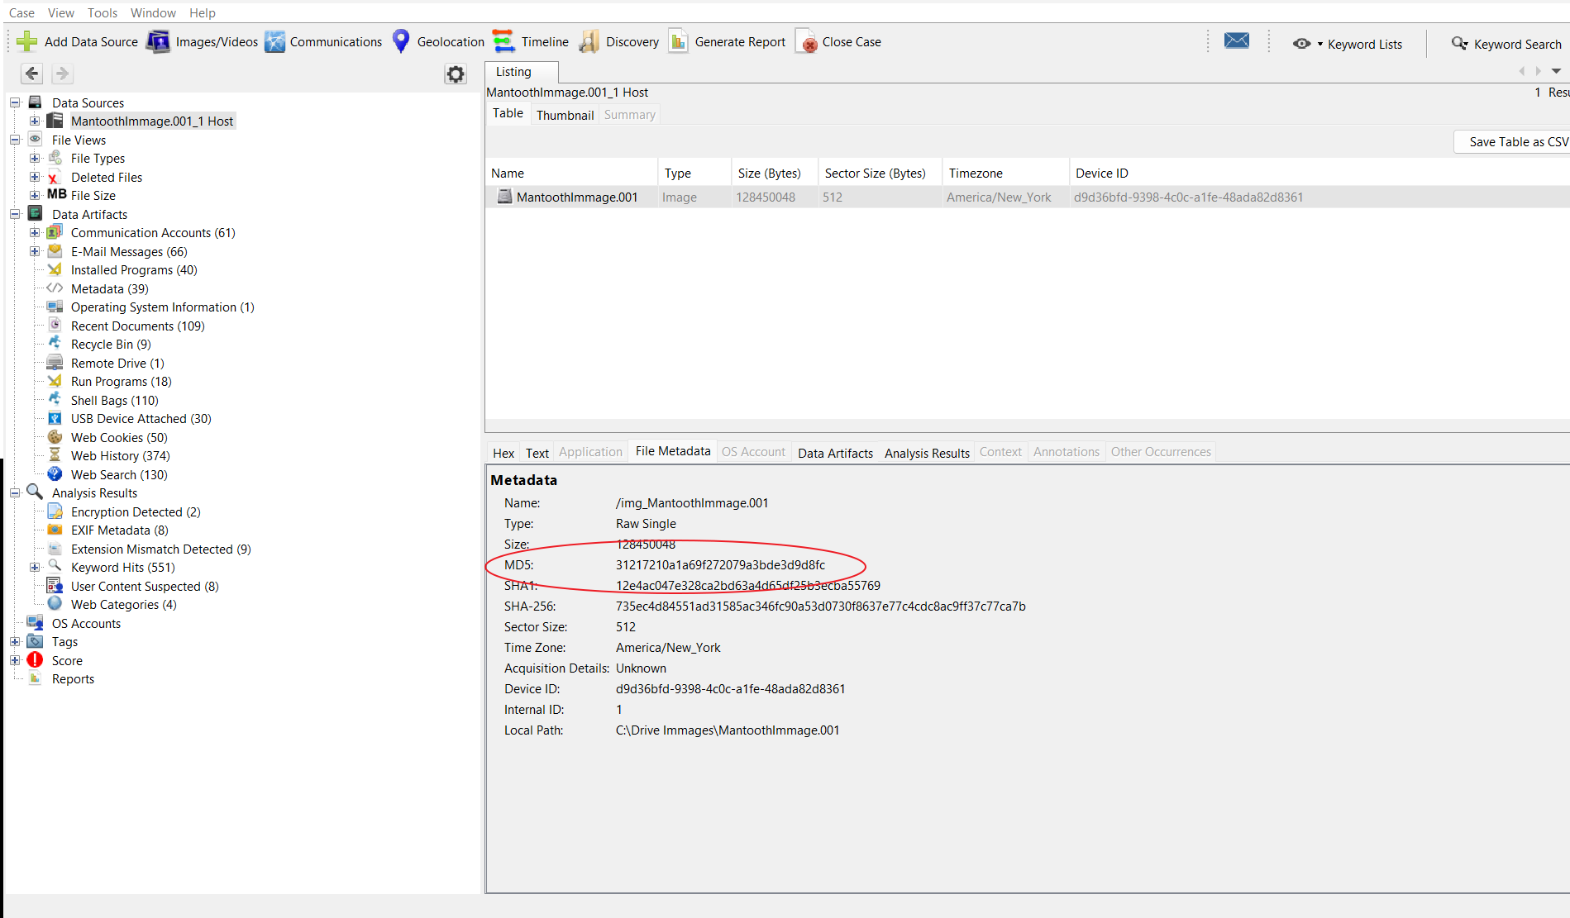
The main Windows user account on this system is Wes Mantooth [RID 1000]. This was the first and most active account, logging in 96 times. The account was created on February 27, 2007, at 18:29:10 UTC, and the last login occurred on February 12, 2008, at 19:12:08 UTC. Other accounts include Dracula [1002], which logged in three times, and Laurent [1003], which never logged in. This information was verified using both RegRipper and Windows Registry Viewer.
Figure 2: User accounts as shown in RegRipper output.
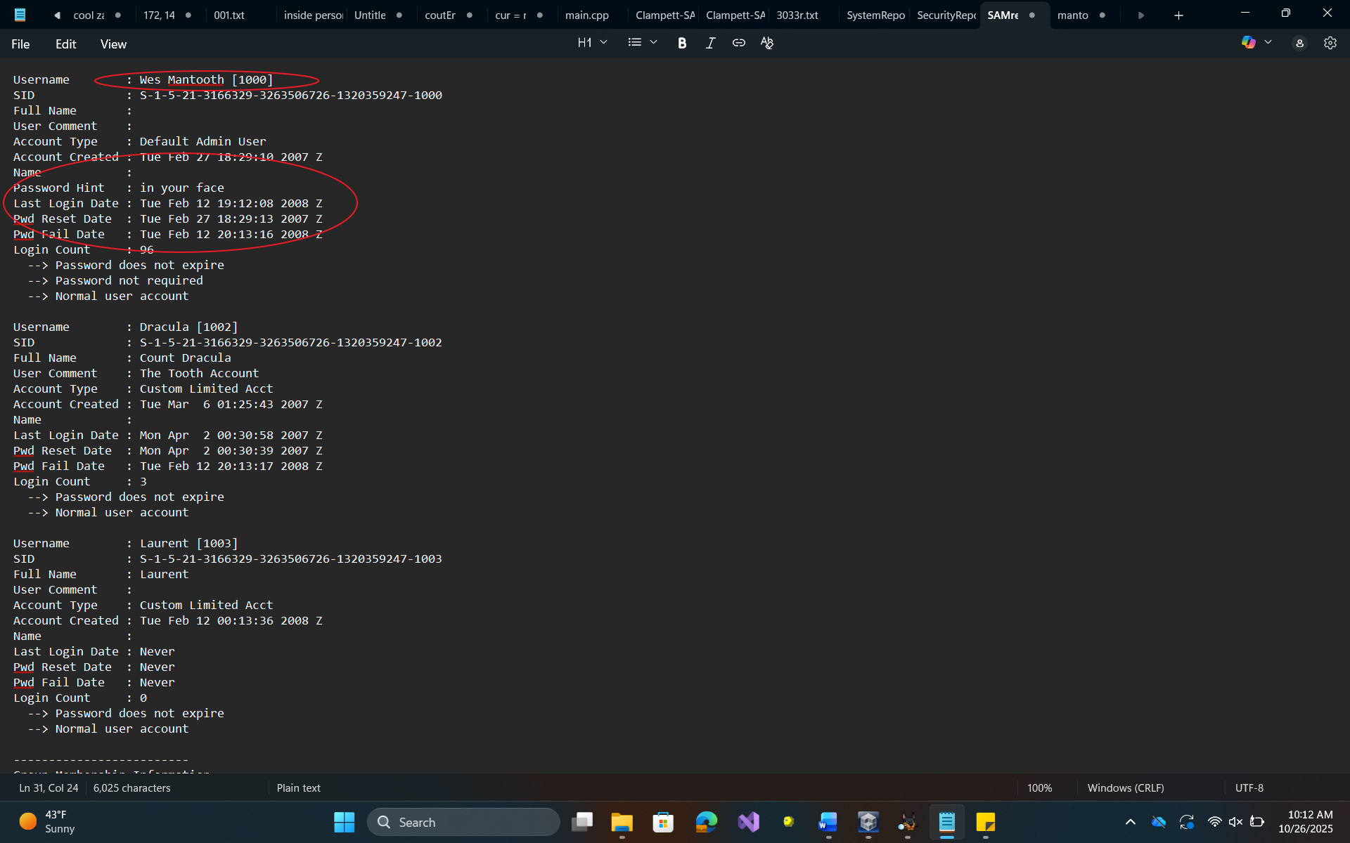
The last login time of the primary user, Wes Mantooth, was recorded as February 12, 2008, at 19:12:08 UTC.
Figure 3: Last login timestamp in registry data.
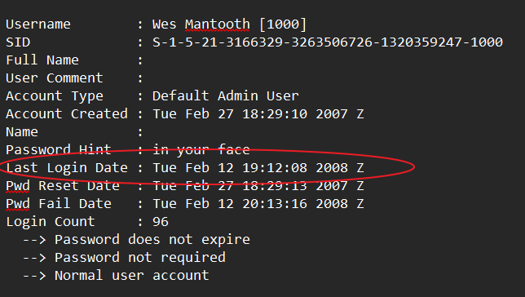
The operating system version was identified as Win2K3/Vista/Win2K8 (32-bit), verified through regRipper.
Figure 4: Operating system version artifact.
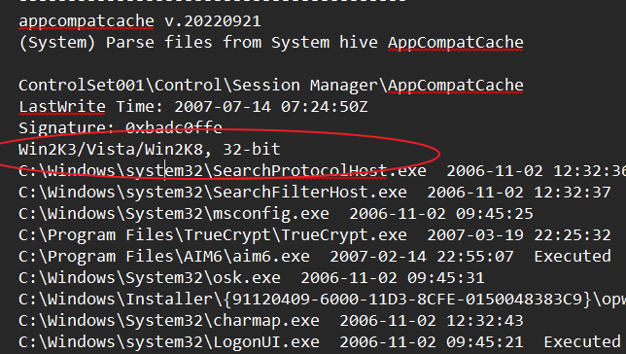

The system was configured to Mountain Standard Time (MST), verified through both RegRipper and Windows Registry Viewer.
Figure 5: Registry evidence of Mountain Standard Time setting.
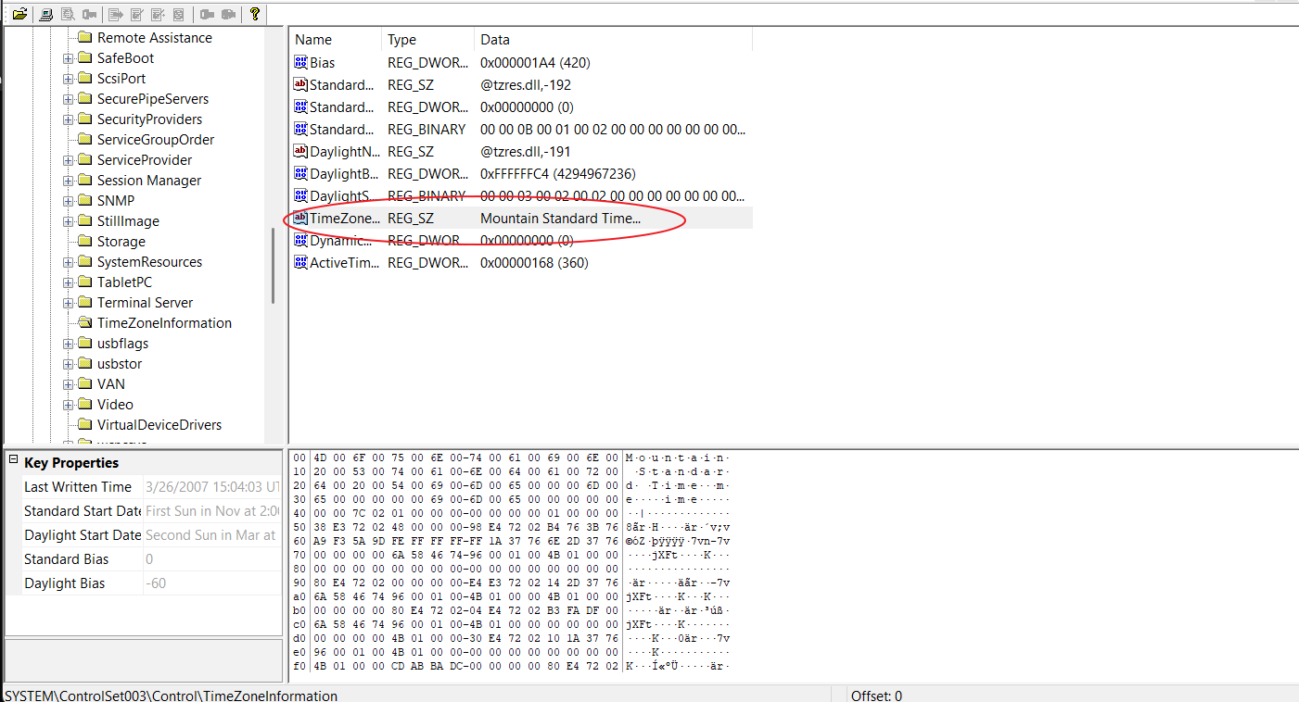

A Canon PowerShot SD500 digital camera was connected to the computer through USB. The system recognized it as a Canon media device, which would have allowed access to photos and videos stored on the camera.
Figure 6: USB device entry showing Canon PowerShot SD500.
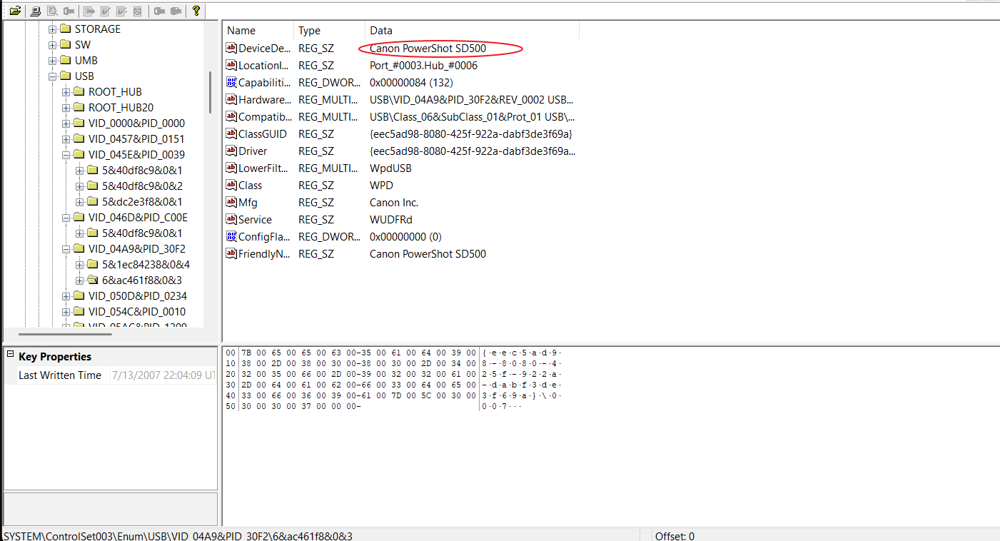
The browser history contained multiple searches and visits related to fraudulent and chemical activities. Notable entries include:
http://images.google.com
– “check washing” image search on February 27, 2007, at 14:01:49 EST.
http://www.mbgrafix.com

– “Check Washing Awareness” image on July 12, 2007, at 23:17:36 EDT.
http://www.shomer-tec.com
– “CGP check washing products” image on July 12, 2007, at 23:17:36 EDT.
Figure 7: Browser history entries showing suspicious searches.
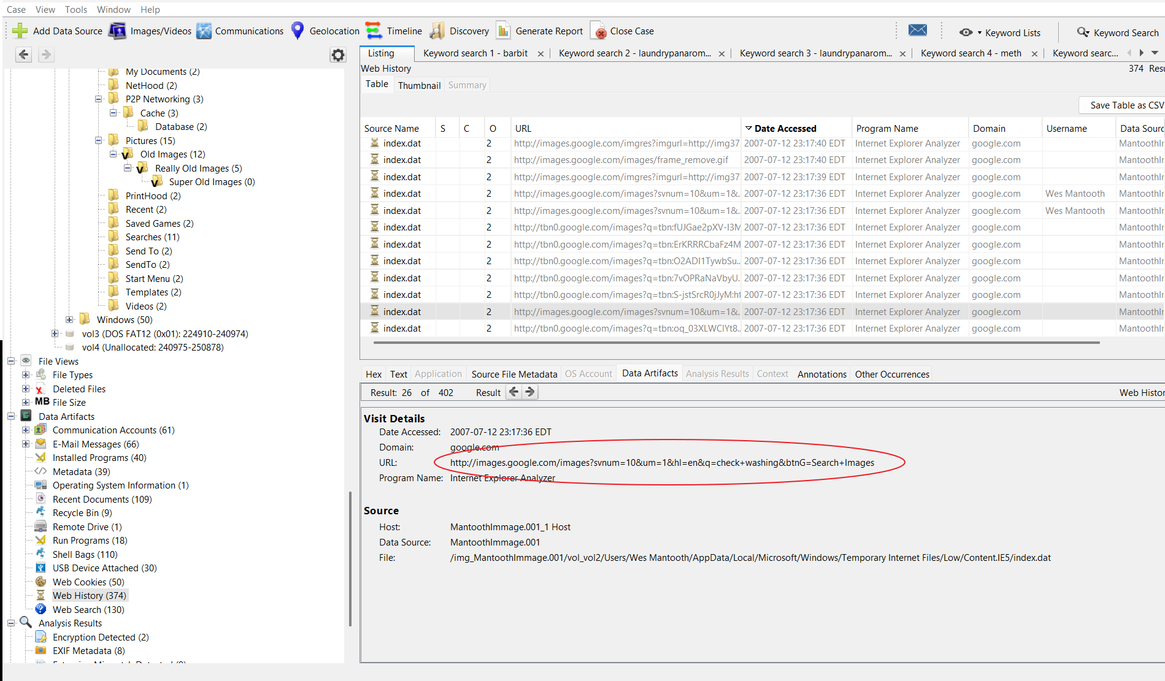
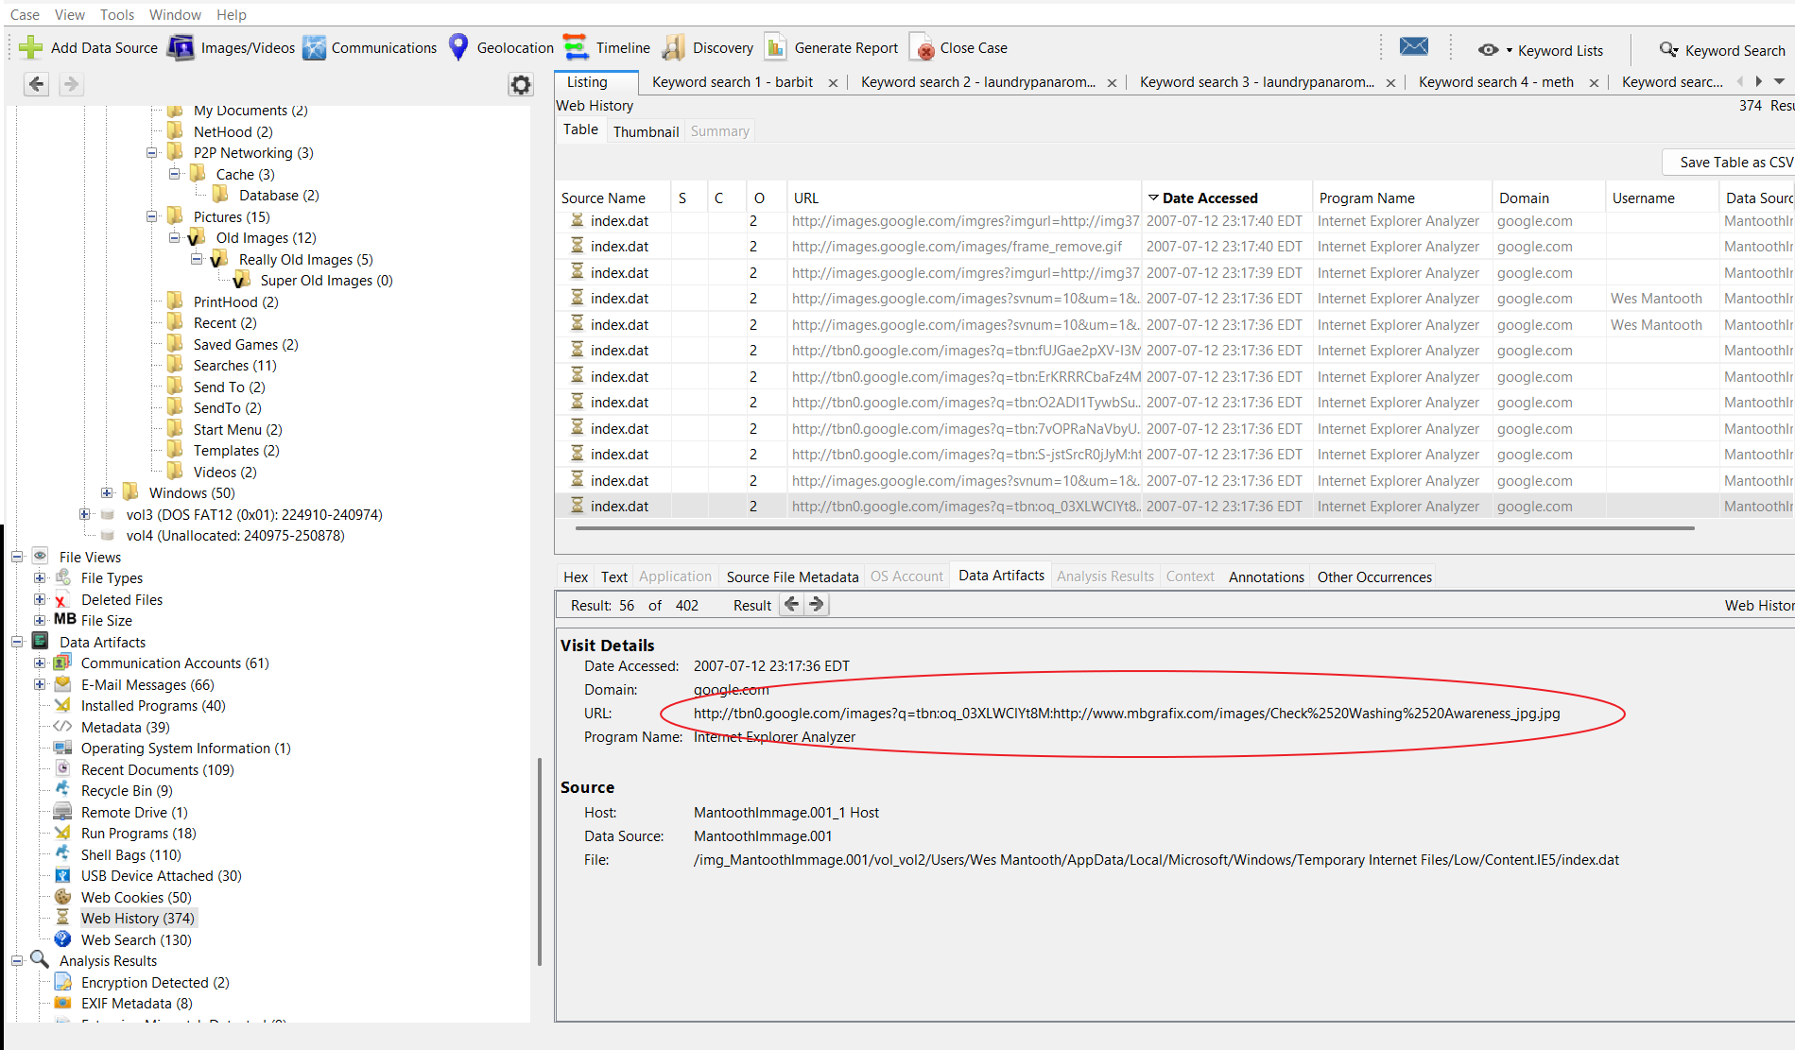
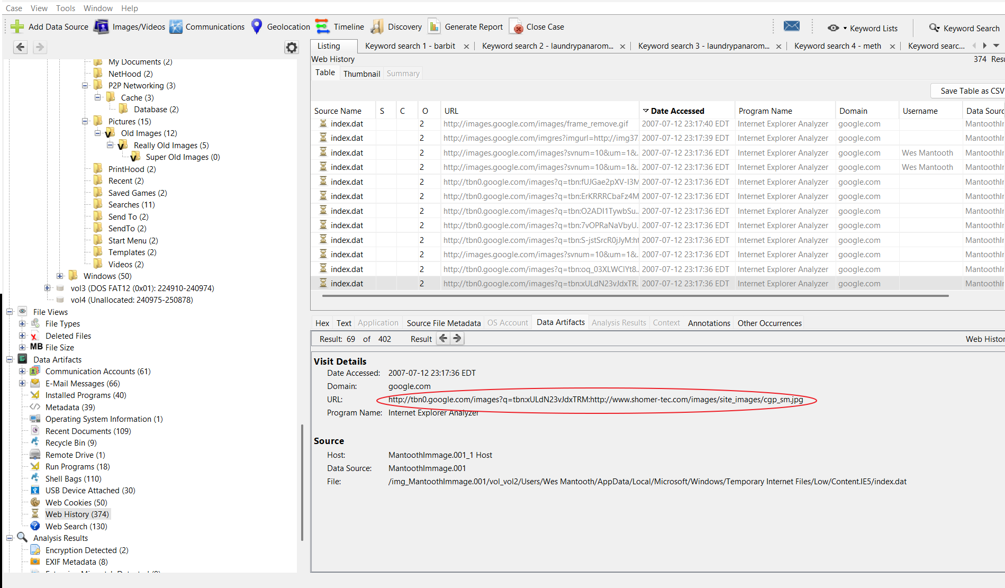

On July 12, 2007, the user made approximately 130 search queries within a few hours. These included terms related to making meth, check washing, and ATM card theft.
Figure 8: Cluster of suspicious search activity.
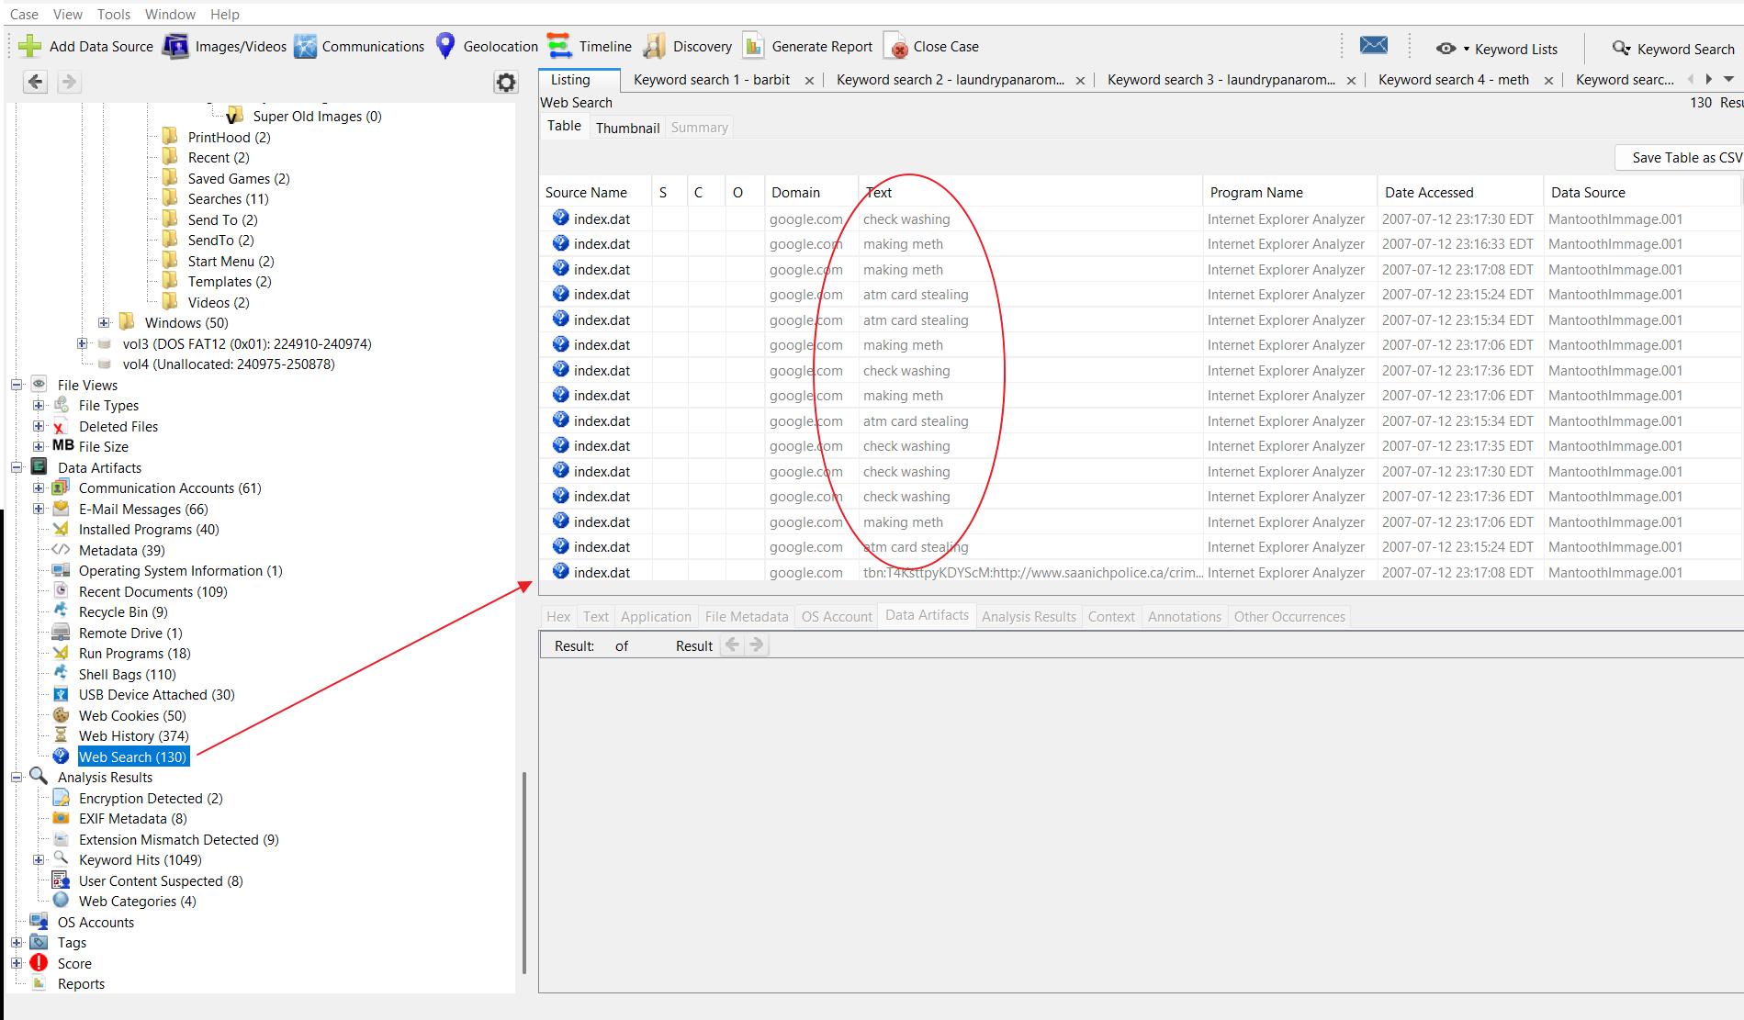
An email sent to a contact named John Washer included a faked prescription document attached to a message regarding prescription medication fraud.
Figure 9: Email artifact with forged prescription attachment.
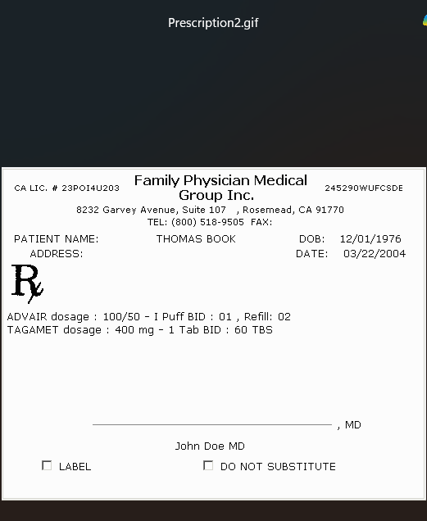
Email address associated with the user dollarhyde86@comcast.net (Wes Mantooth’s address). The contents of these communications suggest possible involvement in illicit financial and prescription-related activities.
Figure 10: Email metadata showing sender and recipients.
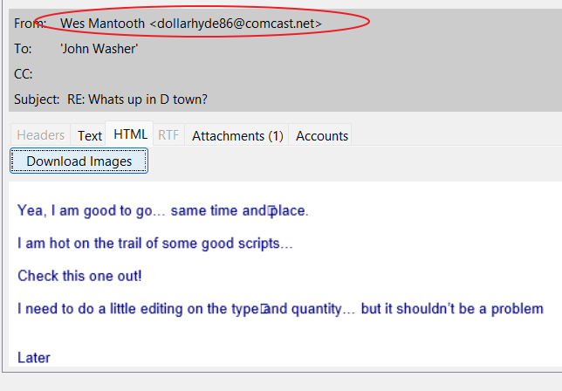
Several meaningful images were recovered from the device. These include a low-resolution photograph of a meth laboratory, an image of an ATM, and a closeup photograph of the inside of an ATM skimmer.
Figure 11: Meth lab image.
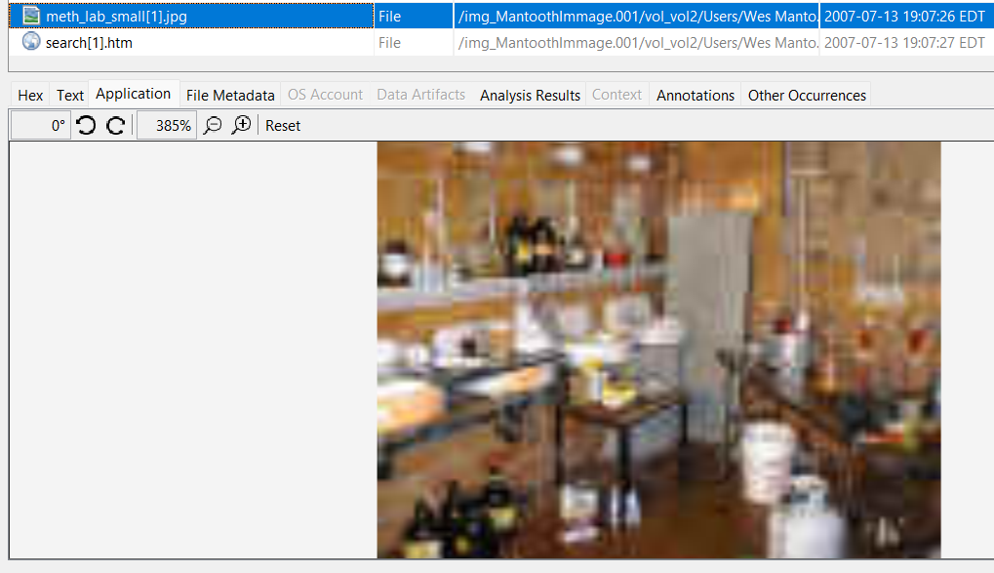
Figure 12: ATM exterior image.
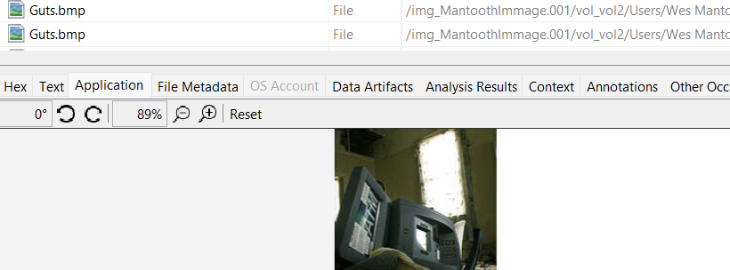
Figure 13: ATM skimmer image.
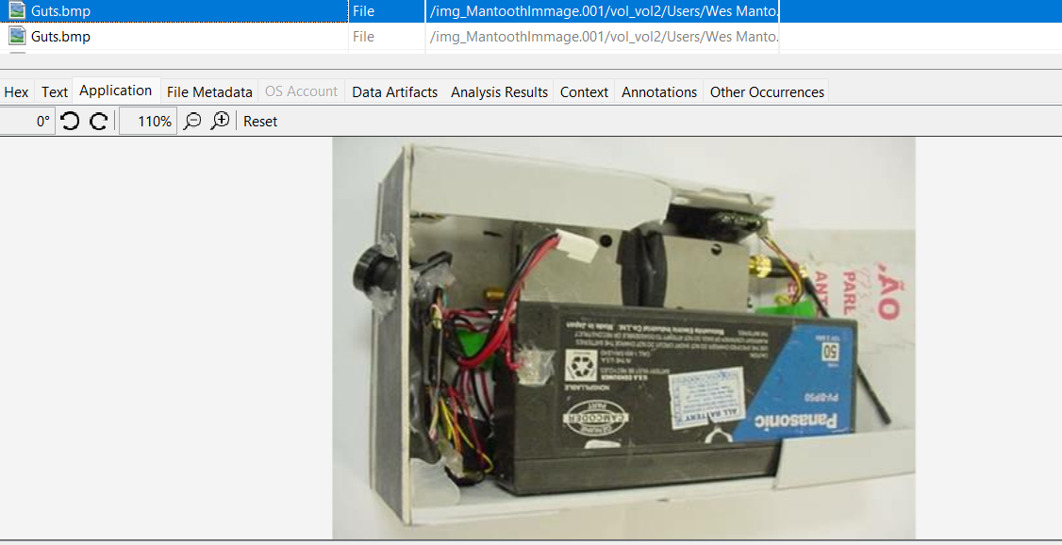
Three notable software applications were identified on the system. Trout v2.00, a traceroute and Whois utility found in a “Hacker Stuff” folder, Trillian, a secure instant messaging software; and Yahoo Messenger, another communication tool.
Figure 14: Installed software list from Autopsy.
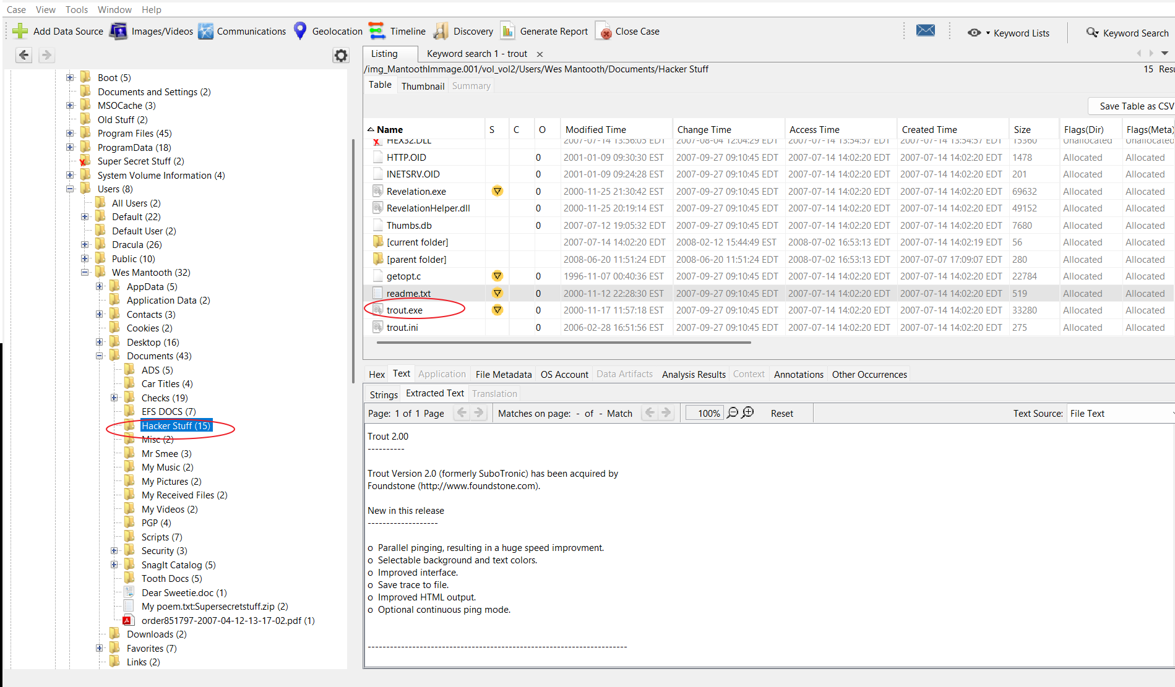
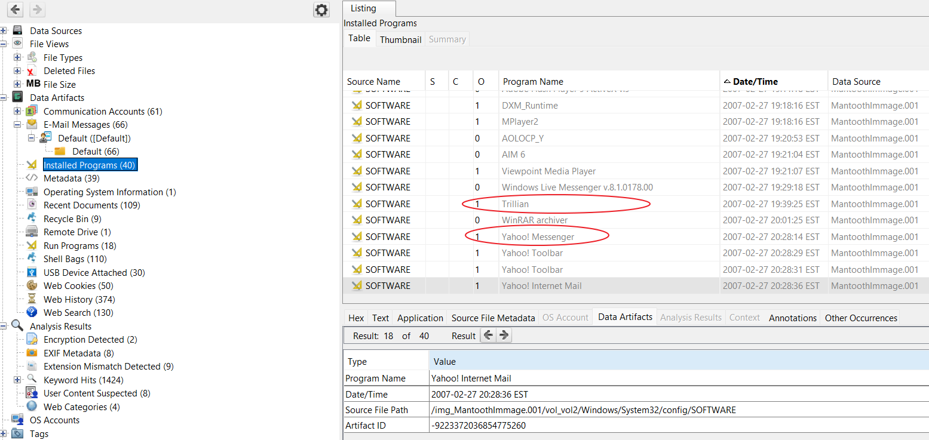
Prefetch data indicates that the user ran FTK Imager on August 8, 2007. This application is used for digital forensics and imaging drives, which suggests that the user may have been attempting to examine or conceal evidence.
Figure 15: FTK Imager execution.
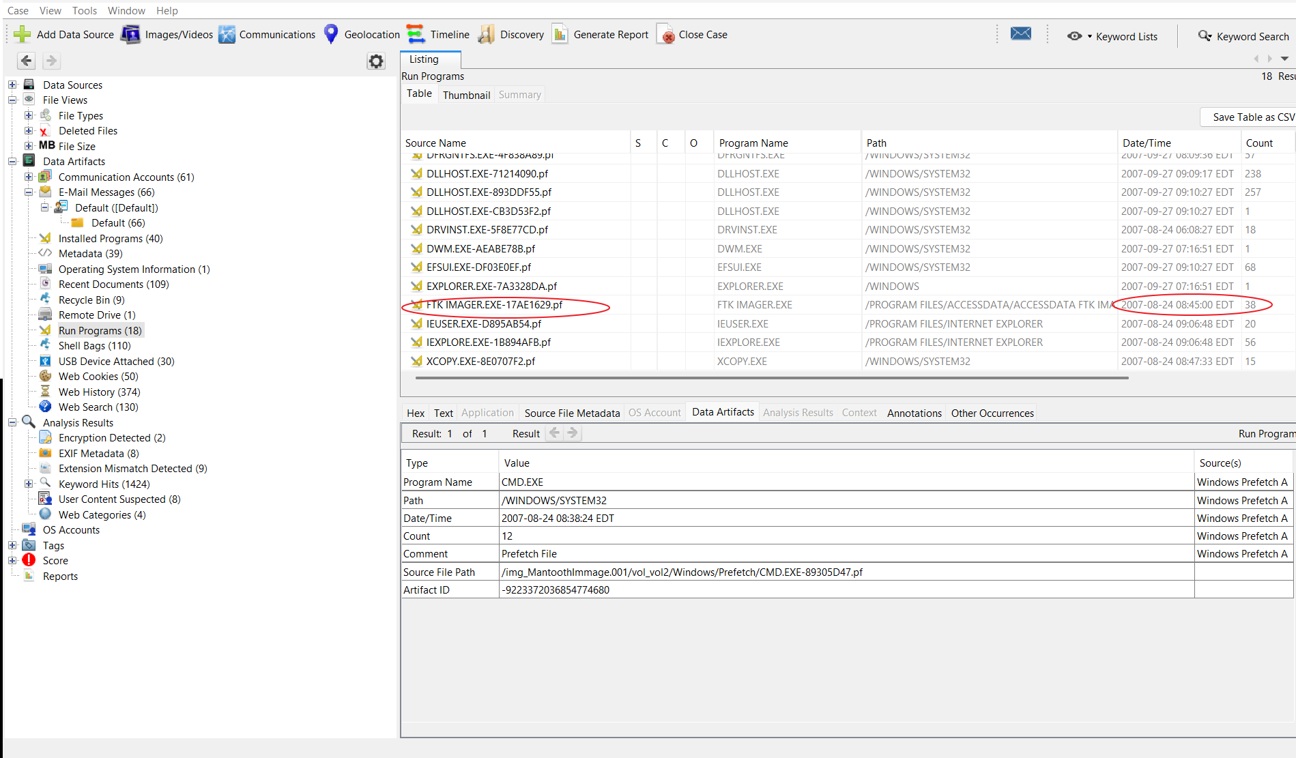

A deleted image of an elderly man was successfully recovered from deleted files;
Figure 16: Deleted image file recovered from unallocated space.
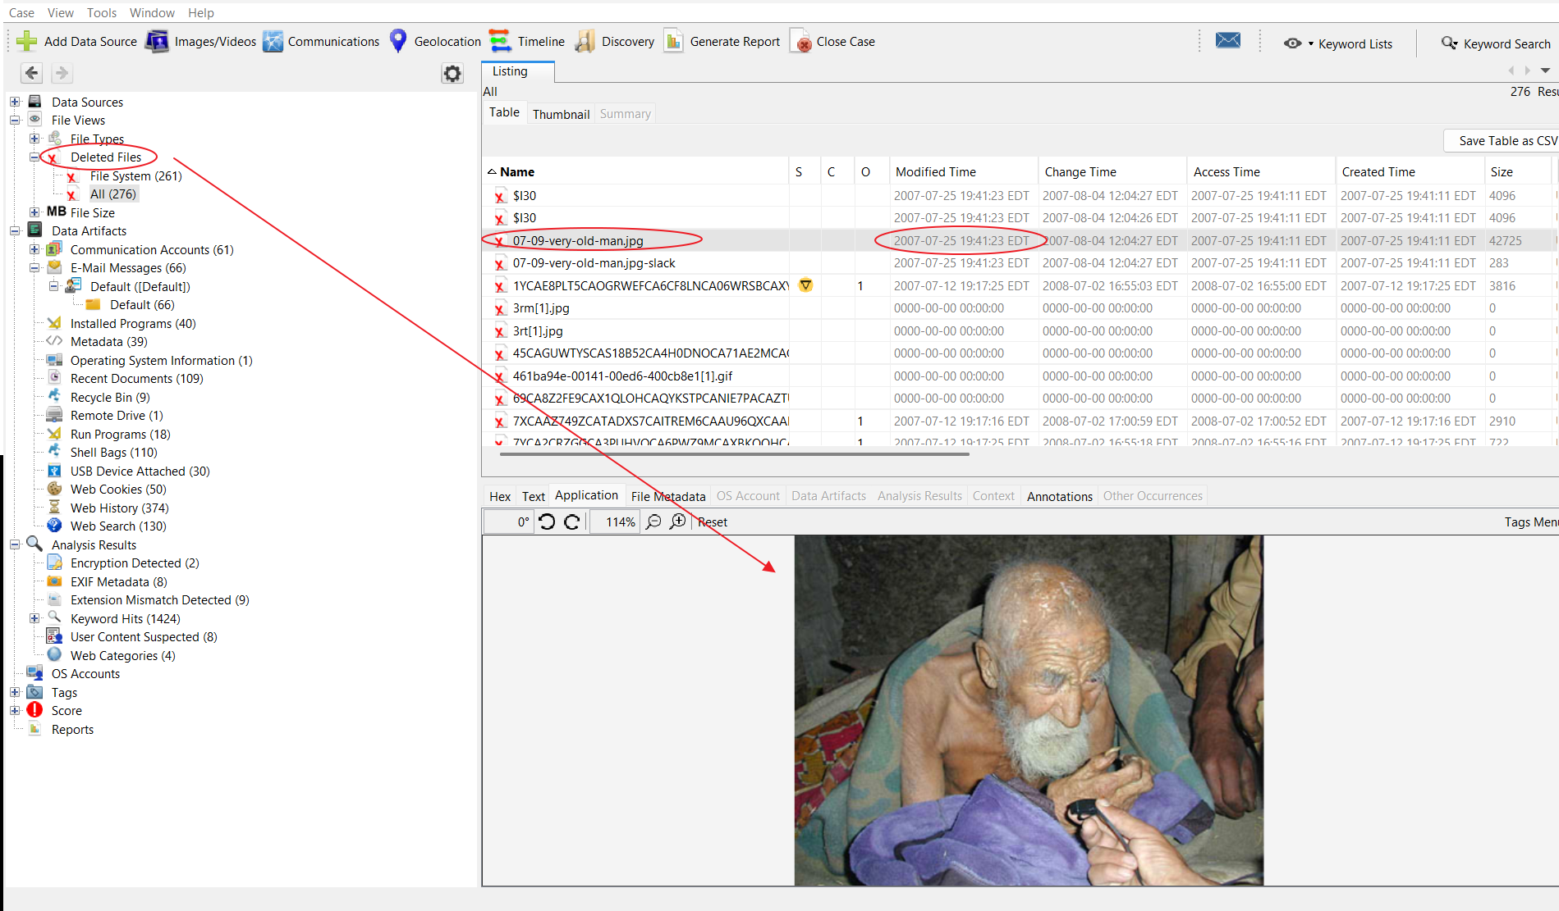
One particularly notable finding was an email authored by an individual referred to as “R~.” The message references a fraudulent “working capital” letter to be distributed via a remailer service in Bujumbura, Africa. The content and tone of the message closely resemble a Nigerian 419 scam.
Figure 17: Email artifact associated with Nigerian scam.
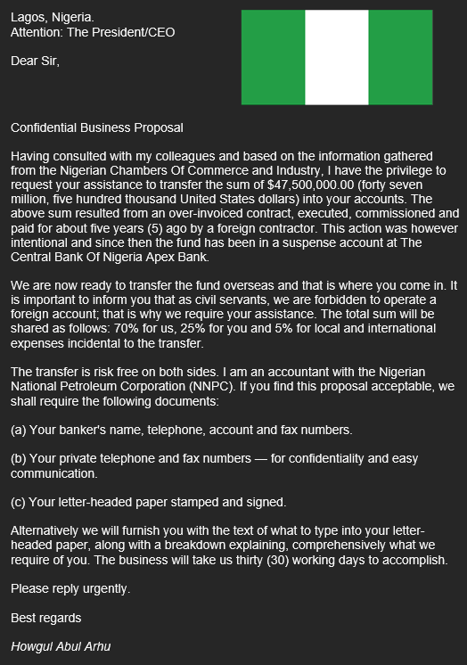

A timeline of key activity on the device shows consistent patterns of behavior. On February 27, 2007, the Wes Mantooth account was created. On July 12, 2007, 130 suspicious search queries were made related to meth and financial fraud. On August 8, 2007, FTK Imager was executed. The final recorded login for Wes Mantooth was on February 12, 2008, and various registry and browser artifacts confirm activity including USB connections, email communication, and image access during that period.
Overall, the evidence indicates that Wes Mantooth is the primary user of the system and engaged in activities that suggest possible criminal intent. His browsing history, communications, and recovered documents demonstrate knowledge of and interest in illegal practices, including drug manufacturing, check washing, and ATM scams. Artifacts across Autopsy, RegRipper, and Registry Viewer support this narrative. While not every file is explicitly illegal, the context of the searches, emails, and attached documents provides strong indicators of illicit activity. The most incriminating pieces of evidence include the forged prescription email, the check-washing search history, and the scam correspondence linked to African remailer operations.

