Case Overview
This report presents the findings from a forensic analysis of a Windows XP system, including user account activity, file access history, and potential illicit content. The primary objectives of this examination were to identify the main users of the system, detect any evidence of illegal or suspicious activity, and verify the integrity of the collected data.
Evidence and Methodology
Analysis was conducted using forensic images of the target system, which included registry hive files (SAM and NTUSER.DAT), user document and picture directories, email artifacts, PDFs, and program execution history. To ensure the integrity of the evidence, MD5 hash verification was performed. The provided hash value of a9fb9bb2f697b25676b92153b60f1b7b (figure 1) matched the hash values obtained from both Autopsy and FTK Imager, confirming that the data had not been altered during collection or examination.
Figure 1:
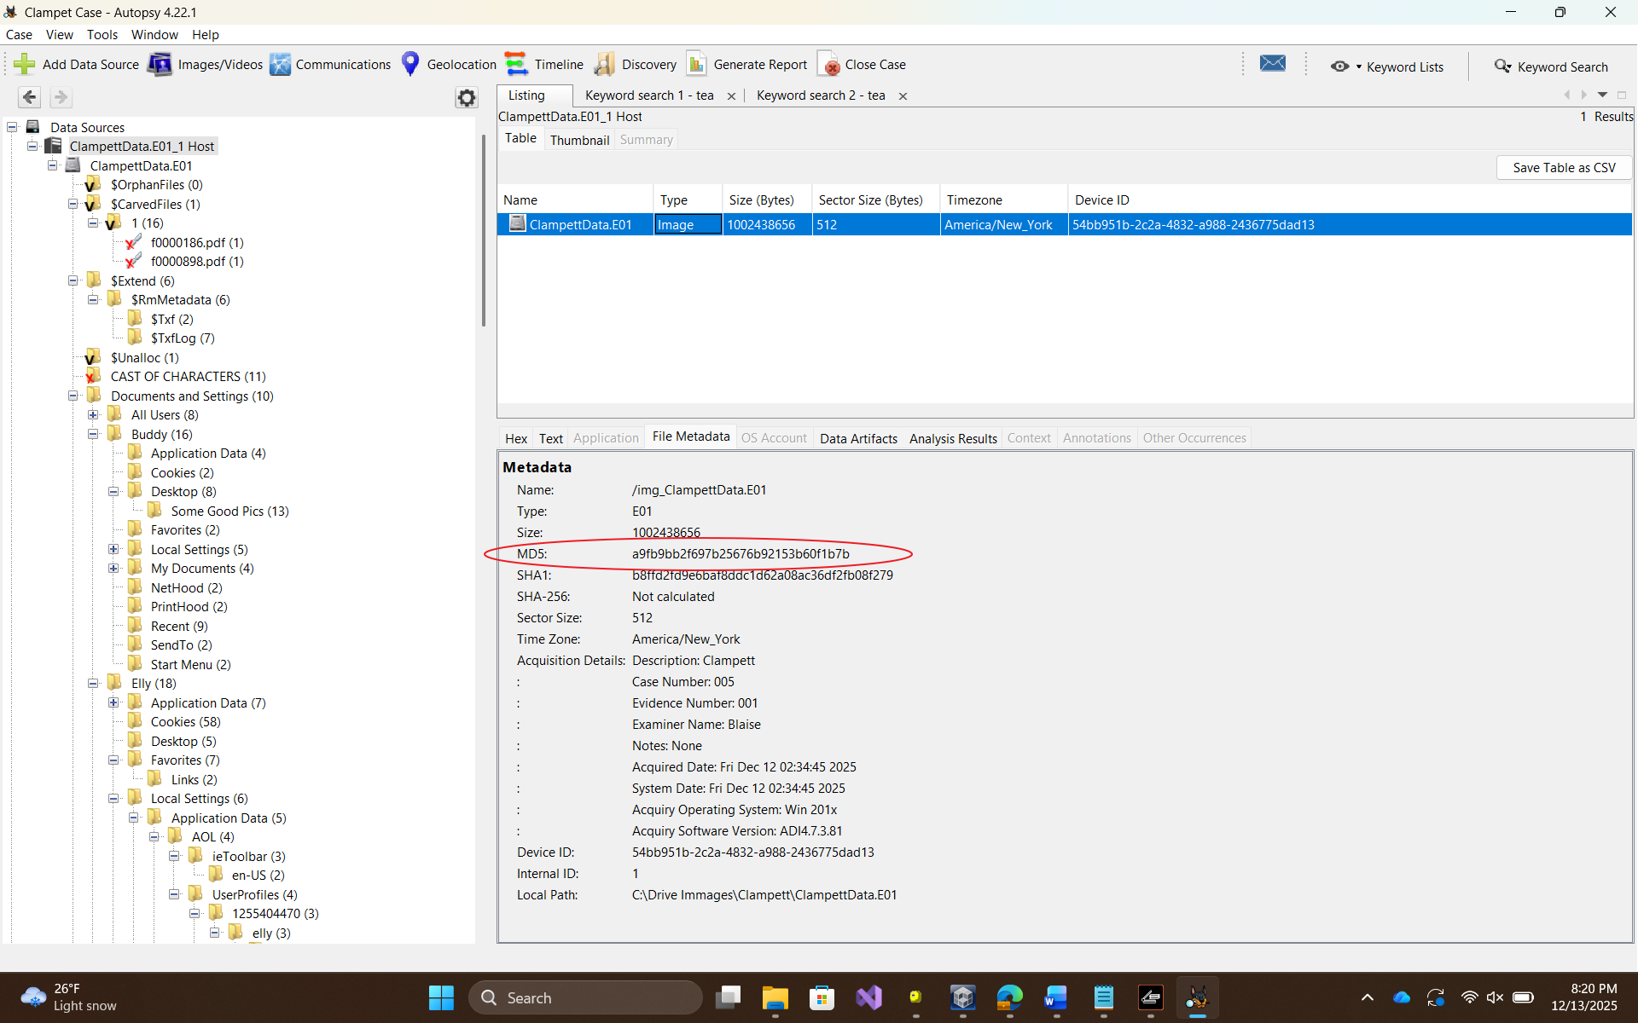
The following forensic tools were employed: Autopsy for file system and disk image examination, FTK Imager for hash verification, RegRipper for parsing and extracting registry data, and Windows Registry Viewer for OS and timezone verification. Each registry hive was carefully decoded in UTF-16 Little Endian format, preserving all artifacts for accurate analysis.
System Information
The examined system was determined to be running Windows XP, as confirmed in the SOFTWARE\Microsoft\Windows NT\CurrentVersion registry key (Figure 2). The computer was configured to Pacific Standard Time (PST), as identified in the SYSTEM\ControlSet001\Control\TimeZoneInformation key (Figure 3). These system settings provide context for timestamps and user activity patterns observed throughout the investigation.
Figure 2-3: 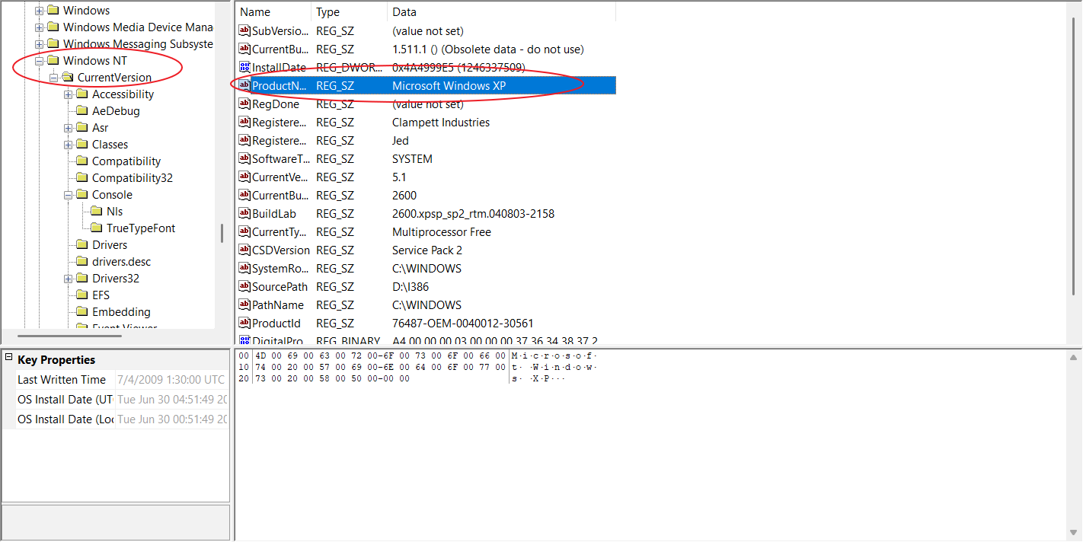
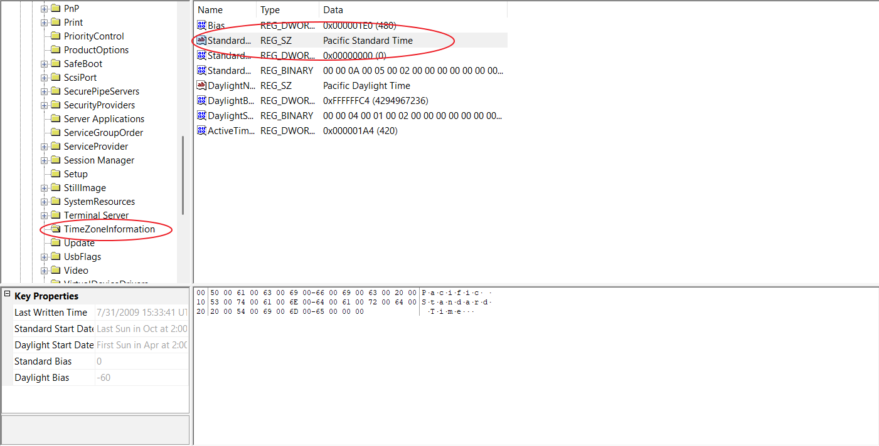
User Account Analysis
Analysis of the SAM registry hive identified several named user accounts, all of which had administrative privileges. The accounts and their activity levels are summarized as follows. Jethro had the highest number of logins, totaling 52, with the last login recorded on July 4, 2009, suggesting he was the primary user of the device. Buddy logged in 42 times, also last active on July 4, 2009, indicating regular use. Jed had 34 logins with a last login on the same date, KayKay logged in 22 times and last accessed the system on October 14, 2009, Elly logged in 19 times, last active on July 4, 2009, and Granny had 13 logins, with the last recorded activity on July 3, 2009 (figure 4 and 5).
Figure 4-5:
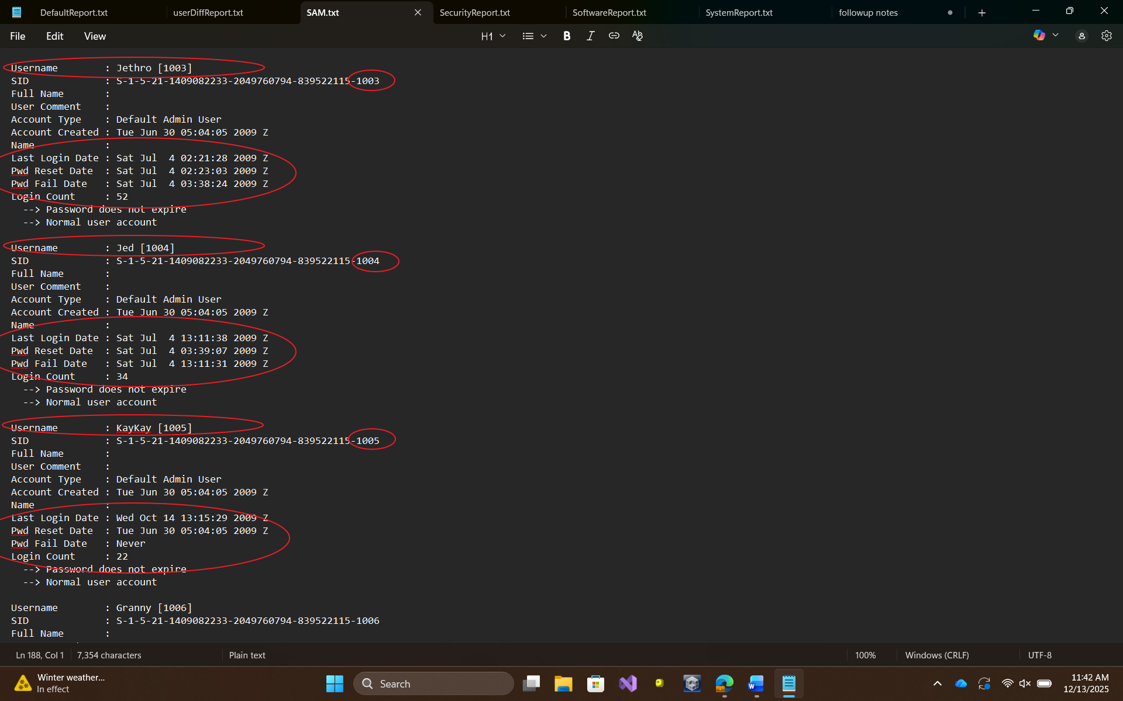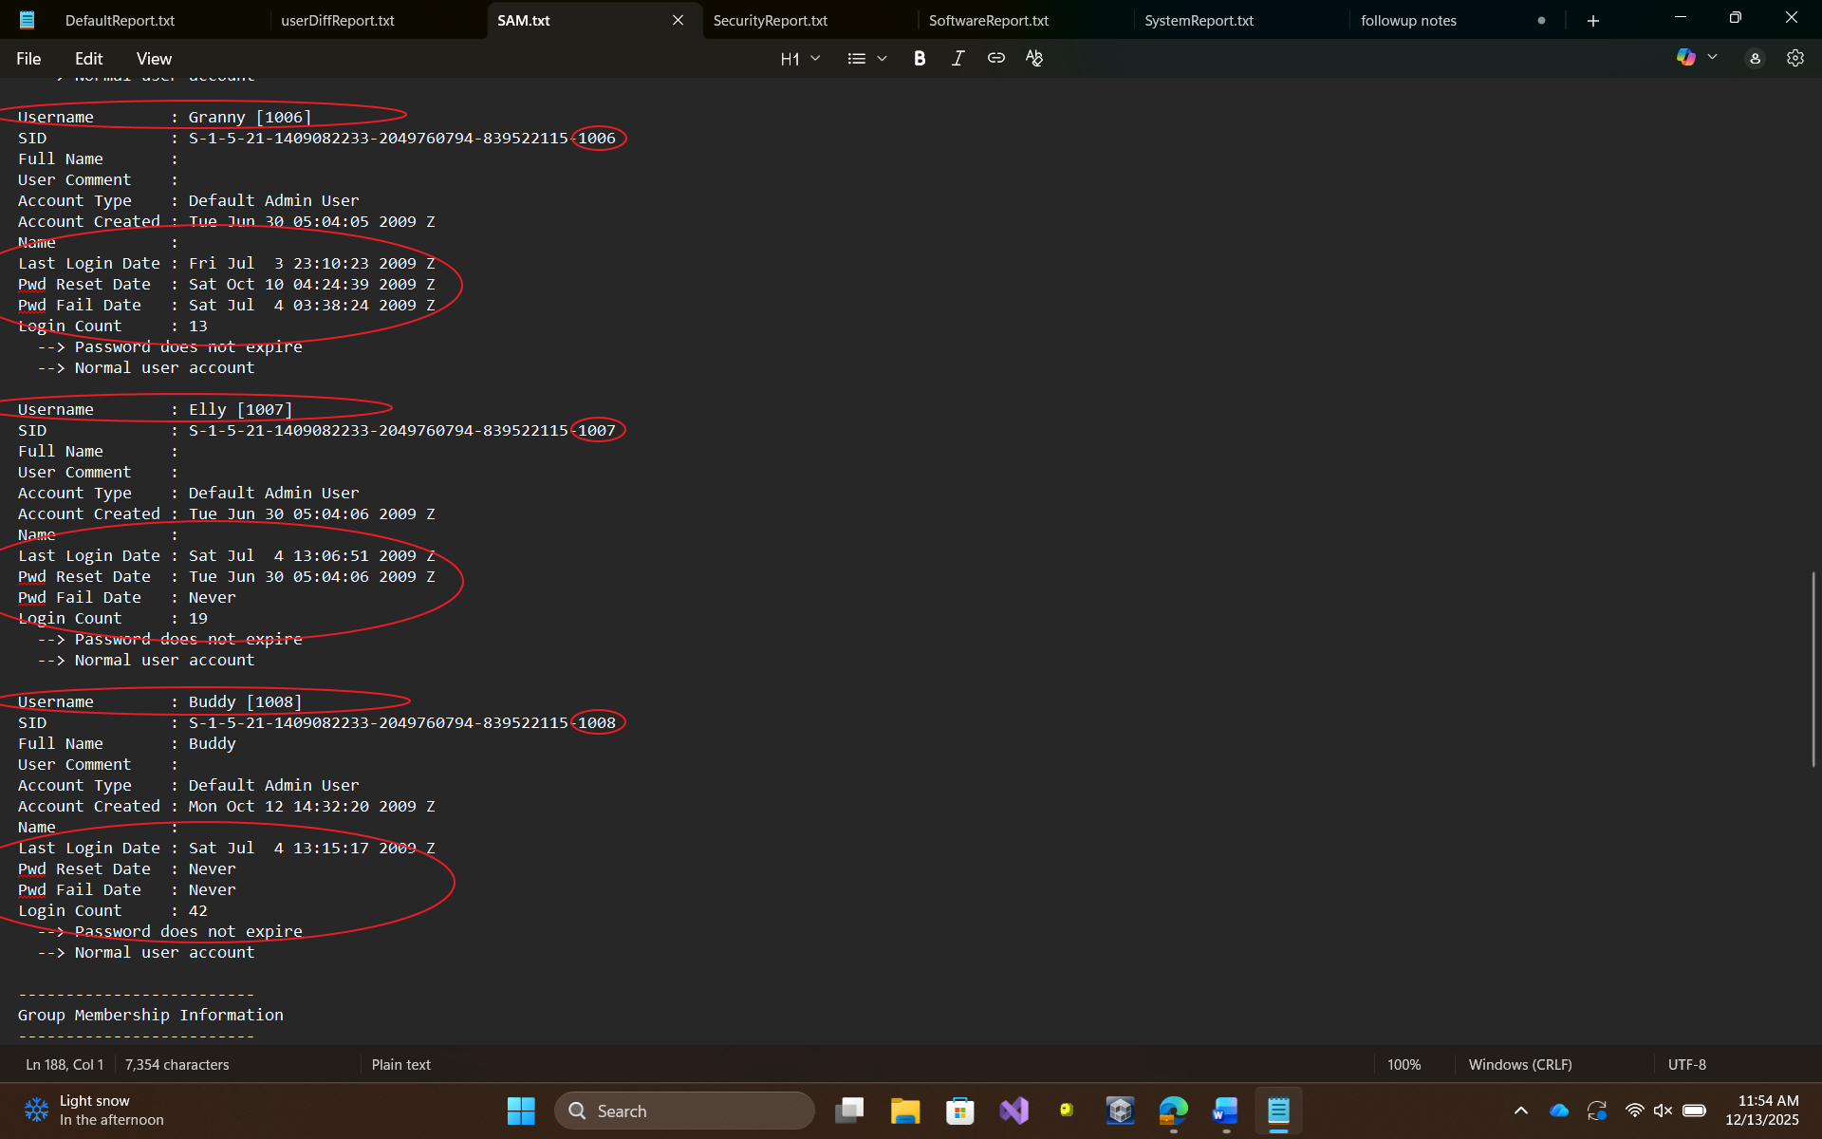
Individual User Findings
Buddy’s NTUSER.DAT hive was successfully parsed and found to be not dirty. Analysis showed that Buddy engaged in advanced technical activity, including repeated access to sensitive system files, forensic images, and system analysis tools such as FTK Imager, WinHex, and Registry Viewer. File access records indicated interaction with humorous images related to cybersecurity and Star Wars (Figure 6). Program execution logs and device mount points confirmed frequent administrative or investigative use. No evidence of illicit activity was identified.
Figure 6:
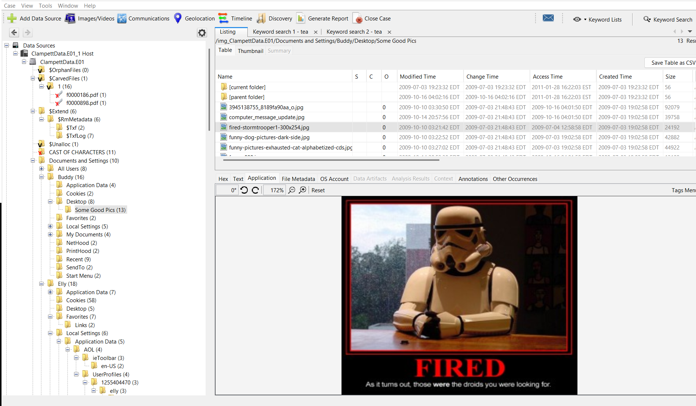
Elly’s account showed primarily non-technical, casual use of the system. The user accessed personal media including JPEG, BMP, GIF, and JPG files, as well as basic Word and Excel documents stored in the “My Pictures” and document directories. Most of the files were related to the care of infant animals (figure 7). Program execution was limited to Microsoft Office applications and Internet Explorer, with minimal exposure to FTK Imager likely incidental or guided. No suspicious or malicious activity was detected.
Figure 7:
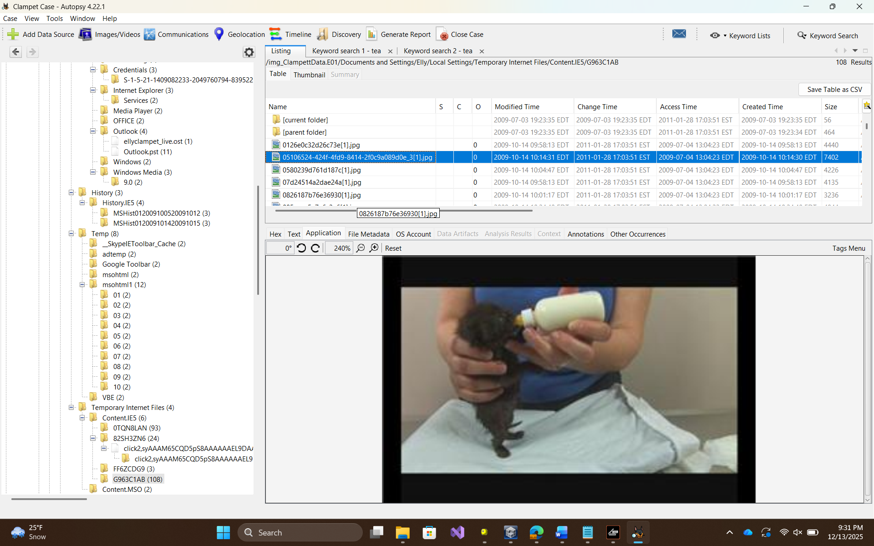
Granny’s account contained material related to moonshining. While her NTUSER.DAT hive was confirmed to be not dirty, analysis revealed documents including a Wikipedia article about moonshine, a detailed shopping list of ingredients (Figure 9, Figure 10 see below), and design schematics for distillation equipment (Figure 12 see below). Email correspondence established Granny’s involvement in the activity, linking the user to instructions from Daisy Moses and requests to Jethro Bodean for the acquisition of ingredients (Figure 11 see below).
Jed’s account activity was minimal and non-technical. Notable artifacts included personal images and PDF guides for banjo music (Figure 8). Program usage included Internet Explorer, AOL software, and Microsoft Office applications, with no indicators of administrative or illicit activity.
Figure 8:
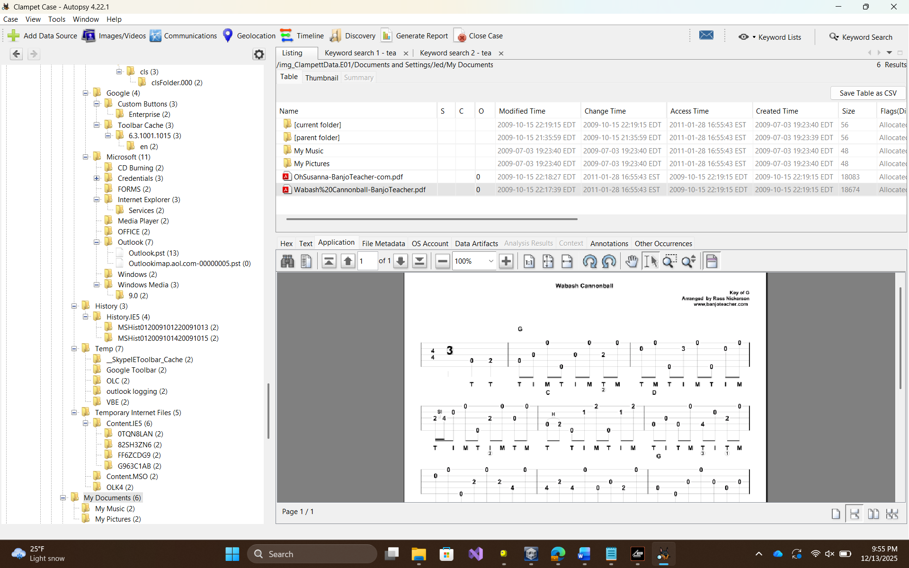
Jethro’s account was highly active, consistent with primary user behavior. Artifacts included routine interaction with documents, images, PDFs, and applications within standard user directories. A deleted file named “Delete this,” containing a report named cipack.pdf, was recovered (Figure 9). Evidence suggested involvement in financial activities, such as money laundering (figure 10-11). Program execution history indicated use of productivity software, web browsers, and multimedia applications. Device and volume records showed repeated interaction with local and removable storage, confirming frequent use of the system.
Figure 9-11:
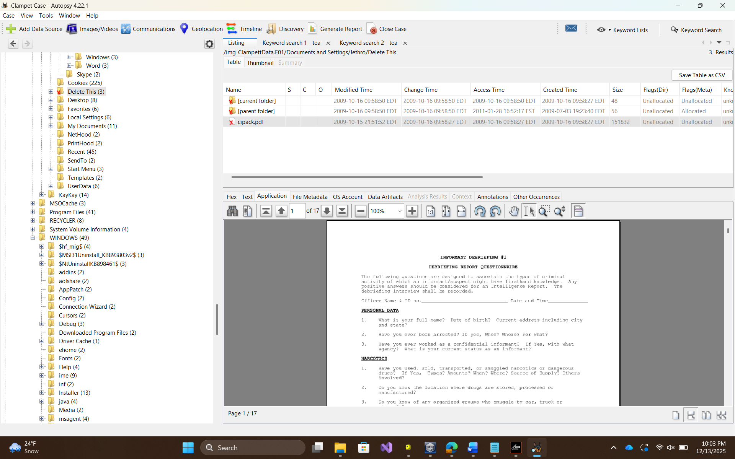
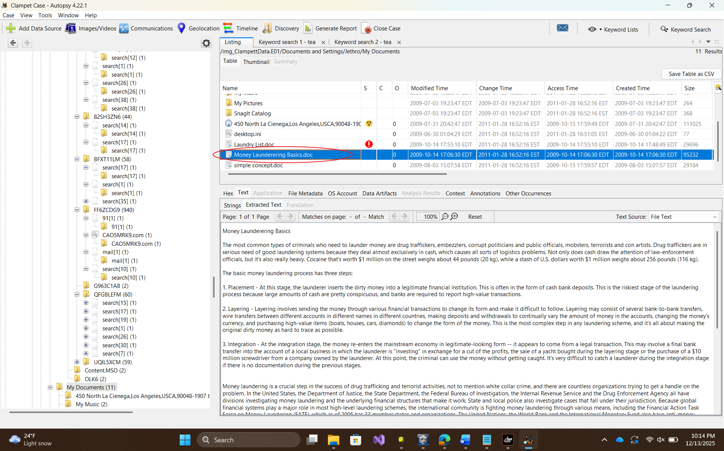


KayKay’s account showed minimal activity, with routine use of Microsoft Office applications, Adobe Reader, and Internet Explorer, as well as occasional registry viewing through Regedit and AccessData Registry Viewer. No signs of malware, hidden folders, startup persistence, or attempts to obscure activity were identified.
Moonshining-Related Findings
Artifacts linked to moonshining were located in Granny’s account. A Wikipedia article provided production methods and cultural notes (Figure 12), while a detailed ingredient list suggested preparation of significant quantities of alcohol (Figure 13). Email correspondence with Daisy Moses, who was later confirmed to be Granny, instructed Jethro to acquire the listed ingredients under the guise of making “corn cakes” (Figure 14). The image file “Old Still.bmp,” found in Granny’s Pictures directory under “Possible Still Designs,” was created, accessed, and last modified on October 13, 2009, with metadata altered on January 28, 2011, indicating later modification (Figure 15).
Figures 12 -15:
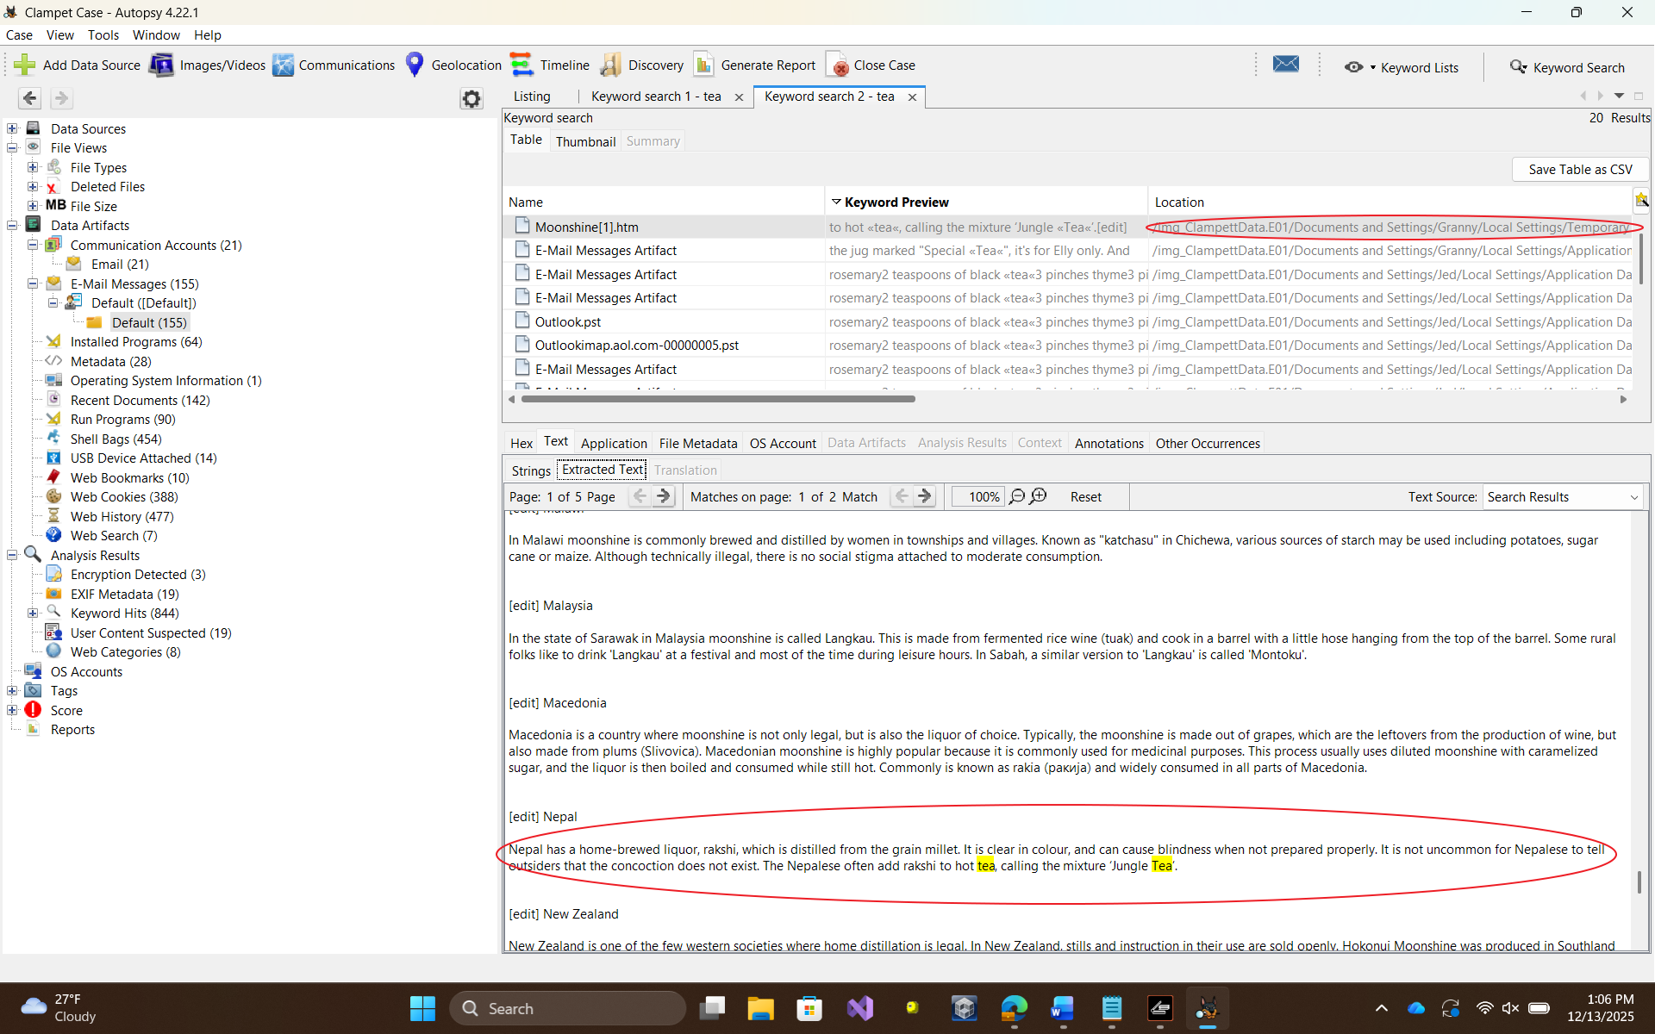
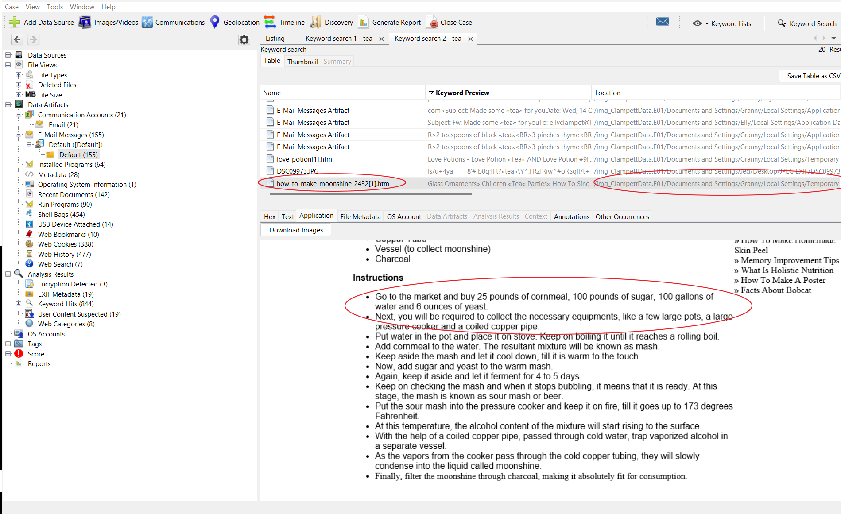
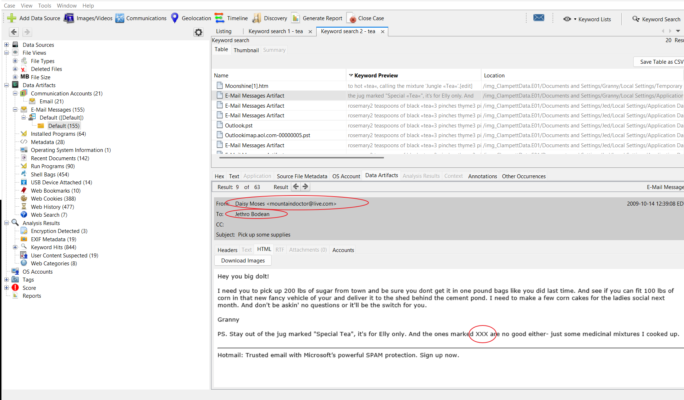
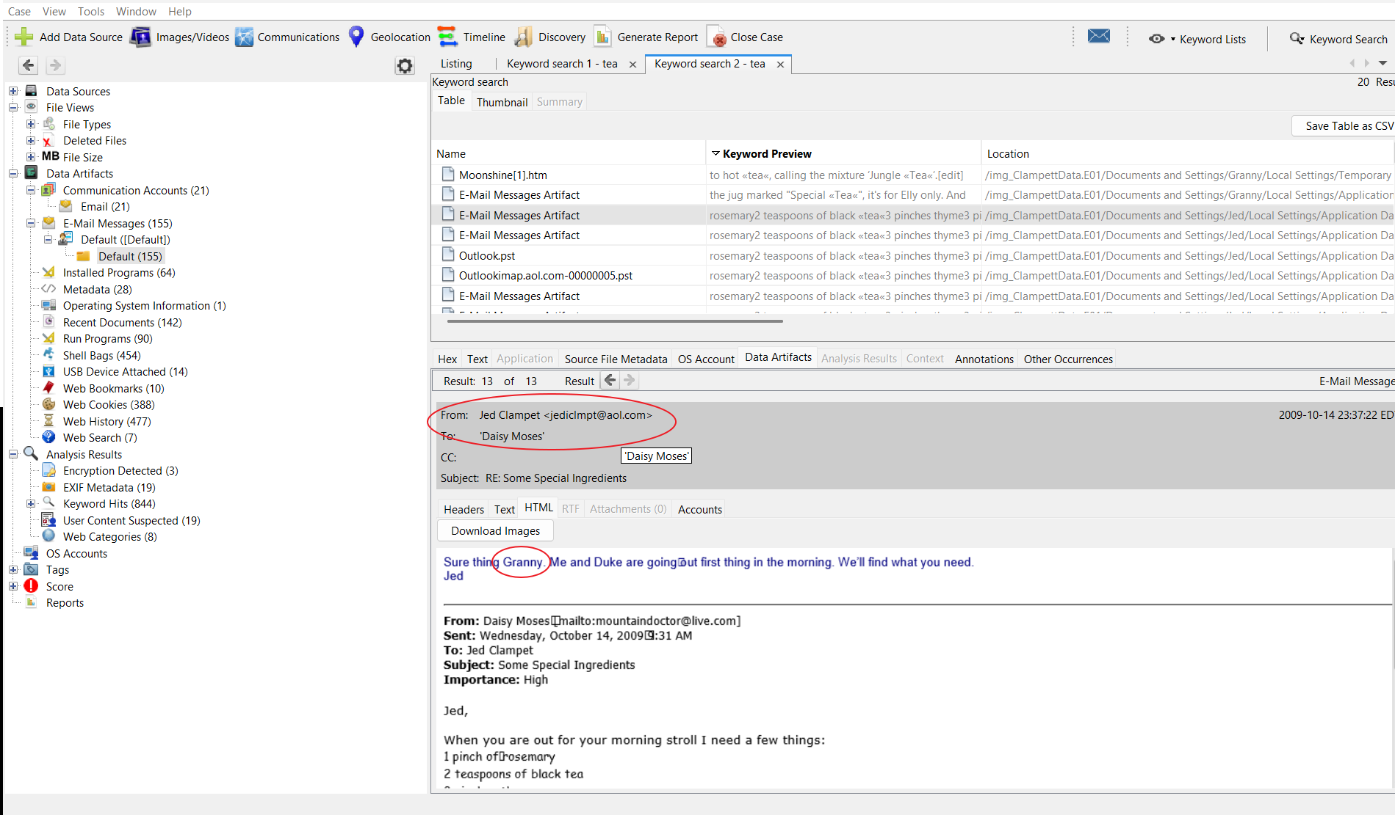
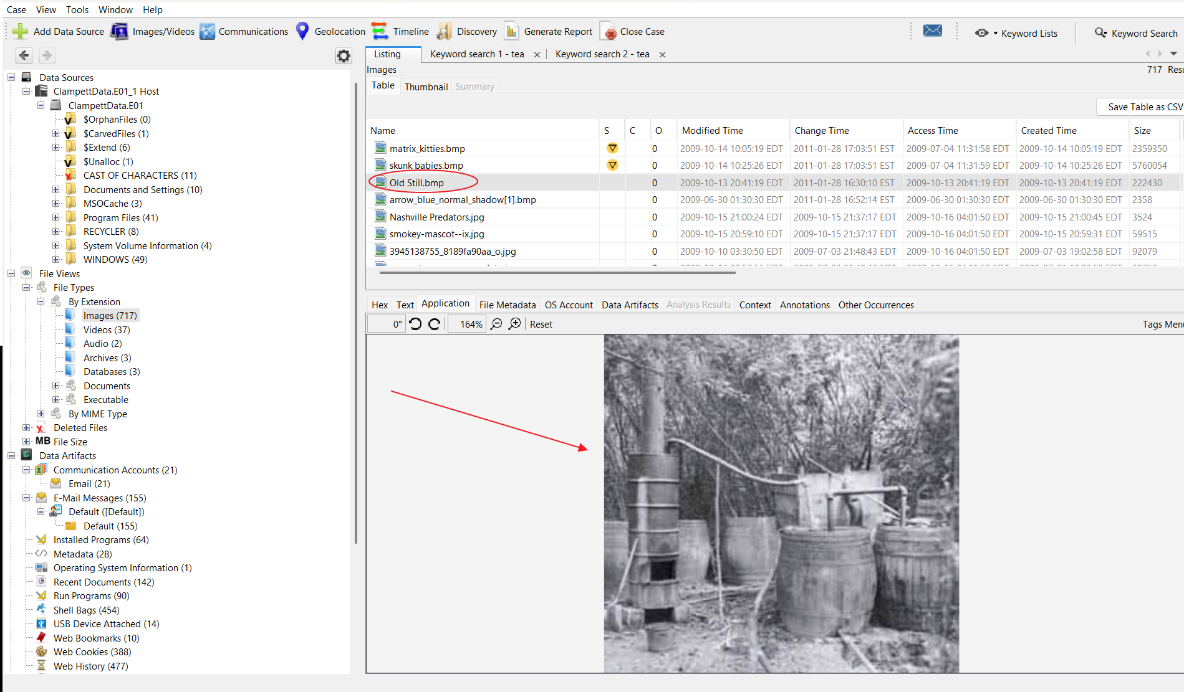
Conclusion
The forensic analysis determined that Jethro was the primary user of the system, based on login frequency and extensive activity across applications and file systems. Evidence integrity was verified through matching MD5 hashes, ensuring the data analyzed had not been tampered with. Users Buddy, Elly, Jed, and KayKay were cleared of any illicit activity, as all recovered artifacts reflected normal or casual usage. Granny’s account contained substantial artifacts related to moonshining, establishing her involvement in the preparation and coordination of alcohol production.

