Holiday Checker Use Case

Document Information

|  |  |
| --- | --- |
| **Document Title** | Check Holidays |
| **Document Owner** | Jeremy Blake |
| **Version** | 1.0 |
| **Status** | Final |
| **Date** | February 1, 2020 |

1. Brief Description

The basic use for the software is to be able to verify if the current day, or a custom inserted date is a national holiday, along with the ability to create custom holidays like birthdays, that are also queried as part of the program’s logic. The program starts when the menu is presented to the end user, and stops when the customer chooses the ‘Exit’ command.

1. Actors

The following roles and systems are involved with the program Holiday Checker’s use case:

* User
* System presenting the menu and prompts
* Two external holiday data files

1. Pre-Conditions

The following conditions must be validated by the system to be true before the Holiday Checker functionality begins:

* The system must power on
* The Holiday Checker program must be running

1. Basic Flow

The basic flow or happy path for the Holiday Checker program:

1. The system is on and the menu is presented to the user
2. The user selects the 2nd option that allows a user to select a custom date to be checked as a holiday
3. The user enters 3 values: the day 25, month 12, and year 2012
4. The user is then presented with screen output that displays “It’s Christmas Day!”
5. The prompt ‘Press Enter key to continue…’ is displayed and waits for the user to press the enter key
6. The user is then presented with the starting menu
7. The user selects the 5th option which exits the program’s execution
8. Happy path user case ends
9. Alternate/Exception Flows

1a. The system is not powered on, or the menu is not presented

1b. The system must be powered on, or the program must be started

1c. Normal use case begins

2a. There are 5 total options in the Holiday Checker menu that can be selected by the user, each of those has similar use cases as the Happy path

2b. If exit is selected at this stage, the program terminates and the use case ends

3a. If a year outside of 2012 to 2020 is used, then the program tells the user that the year must be between those years because the program can only figure out holidays between those dates, it then returns the user to the beginning of the date entry of the day, month and year

4a. If the happy path is not used, and a non-holiday date is used, then steps 3 and 4 are different

4b. The message is presented ‘It’s not a holiday.’

4c. Use case continues like happy path

7a. Similar to 2b, any of the 5 options can be selected at this point

7b. Alternate use case ends if exit is selected

1. Post Conditions

The following condition must be validated by the system to be true before the Holiday Checker functionality ends

* Exit must be selected at the main menu
* A break command is executed in the middle of the program

1. Supplemental Requirements

Depending on future requirements, additional date functionality can be added to the external data file, so that the program can cover multiple years outside of the 2012 to 2020 original range. This will focus on business value assessments to be completed in the future, but as of right now the original scope of the business request has been fulfilled.

1. Visual Model

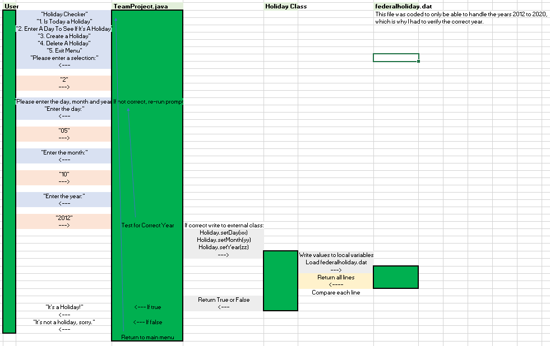

Revision History

|  |  |  |  |  |
| --- | --- | --- | --- | --- |
| V. | Date | Author | Description | Status |
| 1.0 | 1-FEB-202 | Jeremy Blake | Use case details entered in full | Final |
|  |  |  |  |  |