This homework consists of two parts, namely, design and coding convention.

- Design. The template for design is given (see the following pages).
  - You can find explanations regarding each section in the template
  - The UML tool is required to use. Rational Rose/Architect is available at the public lab.
- Coding Convention. You can choose to compose your own coding convention or use existing coding convention (e.g., Sun has coding convention for Java). No matter which way you go, please submit your coding convention document together with the design document.
  - Coding convention is not merely a document. You should stick to it. At the end of this semester, there will be a student peer code-review session. Keep in mind that all the assignments in this semester are competition-based. The teams will be ranked according their performance. The best team will receive the best grade.
  - The student peer code-review questions are given. Hence, when you start to write code, you know what will be evaluated.

Template
Software Design Specification
Version 1.0

Revisions
Version | Primary Author(s) | Description of Version | Date Completed
1.0 | Blake Samani | Initial | 11/21/2020
1.0 | Nicholas Martinez | Initial | 11/21/2020
1.0 | Jason Hunter | Initial | 11/21/2020
1.0 | Jesse Rankins | Initial | 11/21/2020
Contents
1 Introduction 1
1.1 System Overview 1
1.2 Supporting Materials 1
1.3 Definitions and Acronyms 1
2 Design Considerations 2
2.1 Assumptions 2
2.2 Constraints 2
2.3 Goals and Guidelines 2
3 Architecture 3
3.1 Overview 3
3.2 Strategies 3
3.2.1 Technical Environment 3
3.2.2 Maintainability 3
3.2.3 Performance 3
3.3 Software Specification 3
3.4 Hardware Specification 3
4 System Level Design 5
4.1 Hierarchy Chart Of Components 5
4.2 Sequence Diagrams And Descriptions 5
5 Object Level Design 6
5.1 Component C1 6
5.1.1 Class D1 Of Component C1 6
5.2 Component C2 6
6 User Interface Design 7
6.1 User Interface Design Overview 7
6.2 User Interface Navigation Hierarchy 7
7 Requirements Traceability Matrix 8
8 Appendices 9

Introduction
<Provide an overview of the entire document, including the purpose, the scope and the intended audience of the document. Identify the product using any applicable names and/or version numbers.>
This document is designed as a reference material for any person interested in designing a cancer diagnosis software. The overall composition of this document describes the design pattern used as well as other attached data for its design.

System Overview

<Provide a general description of the software product including its functionality and matters related to the overall system and its design.>
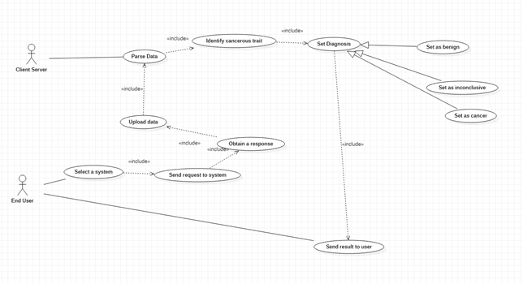
This product is intended to input data and return a diagnosis of cancer. The data is parsed and distributed through the software, indicating any flags that could be cancerous. In addition, our software is meant to be integrated into a server of other similar software.

Supporting Materials
<Provide references for any other pertinent documents such as related and/or companion documents, prerequisite documents and documents which provide background and/or context for this document.>
A referenced SRS document accompanies this document.
Mozilla Developer https://developer.mozilla.org/en-US/
LOG4J https://logging.apache.org/log4j/2.x/
JUNIT https://junit.org/junit5/
Bruegge, B., & Dutoit, A. (2009). Object-Oriented Software Engineering Using UML, Patterns, and Java (3rd ed.). Pearson.

Definitions and Acronyms
<Define any important terms, acronyms, or abbreviations.>
Term | Description

Design Considerations

Constraints
<Describe any global limitations or constraints that have a significant impact on the design of the system's software. Such constraints may be imposed by any of the following (the list is not exhaustive): hardware or software environment, end-user environment, availability or volatility of resources, standards compliance, interoperability requirements, interface/protocol requirements, data repository and distribution requirements, security requirements (or other such regulations), memory and other capacity limitations, performance requirements, network communications, and other requirements described in the requirements specification.>

- Network performance
- Lack of medical expertise
- Liability
- Security
- Time
- Error in other teams XML format

Goals and Guidelines
<Describe any goals, guidelines, principles, or priorities which dominate or embody the design of the system's software. Such goals might be: the KISS principle ("Keep it simple stupid!"), emphasis on speed versus memory use, or working, looking, or "feeling" like an existing product. For each such goal or guideline, unless it is implicitly obvious, describe the reason for its desirability.>

The main goal is to integrate the software to communicate with the server. Without this function, the overall software is limited in versatility. Secondary goals would be to have a fast turnaround time for diagnoses. This would increase the desire to use this product over competitors and provide more than ample enough time for the customers to make informed decisions with the returned data.

Architecture

Overview
< Determine what parts of the application software will be assigned to what hardware. Describe any design decisions and/or strategies that affect the overall organization of the system and its higher-level structures. These strategies should provide insight into the key abstractions and mechanisms used in the system architecture. Describe the reasoning em-ployed for each decision and/or strategy (possibly referring to previously stated design goals and principles) and how any design goals or priorities were balanced or traded-off.>

Supported devices
- PC
- Windows
- Browser that supports HTML and Java
Communication protocol
- P2P

Strategies

Architectural Style
<Specify which architectural style you will choose, e.g., layered, Client/Server, Peer-2-Peer>

This software should be adapted to include Client/Server and Peer-2-Peer architectural styles.

Performance
<The time within which the system must perform its functions; the total and peak number of users and volume of data expected; the extent to which the system will be available to the users and the permissible failure rate due to errors>

The maximum estimated time for a diagnosis should not exceed that of 5 minutes. The system should be incorporated to handle a maximum of 10 users at once. The volume of data expected is minimal. There is always a chance of down time as the product requires access to the internet and the server.

Software Specification
<Determine software needs, such as OS, development IDE, JDK version, other SDK version, etc. >
- Windows
  - Most popular
- School server
  - required
- LOG4J
  - required
- XML
  - required
- JUNIT
  - required

Hardware Specification
<
- Clients
  - Input/output devices employed by users
  - PCs, laptops, handheld devices, cell phones
- Servers
  - Larger computers storing software
  - Accessible by many users
- Network
  - Connects clients and servers>

Clients:
- Mouse
- Keyboard
- CD drive(USB or internal)
- Cell phone
- PC
Servers:
- UCO school server
Network:
- Hosted through the internet connection to the UCO school server

System Level Design
<Provide a high-level overview of how the functionality and responsibilities of the system were partitioned and then assigned to subsystems or components. Don't go into too much detail about the individual components themselves (there is a subsequent section for detailed component descriptions). The main purpose here is to gain a general understanding of how and why the system was decomposed, and how the individual parts work together to provide the desired functionality.>

Hierarchy Chart Of Components
<Describe the major responsibilities that the software must undertake and the various roles that the system (or portions of the system) must play. Describe how the system was broken down into its components/subsystems (identifying each top-level component/subsystem and the roles/responsibilities assigned to it). Describe how the higher-level components collaborate with each other in order to achieve the required results. Don't forget to provide some sort of rationale for choosing this particular decomposition of the system (perhaps discussing other proposed decompositions and why they were rejected).
Hint: You can use UML package symbol to represent a subysystem>
User is abstraction for enduser and admin and Diagnosis class is an abstract class for sending and receiving.
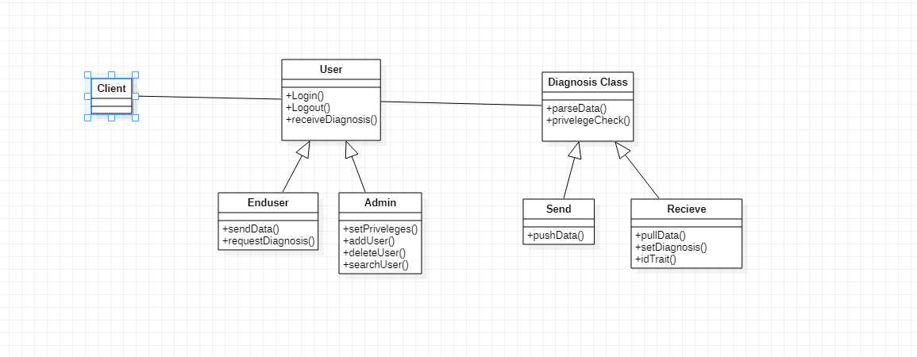
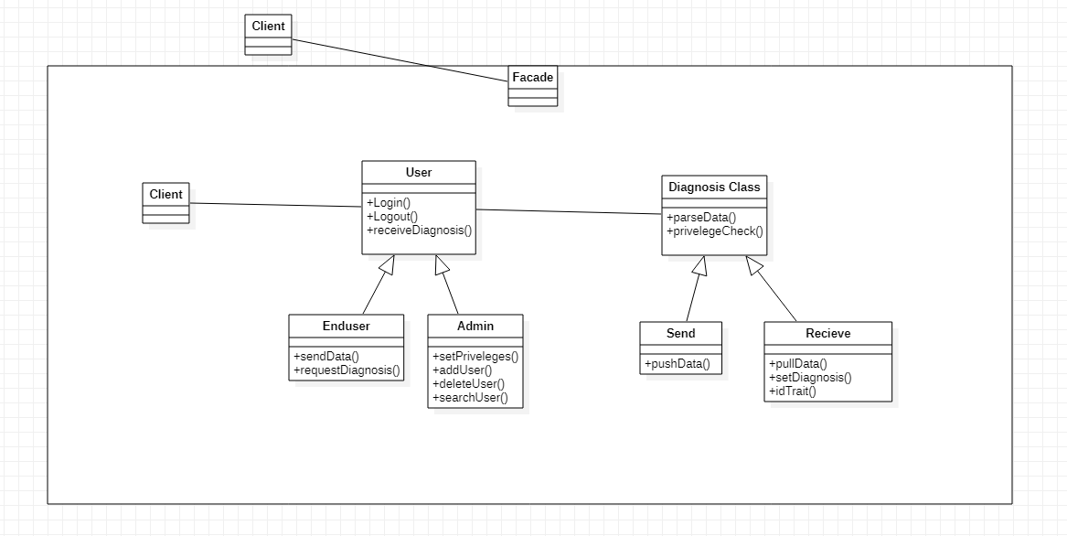

Sequence Diagrams And Descriptions
<Describe the interaction behavior between subsystems. The typical sequence diagram will depict some or all of the behavior described in a use case. Therefore, sequence diagrams serve as an intermediary between use cases and subsystems. As a result, subsystems can be traced back to the requirements. >
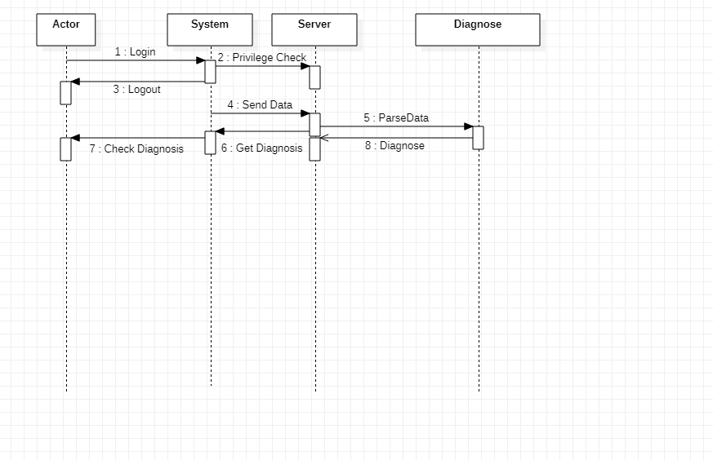

Object Level Design
<Provide more detailed discussion in a subsection/component of the component hierarchy section 4.1. If necessary, describe how the component was further divided into subcomponents, and the relationships and interactions between the subcomponents (similar to what was done for top-level components in Section 4.1).
Use at least two design patterns. Please specify which design patterns you have used.>

Subsystem xxx
<Provide and describe a class hierarchy diagram that depicts the set of classes for Subsystem xxx>
Retrieve (data type here) from the server:
The data will be accessed from the school server and then parsed by the XML parser function.

Parse data file:
The data fille will then be decomposed into smaller segments and tokenized. From here, we will run the parsed data into other functions that can use its values to calculate a positive or negative diagnosis.

Client interface:
The interface will allow the user to insert the data into the software product and return a diagnosis on screen.

Server component:
Server will be utilized to control the GUI, logger and additional server properties.

Class xx
< Provide more detailed description of any relevant characteristics of Class xx, including attributes, operations, dynamic characteristics.>

Subsystem xxx

User Interface Design

User Interface Design Overview
<Provide a high-level description of the user interface for this software application. Describe any systems requirements (e.g., performance or usability) associated with all of the user interfaces. >
The user interface will be simple in design. There will be a drop box portion to allow an upload of the data file. Potentially an estimated time of return and a simple dialog box displaying the results to the user. Performance will be based off of internet connection and server productivity at the time of access.

User Interface Navigation Hierarchy
<Provide and describe a diagram of the navigation hierarchy that illustrates how a user moves through the user interface.
Hint: refer to L11: Dynamic modeling Page 46-47>
User will login, enter data, see results, then be given options to print the results or dive deeper into the data.
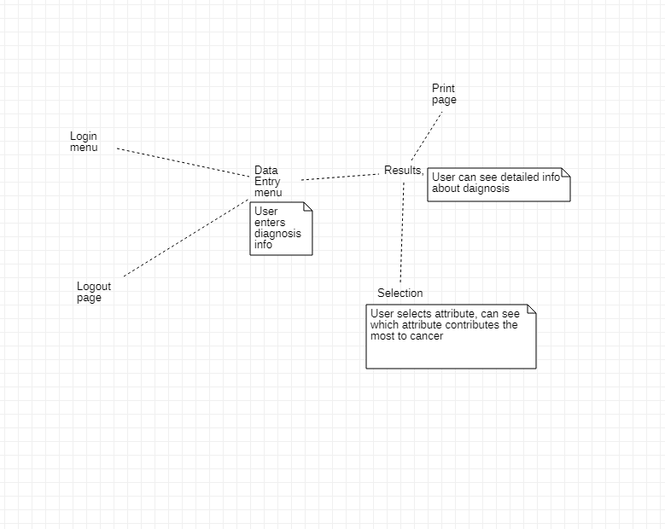

Appendices
<Optional: if you have any appendices. You can also enclose the updated requirement document >

