Software Requirements Specification
for
Cancer Diagnosis System
Version 1.0 approved
Prepared by Blake Samani
Group 7
10/8/2020
Table of Contents
Table of Contents ii
Revision History ii
1. Introduction 1
1.1 Purpose and Scope 1
1.2 Definitions, Acronyms and Abbreviations 1
1.3 References 1
1.4 Overview 1
2. Overall Description 1
2.1 Product Functions 1
2.2 User Classes and Characteristics 1
2.3 Constraints 2
2.4 Assumptions and Dependencies 2
3. Specific requirements 2
3.1 External Interface Requirements 2
3.1.1 User Interfaces 2
3.1.2 Hardware Interfaces 2
3.1.3 Software Interfaces 2
3.1.4 Communications Interfaces 3
3.2 Functional requirements 3
3.2.1 Functional requirement 1 3
3.2.2 Functional requirement 2 3
3.3 Performance Requirements 3
3.4 Software System Attributes 4
3.4.1 Availability 4
3.4.2 Security 4
3.5 Design constraints 4
3.5.1 Standards Compliance 4
3.5.2 Hardware Limitations 4
Appendix A: Issues List 4

Revision History
Name | Date | Reason For Changes | Version
Blake Samani | 10/8/2020 | Init | 1.0
Jason Hunter | 10/8/2020 | Init | 1.0
Nicholas Martinez | 10/8/2020 | Init | 1.0
Jesse Rankins | 10/8/2020 | Init | 1.0

Introduction

Purpose and Scope

Our product does the following:
- Collaborates with a network of other student groups
- Reads and parses XML data
- Utilize JUNIT testing
- Utilize LOG4J as a logging system
- Finds a feature or set of features that are highly correlated to the development of breast cancer.
- Generate a probability of cancer diagnosis
Our product does not do the following:
- Work as a standalone
- Replace a doctor’s diagnosis

Definitions, Acronyms and Abbreviations
- XML – Extensible Markup Language which allows you to store data in a format that can be stored, searched and shared across systems or platforms either locally or over the internet.
- JUNIT testing – Unit testing framework for Java programming language
- LOG4J – Logging utility for debugging and logging purposes
- Feature – Individual measurable property of a characteristic or phenomenon to be observed

References
Mozilla Developer https://developer.mozilla.org/en-US/

LOG4J https://logging.apache.org/log4j/2.x/

JUNIT https://junit.org/junit5/

Bruegge, B., & Dutoit, A. (2009). Object-Oriented Software Engineering Using UML, Patterns, and Java (3rd ed.). Pearson.

Overview
The following outlines our approach for implementation of a total system to identify cancerous traits from a feature

Overall Description

Product Functions 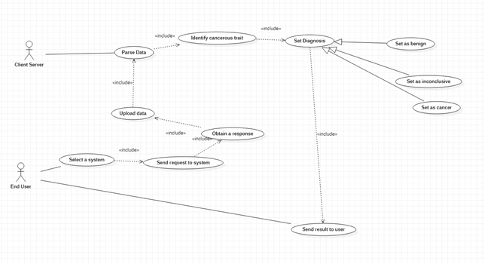

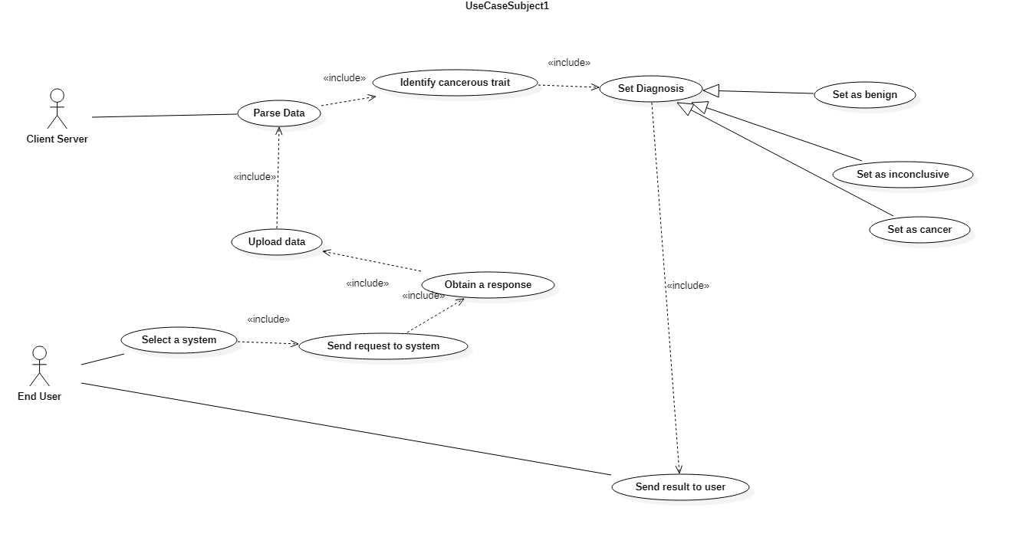

User Classes and Characteristics = characteristics of actors
<Identify the various user classes that you anticipate will use this product. User classes may be differentiated based on frequency of use, subset of product functions used, technical expertise, security or privilege levels, educational level, or experience. Describe the pertinent characteristics of each user class. Certain requirements may pertain only to certain user classes. Distinguish the favored user classes from those who are less important to satisfy.>

Admins
ADMIN FUNCTIONS
- Login()
- Logout()
- Getdata()
- Setpriveleges()
- Getdiagnosis()
- Setdiagnosis()

End Users
- Login()
- Logout()
- Getdata()
- Senddata()
- Request()

Server client
SERVER FUNCTIONS
- Privilegecheck()
- Parsedata()
- Idtrait()
- Setdiagnosis()
- Pushdata()
- Pulldata()

Constraints
<Describe any items or issues that will limit the options available to the developers. These might include: corporate or regulatory policies; hardware limitations (timing requirements, memory requirements); interfaces to other applications; specific technologies, tools, and databases to be used; parallel operations; language requirements; communications protocols; security considerations; design conventions or programming standards (for example, if the customer’s organization will be responsible for maintaining the delivered software).>
- Network performance
- Lack of medical expertise
- Liability
- Security
- Time
- Error in other teams XML format

Assumptions and Dependencies
<List any assumed factors (as opposed to known facts) that could affect the requirements stated in the SRS. These could include third-party or commercial components that you plan to use, issues around the development or operating environment, or constraints. The project could be affected if these assumptions are incorrect, are not shared, or change. Also identify any dependencies the project has on external factors, such as software components that you intend to reuse from another project, unless they are already documented elsewhere (for example, in the vision and scope document or the project plan).>

Dependencies
- JUNIT
- LOG4J
- XML format
- Java
Assumptions
- Assumption of seamless integration of dependencies
- Assumption that diagnosis is correct/incorrect.

Specific requirements

External Interface Requirements

User Interfaces
Java login system
  - Front end software – Java
  - Back end – P2P Server

Hardware Interfaces
Supported devices
- PC
- Windows
- Browser that supports HTML and Java
Communication protocol
- P2P

Software Interfaces
<Describe the connections between this product and other specific software components (name and version), including databases, operating systems, tools, libraries, and integrated commercial components. Identify the data items or messages coming into the system and going out and describe the purpose of each. Describe the services needed and the nature of communications. Refer to documents that describe detailed application programming interface protocols. Identify data that will be shared across software components. If the data sharing mechanism must be implemented in a specific way (for example, use of a global data area in a multitasking operating system), specify this as an implementation constraint.>

- Windows
  - Most popular
- School server
  - required
- LOG4J
  - required
- XML
  - required
- JUNIT
  - required

Communications Interfaces
- Web browsers
  - Electronic forms
- TCP/FTP

Functional requirements
<Describe how the transformation of inputs to outputs is achieved. The description is given for each class of functions, and sometimes for each individual function. To a certain extent, this description can be seen as a solution to the user. This component of the requirement specification is the main starting point for the design phase.>

Select a system

Introduction
User selects a system to parse their data

Inputs entry condition
- User selects a system
- User logs in a system

Processing flow event
- User selects which system to use
- User logs into system

Outputs exit condition
<Describes the outputs (destination, quantities, error messages, and the like).>
- No system selected
- No data provided
- User moves to next step

Send a request to the system

Introduction
User sends a request to the system

Inputs entry condition
- User requests response from system

Processing flow event
- User request is sent
- Received by system

Outputs exit condition
- Request was received
- Request was denied

Obtain a response

Introduction
A response is sent to the system

Inputs entry condition
- System is pinged by user

Processing flow event
- Server acknowledges user and allows access
- Provides user with prompt

Outputs exit condition
- User cancels request
- System denies user

Upload Data

Introduction
Data is uploaded to the system

Inputs entry condition
- System accepts data

Processing flow event
- System receives data from user

Outputs exit condition
- Data is incompatible or corrupt

Parse Data

Introduction
Data is parsed by the system

Inputs entry condition
- System accepts data
- System parses through data

Processing flow event
- System receives data from user
- Data was accepted
- Parses completes

Outputs exit condition
- Data is successfully parsed
- Data is not parsed

Identify Cancerous Trait

Introduction
Cancerous traits are identified via random selection/multivariate regression (undecided)/ Neural network(undecided)

Inputs entry condition
- System successfully parsed data

Processing flow event
- System accepts data from user
- System runs undecided algorithm against data

Outputs exit condition
- Trait is successfully identified
- System was unable to identify a trait

Set Diagnosis

Introduction
Diagnosis is set based on features

Inputs entry condition
- Trait was successfully identified

Processing flow event
- System identifies trait as benign, cancerous, or inconclusive
- System sets diagnosis

Outputs exit condition
- Diagnosis is set
- Diagnosis is unable to be set

Send result to user

Introduction
Diagnosis is sent to user

Inputs entry condition
- Diagnosis is set

Processing flow event
- System receives diagnosis
- System sets diagnosis
- System sends diagnosis to user

Outputs exit condition
- Diagnosis is sent to user
- Diagnosis is unable to be sent

Performance Requirements
Render a result to end user no later than 3 minutes after submitting data for parsing

Software System Attributes
<Particular attention is paid to quality aspects. These requirements must be measurable and verifiable. They must be stated in objective terms.>

Availability
10/100 uptime
90/100 downtime

Security
Prototype, will add later.

Constraints
<Design constraints may result from such things as the prescribed use of certain standards or hardware.>

Standards Compliance
We will adhere to a P2P standard of network communication, Using a unified XML document format shared among teams.

Hardware Limitations
- 16gb of memory
- 8 core processors
- School side limitations

Appendix A: Issues List
Unresolved issues
- GUI
- Mascot
- Logo
- XML parsing standards
- LOG4J standards
- JUNIT standards

