Project 1 Report  
CSC 4320/6320 - Operating Systems  
Spring 2023  
Name: Blake Caraballo  
Email: bcaraballo1@student.gsu.edu

Part 1:  
1) Screenshots of your installed Ubuntu in VirtualBox.

Part 2:  
1) Kernel log buffer contents after loading kernel module project1_part2  
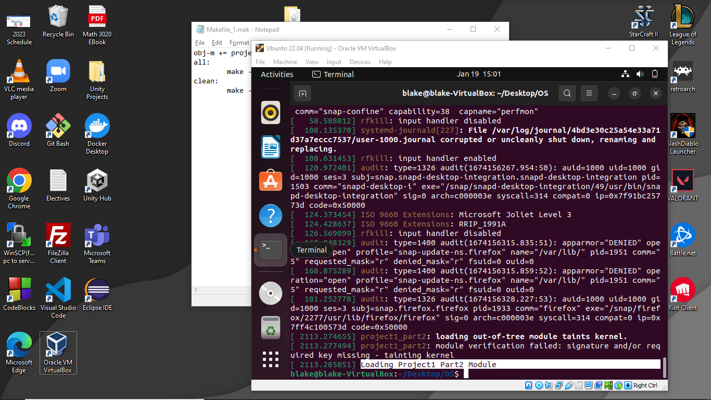

2) Kernel log buffer contents after removing kernel module project1_part2.

Part 3:  
1) Kernel log buffer contents after loading kernel module project1_part3.

2) Kernel log buffer contents after removing kernel module project1_part3.



#include <linux/init.h>

#include <linux/module.h>

#include <linux/kernel.h>

#include <linux/list.h>

#include <linux/slab.h>

struct birthday

{

    char *name;

    int month;

    int day;

    int year;

    struct list_head list; //next pointer?

};

/**

 * The following defines and initializes a list_head object named birthday_list

 */

static LIST_HEAD(birthday_list); //head node

int part3_init(void)

{

    printk(KERN_INFO "***Loading Proejct1 Part3 Module***\n");

    /* Create a linked list containing five struct birthday elements*/

    /* NOTE:THE NAME OF FIRST STRUCT BIRTHDAY SHOULD BE YOUR OWN NAME*/

    struct birthday *person;

    struct birthday *person2;

    struct birthday *person3;

    struct birthday *person4;

    struct birthday *person5;

    person = kmalloc(sizeof(*person), GFP_KERNEL); //node

    person->day = 7;

    person->month = 3;

    person->year = 1993;

    person->name = "Blake Caraballo";

      INIT_LIST_HEAD(&person->list);

    person2 = kmalloc(sizeof(*person2), GFP_KERNEL); //node

    person2->day = 2;

    person2->month = 8;

    person2->year = 1989;

    person2->name = "John";

    INIT_LIST_HEAD(&person2->list);

    person3 = kmalloc(sizeof(*person3), GFP_KERNEL); //node

    person3->day = 1;

    person3->month = 1;

    person3->year = 2000;

    person3->name = "Gary";

    INIT_LIST_HEAD(&person3->list);

    person4 = kmalloc(sizeof(*person4), GFP_KERNEL); //node

    person4->day = 9;

    person4->month = 1;

    person4->year = 1967;

    person4->name = "Wilma";

    INIT_LIST_HEAD(&person4->list);

    person5 = kmalloc(sizeof(*person5), GFP_KERNEL); //node

    person5->day = 4;

    person5->month = 11;

    person5->year = 1999;

    person5->name = "Terry";

    INIT_LIST_HEAD(&person5->list);

    list_add_tail(&person->list, &birthday_list);

    list_add_tail(&person2->list, &birthday_list);

    list_add_tail(&person3->list, &birthday_list);

    list_add_tail(&person4->list, &birthday_list);

    list_add_tail(&person5->list, &birthday_list);

    /* Traverse the linked list  */

    struct birthday *ptr;

    list_for_each_entry(ptr, &birthday_list, list){

        printk(KERN_INFO "Name = %s Birthday: Month: %d Day: %d Year %d",ptr->name,ptr->month,ptr->day,ptr->year);

    }

    return 0;

}

void part3_exit(void) {

    printk(KERN_INFO "***Removing Project1 Part3 Module***\n");

    /* Remove the elements from the linked list and return the free memory back to the kernel */

    struct birthday *ptr, *next;

     list_for_each_entry_safe(ptr,next,&birthday_list,list){

        list_del(&ptr->list);

         printk(KERN_INFO "Removing: Name = %s Birthday: Month: %d Day: %d Year %d",ptr->name,ptr->month,ptr->day,ptr->year);

        kfree(next);

     }

}

module_init( part3_init );

module_exit( part3_exit );

MODULE_LICENSE("GPL");

MODULE_DESCRIPTION("Proejct1 Part3");

MODULE_AUTHOR("GSU_CSC4320_6320_TH_Spring2023");