ASSETS LOG
ASSET | TYPE | DESCRIPTION | USE | DATE ACCESSED | SOURCE
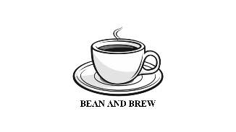 | Image/Logo | This is a logo for Bean and Brew created in Canva. | This will be used as the logo across several pages. | 24/02/2026 | Cup Of Coffee Line Art, Coffee, Beverage, Espresso PNG Transparent Image and Clipart for Free Download
 | Image | An image for the homepage to welcome the users. | This will be used in the homepage. | 24/02/2026 | Gotten from the project brief.
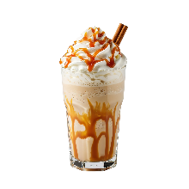 | Image | An image of a caramel Frappuccino, one of the drinks sold by Brew and Bean. | This will be used in the homepage and the products page. | 24/02/2026 | Delicious caramel frappuccino with whipped cream and caramel drizzle isolated on transparent background 68186237 PNG
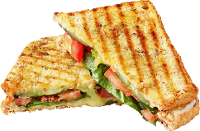 | Image | An image of a pressed sandwich. | This will be used in the homepage and the products page | 24/02/2026 | Sandwich Clip, Food Item, Culinary Delight PNG Photo
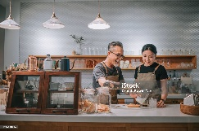 | Image | An image of employees working at a coffee shop. | This will be used in the about us page. | 24/02/2026 | Asian Chinese Senior Male Barista Teaching His Daughter Making Coffee At Cafe Bar Counter Stock Photo - Download Image Now - iStock
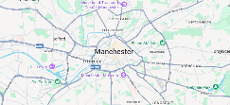 | Image | A screenshot taken from the google maps website (view of Manchester). | This will be used as a template for the real google maps API in the about us page. | 24/02/2026 | Google Maps

