DOCUMENTATION
At the beginning of the project, I looked for assets relating to the website, this includes images for some of the products, images of employees working in a coffee shop and APIs like google maps. I also did the designs for the website, I decided to use a top-down approach, i.e. create the complete visual design of how the website would look and then break it down and do the algorithm designs individually.

DESCRIPTION
The user goes on to the homepage of the website, they may try to access a service, but they must log in to access any service. They user may then be prompted to register an account since they do not have an existing account, after the registration, the user can now log in.
Once the user is logged in, they can access all the services. If the user goes to order an item, they must enter the location, what product they want to order and not date or time since you can only preorder for the same day and the shop gives you a time estimate of when your order will be ready. When on this page, the user can choose to view the complete menu to see all the items we offer, when in this page, they can then view the ingredients of the items.
You can also book a baking class; you would have to put in the time and data you wish to attend for and the type of class you want to attend. You can also choose to book a space at the shop; you must put in what location you want, the data, the time and the number of guests that would be going to the shop.
The user can also view the account section, this section contains the user’s account details, their orders, their booked lessons, the option to sign out and the option to delete account. In the settings page, a text size changer is available, the user can increase ad reduce the text to a specific size as to make it accessible and the user can change the font style and enable dark mode, these functions use JavaScript to carry out the actions.
When the user registers their account, all their details will be saved to a table in the database, and the database will be relational. When the user books a space, it is also saved to a table, and it is related to that specific customer account via a customer ID.
Also, data will be pulled from the database to check if the username the user tries to enter is already in the database, if it is, an error is given to the user, and they must choose another username. When the user is booking a space, data is also gotten from the database to check if the slot is already booked, if it is, the user is prompted to pick another slot.
When the user checks their account details, the data is already stored locally as it is stored when the user logs in, all their details are gotten from the database are stored and they can be viewed in the account details page, the only detail that isn’t shown is the password for security reason, but the password is needed as it will need to be confirmed when the user wants to delete their account. Also, when the user views their orders or booked lesson, the data is pulled from the database and displayed to the user.
I am going to use alternate texts in images as an accessibility feature in case the images cannot be loaded for whatever reason, the user can still have a description of the image instead of a visualisation.

VISUAL INTERFACE DESIGN

LOGGED OUT

HOMEPAGE
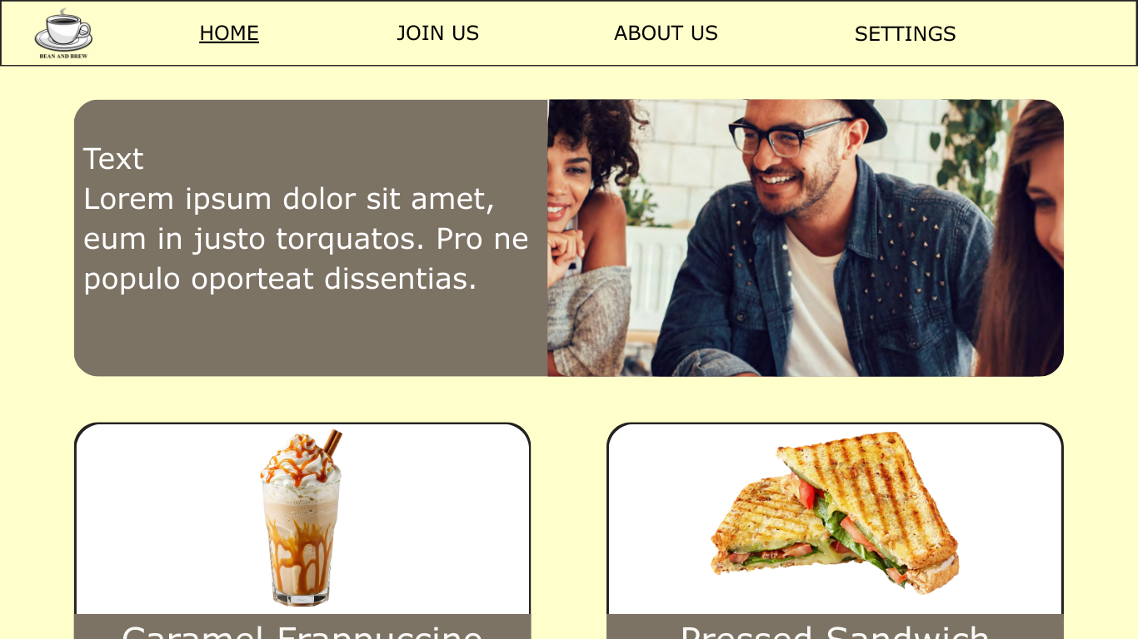
This is the homepage, when the user tries to access the website, this is the first page that they view, it gives them some information about their company and their products. This page consists of a navigation bar that is consistent throughout all the pages, its links to all the other pages that the user can access while logged out.
The navigation bar consists of a link to the join us page which is the login page a link to the about us page and the settings page.
There are boxes in the homepage containing images and text that give quick info about the company or promos, there are also some items that are displayed to attract the user. If the user decides to click on one of those items, it takes them to the login page as they have to login to purchase a product.

LOGIN PAGE
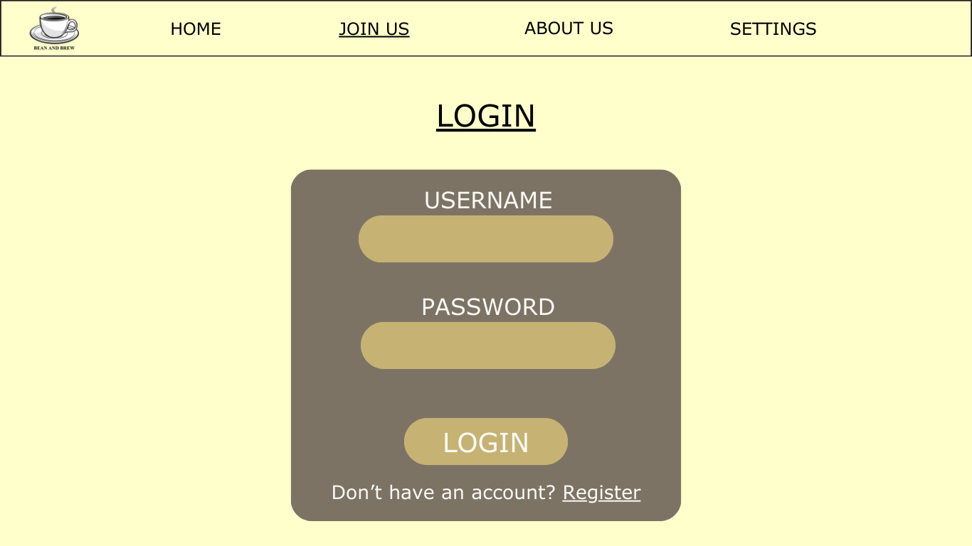
This is the login page, it consists of a form that allows the user to enter their username and password, and then login to their account, if there is any error logging in, the user is given an error, if they login process does go through, the user is logged in and taken to the homepage where they can then access other services.

REGISTER PAGE
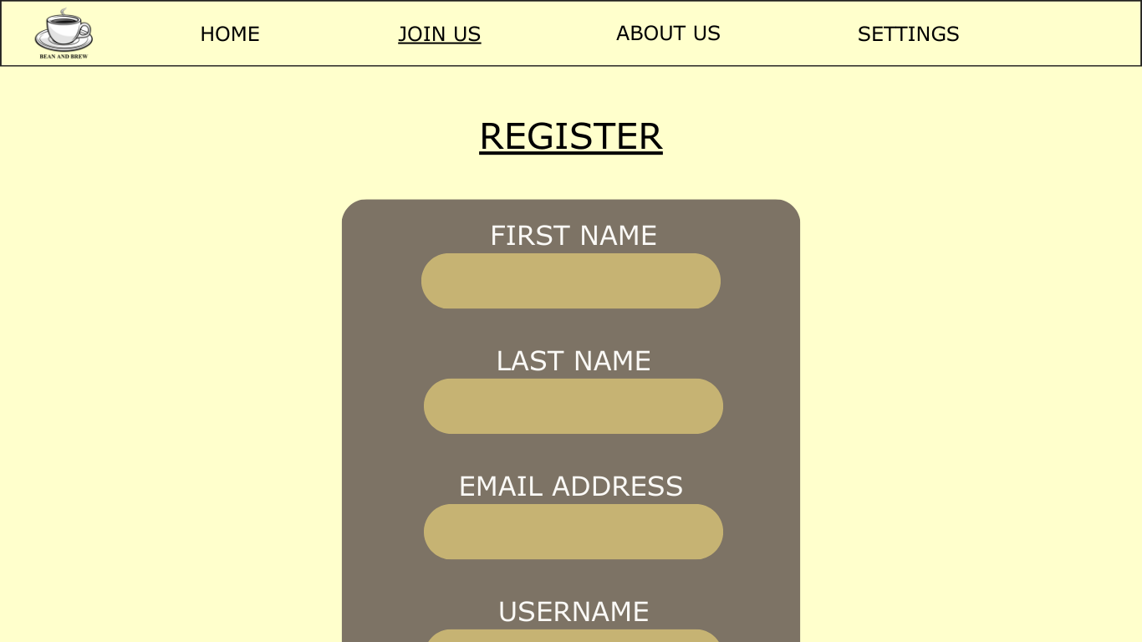
This is the register page, this page consists of a form where the user can enter their first name, last name, email address, username and password and if they meet all the requirements, the account is registered and they are taken to the login page, if they don’t, a specific error is shown to them. The page also contains a link to the login page.

ABOUT US PAGE
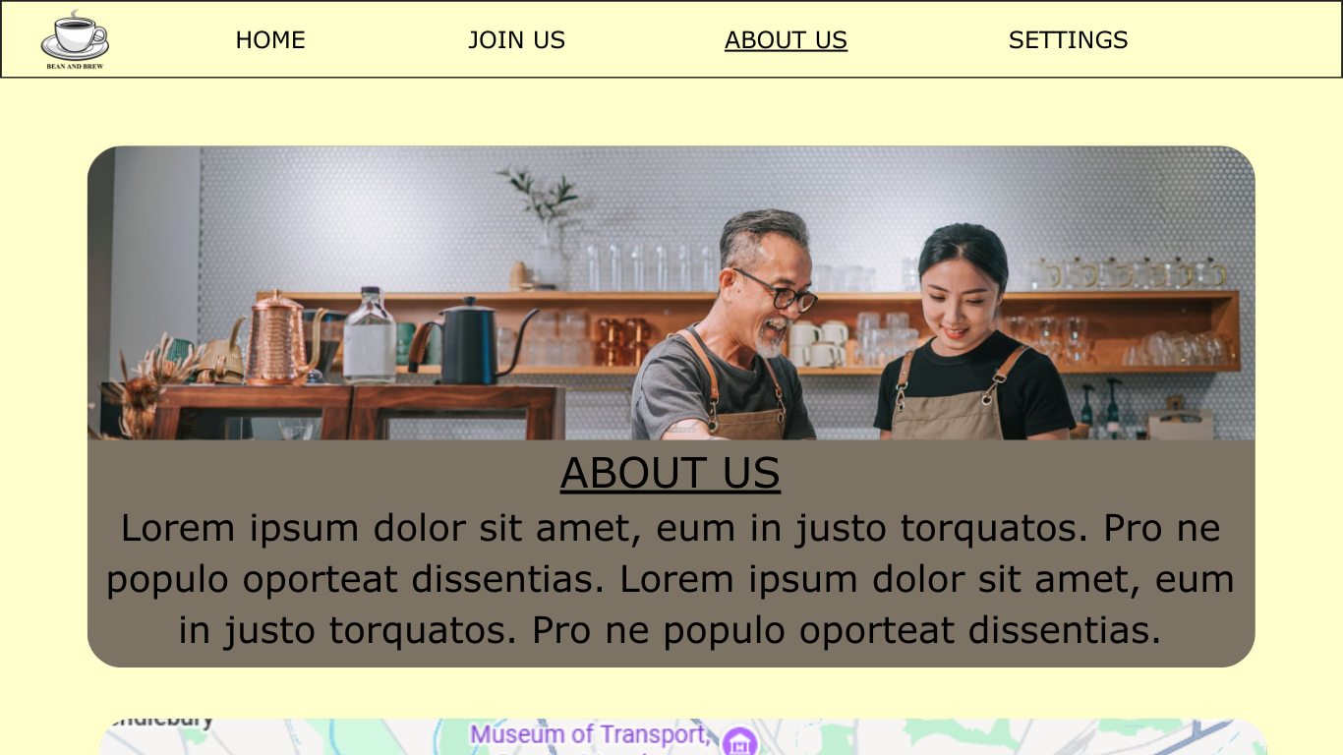
This is the about us page, it consists of a box containing text and images about the company and the page also consists of a find us section which contains google maps APIs on the location of the 3 stores and text on their addresses.

SETTINGS PAGE
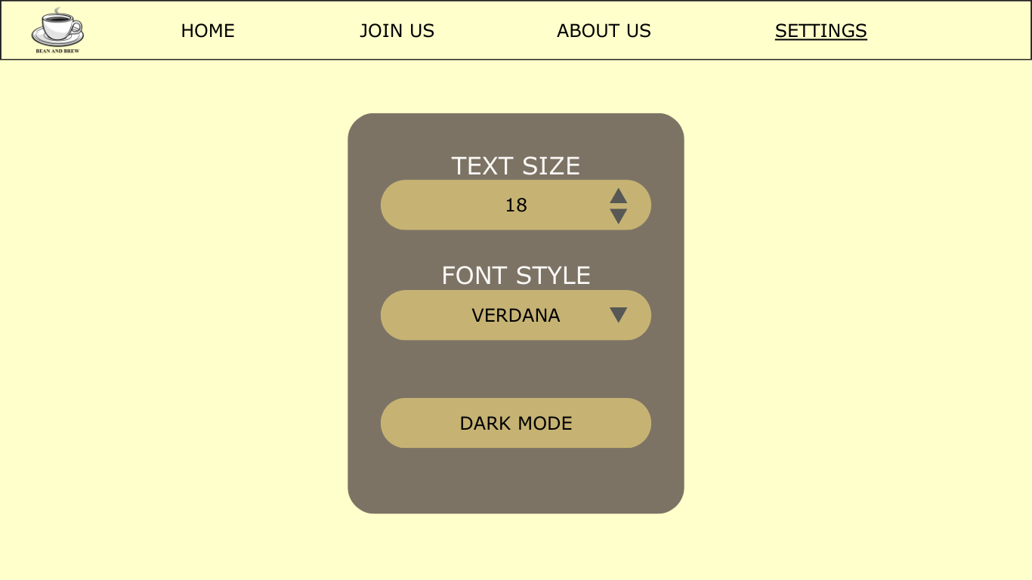
This is the settings page, it consists of a box containing a text size changer with the minimum value at 18 and maximum at 22, there is also a dropdown font style changes so the user can select their font and it is a dropdown so it limits wrong data entry and there is no need for extra validation. There is also a dark mode for aesthetics and accessibility.

LOGGED IN

HOMEPAGE
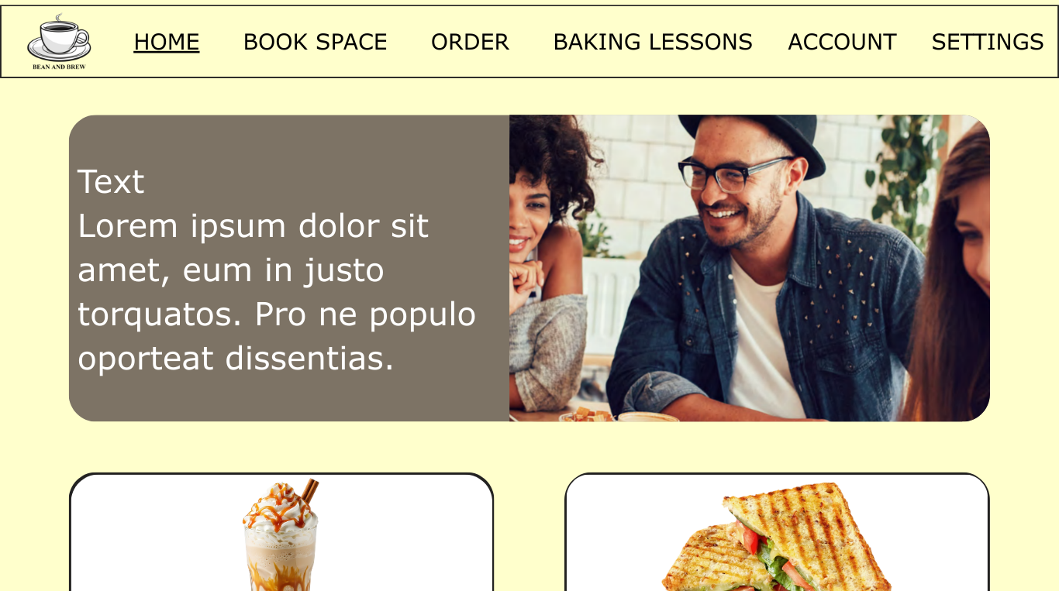
When the user is logged in, the navigation bar changes and the user can now access some services like booking a space, nothing else changes in the homepage apart from when the user clicks to buy and item, it takes them to the preorder page instead of the login page.

BOOK SPACE
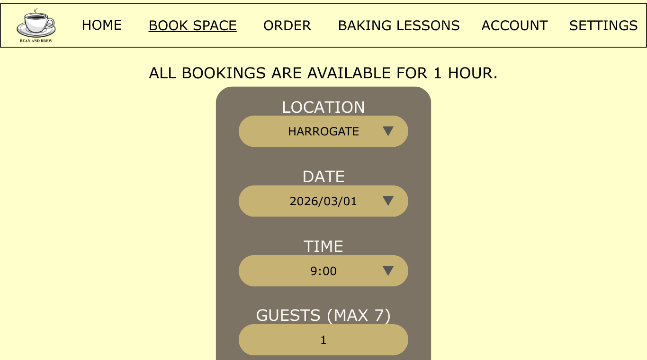
This is the book space page, it contains info about the booking spaces and a form where they can enter the location, date, time and number of guests for the location they want to book and if the slot isn’t already taken, it books the space for the user and gives the a message with the details of their booking.

ORDER PAGE
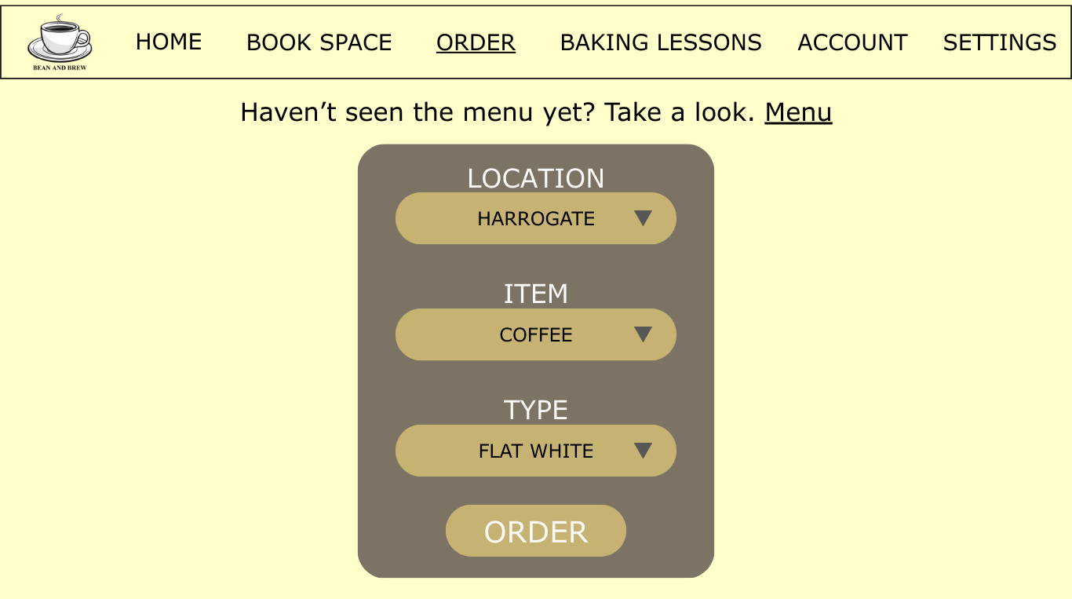
This is the order page, it consists of information about ordering a product, a link to the menu page and a form where the user can enter the location, item and type of item and then order it and they get details on when to pick up the item. All the options are dropdown to limit wrong data entry, and it does not need extra validation as the options given to the user are options that are predetermined and acceptable by the system.

MENU PAGE
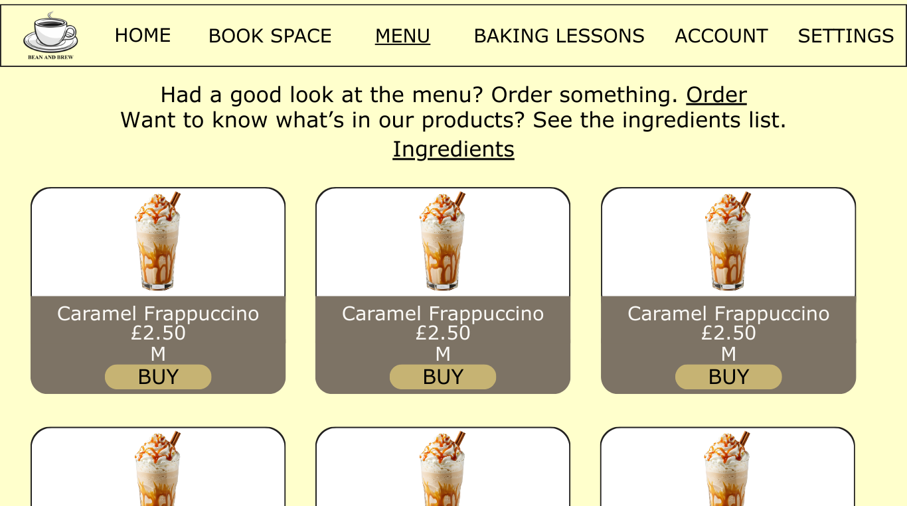
This is the menu page, it consists of information about the menu, a link to the ingredients page and a link back to the order page. It also consists of all the items the shops offer, their price and their size or type and a buy option.

INGREDIENTS PAGE
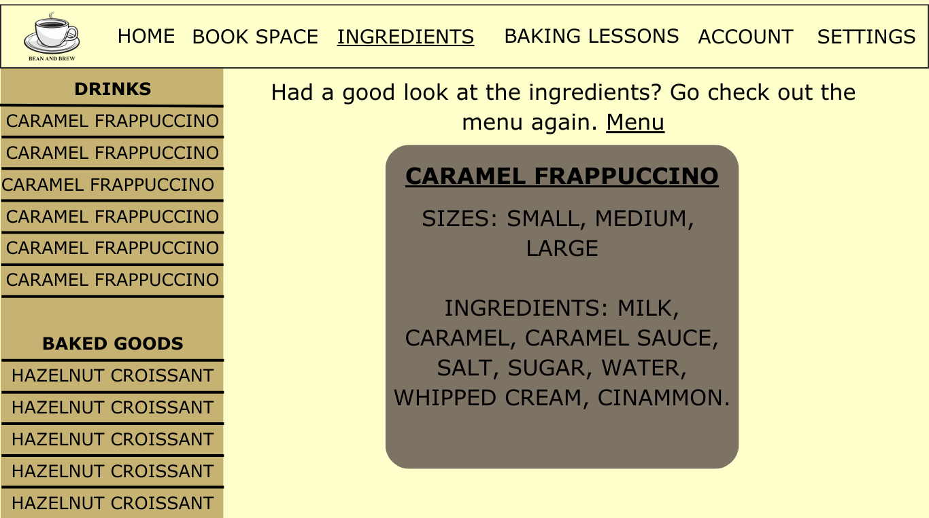
This is the ingredients page, it consists of information about the ingredients and, a link back to the menu page, a section containing the lists of items on the left and a box containing the ingredients and types or sizes on the right, if the user selects a different product, the information for that product displays on the right section.

BAKING LESSONS PAGE
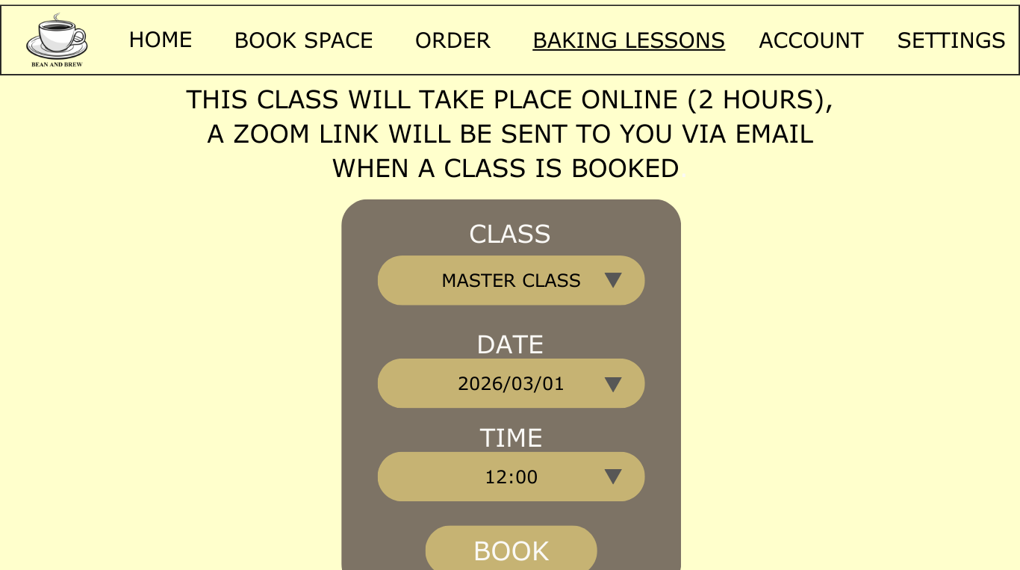
This is the baking lessons page, it consists of information about the baking lessons and a form where the user can enter their class type, date and time and book a day for their baking class, after the class is booked, the user is given n output message containing their booking details. All the options are dropdown to limit wrong data entry, and it does not need extra validation as the options given to the user are options that are predetermined and acceptable by the system.

ACCOUNT PAGE
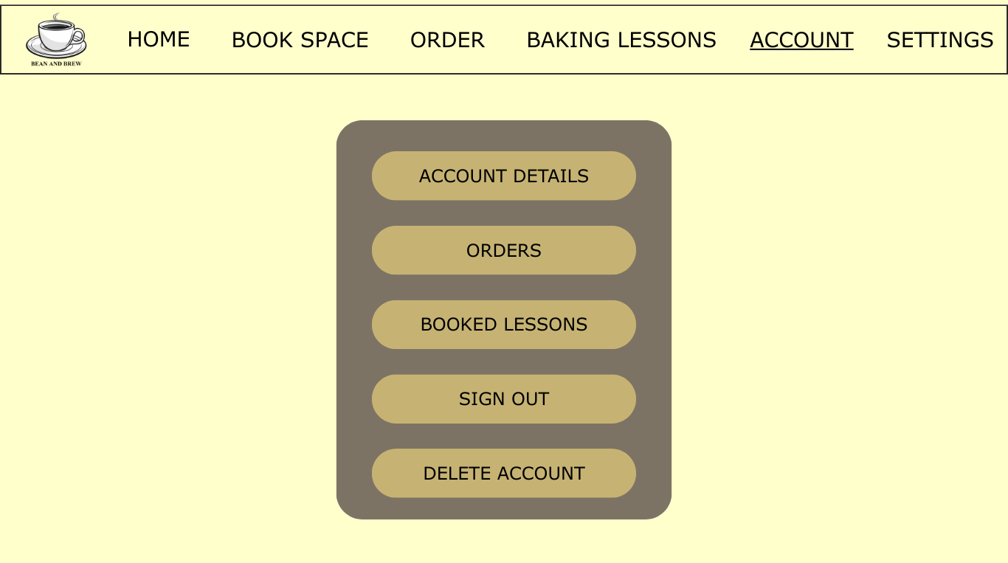
This is the account page, it consists of a section where the user has various options to pick from, they can go to their account details page and view all their account details apart from their password for security reasons, they can also go into their orders page which will contains all their pre orders information, they can also view their booked lessons which shows all the baking lessons they’ve booked for, they can also choose to sign out of their account and they have to confirm the sign out before the website signs them out and it takes them to the homepage, and they can delete their account, if they click on this, they are taken to a separate page where they have to verify their password first before their account can be deleted and then they are taken to the homepage and they cannot sign into their account again as it is deleted from the database.

ENTITY RELATIONSHIP DIAGRAM
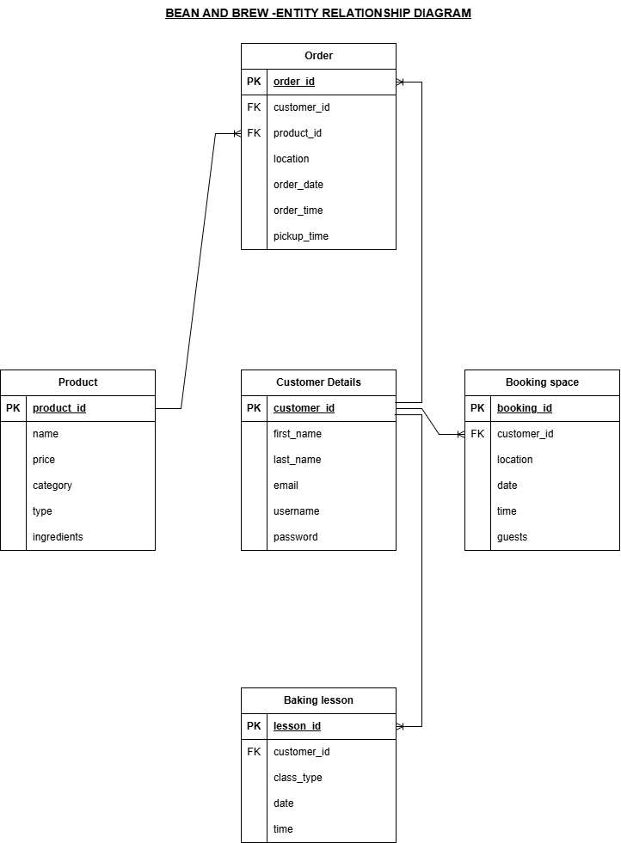
This is an ERD for Bean and Brew, it shows the relationships between all the table in the database, it establishes the presence of primary keys and foreign keys that make the database relational. The parent tables are the customer details and the products tables, while the daughter tables are the order, booking space, baking lesson and order tables.

DATA DICTIONARY

CUSTOMER
Field name | Type | Description | Example
customer_id | INT (PK) | This is a unique customer identifier number. | 17
First_name | VARCHAR (255) | This is the customer’s first name. | Max
Last_name | VARCHAR (255) | This is the customer’s last name. | Jackson
email | VARCHAR (255) | This is the user’s email address. | maxjackson@email.com
Username | VARCHAR (255) | This is the user’s username. | MaxJ
password | VARCHAR (255) | This is a hashed version of the user’s password. | 25$uwg0tkghtebikbgkgibe kgejhgonbano

PRODUCT
Field name | Type | Description | Example
Product_id | INT (PK) | This is the unique product identifier number. | 25
name | VARCHAR (255) | This is the name of the product. | Caramel Coffee
price | DECIMAL (5,2) | This is the price of the product. | 12.50
category | VARCHAR (255) | This is either baked goods or drink to classify the product. | Baked goods
type | VARCHAR (255) | This is either the size or type of product. | Medium
ingredients | TEXT | This is the list of ingredients contained in the product. | Caramel, sugar, water, whipped cream.

ORDER
Field name | Type | Description | Example
Order_id | INT (PK) | Unique identifier for the order. | 3
Customer_id | INT (FK) | This links to the specific customer. | 2
Product_id | INT (FK) | This links to the specific product. | 5
location | VARCHAR (255) | This is the location where the order is to be picked up from. | Haarrogate.
Order_date | DATE | This is the date which the order is made. | 12/03/2026
Order_time | TIME | This is the time which the order is made. | 09:27
Pickup_time | TIME | This is the time which the order is to be picked up. | 8:27

BOOKING SPACE
Field name | Type | Description | Example
Booking_id | INT (PK) | This is the unique identifier for the booking space. | 7
Customer_id | INT (FK) | This links to the specific customer. | 8
location | VARCHAR (255) | This is the location where the booking space is at. | Harrogate.
date | DATE | This is the date the space is to be booked for. | 19/09/2026
time | TIME | This is the time the space is to be booked for. | 12:00
guests | INT | This is the number of guests to use the booking space. | 6

BAKING LESSON
Field name | Type | Description | Example
lesson_id | INT (PK) | This is the unique lesson ID. | 1
customer_id | INT (FK) | This links to the specific customer. | 3
class_type | VARCHAR (255) | This is the type of class the user registered for. | Beginner.
date | DATE | This is the date which the lesson will take place. | 12/12/2026
time | TIME | This is the time which the lesson will take place. | 11:30

