

**Fasenmyer Senior Design Project Showcase-Spring 2022**

**Super Mileage Vehicle Camera System**



**Overview**

Professor Jill Johnson from Pennsylvania State University, Behrend wanted to create a low-profile camera system for the driver of the super mileage vehicle. The requirements were to use 3 lower profile cameras, for the driver to see out of the front and sides of the vehicle. This system will be using a Raspberry Pi 4 minicomputer for video processing from each of the cameras simultaneously.

**Objectives**

This project’s main objectives were as follows:

* To ensure that the system used has a simple operating system for any driver to use without having to learn much about the system.
* To ensure that the cameras are low profile as to not interrupt the aerodynamics of the vehicle.
* Make sure that the camera system follows the rules of the competition

**Approach**

* Obtained objectives and needs from sponsor
* Research the rules of the competition
* Designed the system around a minicomputer
* Found appropriate cameras and minicomputer for the system
* Downloaded OpenCV library on Raspberry Pi4
* Used Python language to make the cameras play live video to monitor
* Created a script for python code to run on boot up of system
* Make multiple windows for each camera on one monitor
* Make the entire system portable using a power bank
* Create a mock mount to test angles of cameras for best design
* Test the entire system as a whole for a final output

**Outcomes**

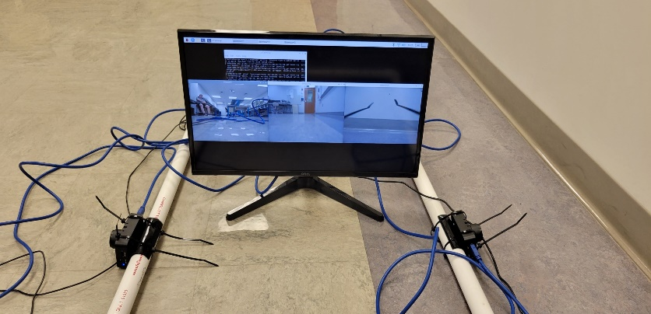

* The goal was to create a low-profile camera system and make it portable, which was able to be done.
* The system runs three cameras at the same time using a Raspberry Pi4, and 3 cameras.
* The system is simple and is able to be used by anyone by simply turning it on and making sure the cameras are plugged in correctly