Blake Pahler

Anthony Mazzocco

Andy Breier

**Super Mileage Vehicle**

**Weekly Report #3**

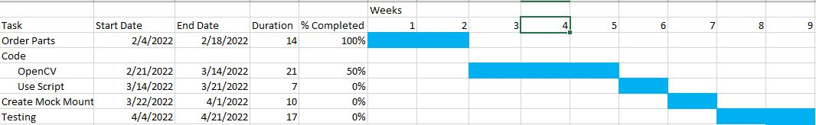

**Order Parts:** Ordered parts are 3 monitors and 3 screens, as our first idea had changed. However, we have now returned to our first idea and these parts can be used as a backup plan for the system

**Coding:**

**Open CV:** Created code to live stream a USB camera. We have attached 2 cameras total and checked to see if they both work. They work using separate code but do not run simultaneously. We have also set the resolution lower (640x480) in order to decrease latency.

**Use Script:** Use a script to ensure that the python/C++ code runs on start up of the Raspberry Pi system.

**Creating a Mock Mount:** A mock mount will be created in order to test the stability of the system while moving.

**Testing:** Testing the entire system will be done to prove that our system would work in the vehicle.

**Technical Problems:** Having both camera windows open at the same time and run. Only 1 window opens up at a time.

**Logistical Problems:** Currently we have no Logistical Problems.