Blake Pahler

Anthony Mazzocco

Andy Breier

**Super Mileage Vehicle**

**Weekly Report #4**

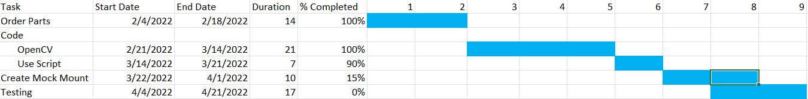

**Order Parts:** Ordered parts are 3 monitors and 3 screens, as our first idea had changed. However, we have now returned to our first idea and these parts can be used as a backup plan for the system

**Coding:**

**Open CV:** Created code to live stream a USB camera to monitor. We have attached 2 cameras total and checked to see if they both work. Both windows for each camera open and run simultaneously at 640x480 resolution.

**Use Script:** Created a script using crontab in the command line. Runs a test python file on bootup, but will not run video python file. Also created a shell script that is called on boot up to run the python file.

**Creating a Mock Mount:** Measurements have been taken for the mock mount, and planning has begun to determine how the mount will be constructed

**Testing:** Testing the entire system will be done to prove that our system would work in the vehicle.

**Technical Problems:** Boot up script will not run the Video capture python file. However, we do know that the crontab method works, as a test python file is used and runs on bootup for the system. We do not know what is causing the Video capture python file to not run.

The Raspberry Pi4 cannot run 3 USB cameras at the same time. One shuts off, we believe this is due to too much power consumption.

Due to these issues, some tasks have been extended

**Logistical Problems:** Currently we have no Logistical Problems.