Name: Muhammad Maaz Mirza

Roll Number: 214414

**Assignment # 1**

Q.1:

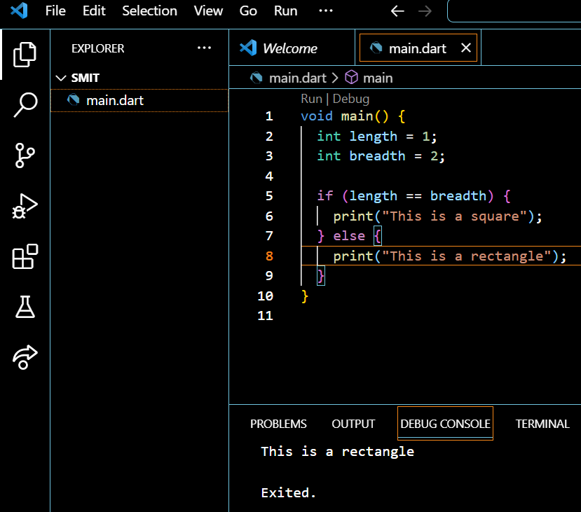

Q.2

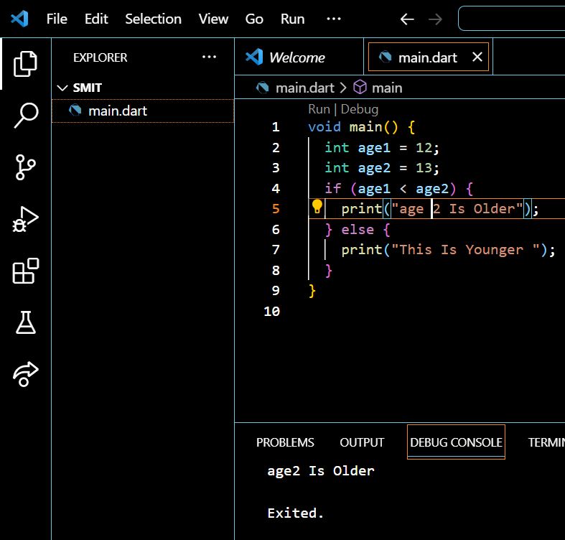

Q.3

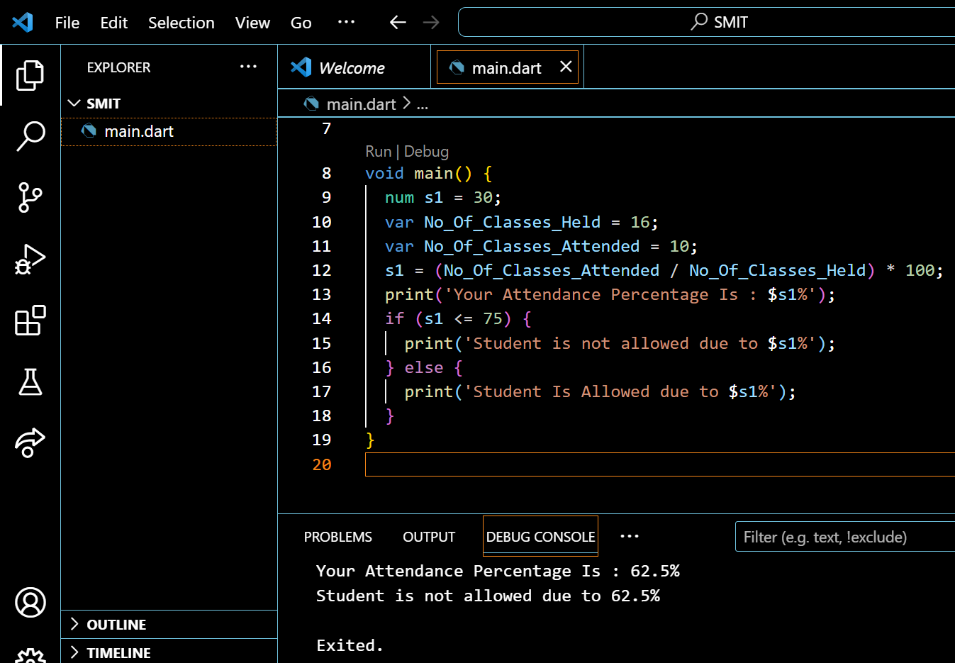

Q.4

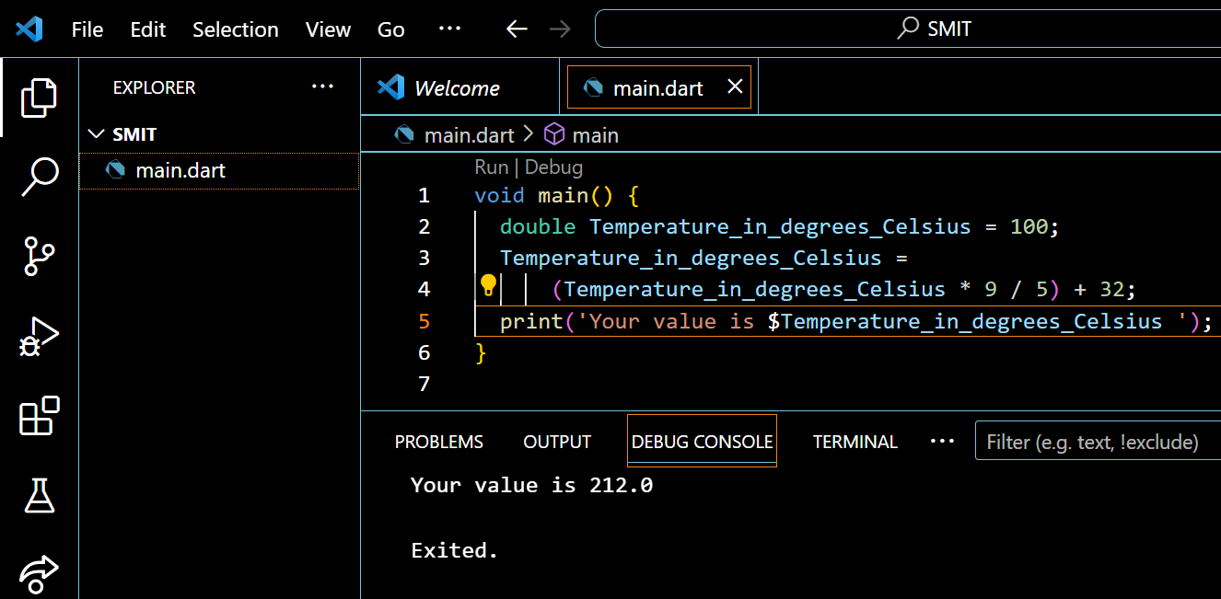

Q.5

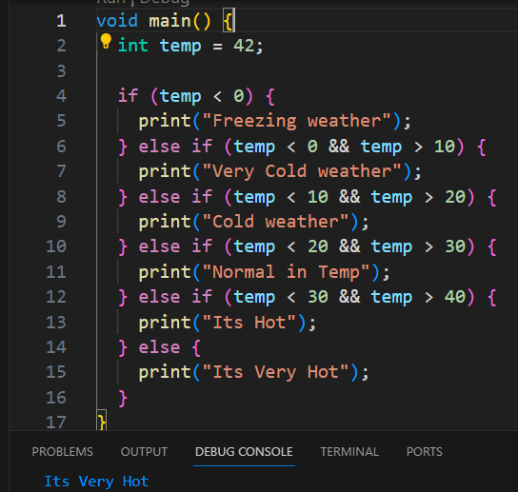

Q.6

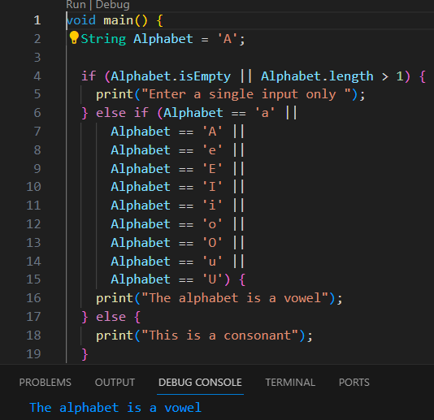

Q.7

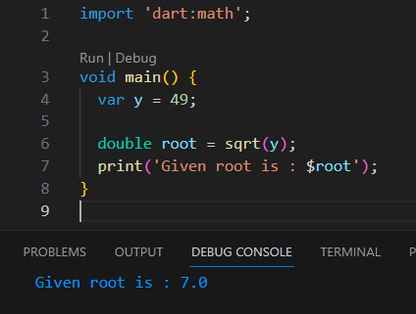

Q.8

import 'dart:math';

class Subject {

  String name;

  int maxMarks;

  int obtainedMarks;

  Subject(

      {required this.name,

      required this.maxMarks,

      required this.obtainedMarks});

}

class Student {

  String name;

  int rollNumber;

  String classValue;

  List<Subject> subjects;

  Student(

      {required this.name,

      required this.rollNumber,

      required this.classValue,

      required this.subjects});

  double getPercentage() {

    double totalObtainedMarks = 0;

    double totalMaxMarks = 0;

    subjects.forEach((subject) {

      totalObtainedMarks += subject.obtainedMarks;

      totalMaxMarks += subject.maxMarks;

    });

    return (totalObtainedMarks / totalMaxMarks) * 100;

  }

  String getGrade() {

    double percentage = getPercentage();

    if (percentage >= 90) {

      return 'A+';

    } else if (percentage >= 80) {

      return 'A';

    } else if (percentage >= 70) {

      return 'B';

    } else if (percentage >= 60) {

      return 'C';

    } else if (percentage >= 50) {

      return 'D';

    } else {

      return 'F';

    }

  }

  String generateMarksheet() {

    String marksheet = '';

    marksheet += 'Student Name: $name\n';

    marksheet += 'Student Roll Number: $rollNumber\n';

    marksheet += 'Class: $classValue\n';

    marksheet += 'Percentage: ${getPercentage().toStringAsFixed(2)}\n';

    marksheet += 'Grade: ${getGrade()}\n';

    marksheet += 'Subjects: \n';

    subjects.forEach((subject) {

      marksheet +=

          '${subject.name}: ${subject.obtainedMarks}/${subject.maxMarks}\n';

    });

    return marksheet;

  }

}

void main() {

  List<Subject> subjects = [

    Subject(name: 'Maths', maxMarks: 100, obtainedMarks: 90),

    Subject(name: 'English', maxMarks: 100, obtainedMarks: 85),

    Subject(name: 'Science', maxMarks: 100, obtainedMarks: 80),

    Subject(name: 'Social Science', maxMarks: 100, obtainedMarks: 75),

    Subject(name: 'Computer', maxMarks: 100, obtainedMarks: 85),

  ];

  Student student = Student(

      name: 'Talha Ayaz',

      rollNumber: 786,

      classValue: '10',

      subjects: subjects);

  print(student.generateMarksheet());

}

Output :

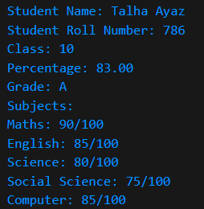

**Q.9**

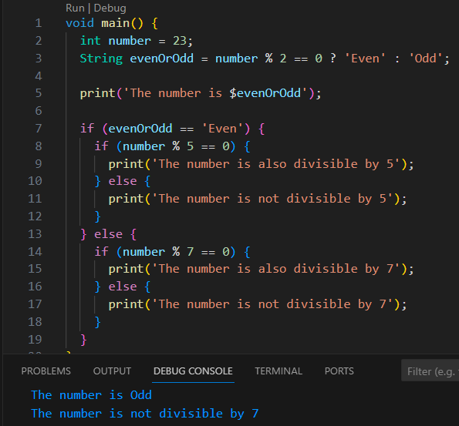

**Q.10**

import 'dart:io';

void main() {

  print("Enter the first number:");

  var num1 = int.parse(stdin.readLineSync()!);

  print("Enter the second number:");

  var num2 = int.parse(stdin.readLineSync()!);

  print("Enter the third number:");

  var num3 = int.parse(stdin.readLineSync()!);

  if (num1 > num2 && num1 > num3) {

    print("$num1 is the greatest number.");

  } else if (num2 > num1 && num2 > num3) {

    print("$num2 is the greatest number.");

  } else {

    print("$num3 is the greatest number.");

  }

  if (num1 < num2 && num1 < num3) {

    print("$num1 is the lowest number.");

  } else if (num2 < num1 && num2 < num3) {

    print("$num2 is the lowest number.");

  } else {

    print("$num3 is the lowest number.");

  }

}

**Output:**

